

**OpenELIS Global**

**Laboratory Information System Software**

**User Manual**

Version 3.0

October 2023

For information on OpenELIS Global,

visit [www.openelisglobal.org](http://www.openelisglobal.org)

Or contact:

Casey Iiams-Hauser

OpenELIS Global Product Owner

Digital Initiatives Group at I-TECH (DIGI) University of Washington digit@uw.edu

**PART 1: NAVIGATING OpenELIS GLOBAL 3**

How to change the language on OpenELIS 5

How to access the OpenELIS menu 7

**PART 2: QUICK TROUBLESHOOTING 8**

**PART 3: QUICK LINKS 8**

**PART 4: ENTERING LABORATORY ORDERS 9**

How to create a laboratory analysis order for an existing patient 9

How to create a laboratory analysis order for a new patient 25

How to modify or update a laboratory order 26

**PART 5: ELECTRONIC ORDERS 35**

**PART 6: BATCH ORDER ENTRY 36**

How to set up batch order entry without individual patient data 36

How to set up a batch order entry with individual patient data. 44

How to print barcode labels 47

**PART 7: WORK PLANS 49**

How to create a work plan by test type, by panel type, unit type or by priority 49

**PART 8: PATHOLOGY 54**

How to create a pathology case. 54

How a pathology specimen is processed by a laboratory technician. 54

How to review and conclude a pathology test.. 63

How to refer a pathology specimen to immunochemistry. 70

**PART 9: IMMUNOCHEMISTRY 71**

How to access the immunohistochemistry module and create an immunohistochemistry test. 71

How to access and process an immunohistochemistry test. 77

How to upload or generate an immunohistochemistry report. 86

**PART 10: CYTOLOGY 93**

How to create a cytology test order. 94

How to access the cytology module and process a test. 99

How to upload or generate a cytology report. 119

**PART 11: NON CONFORMING EVENTS 122**

How to report a non-conforming event (NCE) 123

How to create a NCE Corrective Action Plan 126

How to monitor an NCE Corrective Action Plan 129

How to close a resolved NCE 131

**PART 12: ENTERING LAB TEST RESULTS 134**

How to get to the results entry page 134

How to enter results by unit 135

How to enter results by Patient 137

How to enter results by Order 140

How to enter results by Range of Order Number 141

How to enter results By Test Date 142

How to fill the result entry section. 143

How to refer a test to another laboratory 146

**PART 13: RESULTS VALIDATION (BIOLOGICAL VALIDATION) 147**

How to get to the results validation page 147

How to validate results By Routine Search 148

How to validate results By Study. 156

How to validate results By Test Date 160

**PART 13: REPORT 166**

How to get to the results validation page and generate a report by routine. 167

How to generate a report by by study. 170

# **PART 1: NAVIGATING OpenELIS GLOBAL**

The OpenELIS Global system is made up of a variety of concise screens and workflows to help with the collection, management, and reporting of laboratory data. The use of this system is intended to provide a structured approach to managing the data within the clinical laboratory setting to ensure high-quality testing processes and results data that is then made accessible to external systems and people in the clinical, population, and programmatic health workflows.

## **How to login to OpenELIS**

To login to OpeELIS, You will require a **username** and **password** obtained from the administrator of your OpenELIS instance.

1. Type in your **username** and **password** and click on the **Submit** button.

**Notice**: Access to this service is for authorized personnel only. If you do not have the expressed authorization of the administrator, you must exit now. This organization prohibits unauthorized access, disclosure, duplication, modification, diversion, destruction, loss, misuse, or theft of its information.

# 

*OpenELIS Global 3.0 Login page*

Once you connect to OpenELIS Global, the home page will display the laboratory management statistics for your understanding of the current state of the lab testing processes.

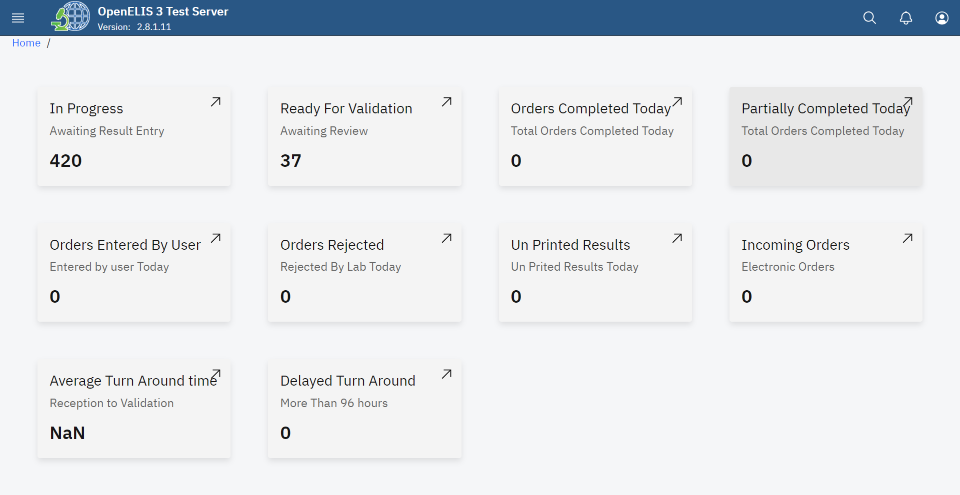

*OpenELIS Statistics*

## **How to change the language on OpenELIS**

1. Hover the mouse to the top right corner and click on the profile icon 

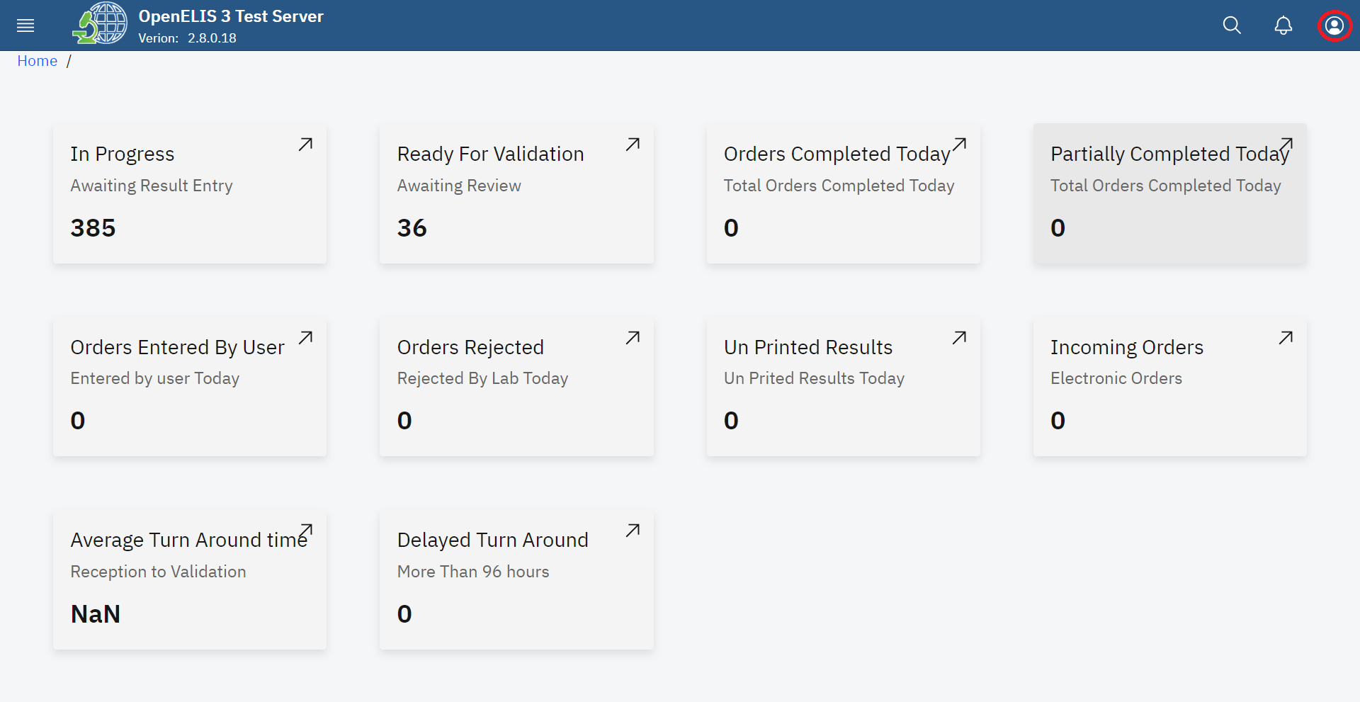

*Accesing Language Preferences*

1. To change the language from English to French, click on the drop down menu.

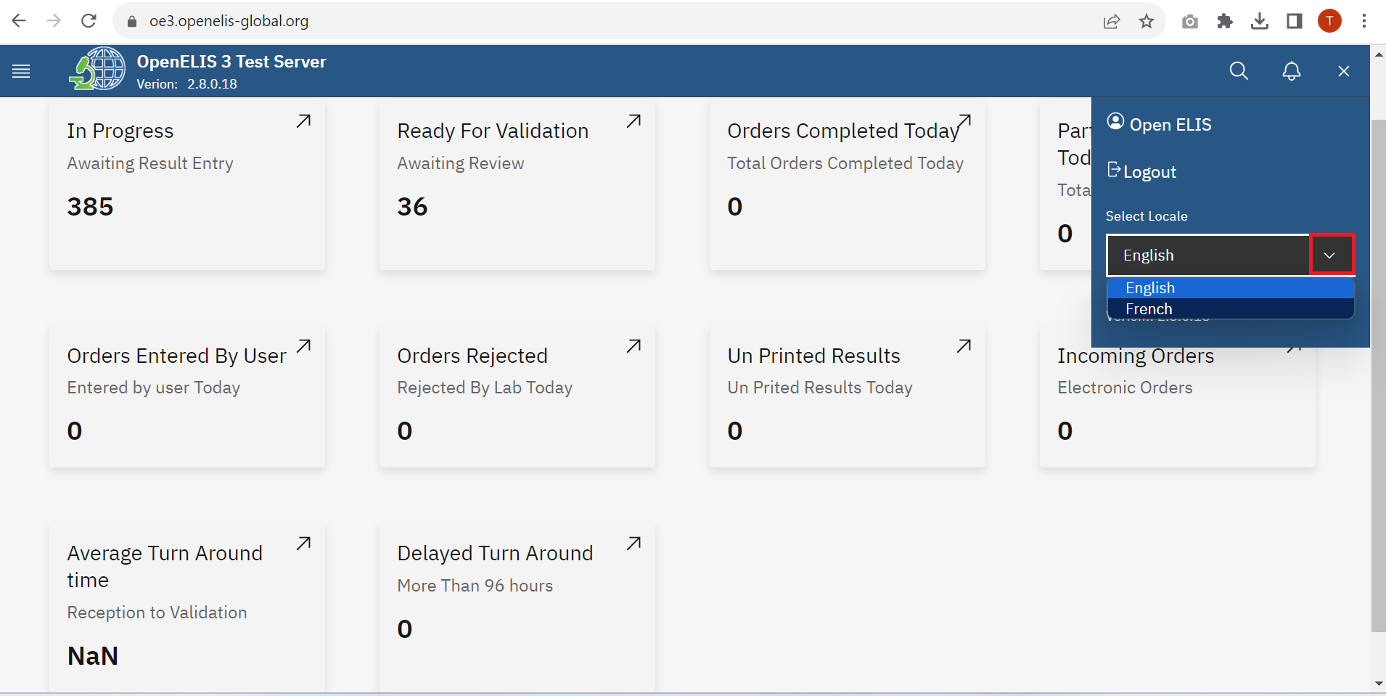

*Language Drop-down Menu*

1. Hover the mouse and click on French

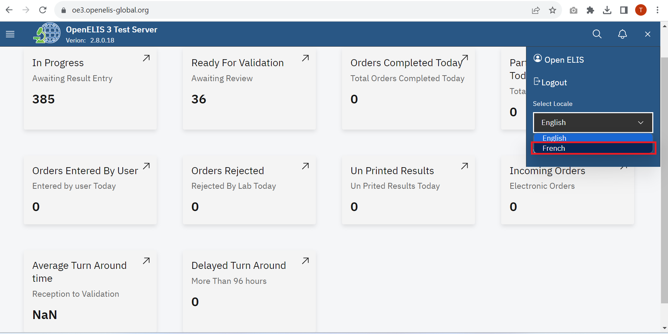

*Change language*

The default language will be changed from English to French

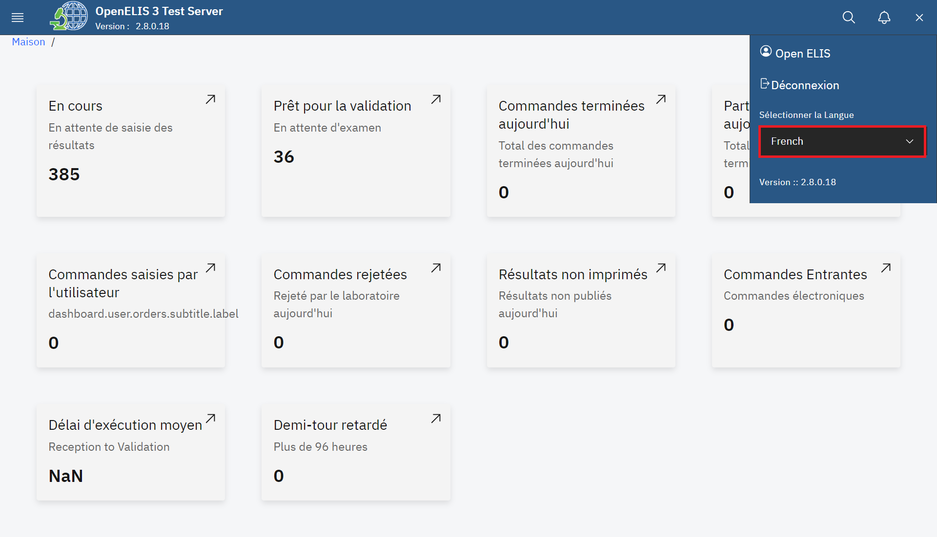

*Language Change*

## 

## **How to access the OpenELIS menu**

To access the main menu, click on the menu icon at the top left side of the screen.

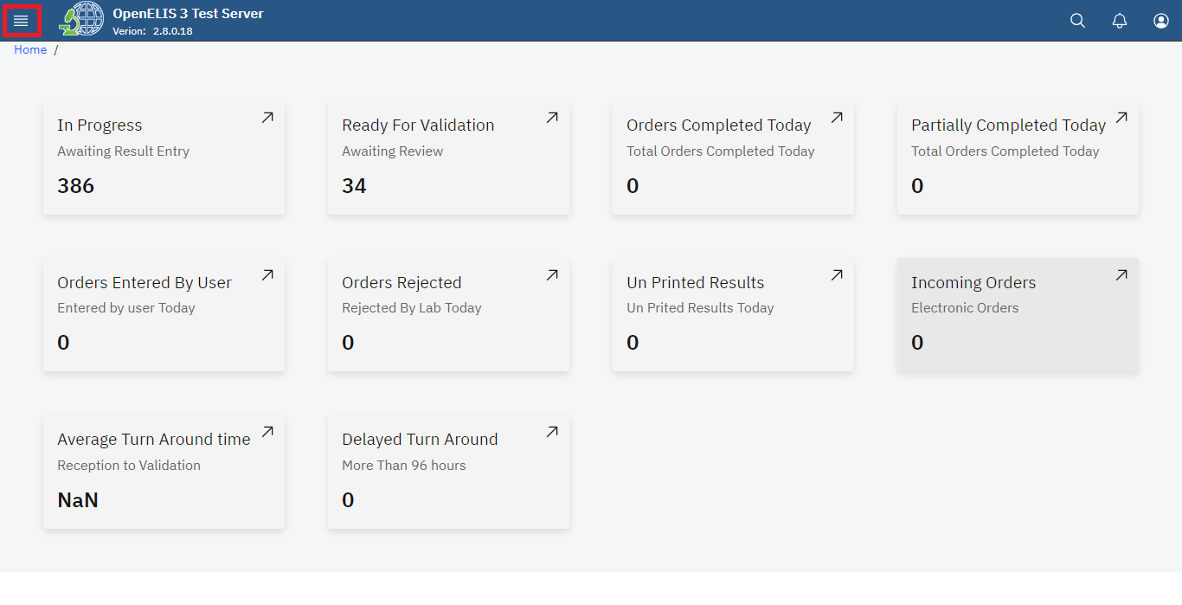

*Accessing OpenELIS 3 Menu*

Upon clicking on the menu icon, the OpenELIS menu will be displayed on the left side of the screen with modules that reflect the main activities of the laboratory workflow. The cancel will close the side menu item.

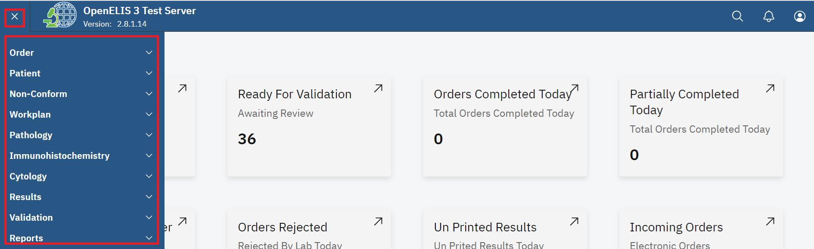

*OpenELIS Global Version 3 Menu*

The modules are presented in the order of the laboratory workflow. The main menu always remains on the page and you can navigate to other modules to suit your work needs.

The modules are:

1. Order
2. Patient
3. Non-Conforming Events
4. Workplan
5. Pathology
6. Immunohistochemistry
7. Cytology
8. Results
9. Validations
10. Reports

Additional modules include

1. Admin
   1. Information about the software and set-up
   2. Menus to configure various parts of the systems
   3. Menus to manage users
   4. Menus to manage the test catalog

*The guide for this module is available separately*

1. Help
   1. User Manual is available here

# **PART 2: QUICK TROUBLESHOOTING**

1. Be sure to use your own login credentials and password. If you need to reset your password, contact your system administrator or other designated User Manager.
2. Select the language (English or French) after logging in.
3. If the Save button is not activated, check that you have completed all required fields.
4. Required fields are marked by a red asterisk: *

# **PART 3: QUICK LINKS**

1. How to create a laboratory analysis order for an existing patient
2. How to set up batch order entry without individual patient data
3. How to print barcode labels
4. How to create a work plan by test type, by panel type, unit type or by priority
5. How to create a pathology case.
6. How to create an immunohistochemistry test.
7. How to create a cytology test order.
8. How to report a non-conforming event (NCE)
9. How to fill the result entry section.
10. How to get to the results validation page
11. How to generate all other reports.

# **PART 4: ENTERING LABORATORY ORDERS**

OpenELIS is organized around laboratory orders which are made up of samples and their associated tests. The laboratory order must also be associated with a patient. The guides in this section include:

* How to create a laboratory analysis order
* How to modify or update a laboratory order
* How to add or update a patient’s information

## **How to create a laboratory analysis order for an existing patient**

1. Hover the mouse to the top left and click on the hamburger icon on the top left of the screen to open the menu.

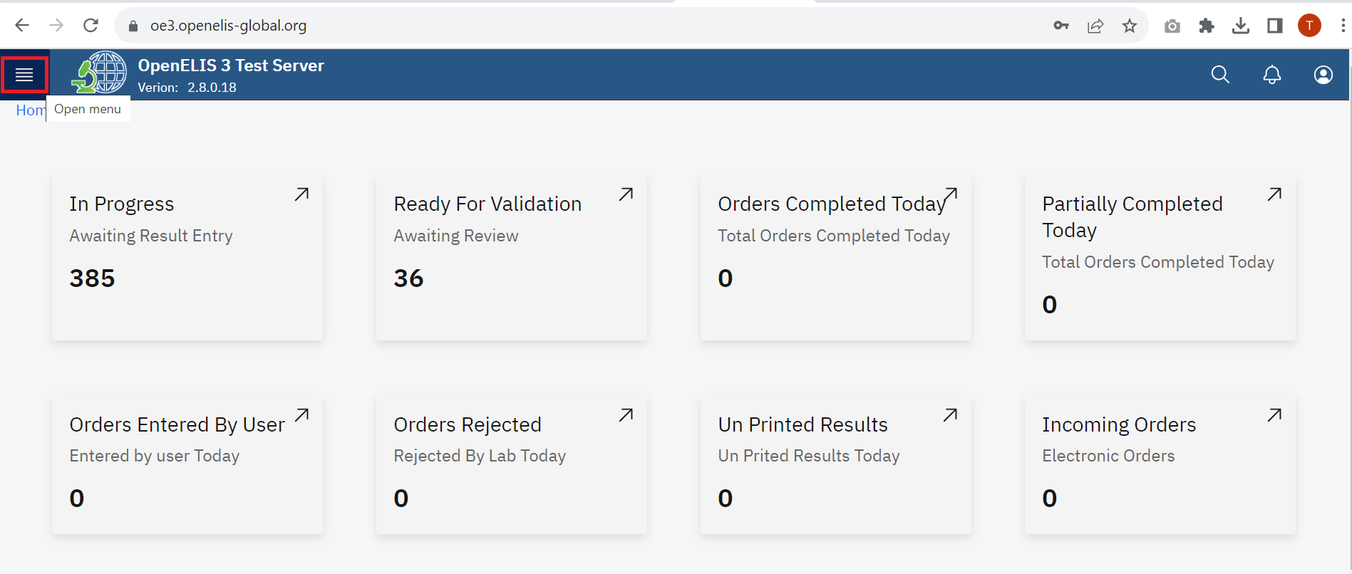

*Access the OpenELIS menu*

1. Hover the mouse and click on the drop-down menu under the Ordersmodule**.**

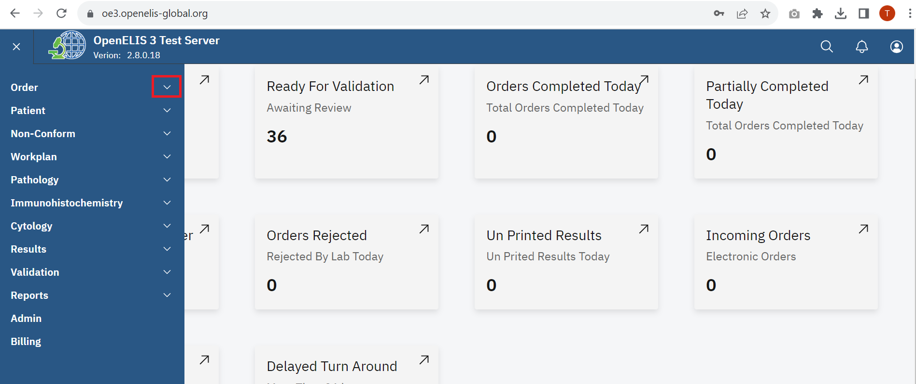

*Accessing Order*

1. Click on Add Order sub-menu item.

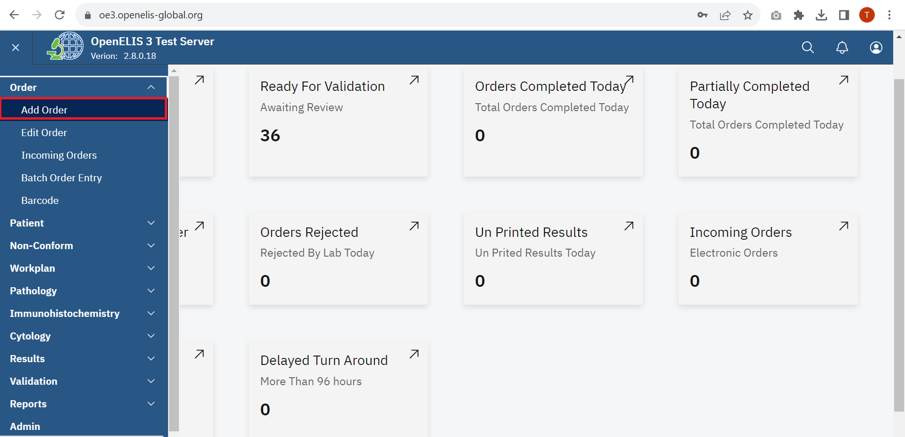

*Accessing Add Order*

Upon clicking on Add Order, the **Test Request** form will be displayed. This form has four parts: **Patient Infor**, **Program Selection**, **Add Sample** and **Add Order**

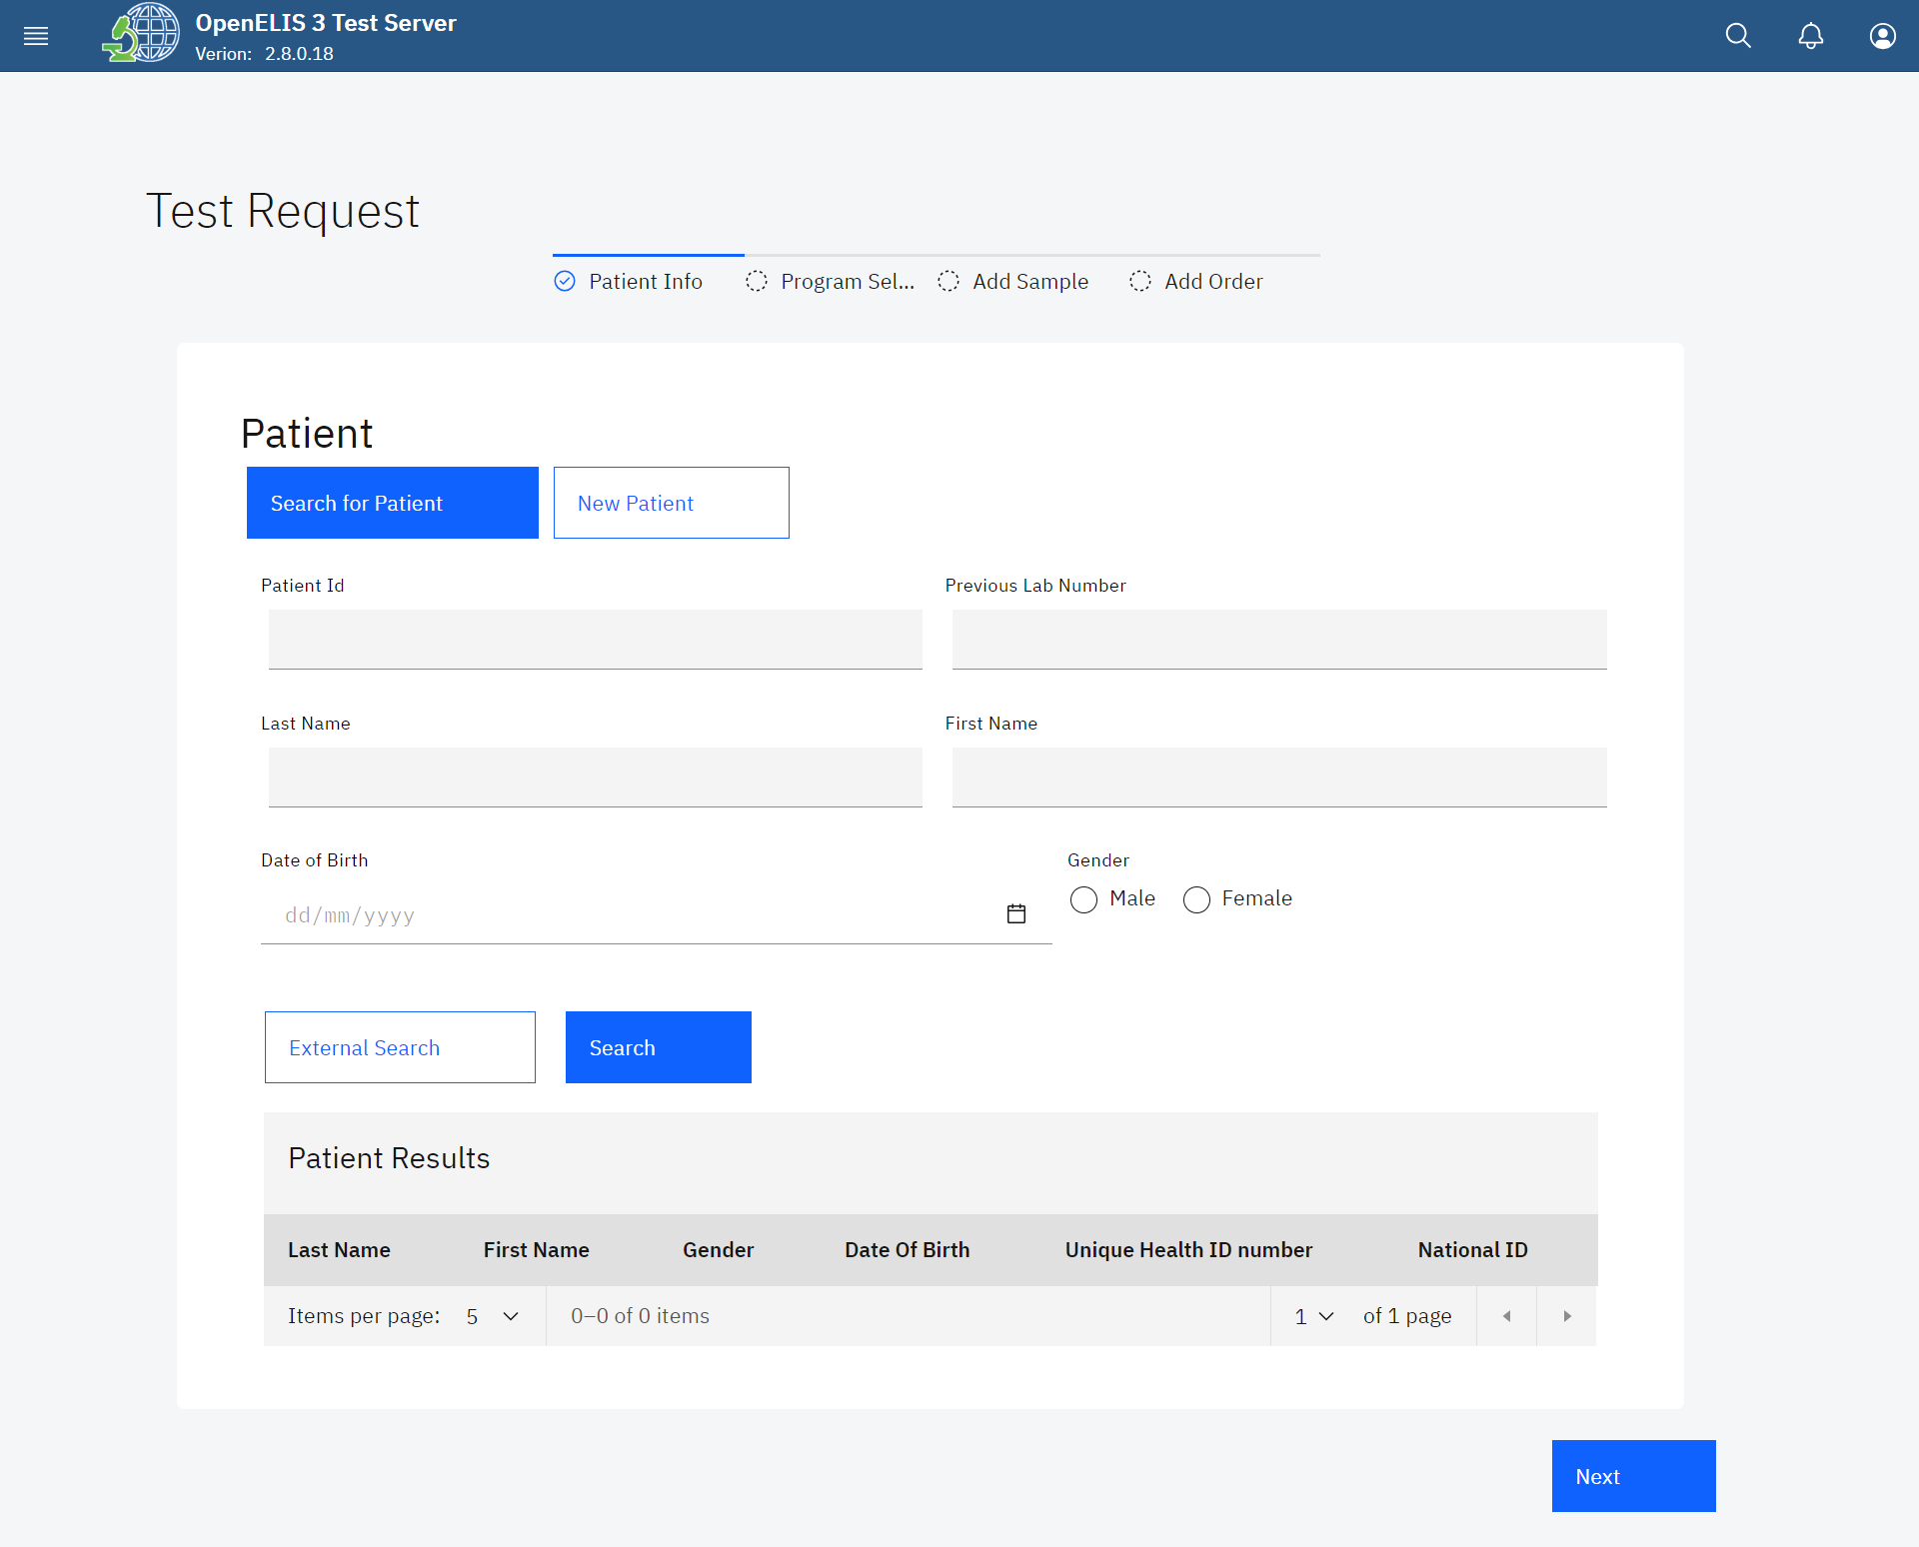*Test Request Form*

The **Test Request Form** allows for the searching of an existing patient and or create a new patient and filling the lab request form for the patient. The **Search for Patient tab** is displayed by default.

1. To search for an existing patient, type the patient identification number under the **Patient Id** text field and click on the **Search** button

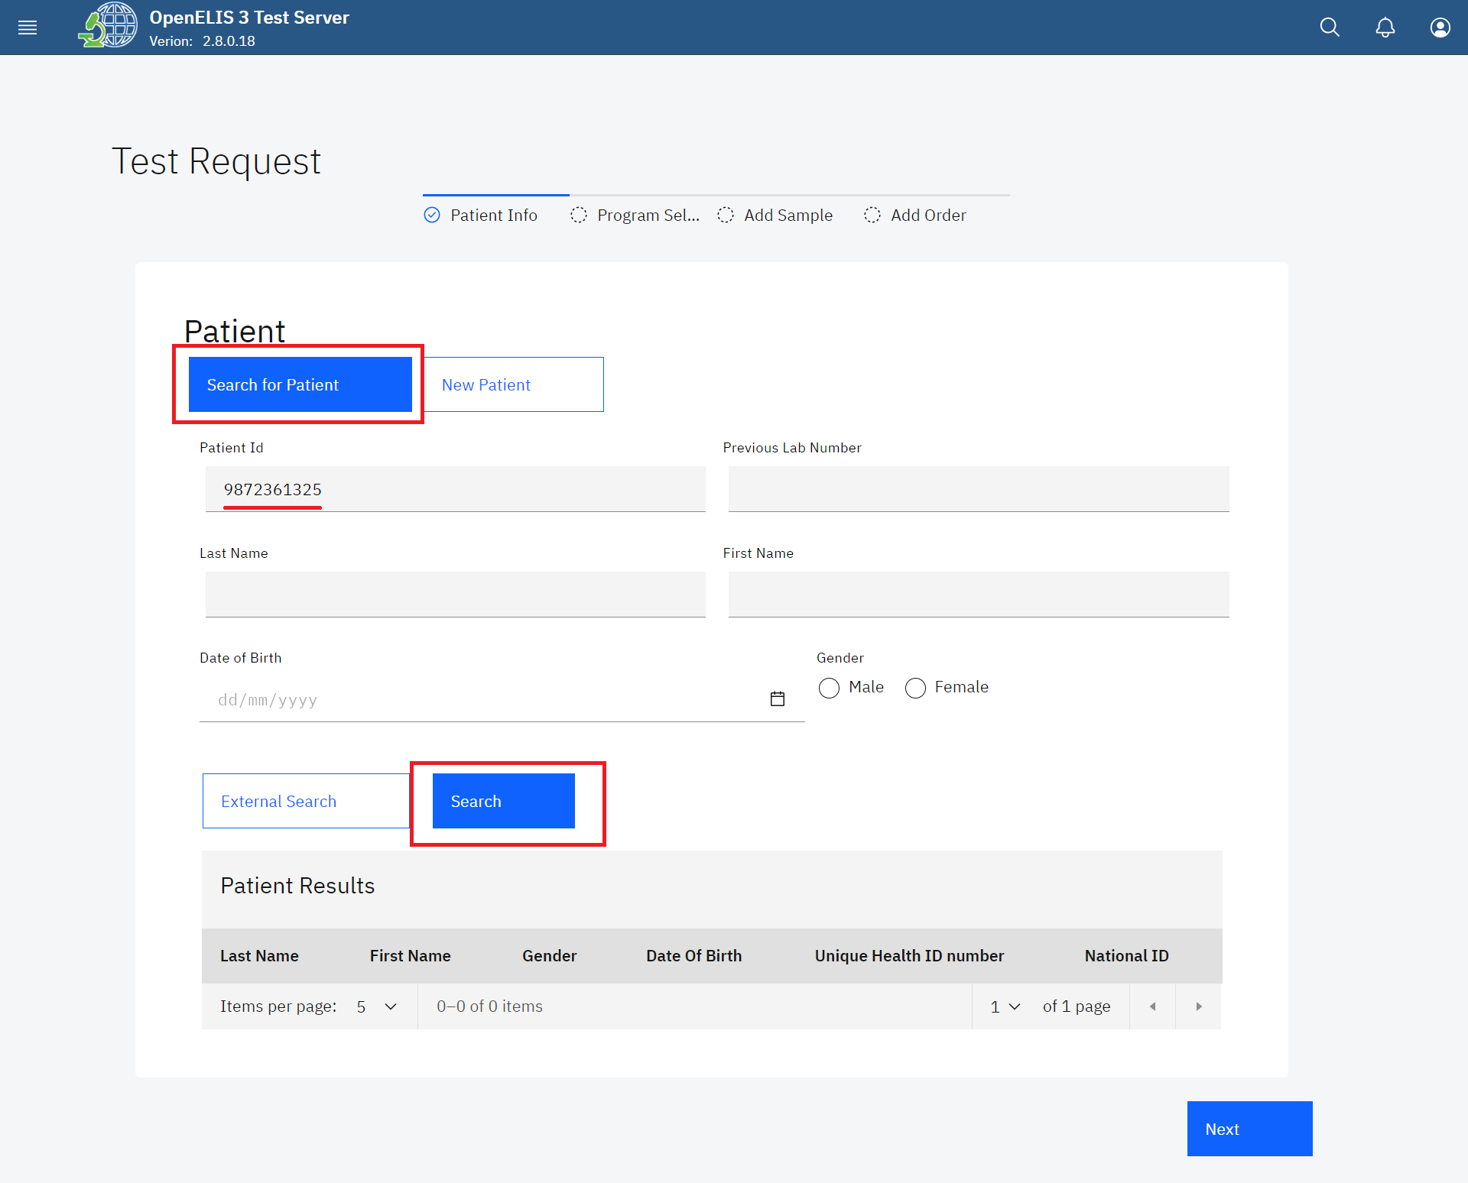

*Patient Search Using Patient ID*

The search will return a matching patient under the **Patient Results** table

1. Click on the radio-button to select the patient.

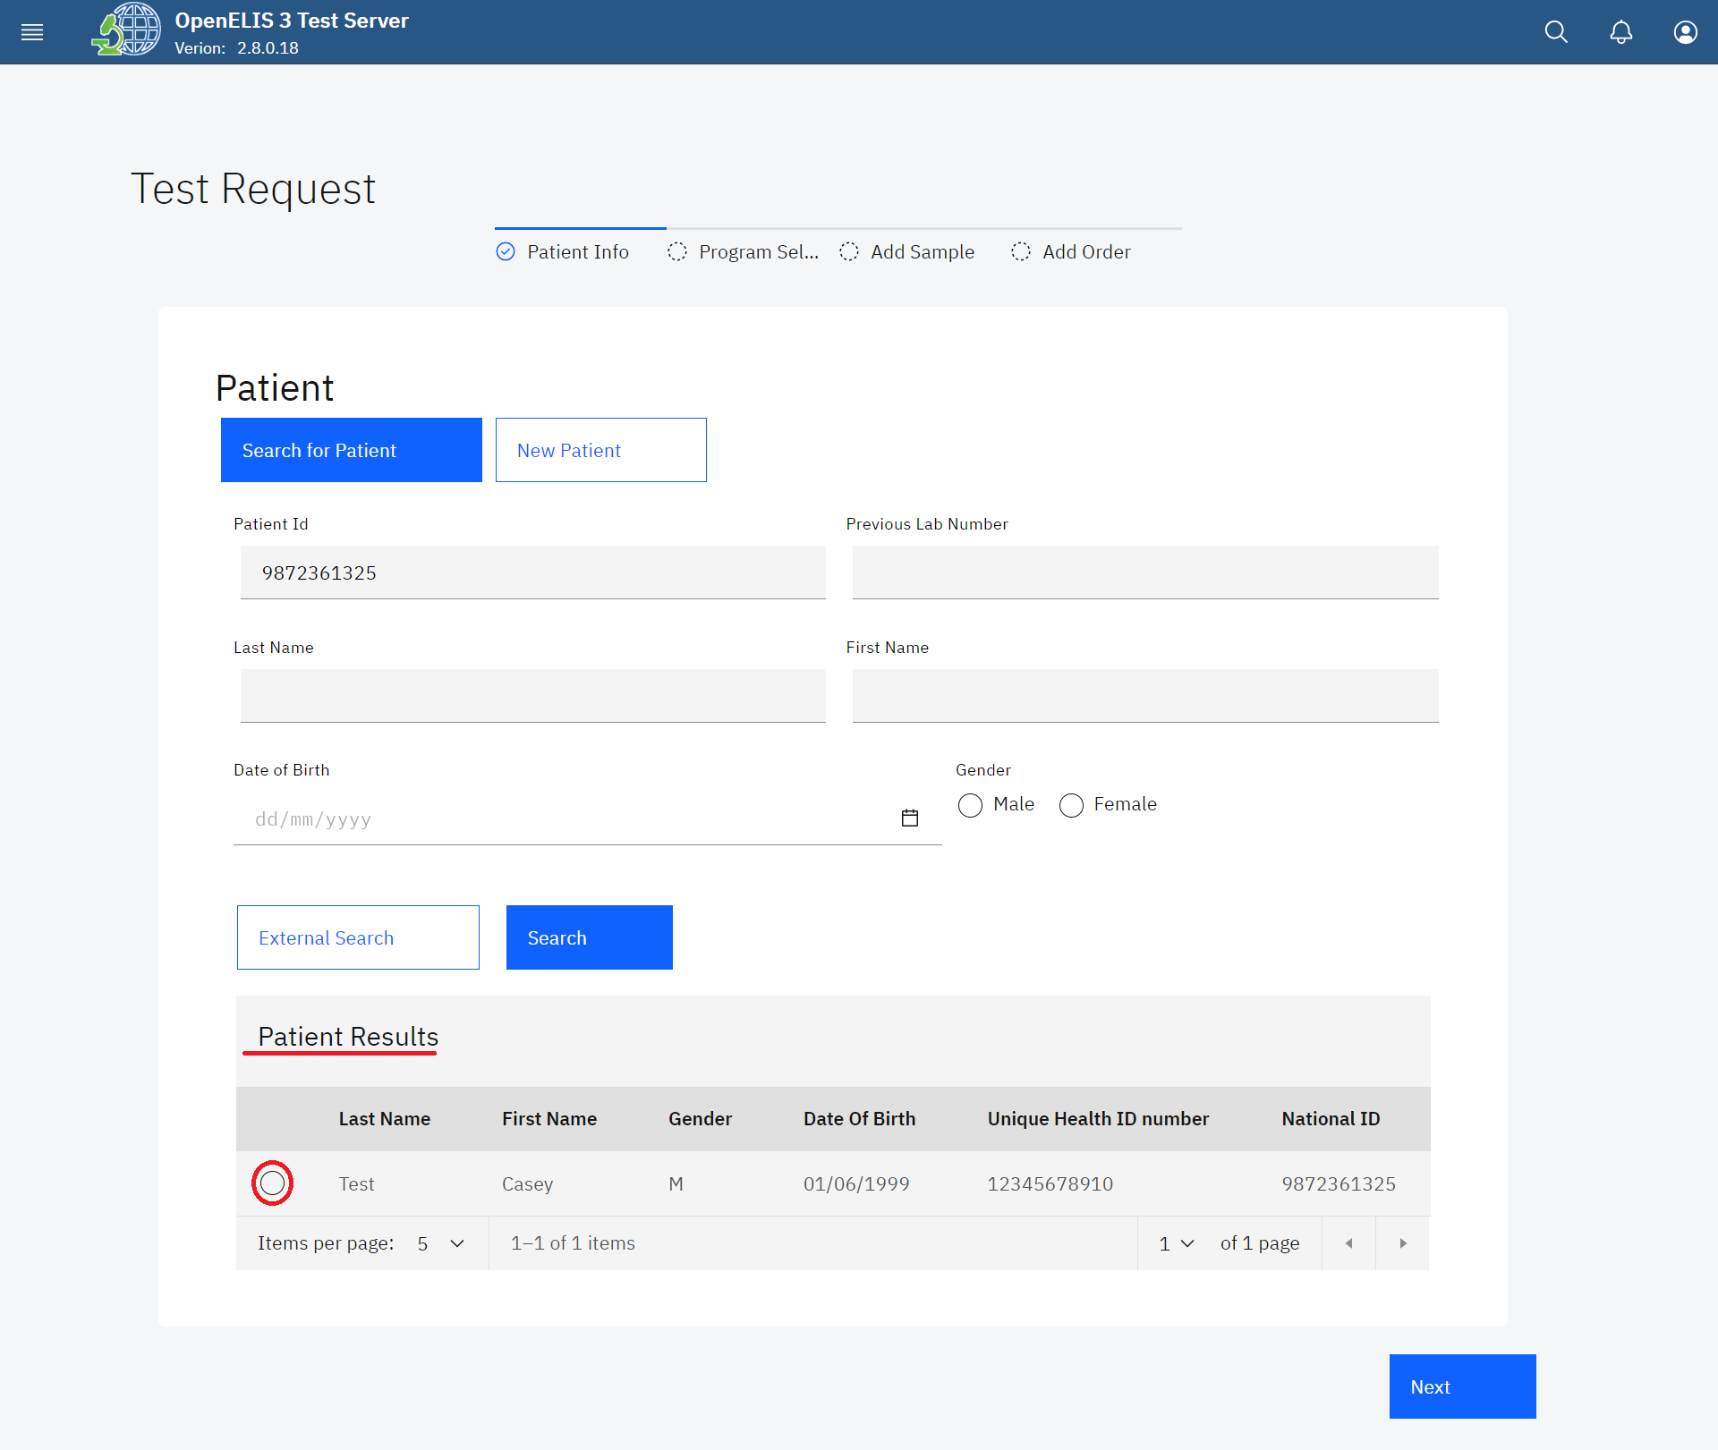

*Select Searched Patient*

1. The patient bio-data will be populated in the fields under the **Search for Patient** tab.

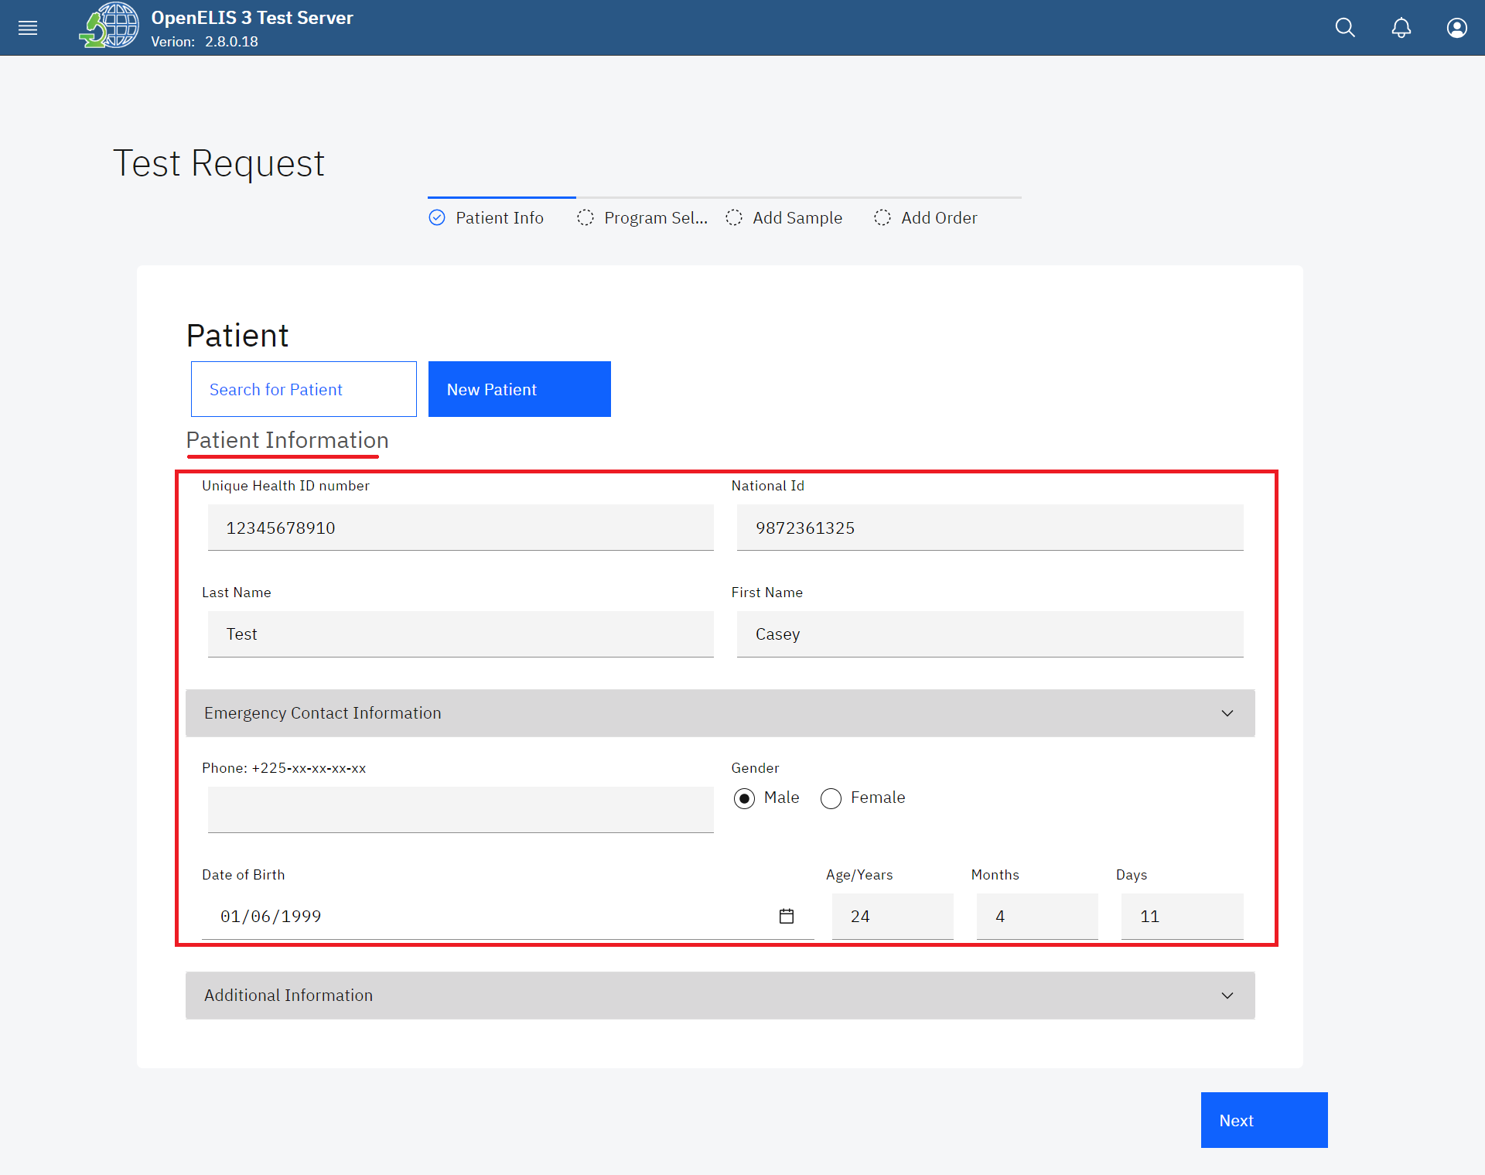

*Searched Patient Information*

1. The Additional Information panel displays the address hierarchy for the patient click on the drop-down menu to expand the panel.

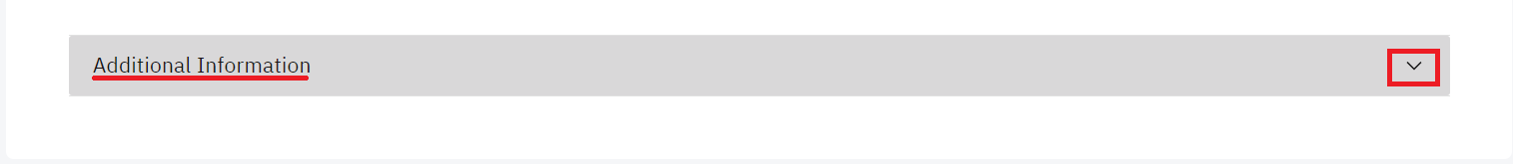

*Expand Panel to View Additional information*

1. Patient additional information can be added by clicking on a field and typing or selecting the respective information from the drop-down menu.

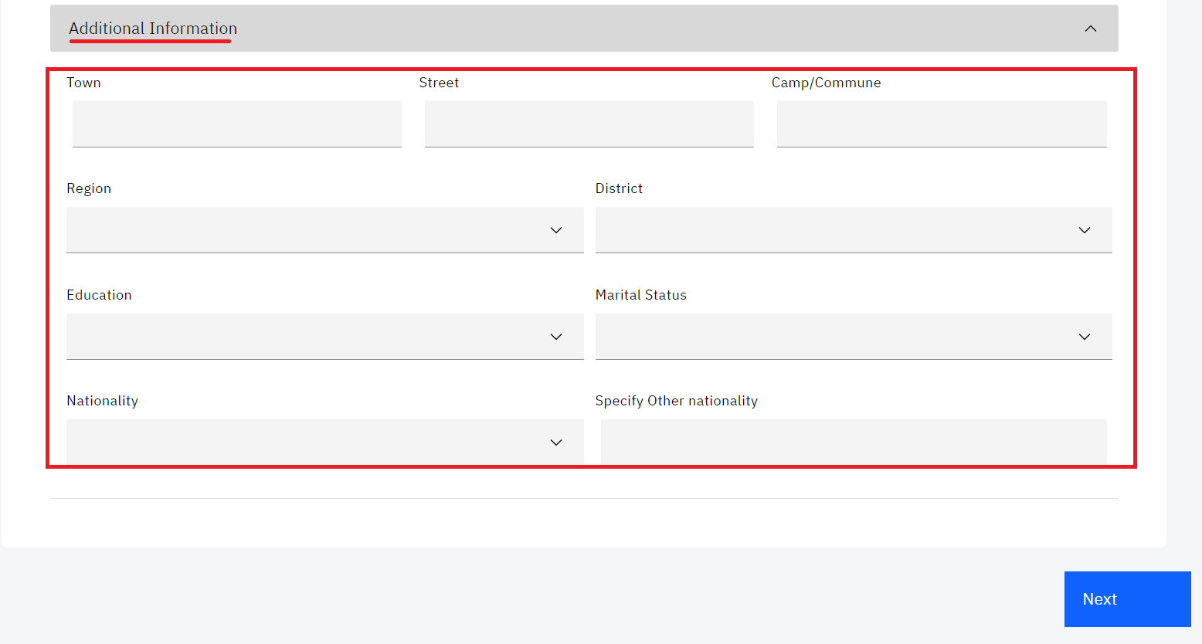

1. Click **Next** button to fill in Program selection for the order.

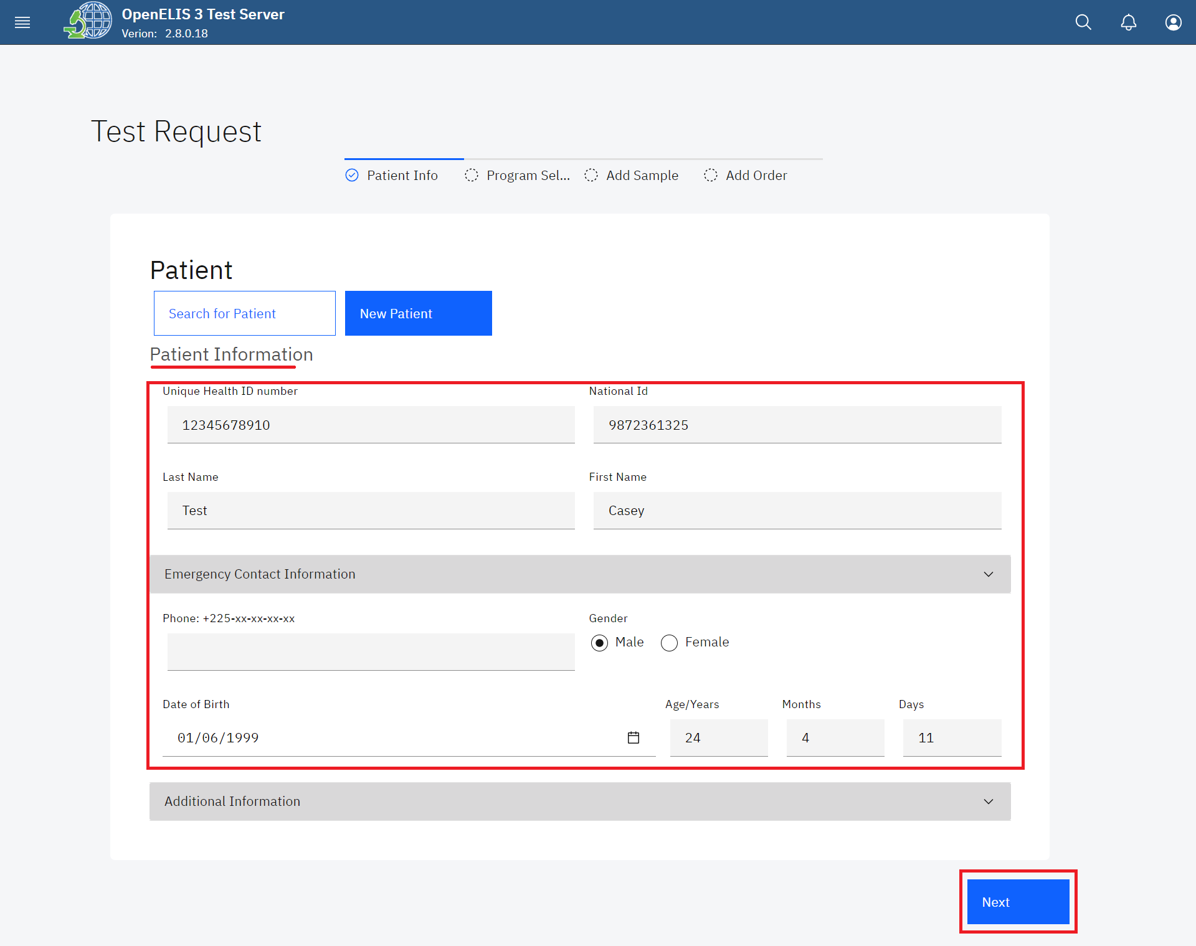

*Click to Navigate to Next Section* 

Clicking on the Next button will navigate you to **Program Selection**. The drop-down menu under **program** allows you to select a program. The Back button will navigate you back to **Patient Information.**

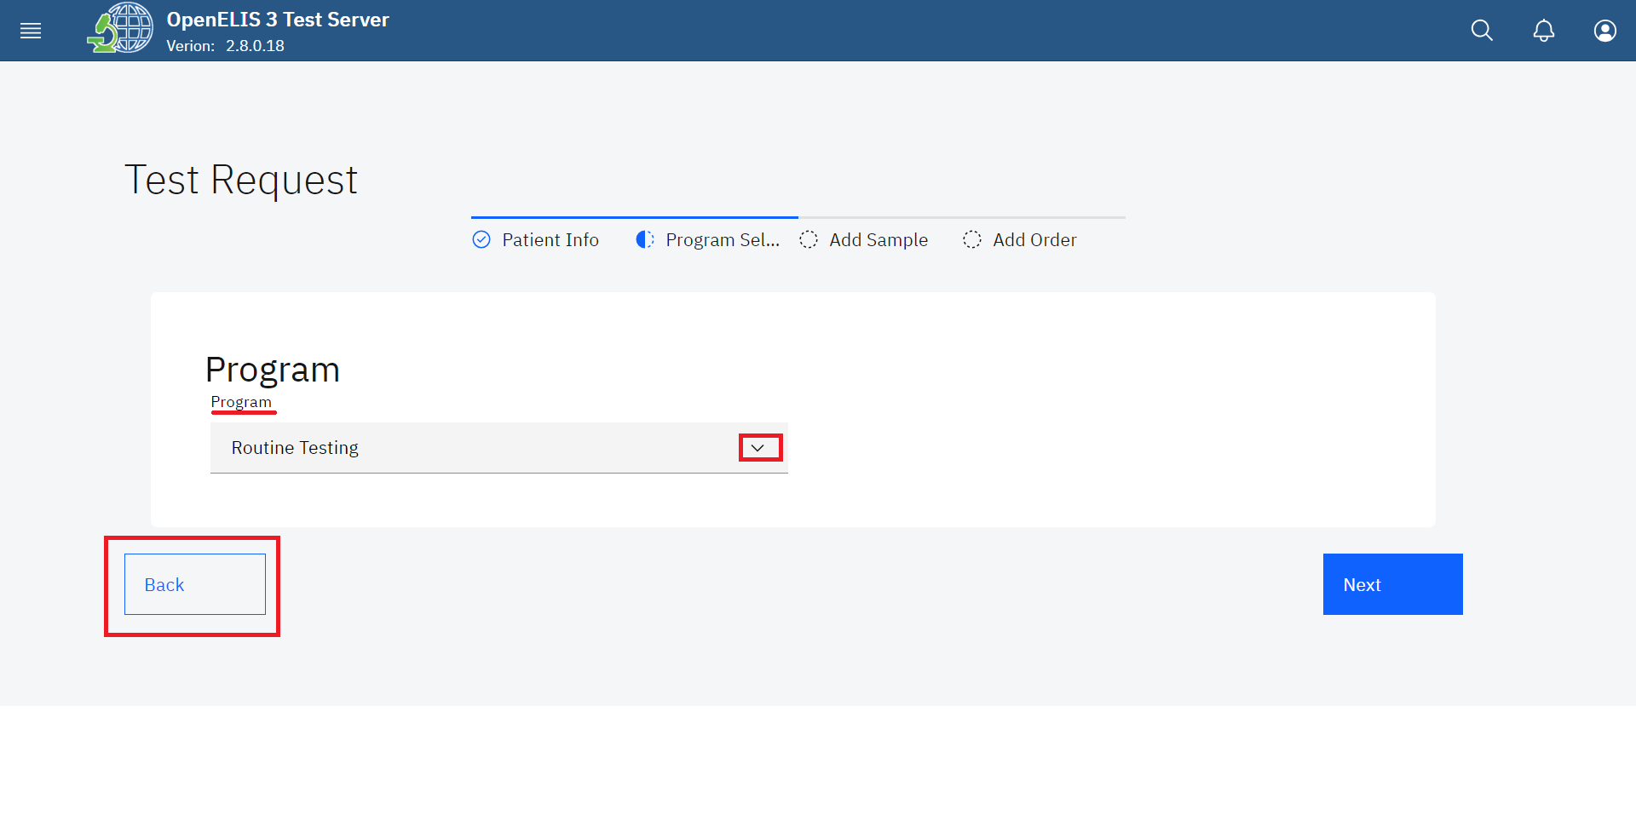

*Program selection*

1. To select a program, click on the program drop-down menu and click on a program under the menu list. In this illustration, **Histopathology** is the program that has been selected.

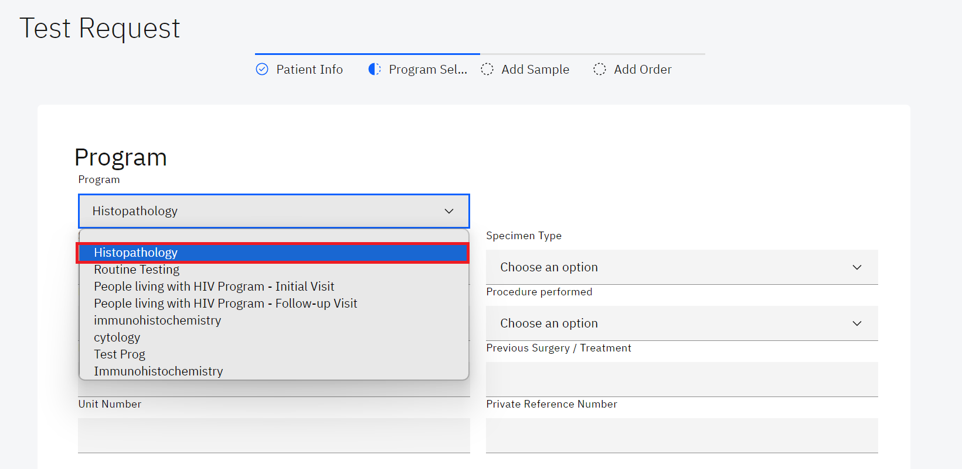

*Select a Program*

**Note:** The fields to be filled for a program are determined by the selection of a program. The illustration below shows the fields to be filled when Histopathology program is selected.

1. Fill in the fields for the program and click on the **Next** button.

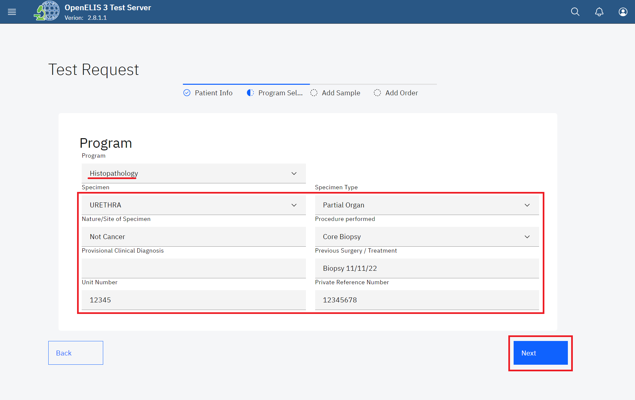

*Click Next Button*

The **Add Sample** page allows for the addition of samples by selecting a sample type. A sample can also be rejected under this page.

1. To Add a sample, click on the **select sample type** drop-down menu item and select the sample In this instance, histopathology was selected as a program we have selected **Tissue Antemortem** as the sample.
2. Fill in the collection date (The system time is picked by default) and Collector.

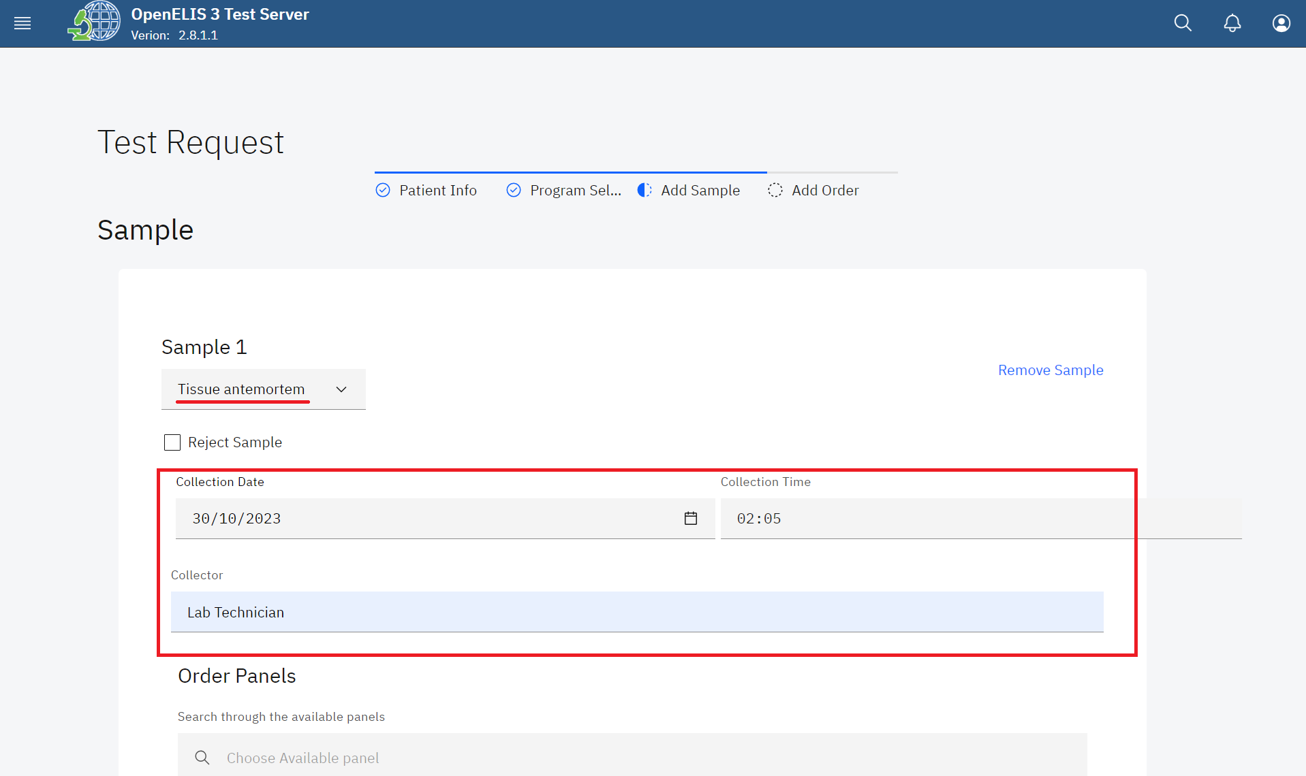

*Select Sample*

**Note:** The **Reject Sample** check box upon checking will prompt the selected sample to be rejected. The Remove Sample label will remove the current sample.

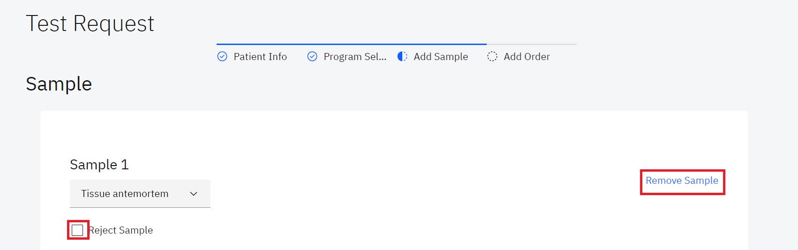

*Reject Sample and Remove Sample*

1. Use the **Choose Available test** search text box to search through the available tests. In this illustration, “**patho**” is typed and **Histopathology Examination** is the displayed results that shall be selected

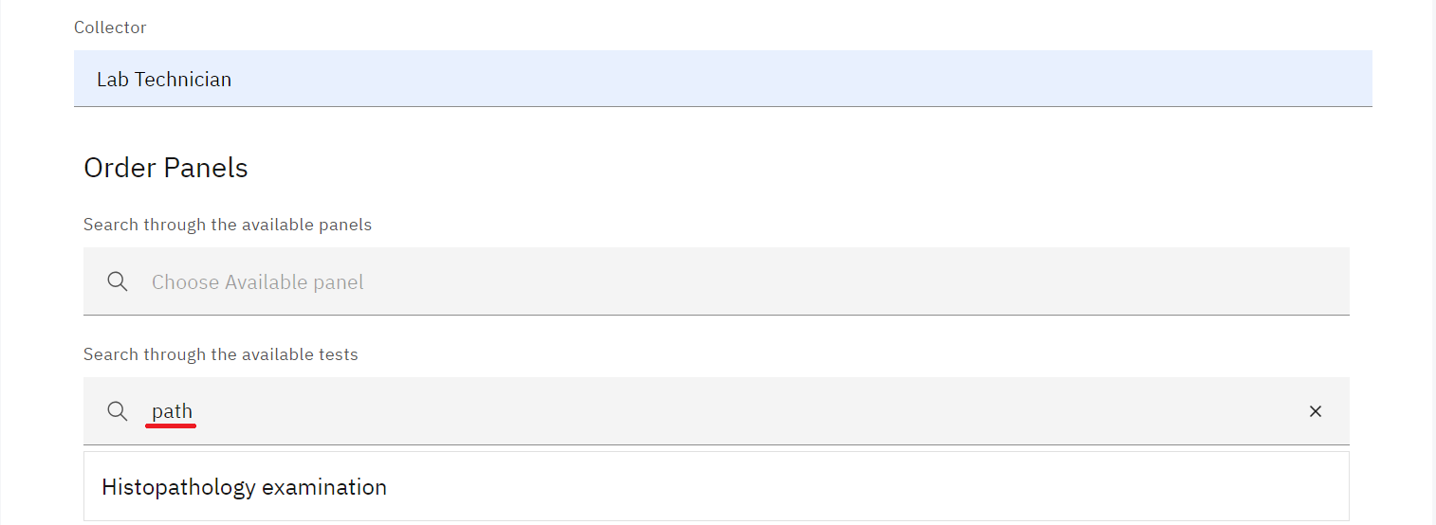

*Searching For Available Tests*

**Note:** The ordered test will be selected for the pathology examination. The corresponding check-box in the list will also be checked in the list of available tests.

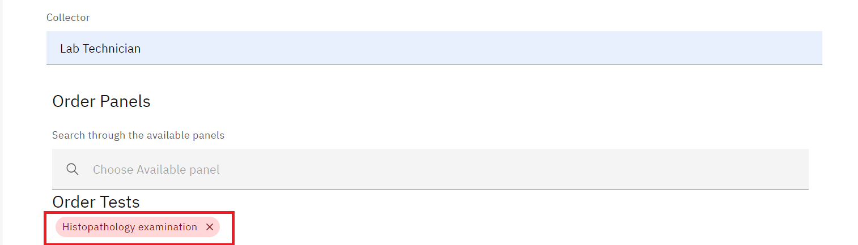

*Order Tests*

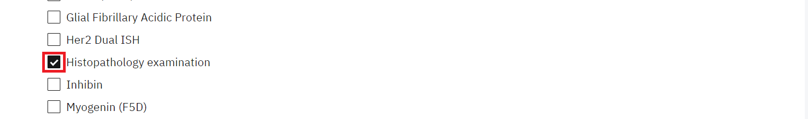

*Order Test Checkbox for Histopathology*

**Note:** A test can be referred to a reference lab.

1. To refer a test to a reference lab, click on the **Refer test to a reference** lab checkbox

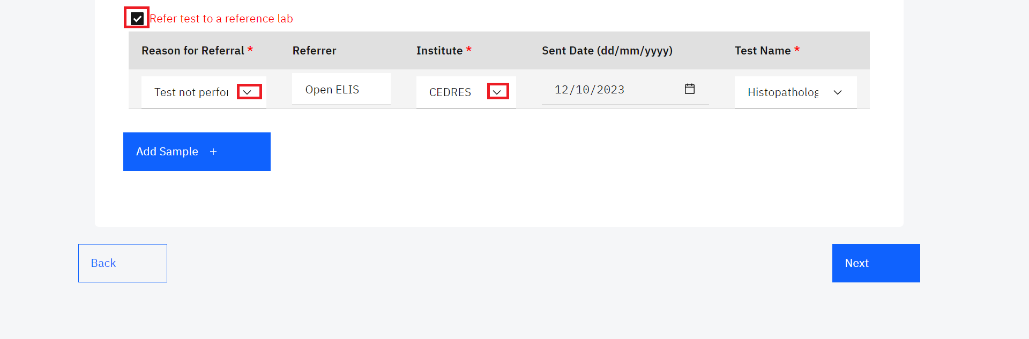

*Refer test to a reference lab*

Note: You can add and remove samples for the patient.

1. To add a sample, click on the **Add Sample** button.

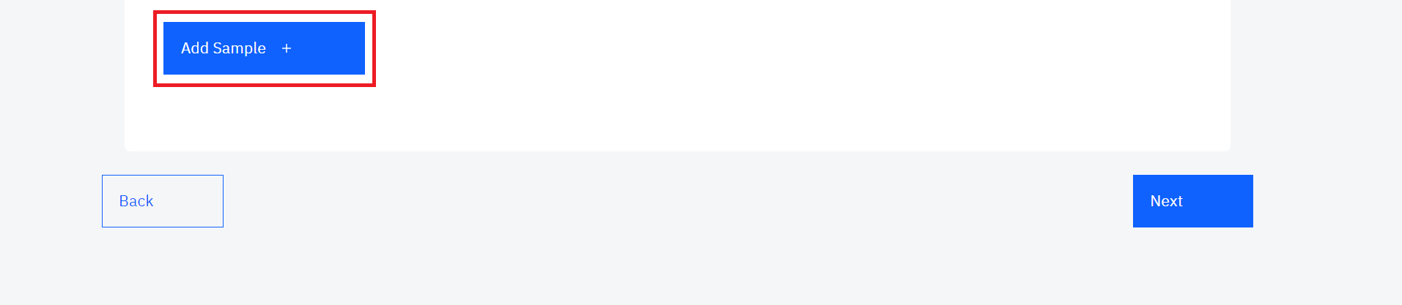

*Add Sample*

1. Select the sample.
2. Fill in the collector field.
3. Search through the available panel for the sample and search through the available test for the sample.

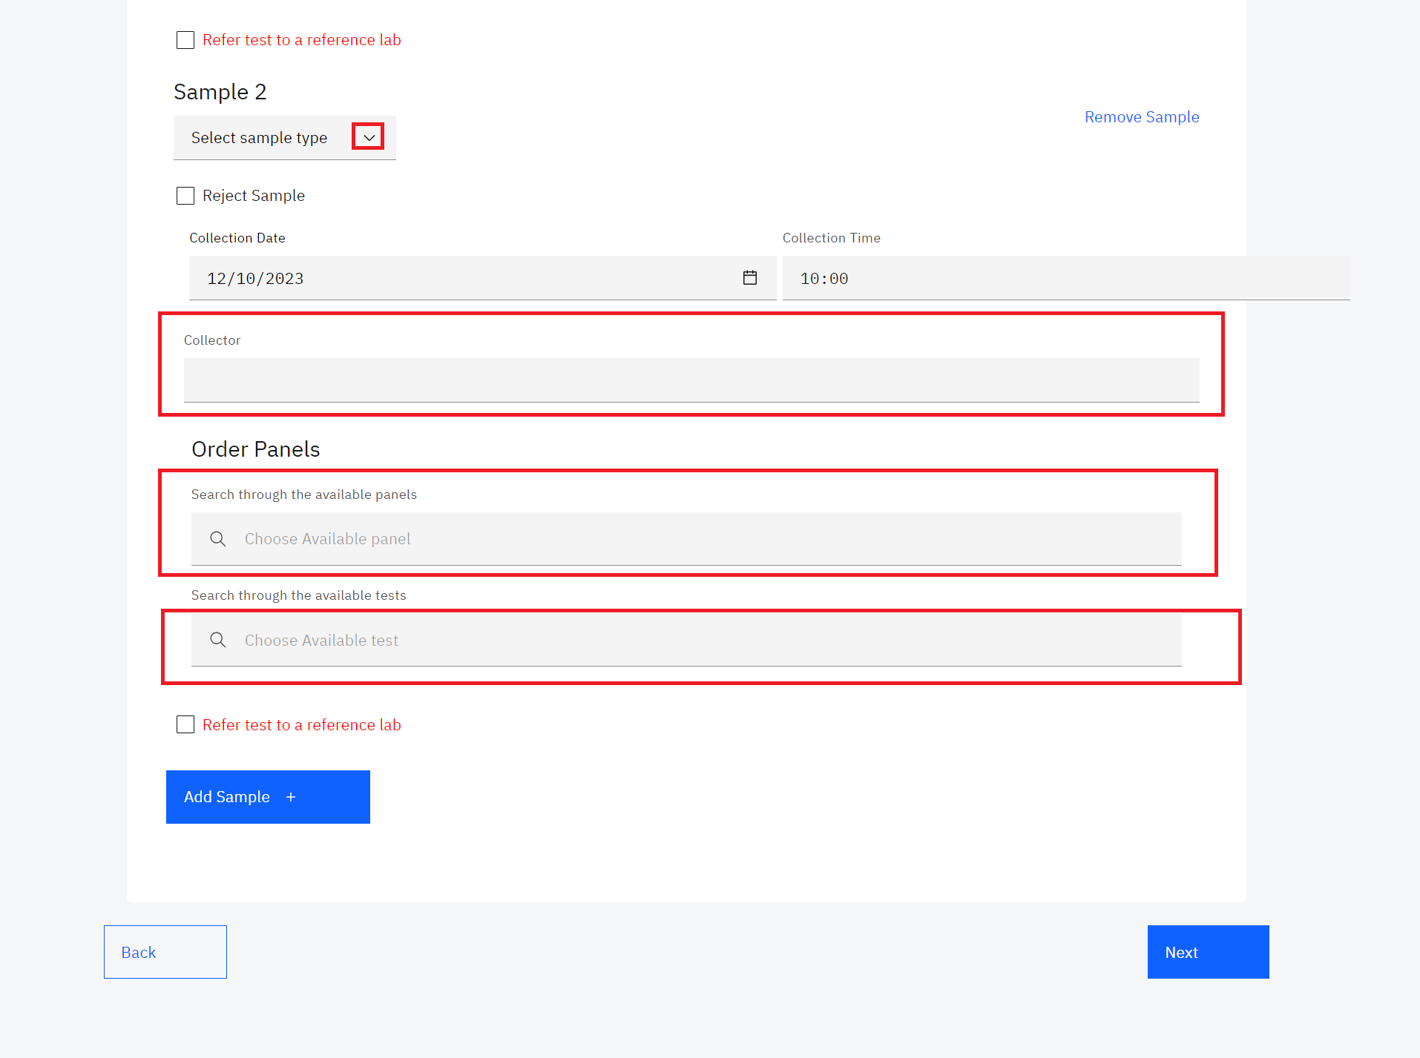

1. To remove the added sample, click on **Remove Sample**

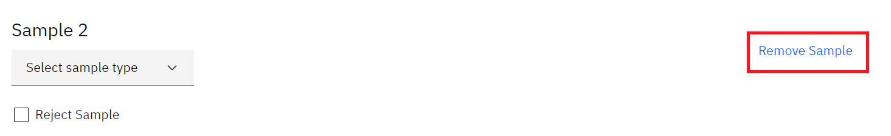

*Remove Sample*

1. Click on the **Next** button to Add the Order.

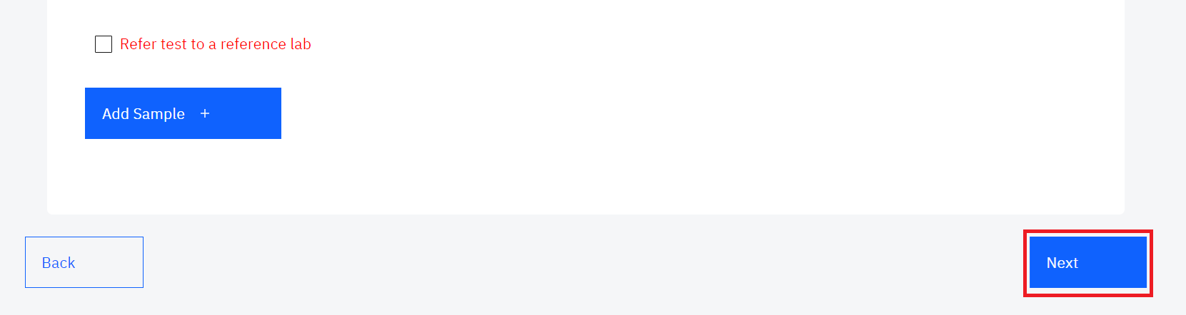

*Click Next Button*

The Order section has numerous fields for capturing the order. These include: Lab Number, Priority, Site Name, Ward/Unit, Names of the requester and email address, patient payment status and Sampling performed for analysis.

1. Scan the barcode for your sample or manually enter the lab number by clicking on **Lab Number**.

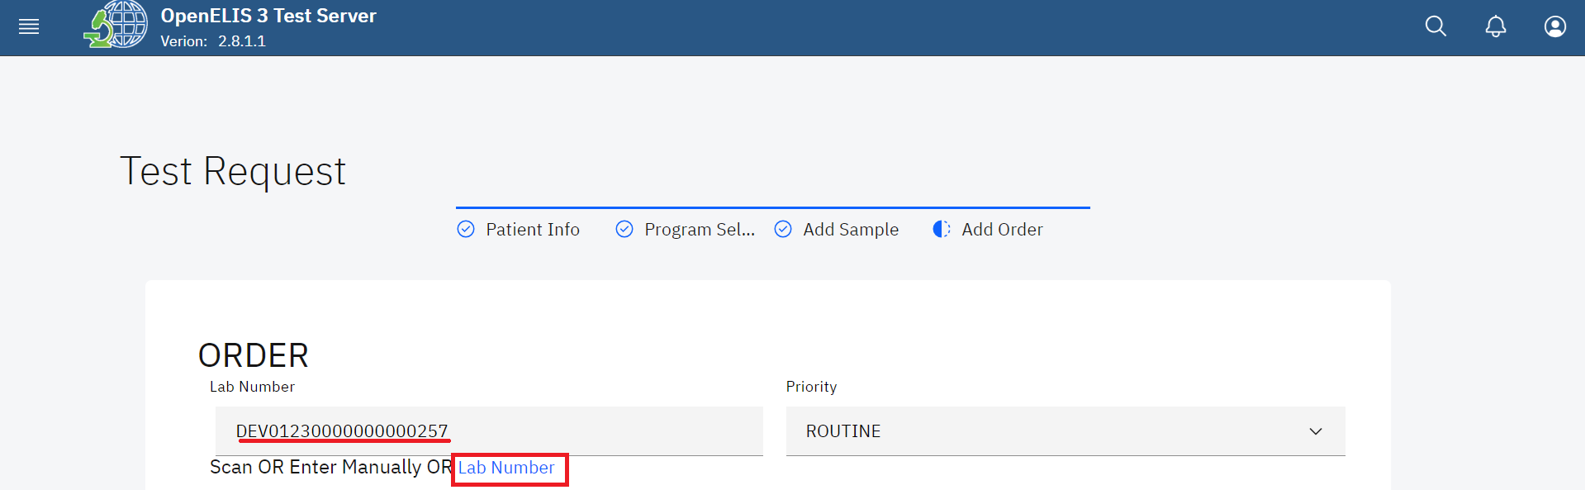

*Scan or Generate Lab Number*

1. Select the Priority for the order under the Priority drop-down menu

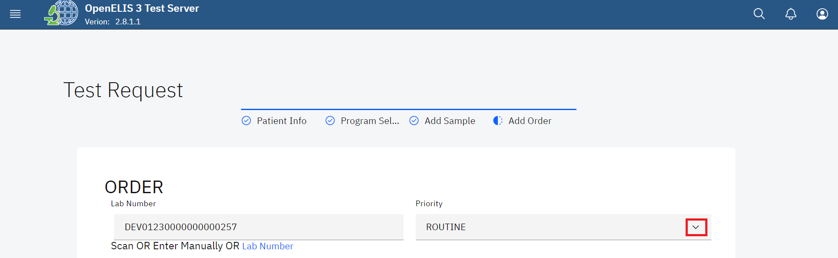

*Select Priority*

1. Fill in the site name and select the ward/department/unit from the drop-down menu.
2. Fill in the requester’s names and phone number.
3. Select the payment status for the patient from the drop-down menu
4. Select the sampling performed for analysis from the drop-down menu.

Note: You may optionally check the **Remember site and requester** checkbox

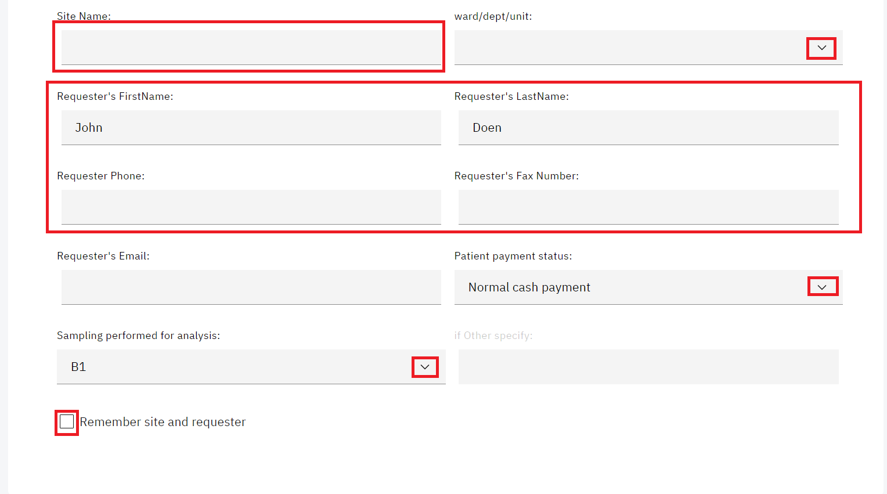

*Fill Add Order Form*

1. You can optionally fill in the results reporting for both the patient and the requester by choosing Email or short message services (SMS) or both. Otherwise, click the **Submit** button.

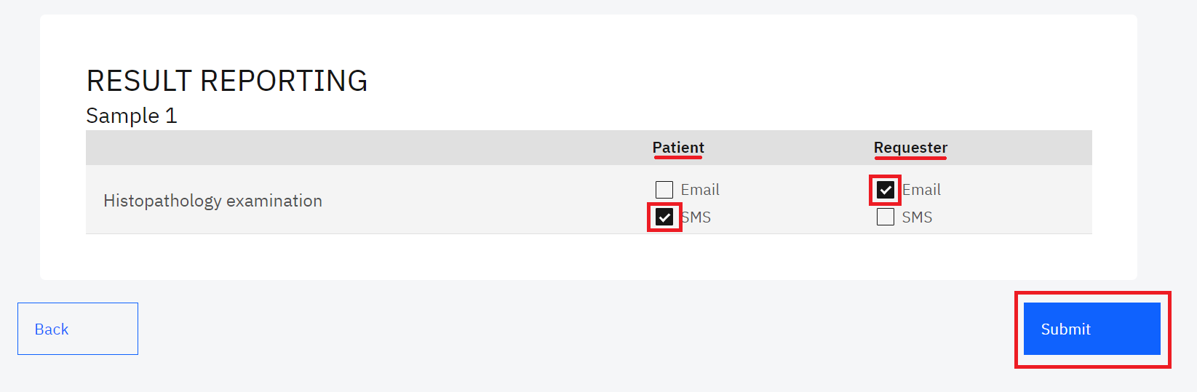

*Submit Test Request*

1. Click on the Print Barcode button to print the barcode for attaching on the sample.

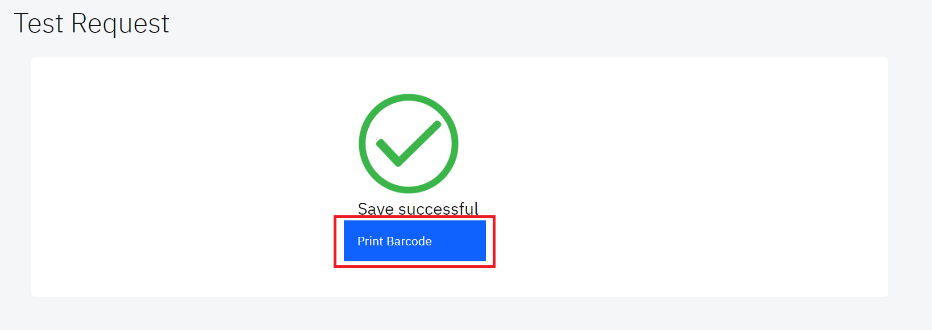

*Print Barcode*

The barcode will be printed on your screen. Click on the download button on the top right to download it on your workstation. Click on the printer icon to print the barcode on your connected printer.

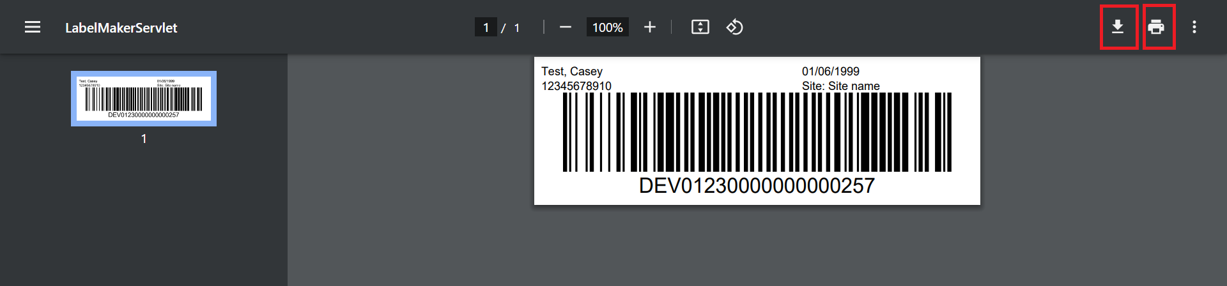

*Download or Print Barcode*

## **How to create a laboratory analysis order for a new patient**

1. Follow steps 1 to 3 under the how to create a laboratory analysis order for an existing patient section
2. Click on the New patient tab and fill in the patient information section.

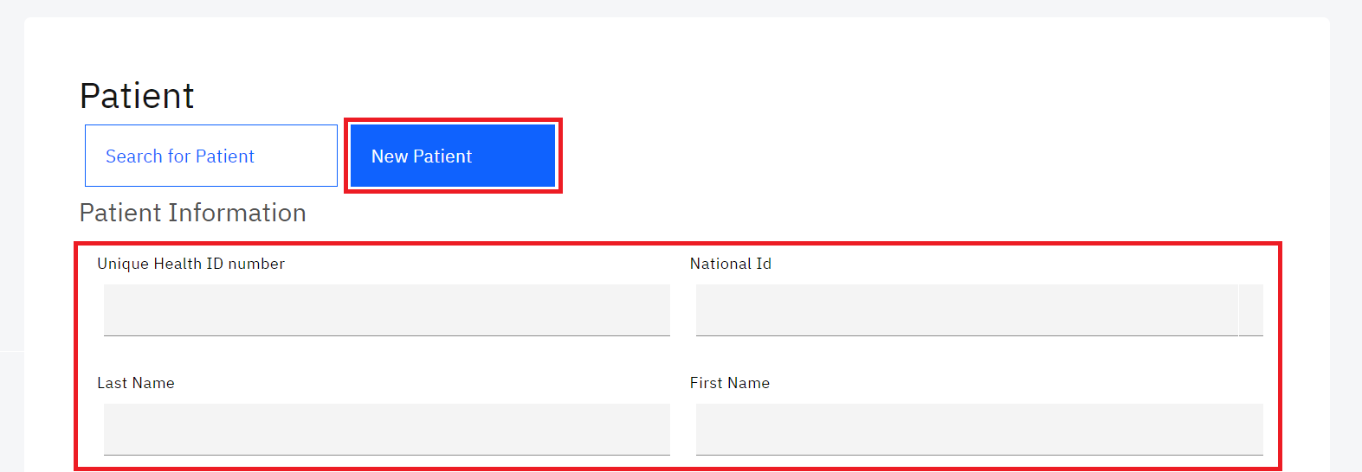

*New Patient Information*

1. Fill in the emergency contact information

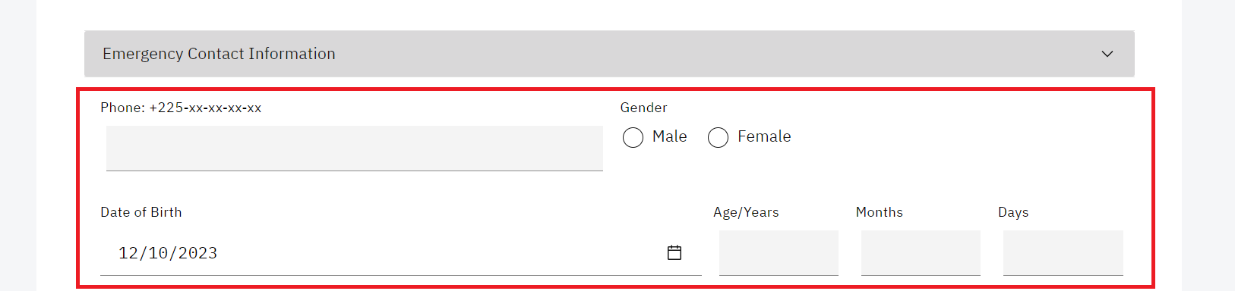

*New Patient emergency contact informatio*n

1. Fill in the fields under the additional information panel and click on the **Next** button.

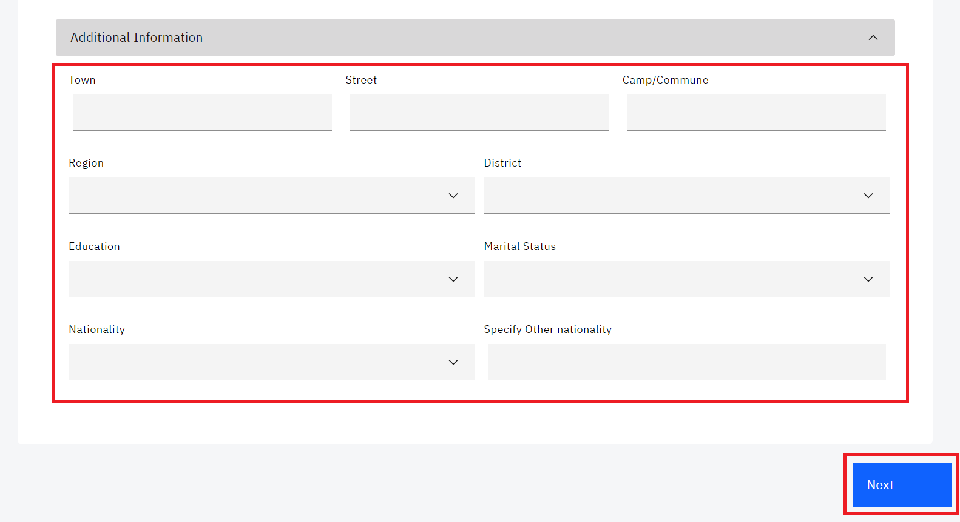

1. Follow steps 4 to 30 under how to create a laboratory analysis order for an existing patient section.

## **How to modify or update a laboratory order**

Use this function when you want to:

1. Change specimen for a test under the **Program Selection** tab
2. Modify sample collection date and time under the **Add Order** tab
3. Remove samples for current test **Add Order** tab
4. Check results as collected and cancel a test for the sample under **Add Order** tab
5. Add a sample
6. To modify a laboratory order, hover the mouse to the top right of your screen and click on the hamburger menu item to open the OpenELIS Global menu. 



*Accessing OpenELIS 3 Menu*

1. Click on click on Order to expand.



*Accessing Order*

1. Click on on **Edit Order**

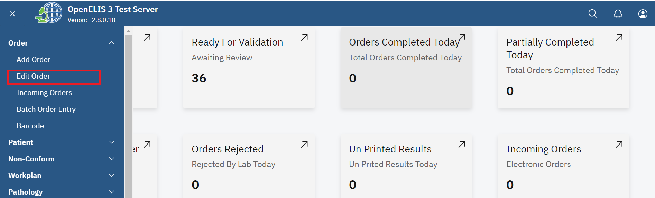*Edit Order*

1. The Modify Order form allows you to search for the order using the laboratory accession number and clicking on the **Submit** button

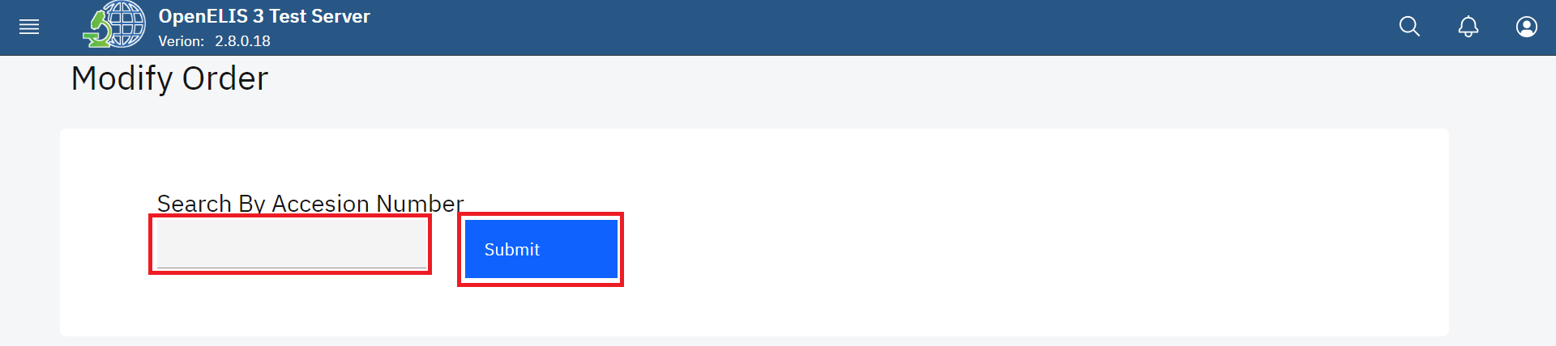*Search By Accession Number*

Alternatively, use the patient information to search for the lab order that is to be modified. The patient identification number can be used to search for the order to be modified. The patient names can also be used in the event the patient does not have an identification number.

1. To search for the laboratory order using the patient information, type in the patient Identification number under the Alternatively, use the to search for the lab order that is to be modified.

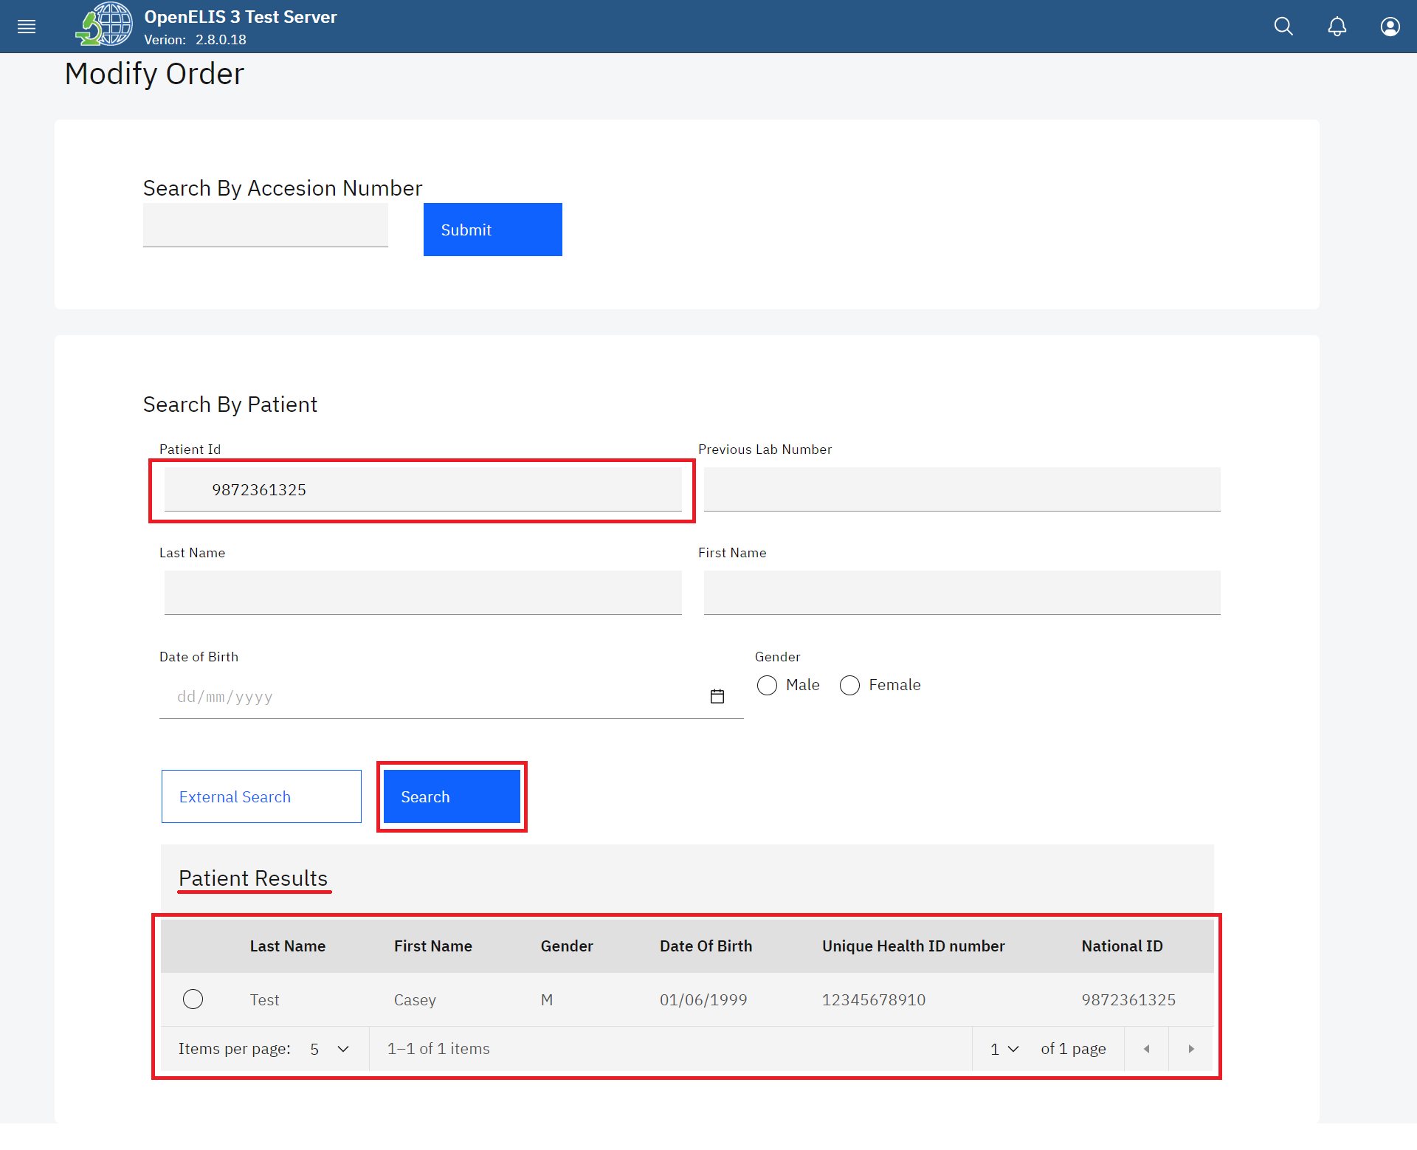

*Search Patient by ID*

1. Click on the radio button to select the patient under the **Patient Results**

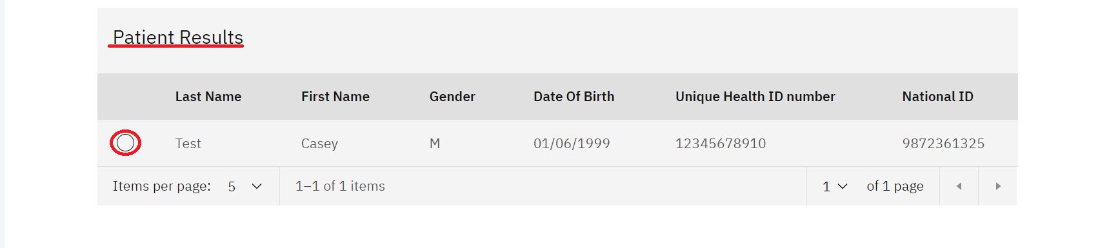

*Click on Searched Patient*

You can edit the information under the **Program Selection** tab:

* 1. Specimen and Specimen Type
  2. Clinical diagnosis and Previous Surgery and or Treatment
  3. Unit Number and Private Reference Number

1. Click the **Next** button

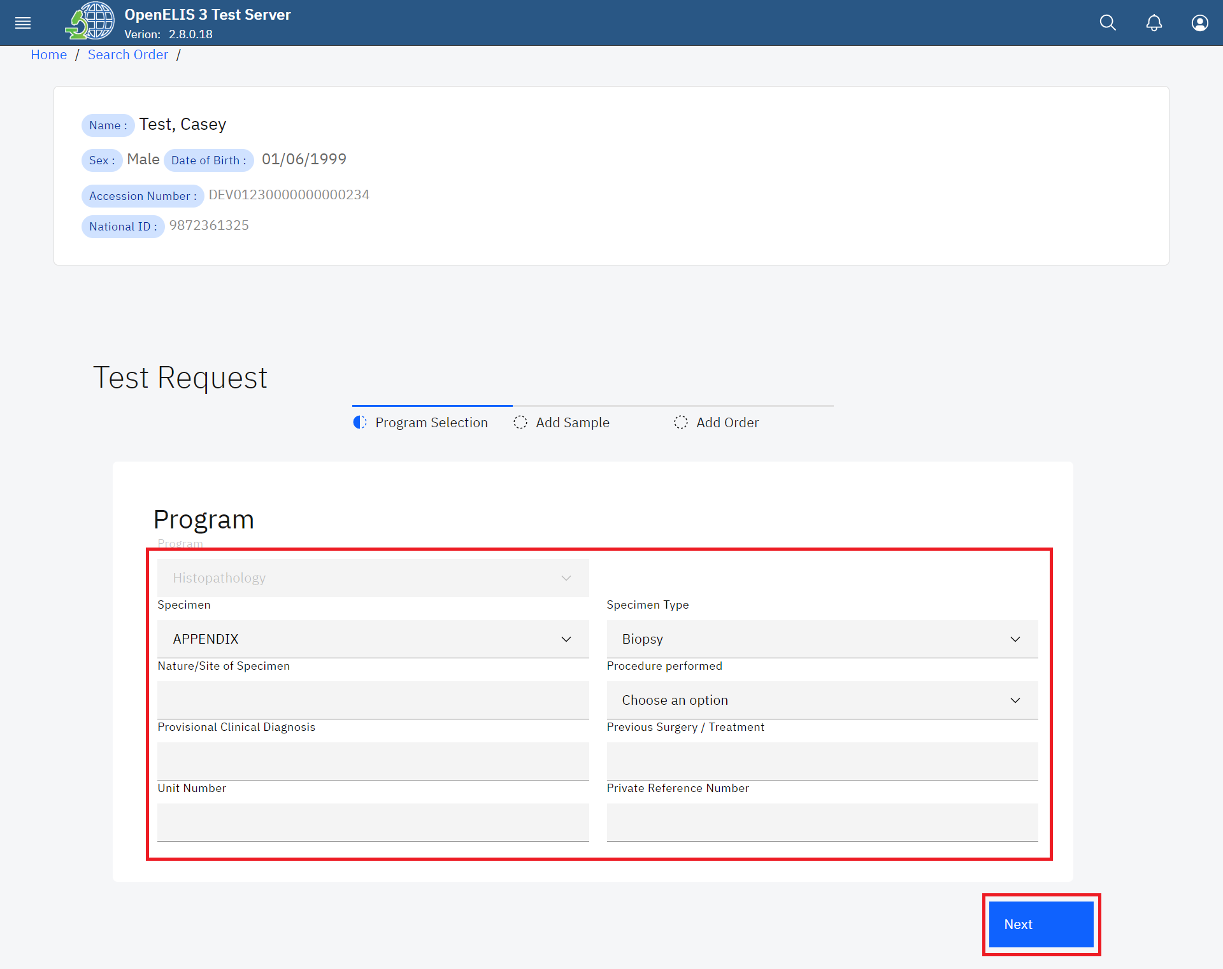

*Modify Program*

You can edit the information under the **Add Sample** tab:

* 1. Sample collection date and time.
  2. Remove the sample from the test request.
  3. Check the check-box for recording results.

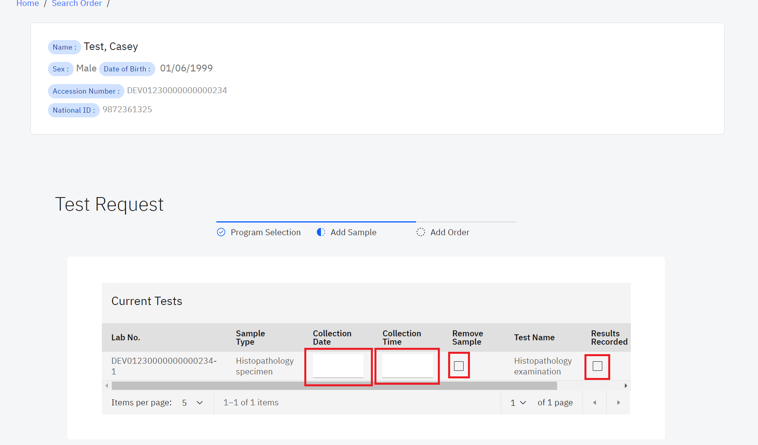

*Edit Test Request for Current Test*

* 1. Assign available tests by checking the assign checkbox.

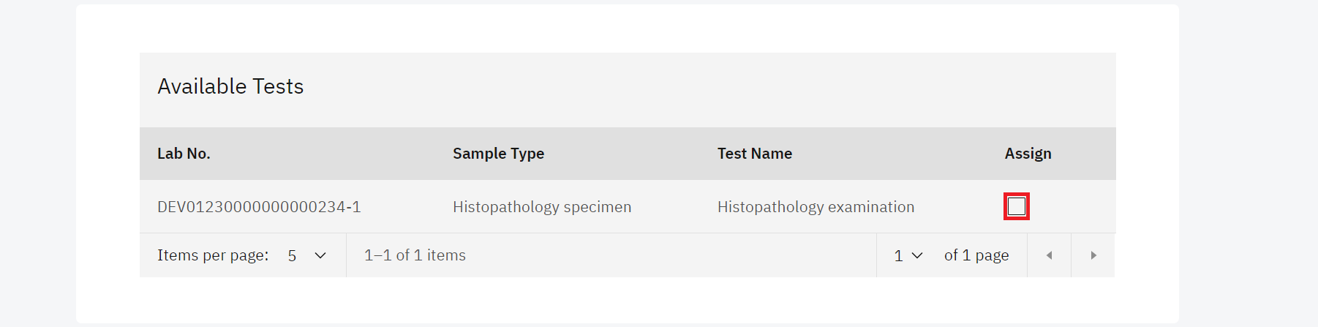

*Assign available tests*

* 1. Add samples and the collector of the sample as well as search for the panels and tests available for the samples

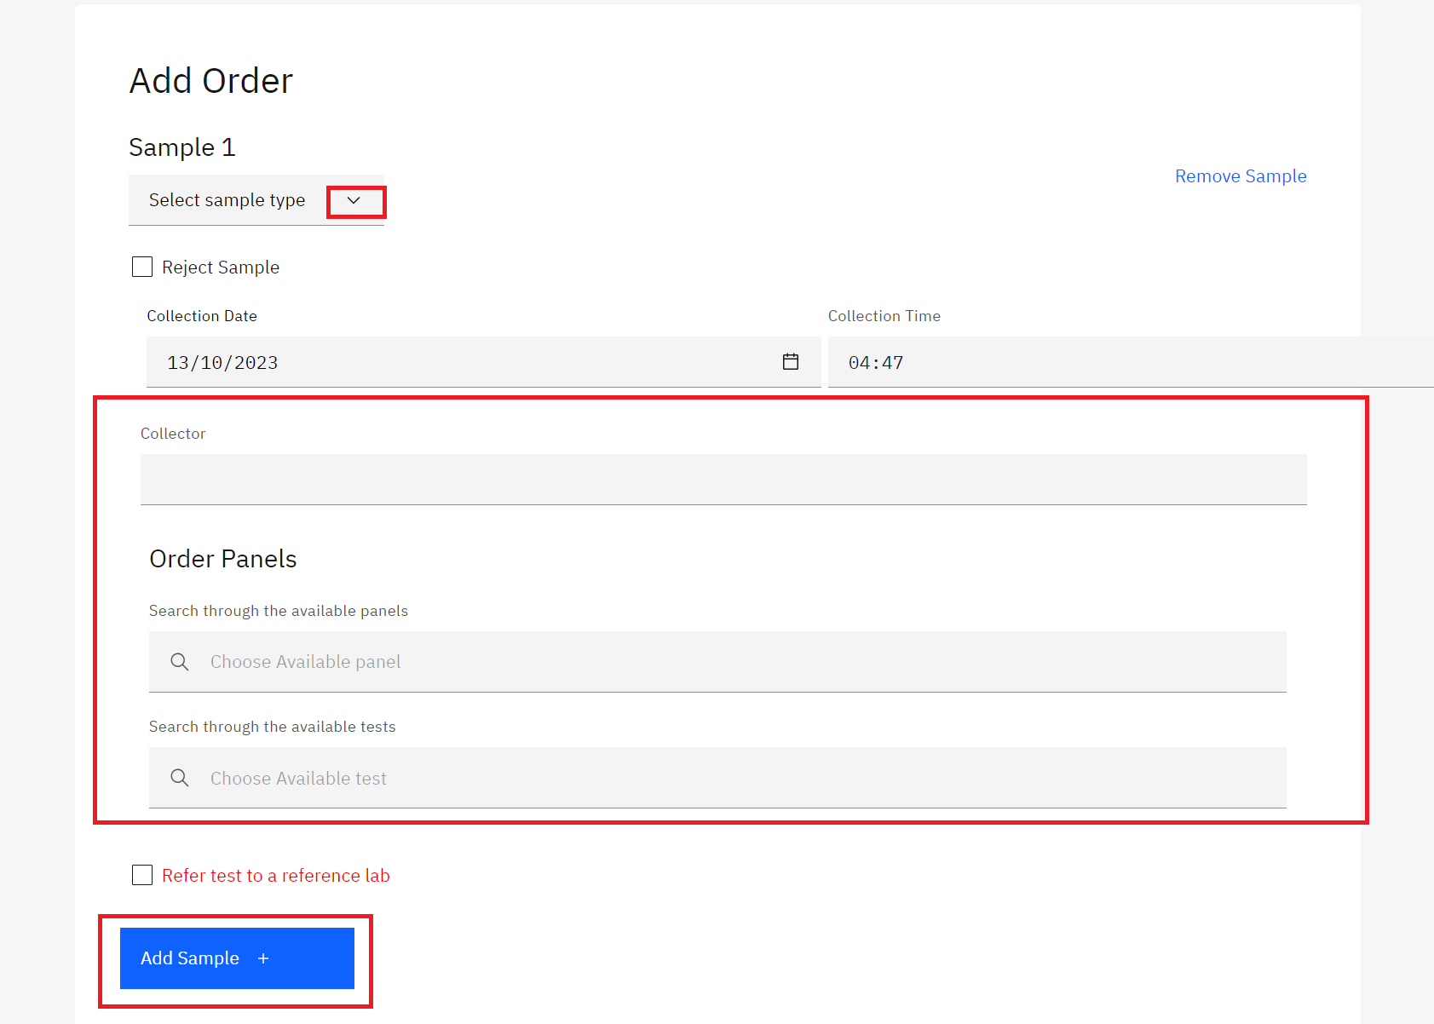

*Add Sample*

1. Click the Next button.

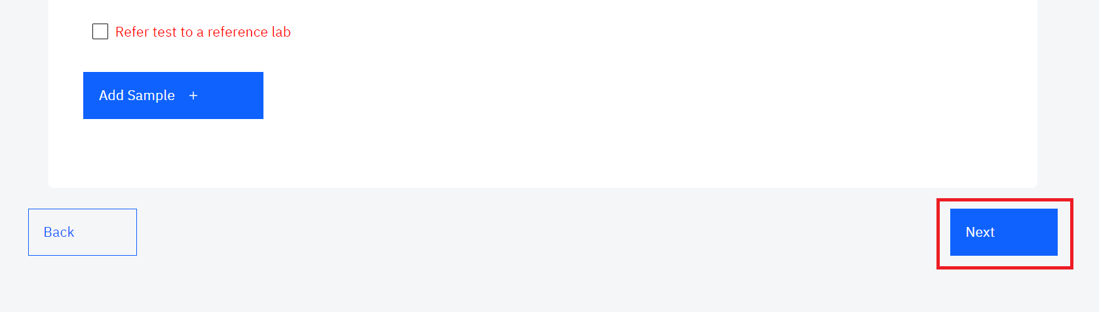

*Click Next*

You can edit the following fields under the **Order** tab:

* 1. Laboratory number and priority.
  2. Request Date, Received Date,Reception Time and Date of next visit.
  3. Site name and ward/department/unit.
  4. Requester information.
  5. Patient payment status.

1. Click on the Submit button to effect the changes.

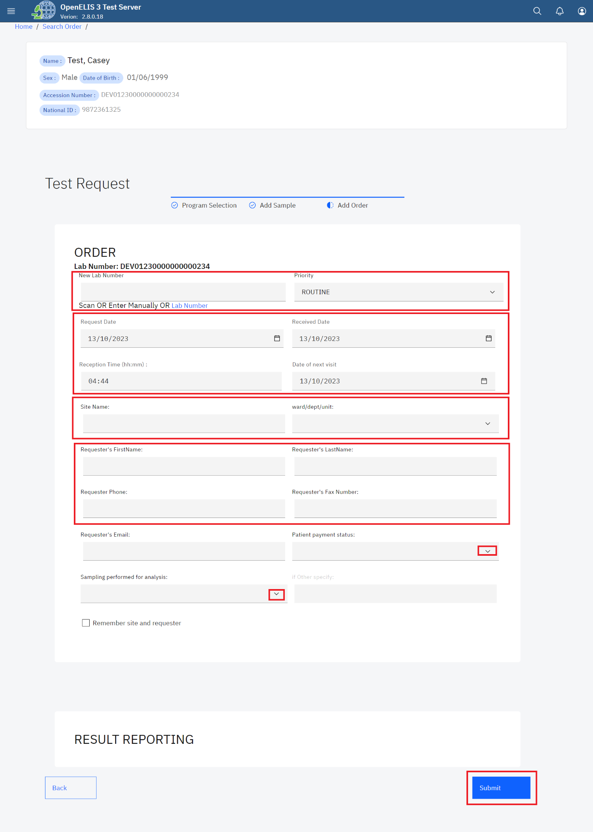

*Modify Order*

# **PART 5: ELECTRONIC ORDERS**

Orders sent electronically to OpenELIS will appear here with their order, sample, and test information. To access electronic orders follow the steps below:

1. Click on Incoming Orders

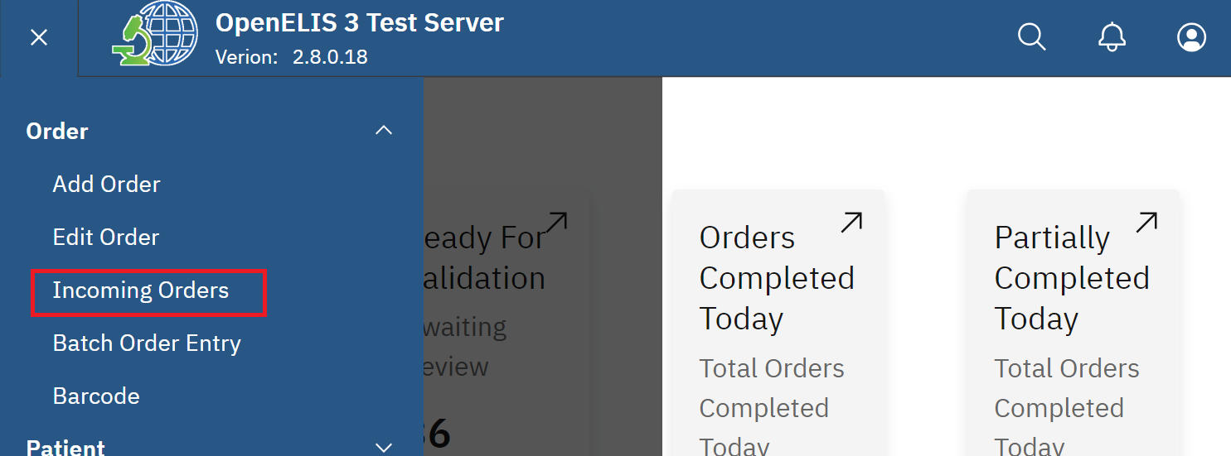

*Click on Incoming Orders*

1. Click on Order and select a term from the dropdown menu to sort the list of electronic orders.

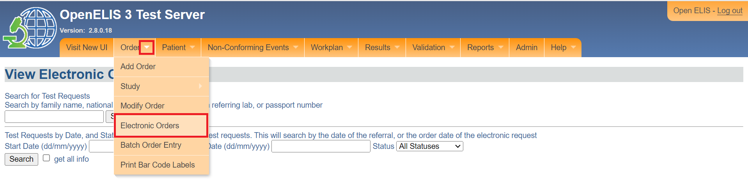

*Electronic Orders*

1. Electronic orders can be searched by entering family name, National ID, lab number from referring lab or patient number and clicking on the **Search** button

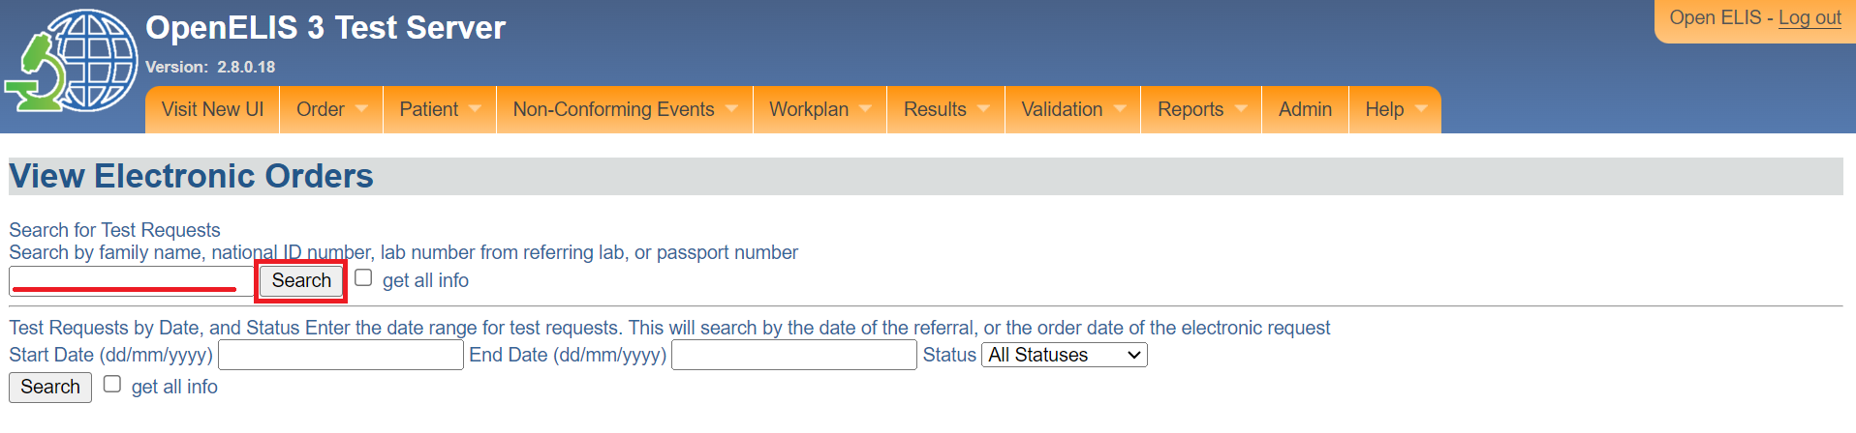

*View Electronic Order*

# **PART 6: BATCH ORDER ENTRY**

The batch order entry can speed up the order entry process when you receive a group or batch of orders with the same sample type, test and/or facility of origin

Illustration, suppose you receive a batch of 100 DBS samples for viral load testing from North Regional Hospital, you can use batch order entry to set the sample type, test and hospital for all the samples at once. Then, you can rapidly print barcode labels for each sample. You have the option to include patient information right away, or save that data entry for a later point in time.

## **How to set up batch order entry without individual patient data**

1. Hover the mouse over the hamburger icon and click to open the menu.



*Access the OpenELIS menu*

1. Click on **Orders** to expand.



*Accessing Order*

1. Click on **Batch Order Entry**.

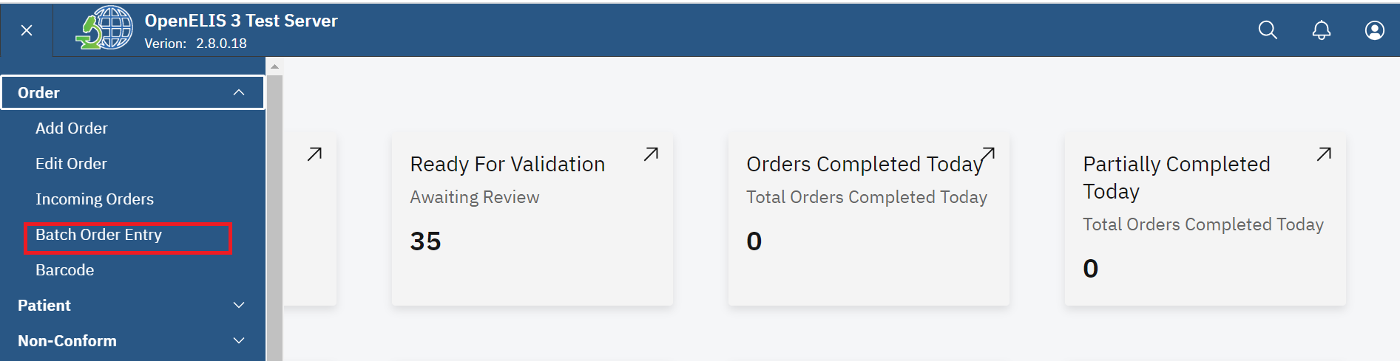*Batch Order Entry*

1. Click the **Order** tab and select **Batch Order Entry**.

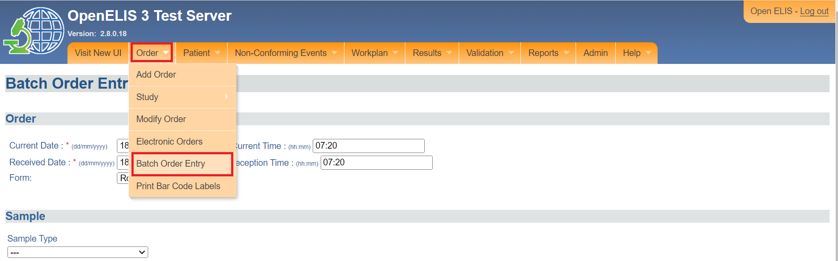*Click on Batch Order Entry*

Note: Fields marked with an asterisks (*)are mandatory.

1. In the Order section, verify the **Current Date** in the format dd/mm/yyyy and **Current Time** in the format hh:mm
2. You can change the **Received Date** in the format dd/mm/yyyy and **Reception Time** in the format hh:mm.

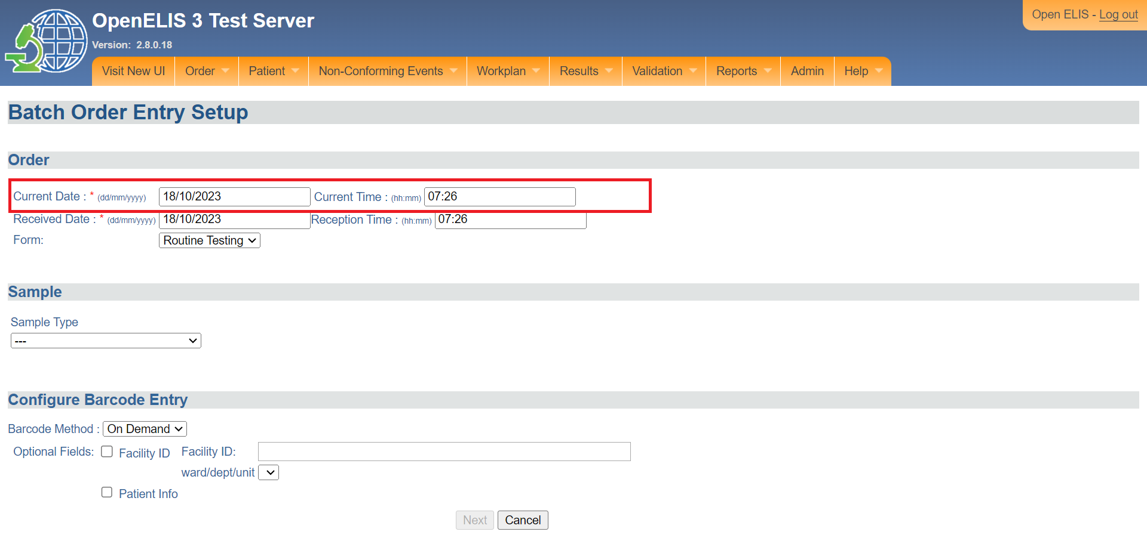*Batch Order Entry Current Date and Time*

1. Select the **Form,** if applicable. The selections will depend on your local configuration. In this illustration, the **Routine Testing** form is selected by clicking on the drop-down menu and clicking on the form.

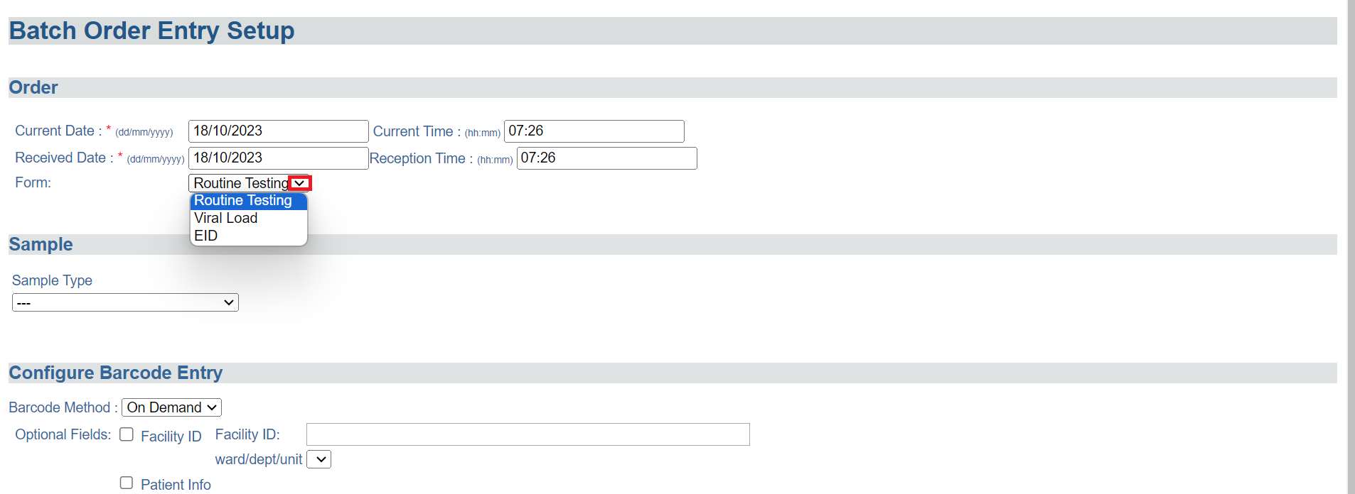*Form Selection* 

1. In the Sample Section, Click on the **Sample Type** from the dropdown menu.

*Click on Sample Type Drop-down Menu*

1. Select the sample from the drop-down menu items. In this illustration, Stool culture is selected as the sample type

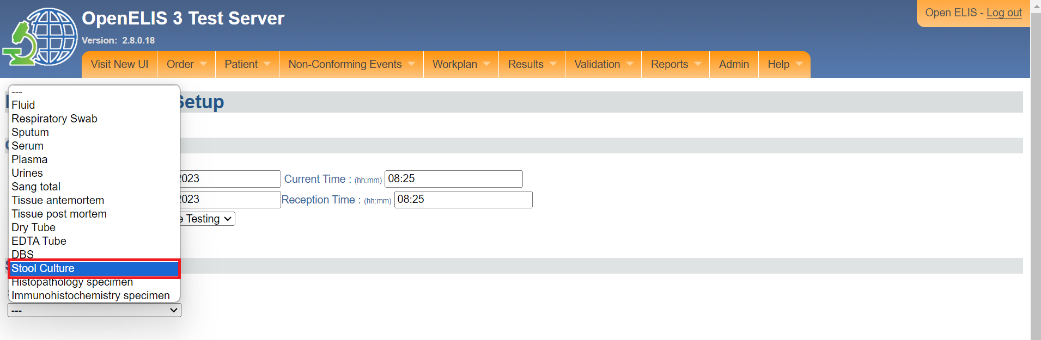*Sample Selected*

1. Check the box(es) corresponding to the desired panel(s) and test(s). In this illustration, the check box for stool culture is checked.

Note: The number of panels and tests available for a sample depends on the type of sample (serum, plasma, blood, urine). The sample type and test will be the same for the entire batch being entered.

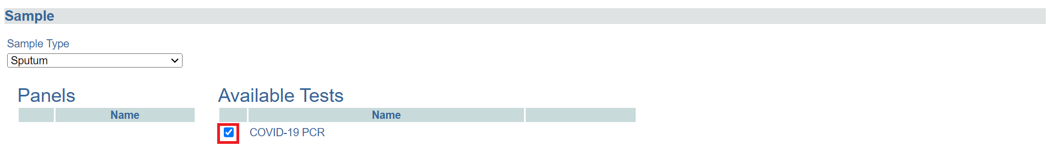*Select Panels and Available tests* 

1. In the Configure Barcode Entry section, select the **Barcode Method** from the dropdown list. Choose **Pre-Printed** if the barcodes you are using are already printed labels. Choose **On Demand** if you will print the entire barcode label from OpenELIS.

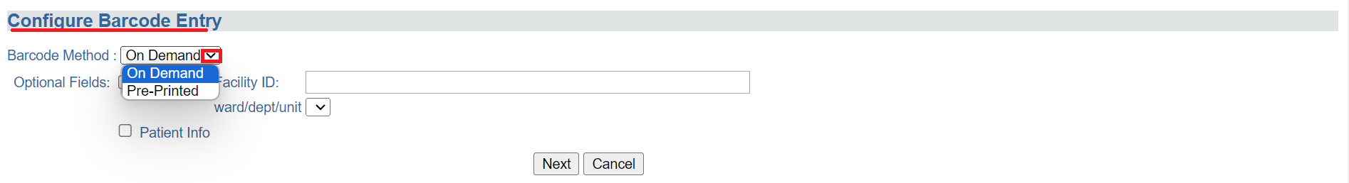*Configure Barcode Entry*

Note: **Facility ID** and **Patient Information** are **Optional Fields**.

You can add **Facility ID** for the batch if they all have the same facility of origin. Check the box for **Facility ID** and enter the ID in the text field.

The section under **How to set up batch order entry with individual patient data** provides a step by step guide on how to use the Patient Info field.

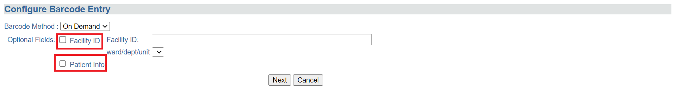*Checkboxes for Optional Field*s

1. Click the **Next** button at the bottom of the page.

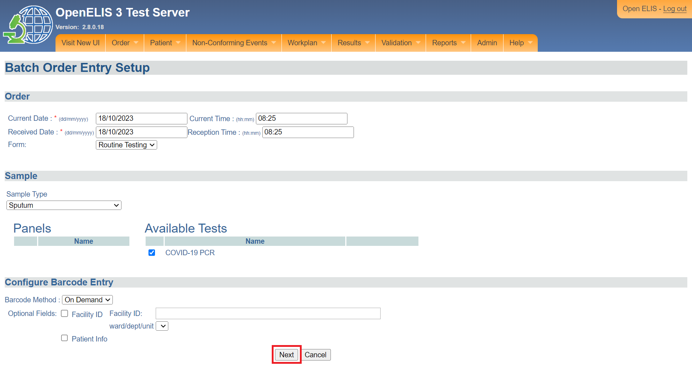*Click Next Button*

A new page appears which gives you the summary of the sample and the option to save and print.

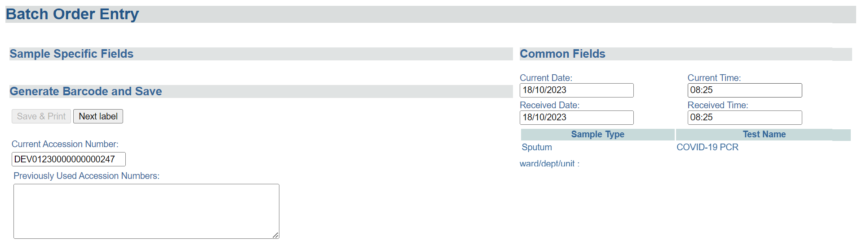*Batch Order Entry Form*

1. You can update the **Current Date, Current Time, Received Date** and **Received Time** as needed.

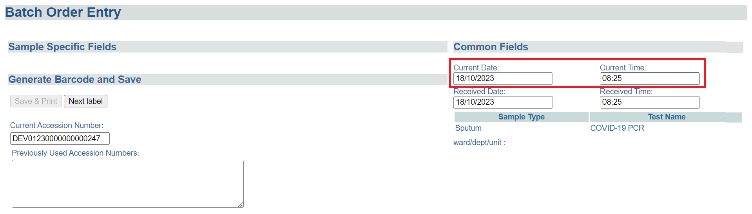*Update Common Fields*

Verify that the **Sample Type** and **Test Name** are correct.

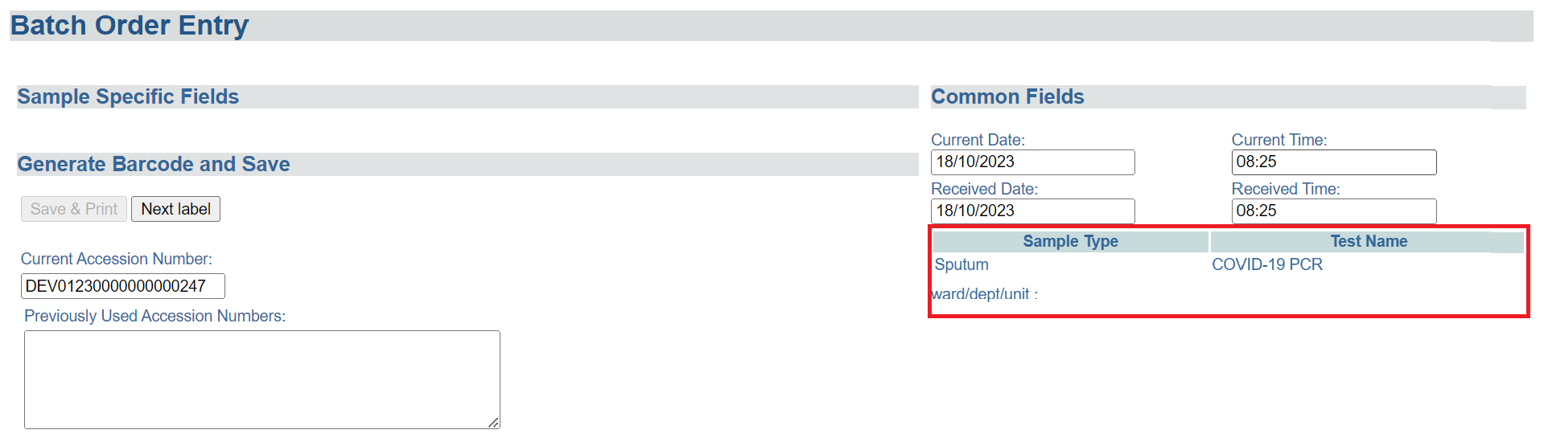 *Sample Type and Test Name*

1. Click **Save & Print.**

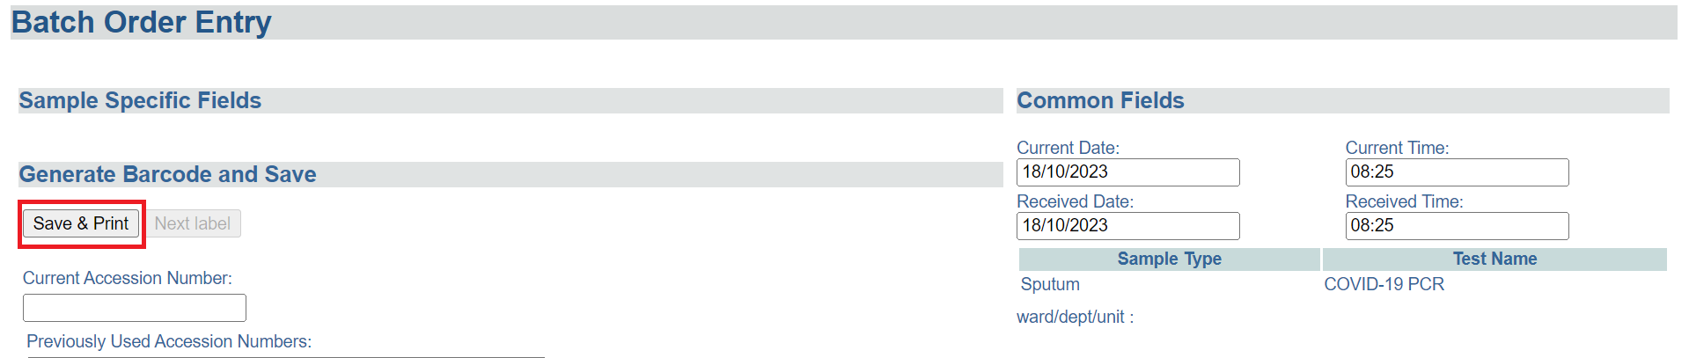*Save and Print* 

The **Current Accession Number** for the first sample in the batch will be generated automatically and the barcode label will appear below.

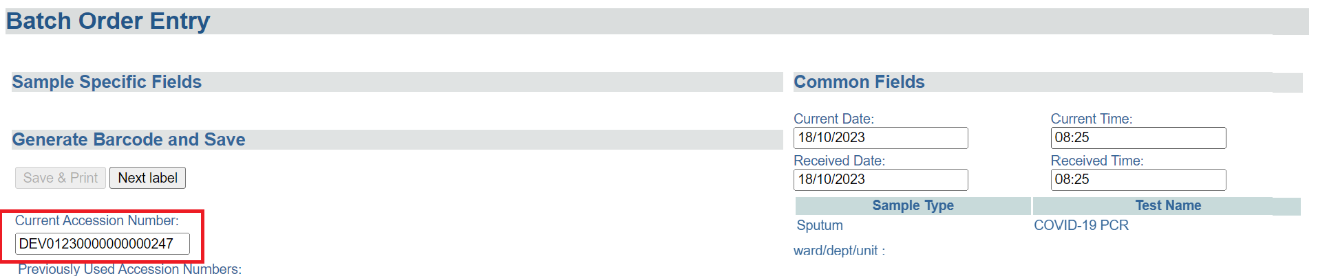*Current Accession Number*

You can enter any other accession/laboratory numbers associated with the sample (for example, the number assigned by the referring lab or facility) in the field **Previous Accession Numbers** to facilitate tracing.

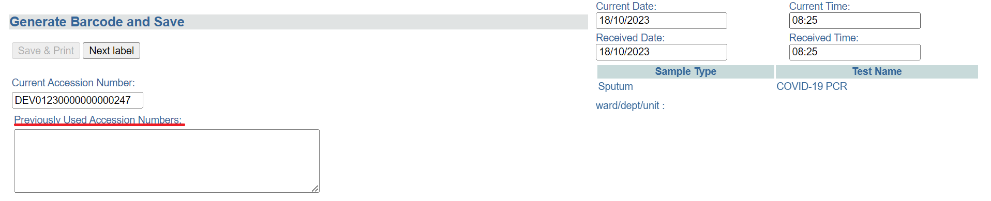*Previous Accession Number*

1. Scroll within the barcode window to see all the labels: one for the paperwork and labels for the sample.

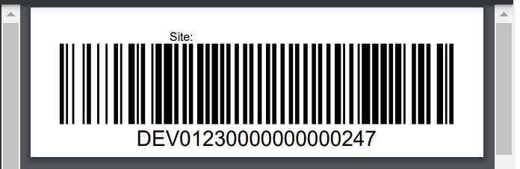*Barcode Label*

1. To go to the next sample in the batch, click the **Next Label** button. Repeat Steps 14-15.

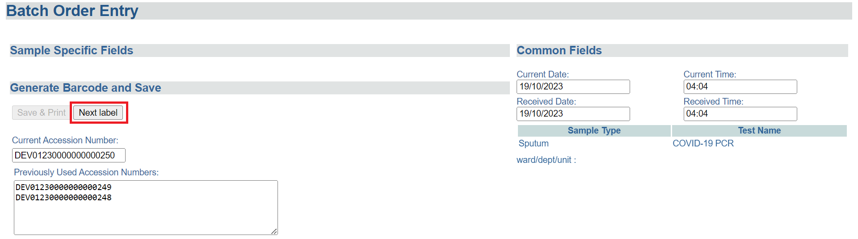*Enter Next Batch*

1. Once you have entered all the samples in the batch, scroll down and click the **Finish** button.

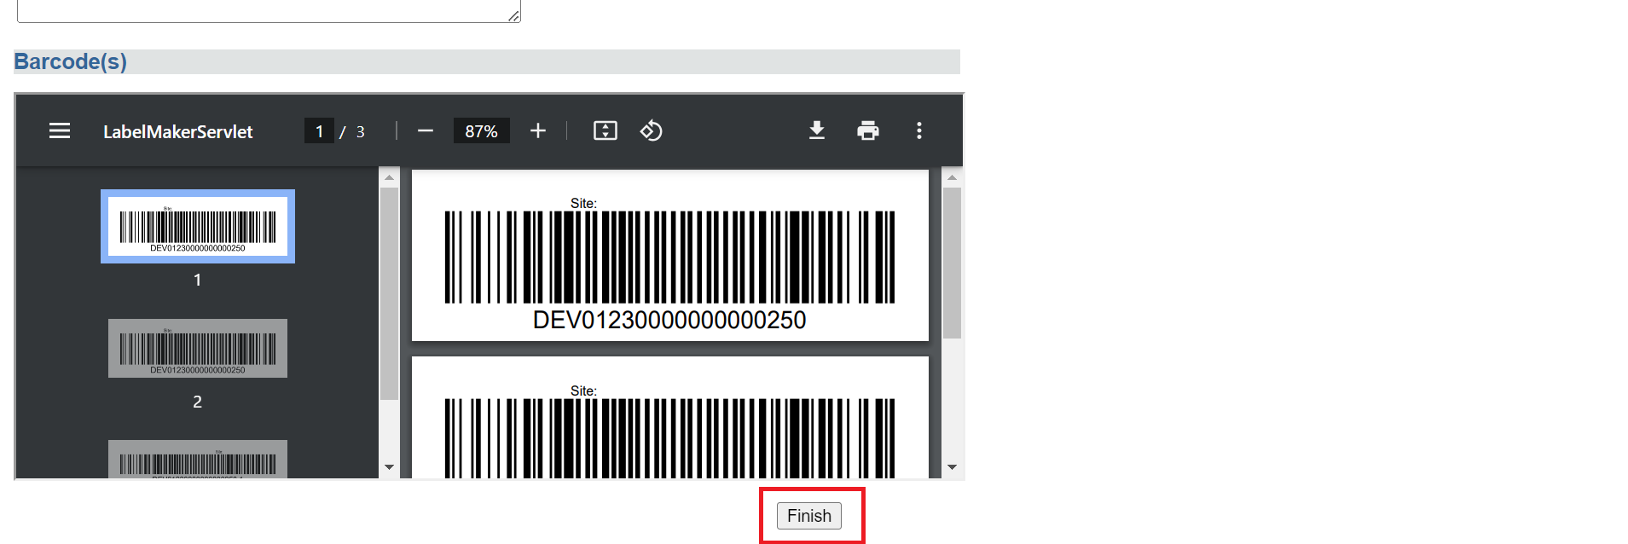*Finish Batch Order Entry* 

At a later point, go to **Order Entry** on the Order tab and scan the barcode to pull up the order and enter the patient data at that time.

## **How to set up a batch order entry with individual patient data.**

1. Complete Steps 1-11 of **How to set up batch order entry without individual patient data**.
2. Check the box next to **Patient Info** under **Optional Fields.** Click the **Next** button.

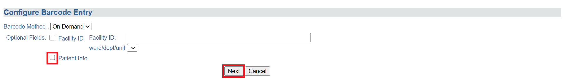*Patient Info Check-box* 

The Batch Entry page will appear with a section **Sample Specific Fields**. This page allows for searching for information for an existing patient as well as creating a new patient

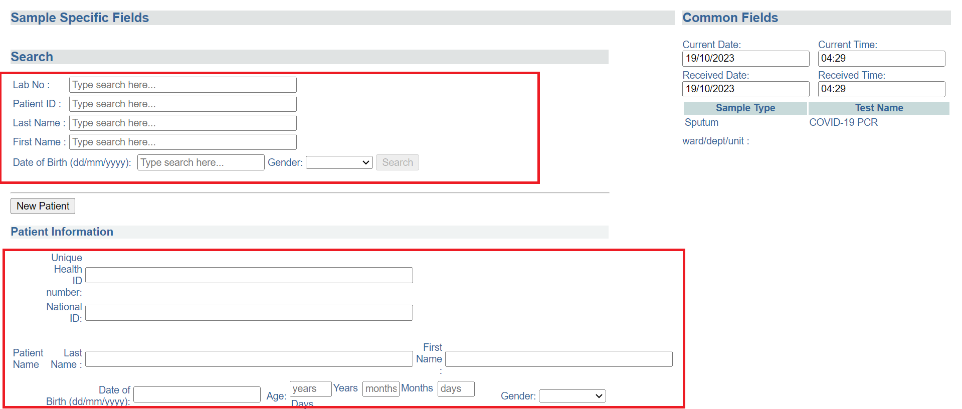*Batch Order Entry Form*

You will need to search for the patient in the database. The search criterion is as follows:

1. Patient’s last name (surname or family name)
2. Patient’s first name (given name)
3. Patient’s last and first name, separated by a comma
4. Patient’s identification code
5. A previous lab order number associated with that patient- you can scan a barcode or enter this manually
6. Type in the search term (the name or code number) into the search field and click **Search.** In this illustration, the patient's last name is used as the search parameter.

The search results appear in a tabular format listing the patient, their birth date, and identification code. Select the patient that matches the one you want by clicking on the radio button next to that patient. The patient form will populate with that patient’s information. The radio-button for the first result is selected by default.

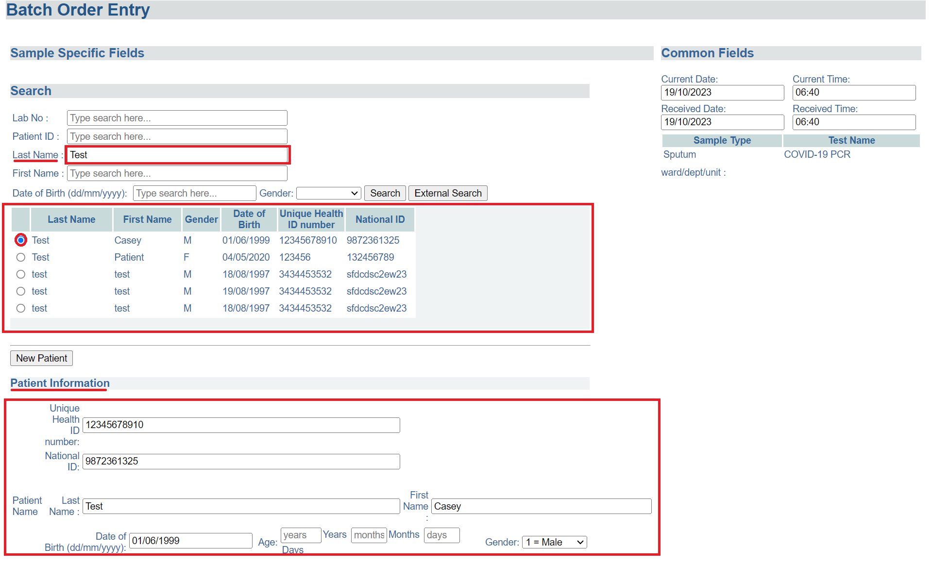*Patient Search* 

If there are no results that match the desired patient, you will have to create a new patient record.

1. Click on **New Patient** button to clear the form if needed.
2. Enter the patient’s **Patient ID, National ID, Last Name, First Names, Date of Birth** or **Age,** and **Sex (Gender).**

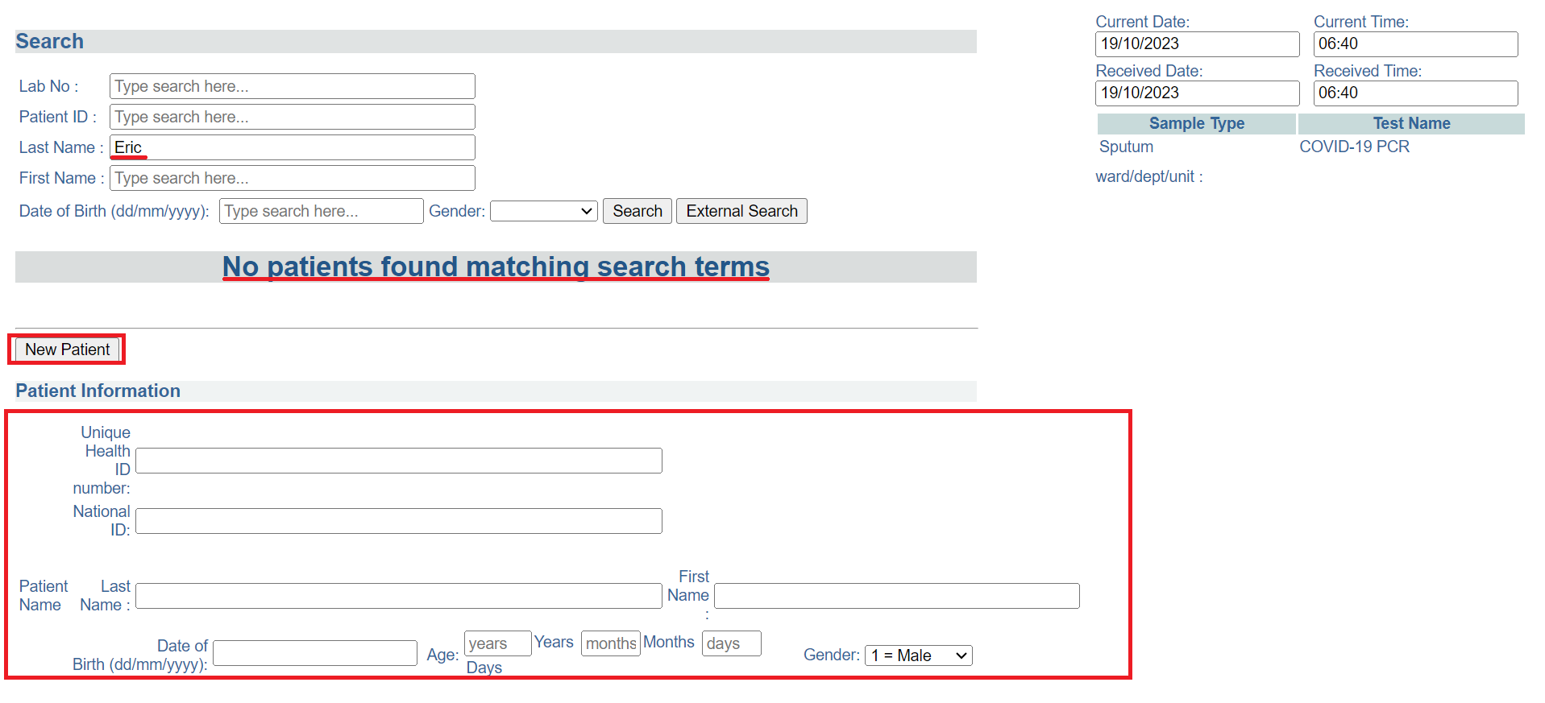*Create New Patient*

**NOTE:** Age is calculated automatically from the date of birth. If date of birth is not available but age is known, enter age only and a proxy date of birth will be assigned

1. Complete Steps 13-17 of How to set up batch entry without individual patient data.

## **How to print barcode labels**

1. Hover the mouse over the Order tab, select Print Barcode Labels.

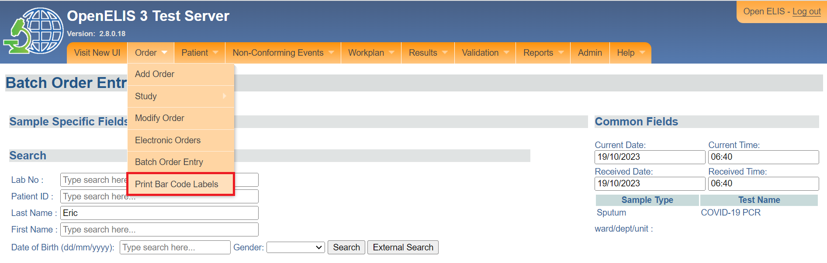

*Print Barcode Labels*

The Print Barcode Label page will appear. You can do the following under the **Pre-Print Barcodes** section:

1. Enter number of label sets
2. Enter number of order labels per set
3. Enter the number of specimen labels per set
4. Enter the total labels to print. This will set the number of barcodes to be printed.
5. Check the optional check-box for facility ID

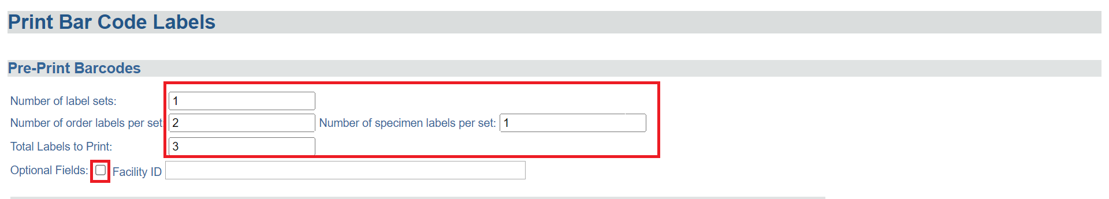*Pre-print Barcodes*

1. Select the **Sample Type** from the drop-down menu and the corresponding panel(s) and available tests.

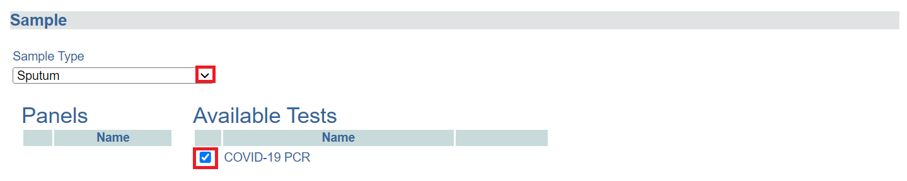

*Select Sample Type, Panels and Available Tests*

1. Click on the **Pre-Print Label** button. The barcode will be displayed. Use the scroll bar to scroll through the labels.

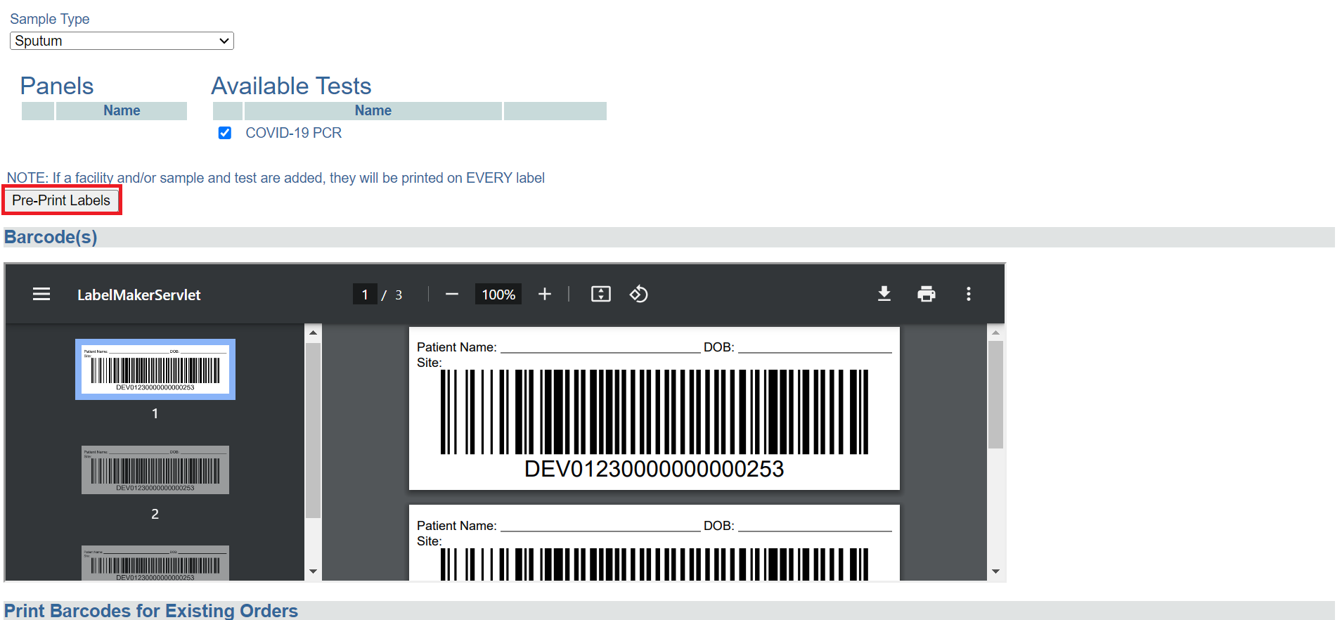

*Pre-print Labels* 

1. Click on the printer icon at the top right to print the labels.

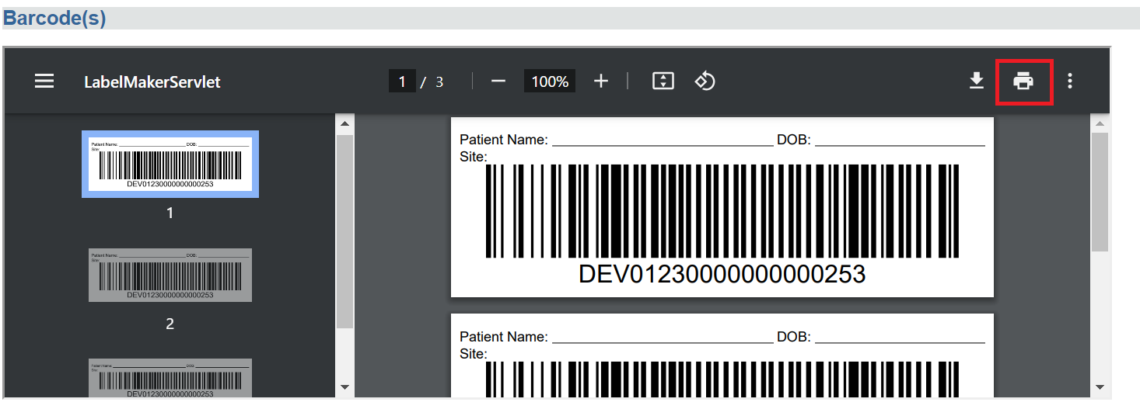

*Launch Printer Dialogue*

# **PART 7: WORK PLANS**

The laboratory can use work plans to facilitate work assignments for lab units, individual technicians, and dispatch of samples within the lab.

Work Plans list the samples and tests to be done. The work plan can be organized by a single test or a panel, or for an entire lab unit.

## **How to create a work plan by test type, by panel type, unit type or by priority**

1. Hover the mouse over the hamburger icon to open the menu.



*Access the OpenELIS menu* 

1. Click on **Work Plan** to expand.

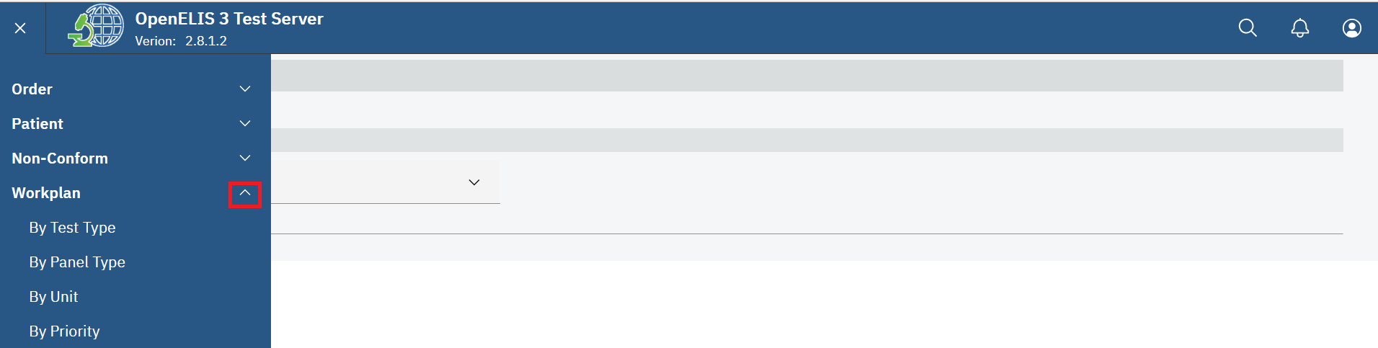*Accessing Work Plan*

1. Click on the type of work plan you want: **By Test Type, By Panel Type,**  **By Unit** or **By Priority.**

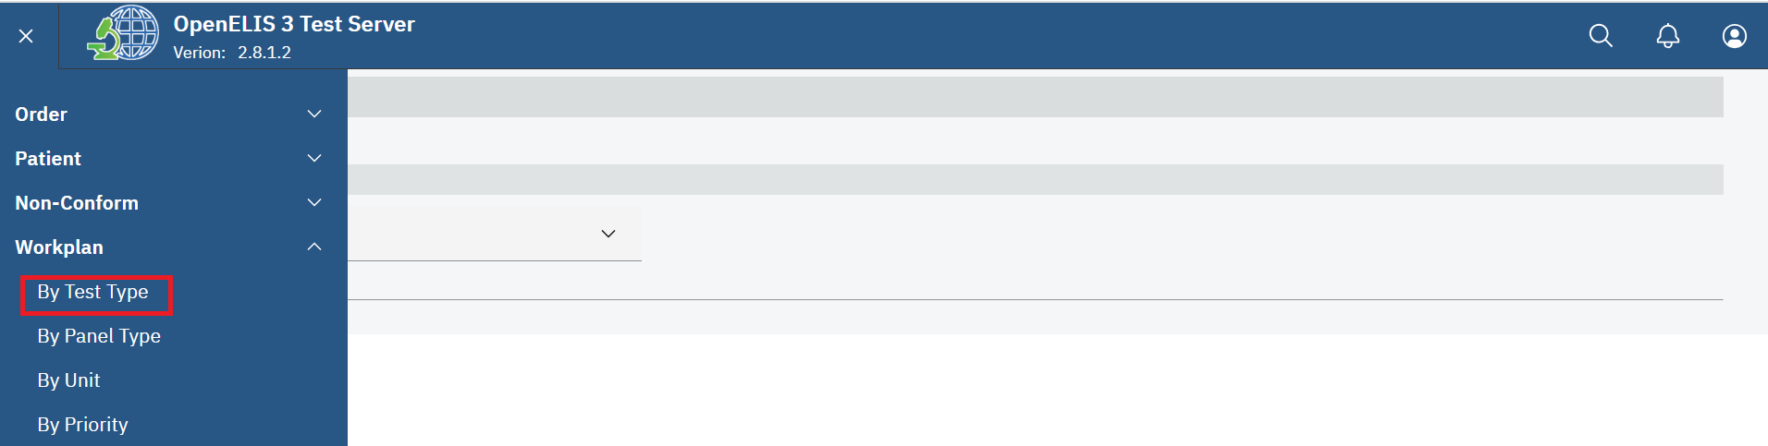

*Work Plan By Test Type*

The work plan by test type page will be displayed.

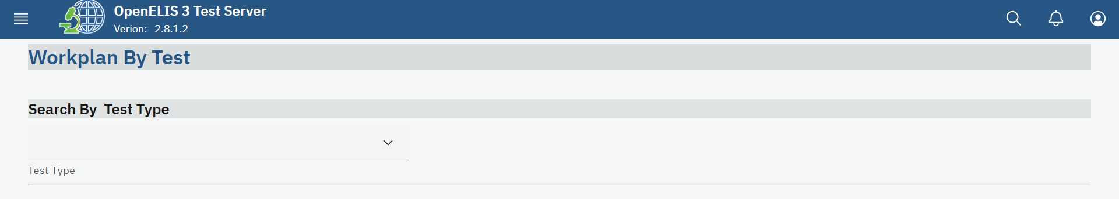

*Work Plan By Test Page*

1. Select the Test Type from the drop-down menu.

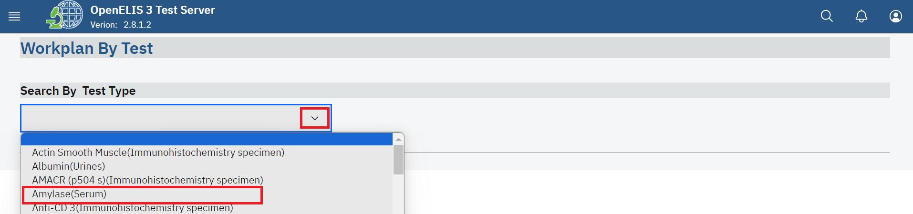*Select Test Type* 

The work plan will appear shown below. The work plan lists all orders for that Test, Panel, Unit or Priority that need to be done, along with the Patient ID (Subject Number), Received Date, Technician ID and other information depending on your local configuration. They are listed in order by lab number.At the top of the page the number of **Total Tests** on the work plan. A **Red Flag** next to an order indicates that either the sample or order has been reported for a non-conforming event.

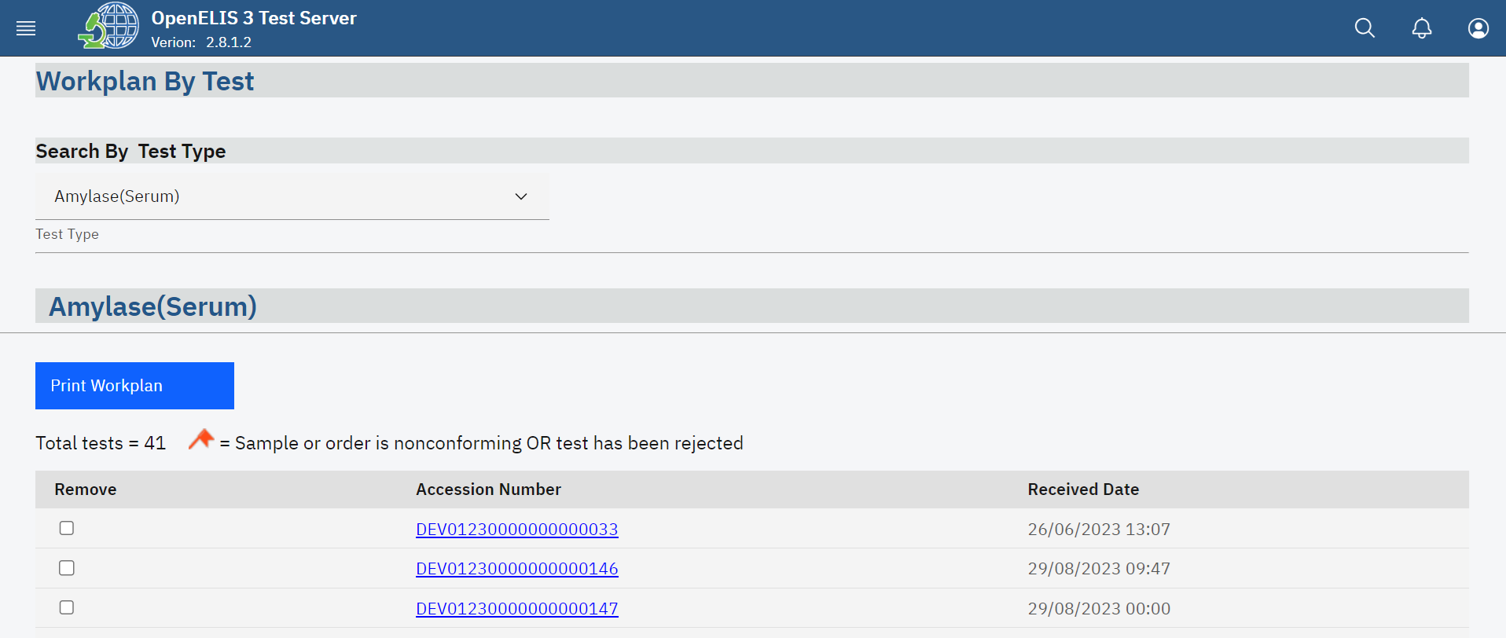*Work Plan By Test*

1. To create a work plan by **Panel type**, **Unit type** or **By Priority** follow steps 1-4.

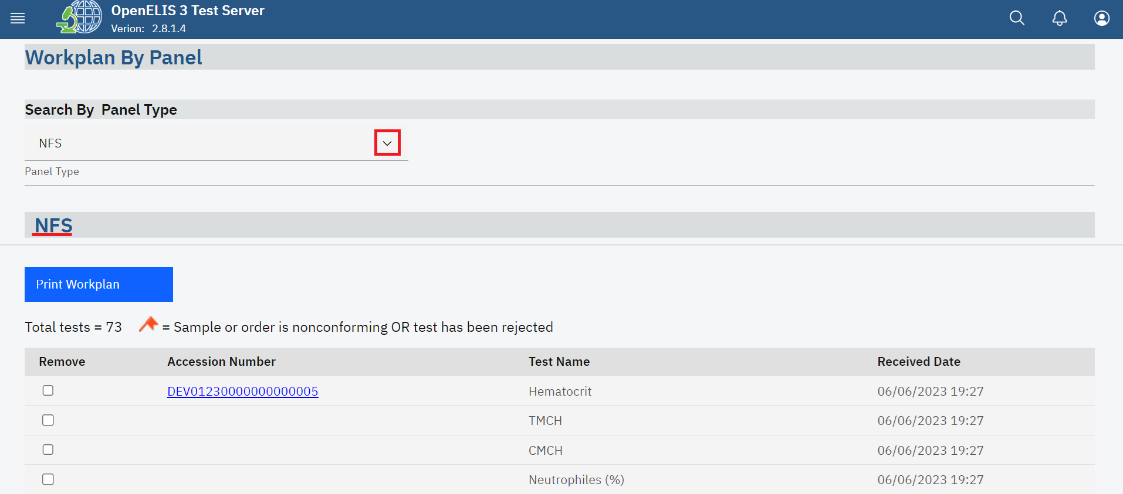*Work Plan by Panel Type* 

*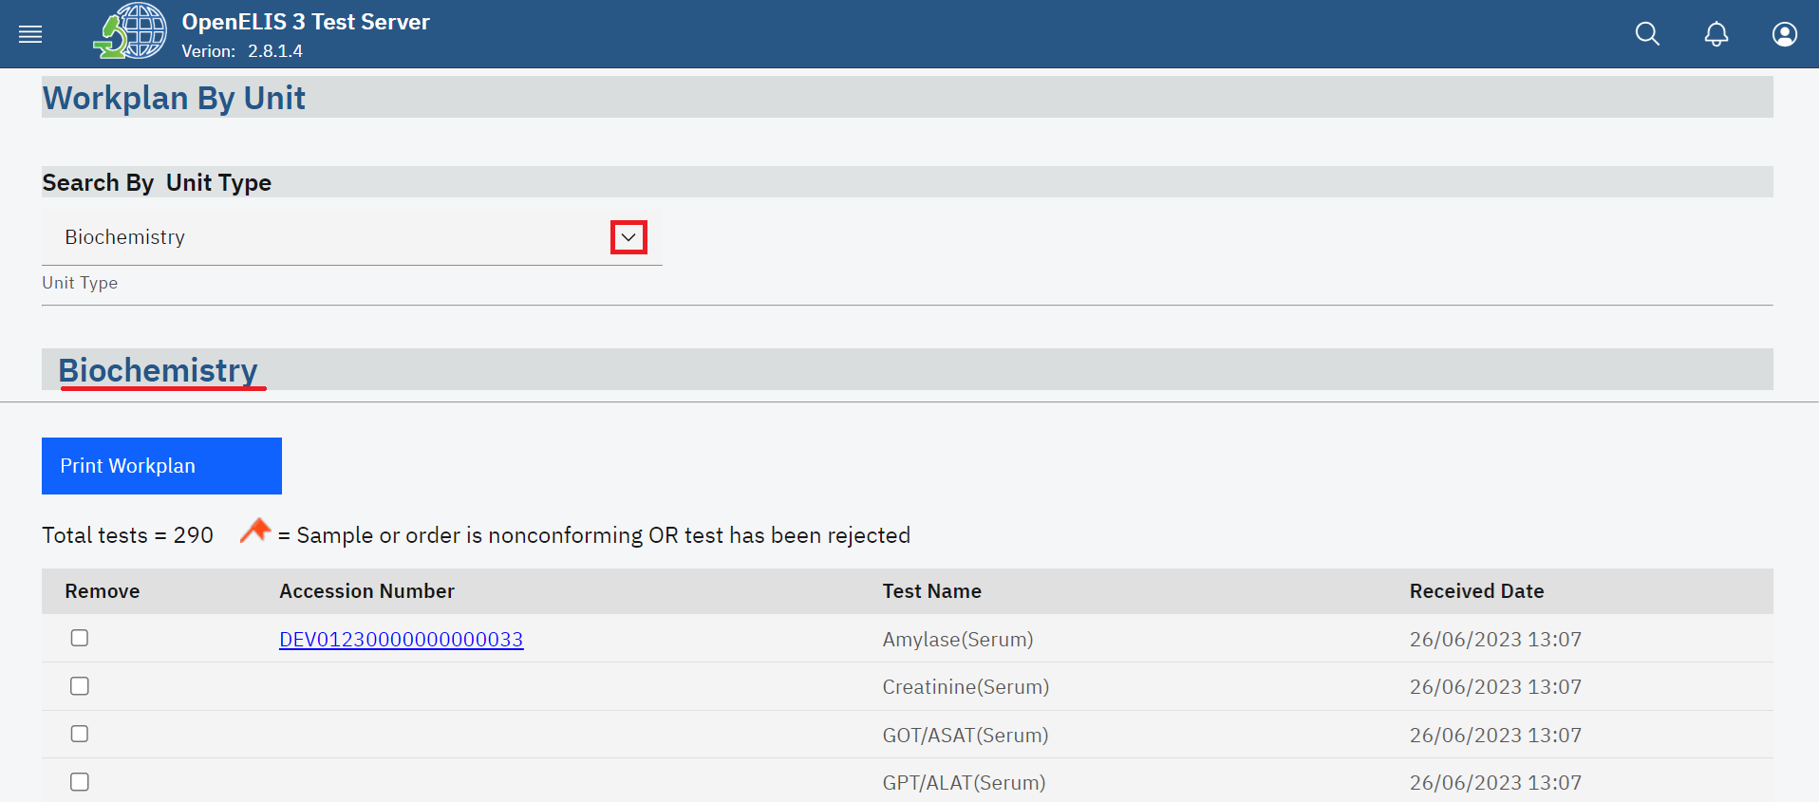Work Plan by Unit*

*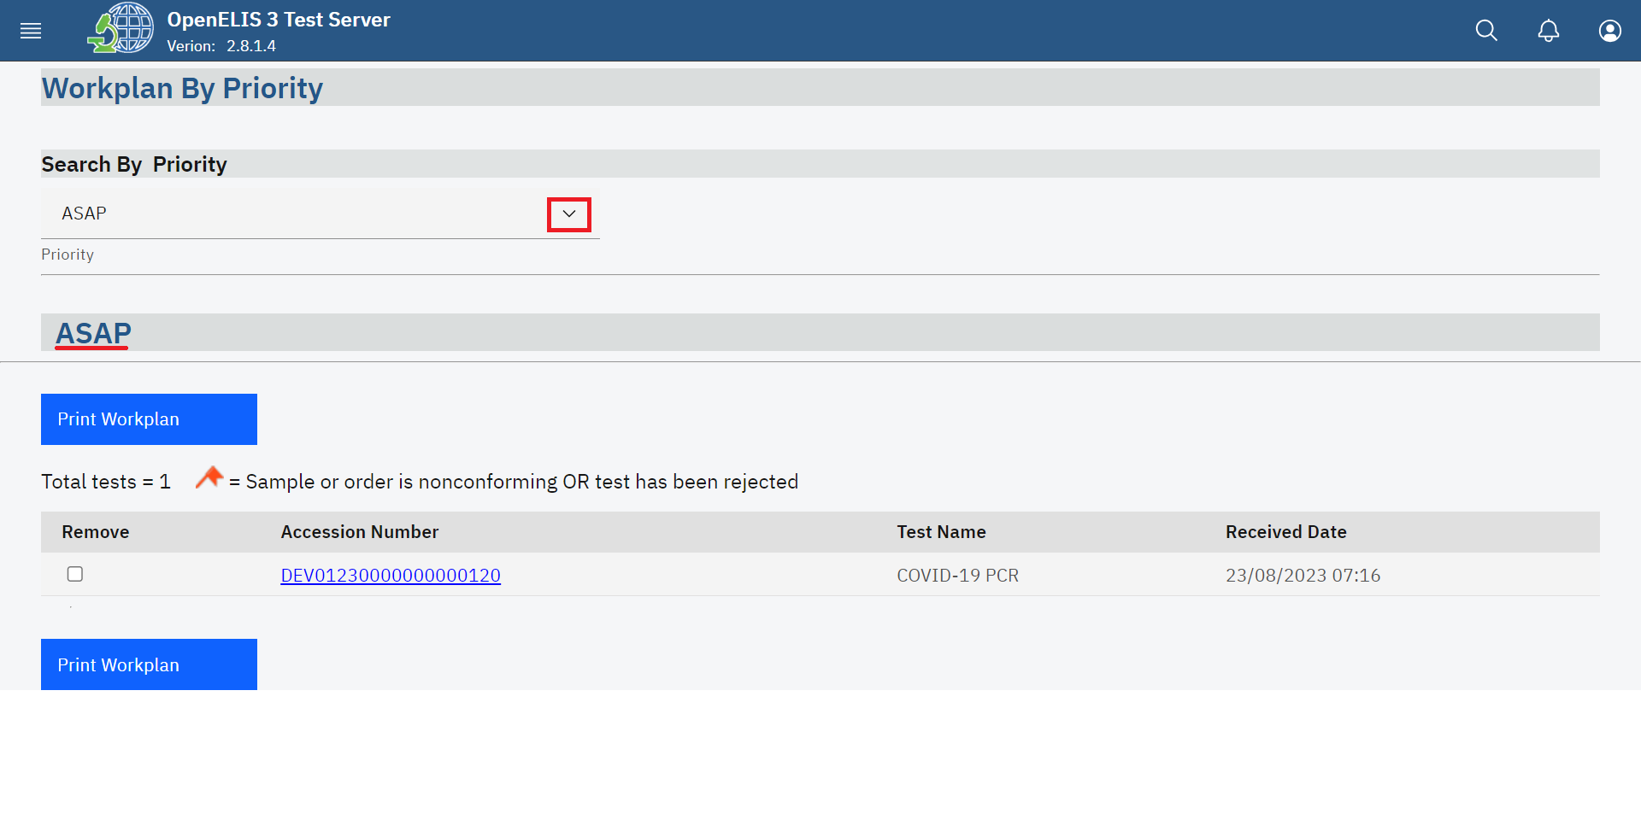Work Plan by Priority*

1. Check the **Remove** checkbox next to the lab number to remove a test from the workplan. This can be used to create different work plans for different technicians, see the illustration below;

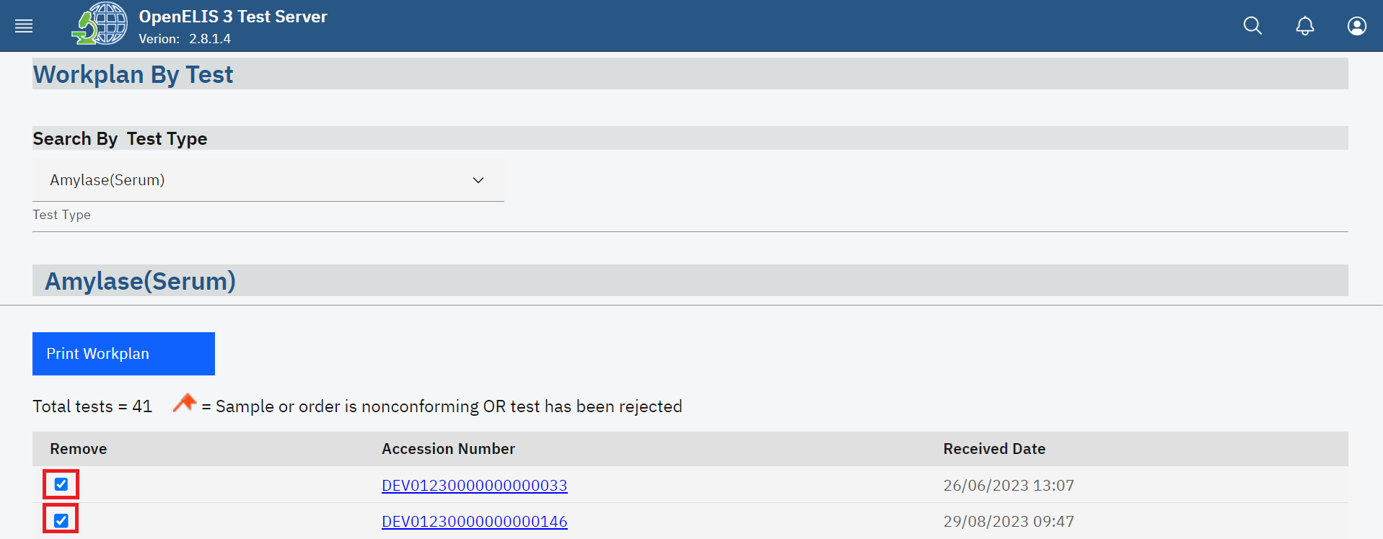*Remove Tests From Work Plan*

1. To print the work plan, verify that all the tests that you want in the workplan appear then click on the **Print Work plan** button.

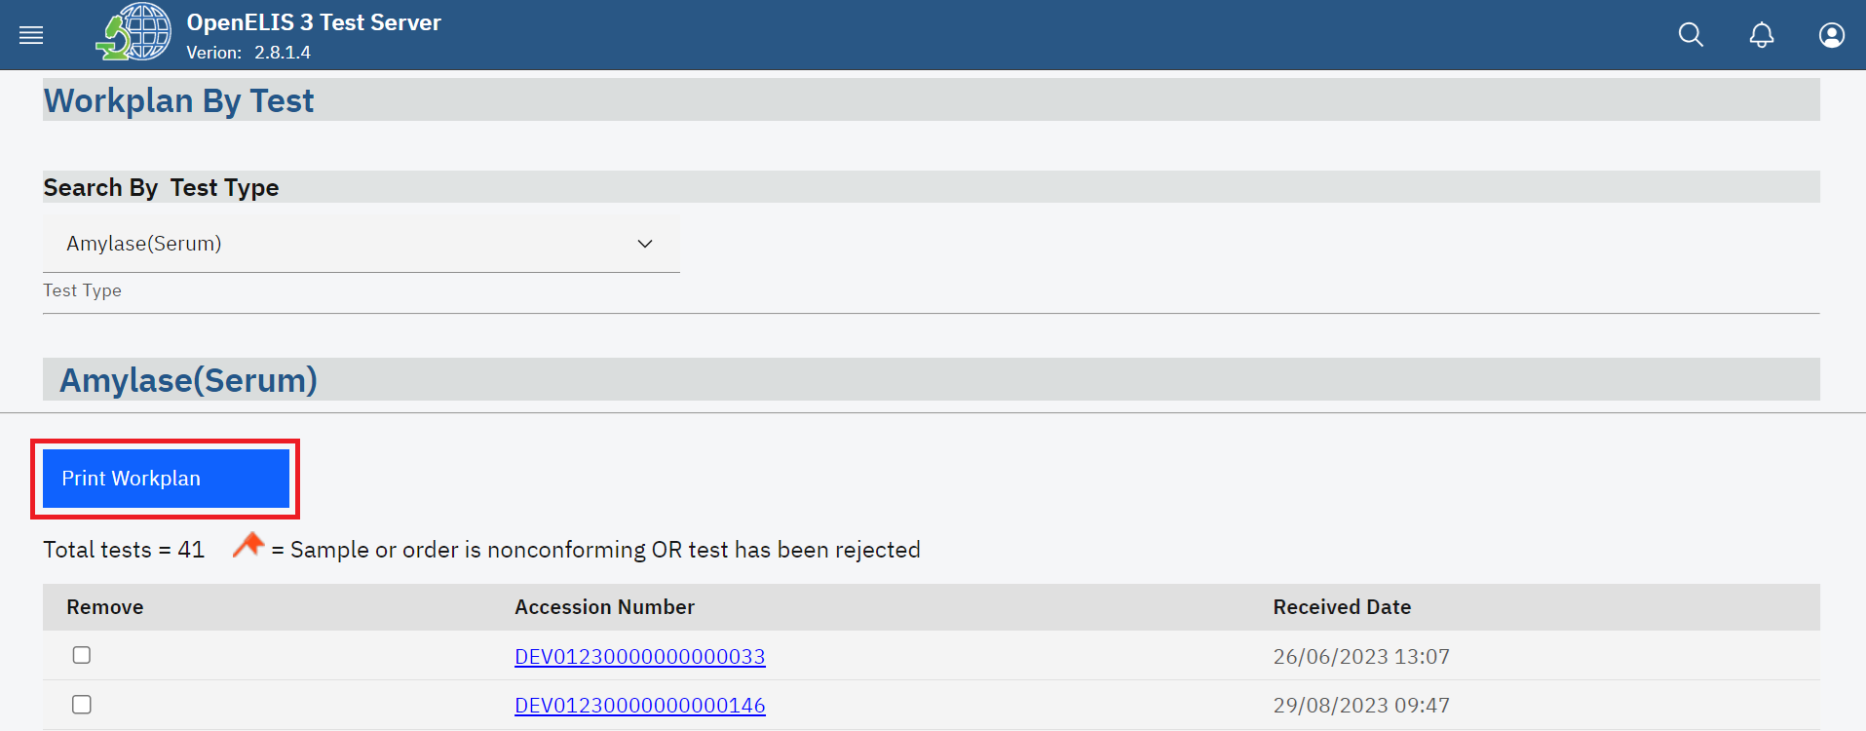

*Print Work Plan*

A new window will open with a PDF version of the work plan. This can be printed from your browser application.

# **PART 8: PATHOLOGY**

The pathology module focuses on conducting tests and examinations related to pathology. A pathologist can use this module to analyze various types of specimens, including tissues, cells, and bodily fluids, to diagnose diseases and provide valuable information for patient care and medical research.

## **How to create a pathology case.**

1. To create a pathology case, follow steps 1 to 29 under how to create a laboratory analysis order for an existing patient.

## **How a pathology specimen is processed by a laboratory technician.**

1. To access the Pathology module, hover the mouse over the hamburger icon and click to open the menu.



*Access the OpenELIS menu*

1. Click on the **Pathology** module to expand.

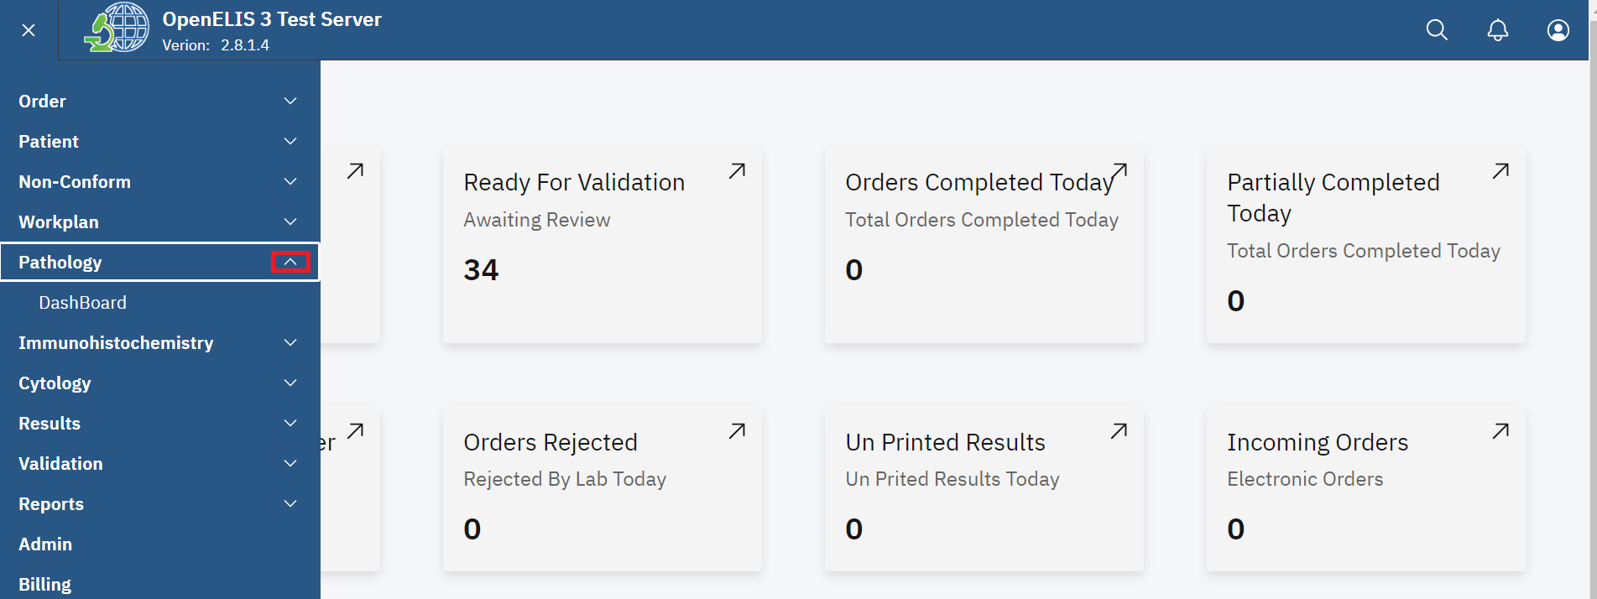

*Accessing Pathology Module*

1. Click on **Dashboard** under the pathology module.

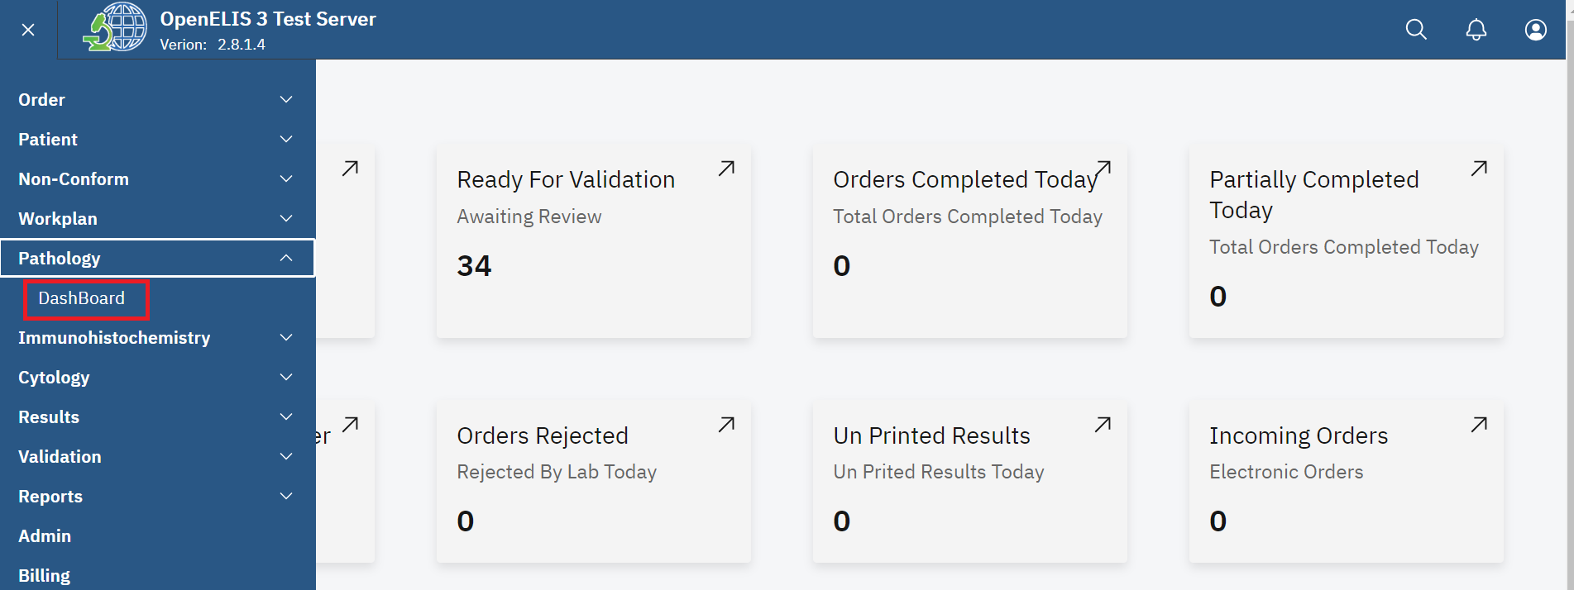

*Click on Dashboard*

The dashboard for pathology will be displayed. The dashboard provides summaries for **Cases in progress**, **Awaiting Pathology Review, Additional Pathology Request** and **Complete** test in a week

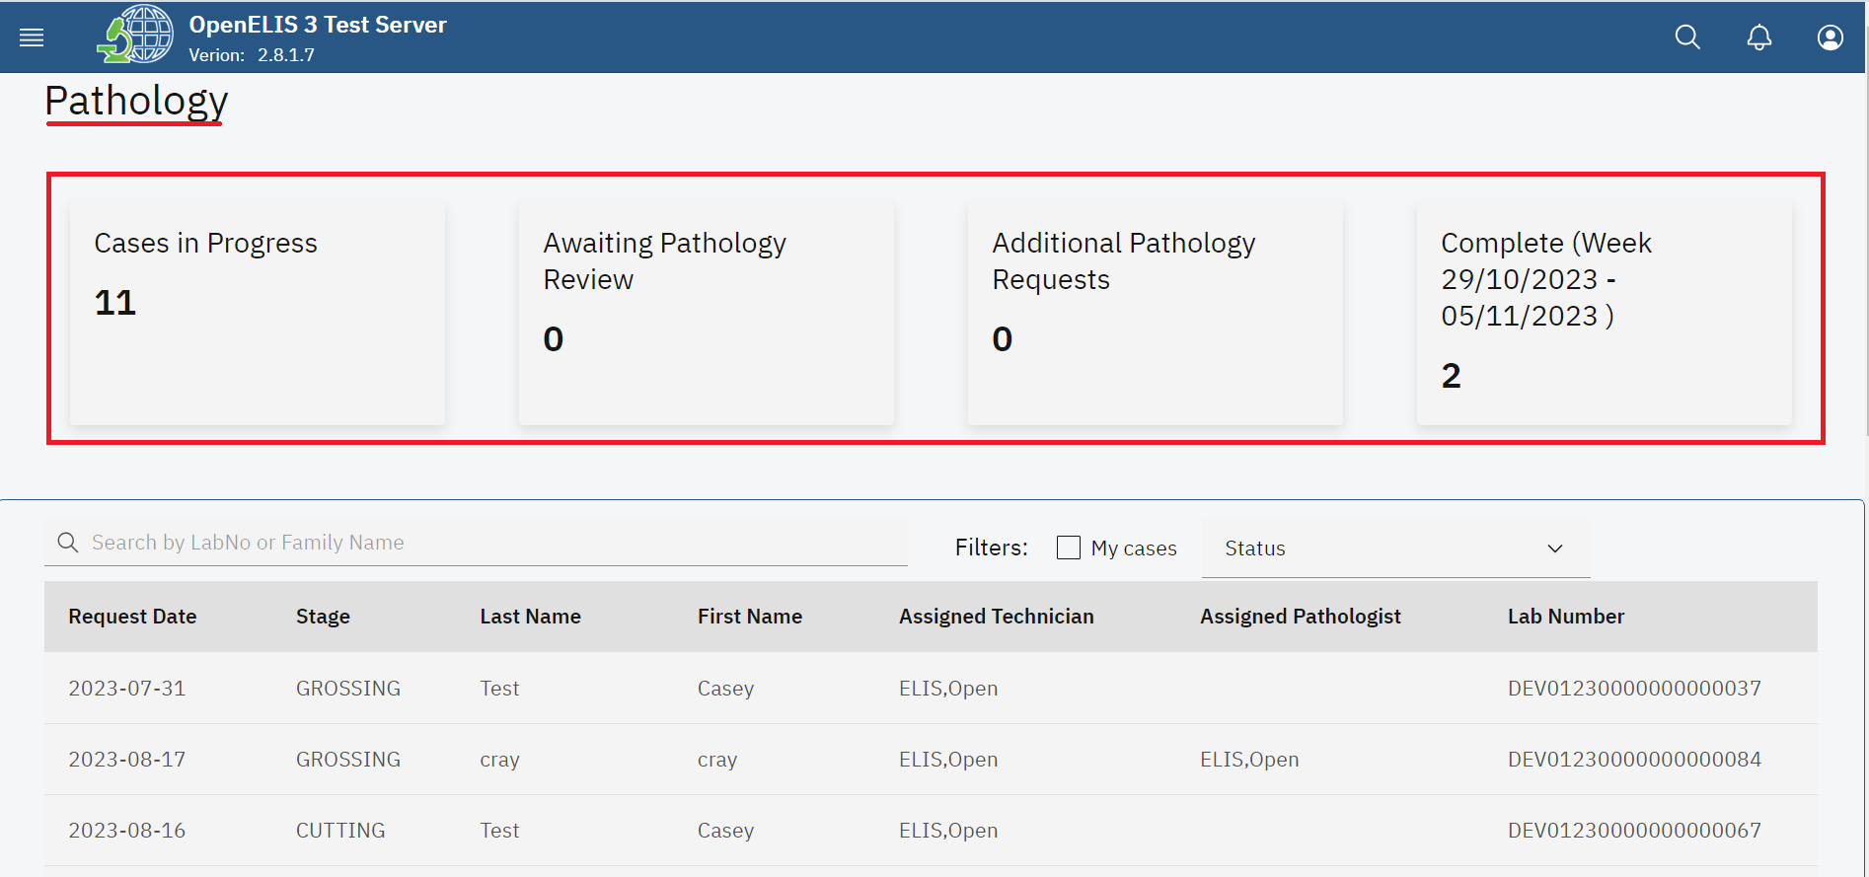

*Pathology Dashboard*

All the pathology test requests entered under **Add Order** (Test Request) are displayed under a table that displays the **Request Date**, **Stage**, **Last Name**, **Assigned Technician**, **Assigned Pathologist** and **Lab Number**.

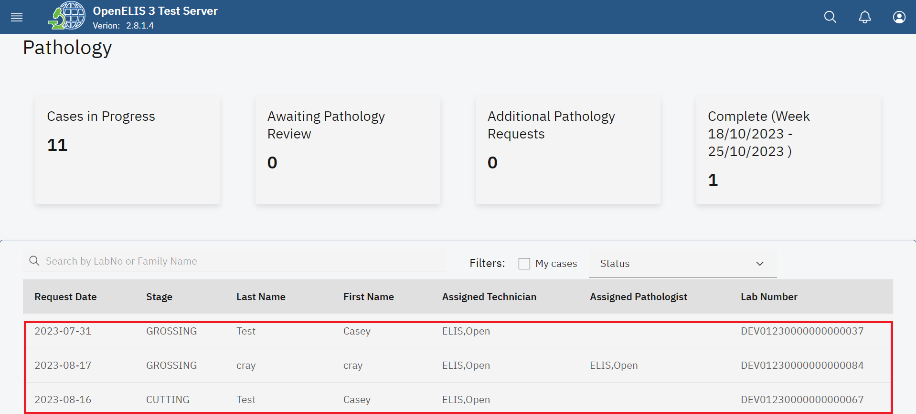

*Pathology Requests*

1. The pathology module allows you to filter the test request . Click on the My cases checkbox to filter the cases.

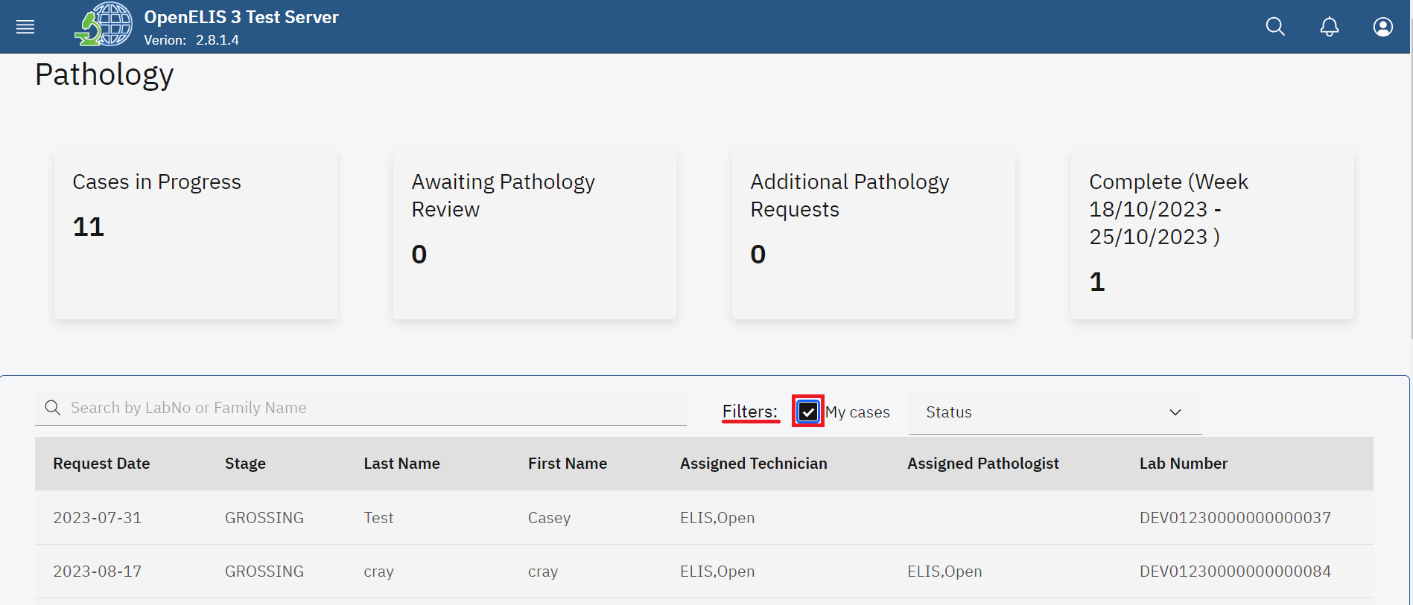

*Filter Pathology Cases*

1. The Status dropdown menu is used to filter the pathology cases by their status.

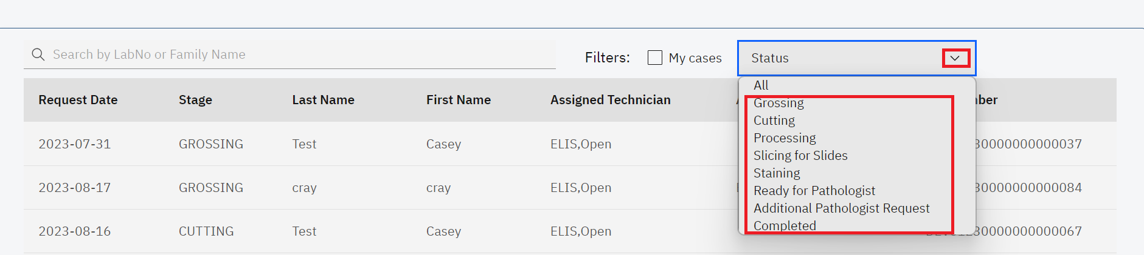

*Status*

1. You can filter the requests in an ascending or descending order for each menu item For instance, click on the **Lab Number** menu item.

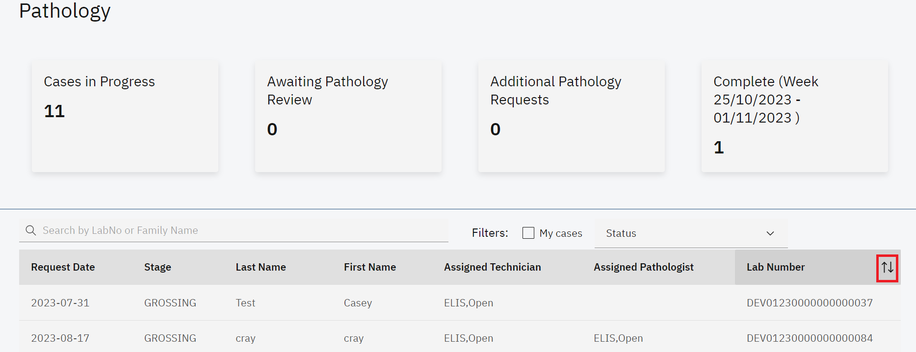

*Filter Request by Ascending or Descending Order*

1. To search for a pathology test, enter the patient name or the lab number under the **Search by LabNo or Family Name** text field. The search results will retort a list of matching patients.The cancel icon **(x)** is used to cancel the search.
2. Click on the desired patient from the search result. In this illustration, the **Start** button is clicked.

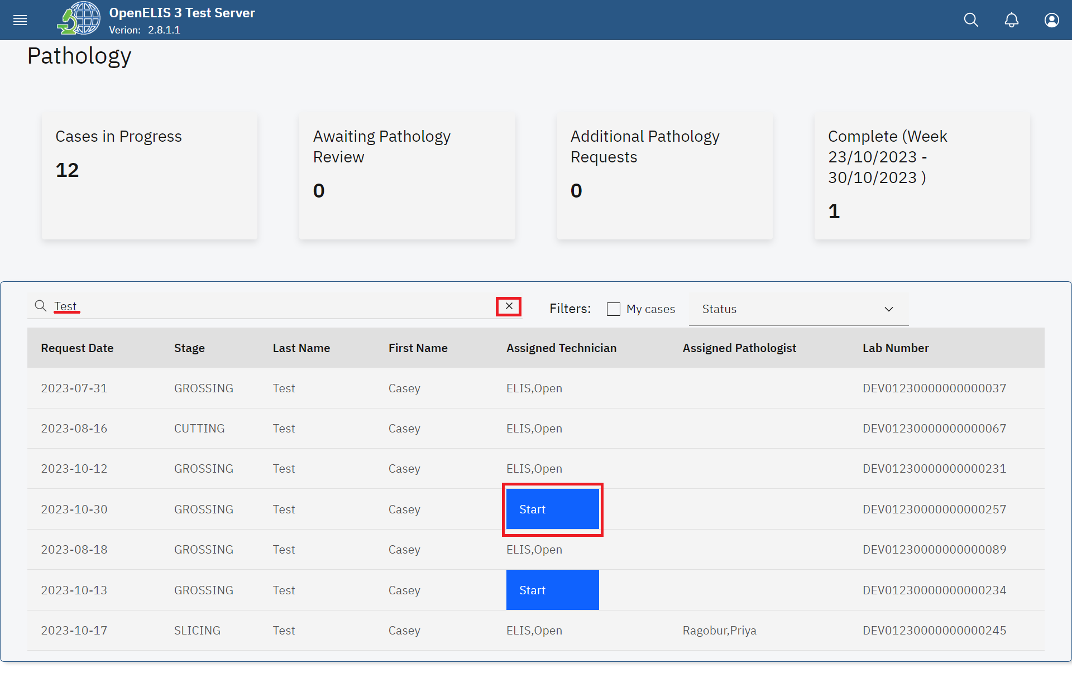

*Search Patient*

**Note**: The top sections of the pathology page display information about the pathology request.

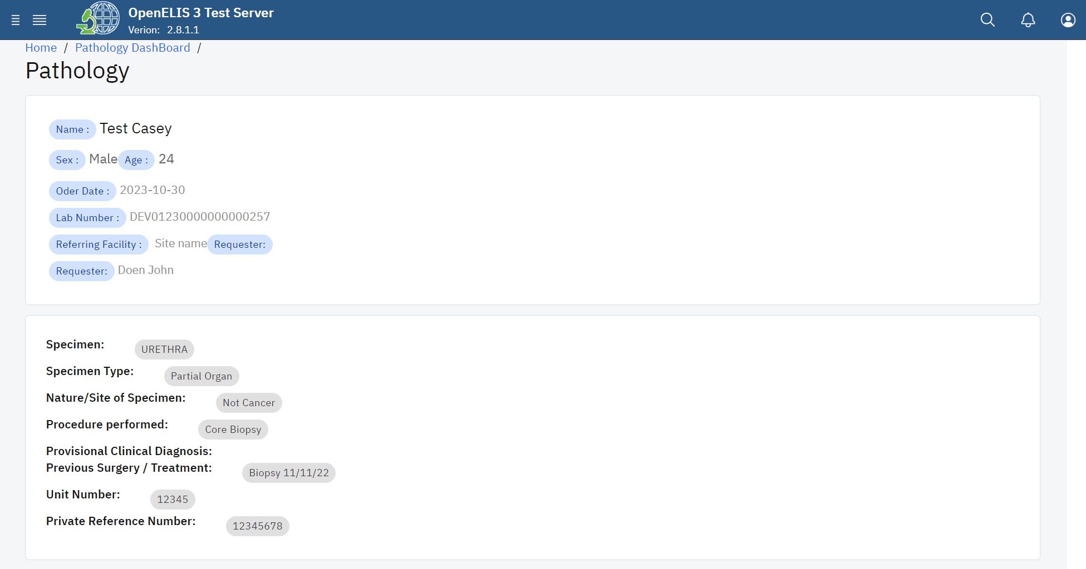

*Pathology Test Information*

**Note:** There is a sequence of stages in pathology examination. The **Status** drop-down menu provides a list of the different stages. The first stage is known as **grossing** which is the default stage in preparing a pathology sample.

1. In this illustration, the drop-down menu item is clicked and **processing** is the status that will be selected.

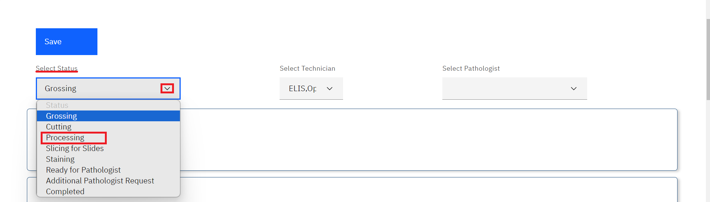

*Select Status from Drop-down Menu*

1. Selecttechnicianto assign for processing the specimen from the drop-down menu items. In this illustration, Test, Test is the selected technician .

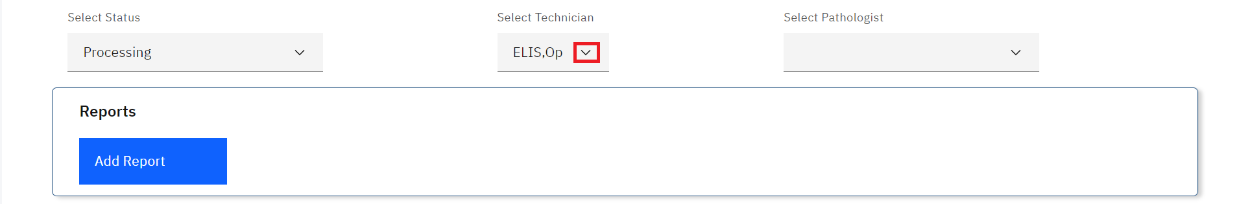

*Select**Technician*

1. Click on the **Save** button.

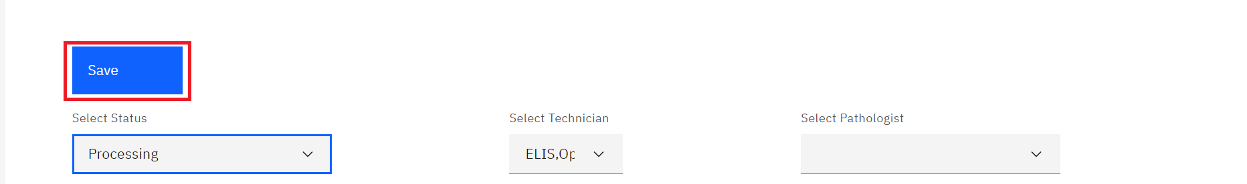

*Click Save*

1. The Blocks section allows you to add the number of blocks that will be used for specimen processing. Click on the upward facing arrow to add the number of blocks then click on the Add Block button. In this illustration, three blocks will be added.

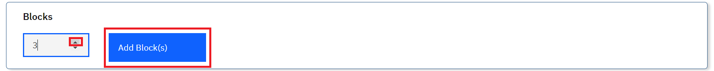

*Add Block(s)*

1. Fill in the locations for the blocks. These could be racks where the specimens are stored. You can print labels for the blocks by clicking on the **Print Label** button

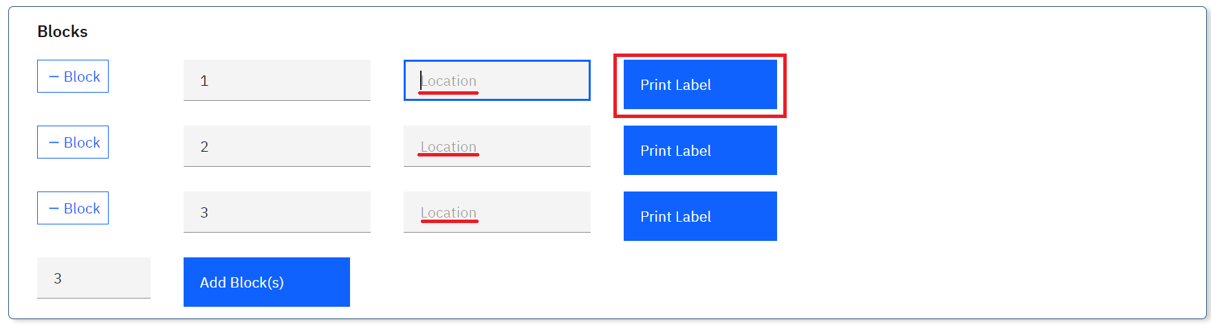

*Filling Block Location and Printing a Label*

In this illustration, the location has been entered and a label printed for one of the blocks.

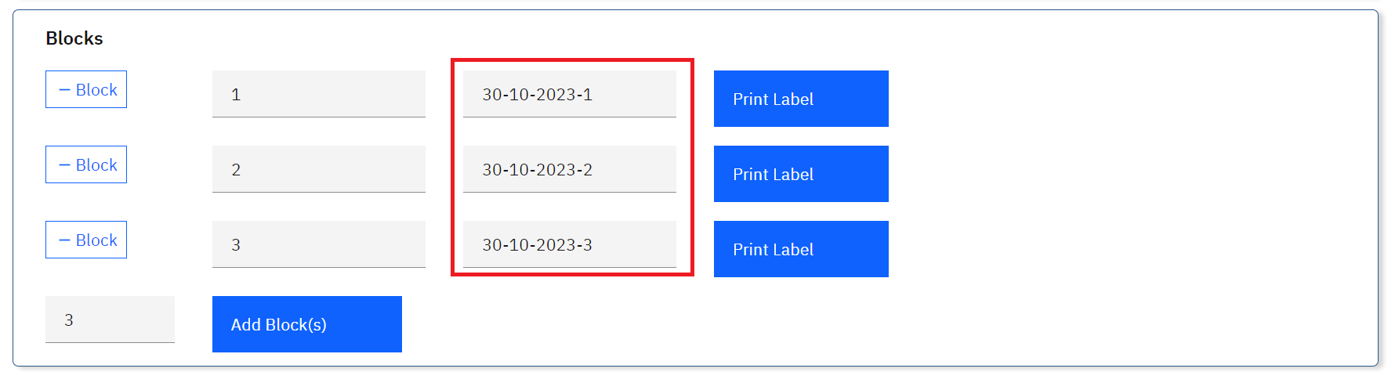

*Blocks Locations for Blocks*

1. Once the Blocks have been set, Click on the upward facing arrow to add the number of slides then click on the Add Slide(s) button.

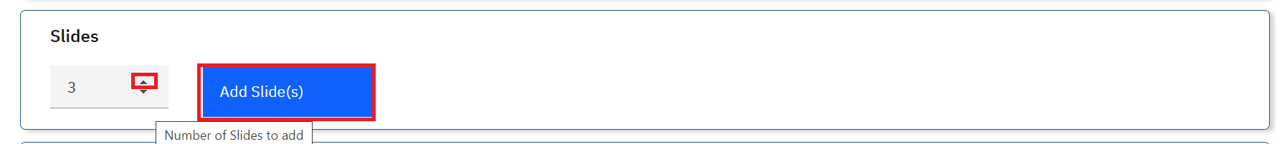

*Add Slides*

1. Fill in the location for the slides.
2. Click the Upload button to upload scanned copies of the slides. This allows a pathologist to view the copies of the slides if the pathologist is not physically located in the lab.
3. Click on the Print Label button to print the labels for the slides.

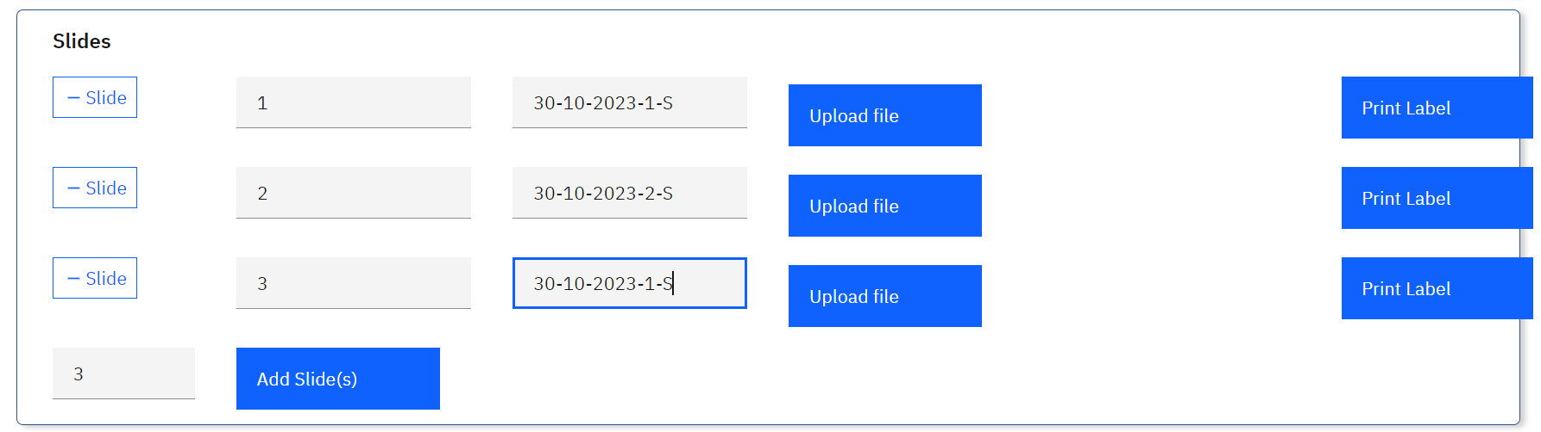

*Preparing Slides*

1. Once the specimens have been sliced in the slides. They can be stained by clicking on the **Status** drop-down menu and selecting the **Staining** status.

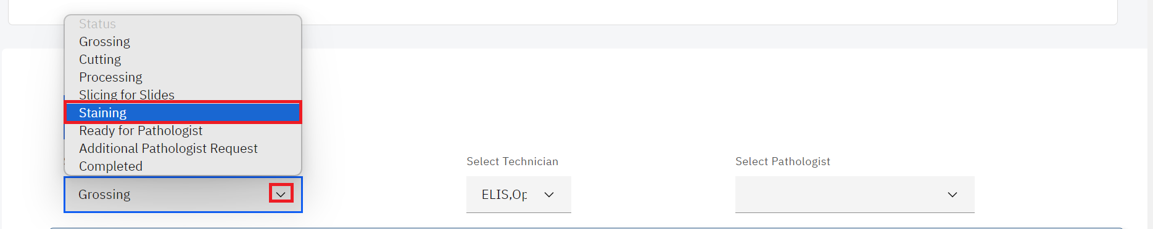

*Status: Staining Slides*

1. Click on the **Save** button upon changing the status.

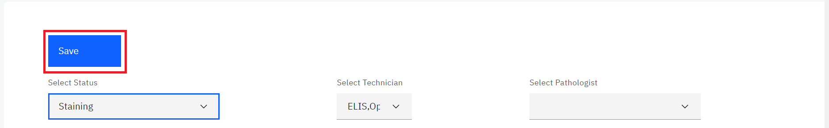

*Click on Save*

1. Once the specimens have been stained, they are now ready for review by a pathologist. Click on the **Status** drop-down menu and select the **Ready for pathologists** status.

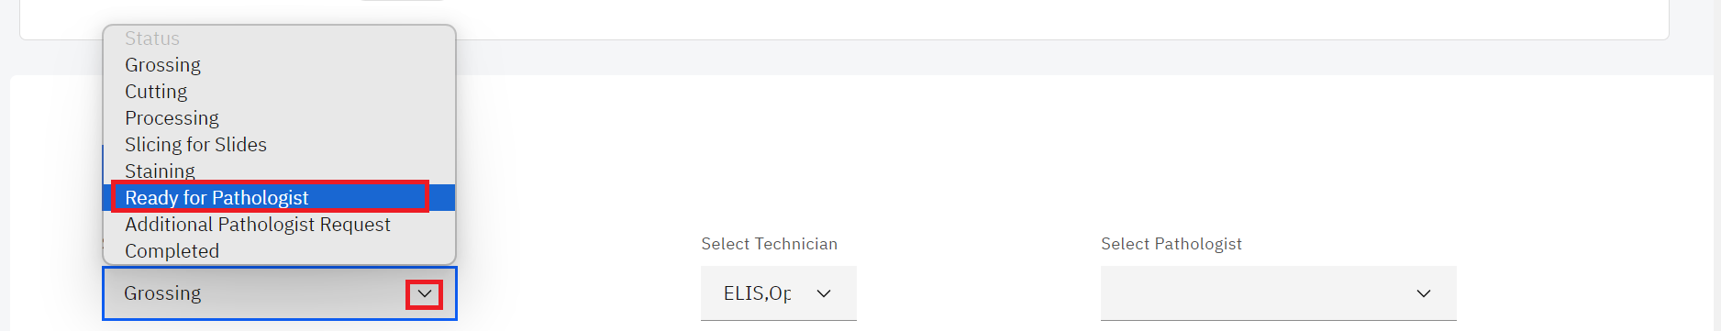

*Status: Ready for Pathologist*

1. Click on the **Select Pathologis**t drop-down menu and select the pathologist and click on the **Save** button.

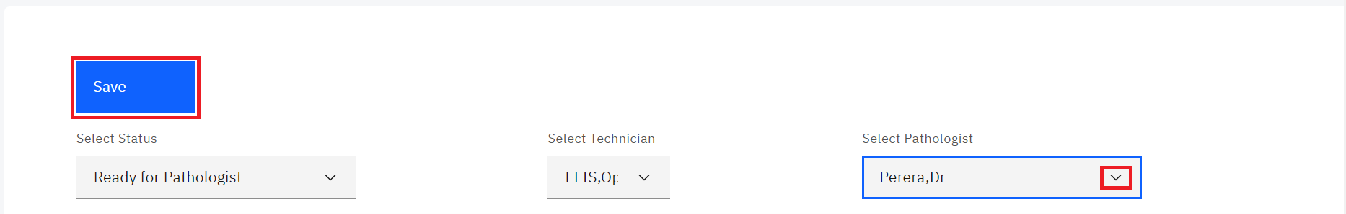

*Select Pathologist and Save*

## **How to review and conclude a pathology test.**

Once a case is ready for a pathology review and a pathologist has been selected, the pathologist can conduct a review through the following steps;

1. Click on drop-down menu item under the **Technique Used** section



*Technique Used*

1. Select the technique to be used by checking the checkbox for a technique.

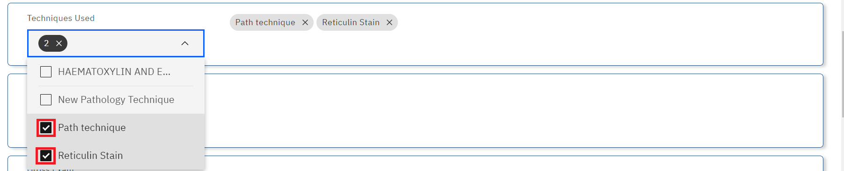

*Select Technique*

1. To remove a technique, click on **x** to cancel a technique.

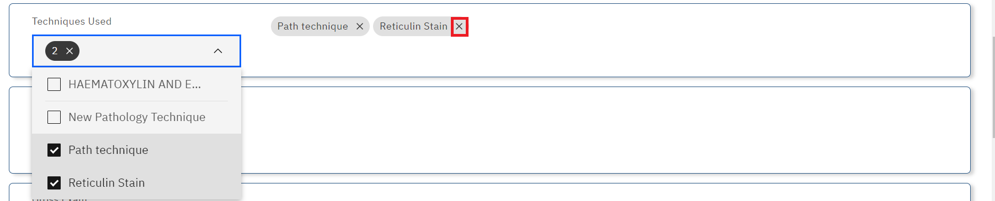

*Canceling a Technique*

Note: A pathologist can put in a request for the slides upon review

1. The pathologist will then click on the Requests drop-down menu.

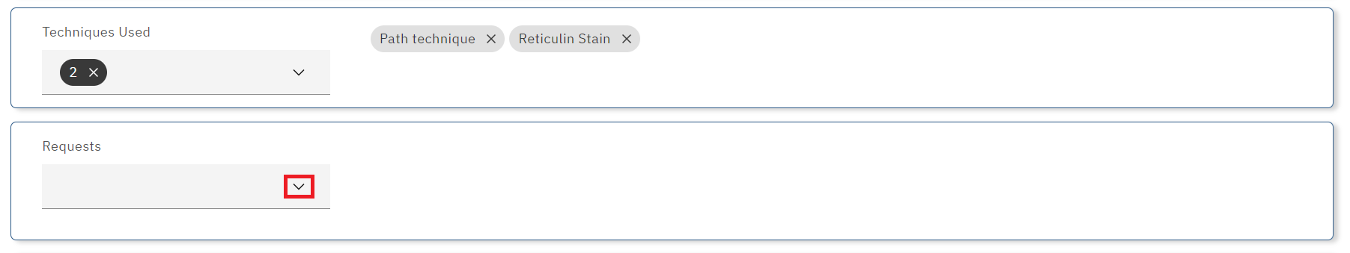

*Request drop-down menu*

1. The pathologist will select the respective checkboxes for the request. In this illustration, the pathologist has asked for the slides to be rotated and chose two stains.

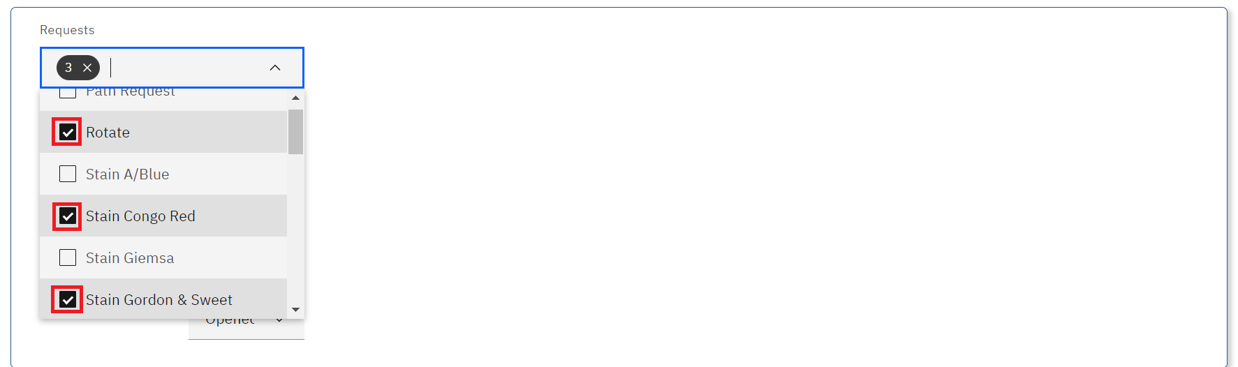

*Pathology Request*

**Note:** Once the requests have been placed, the status for the requests are opened by default.

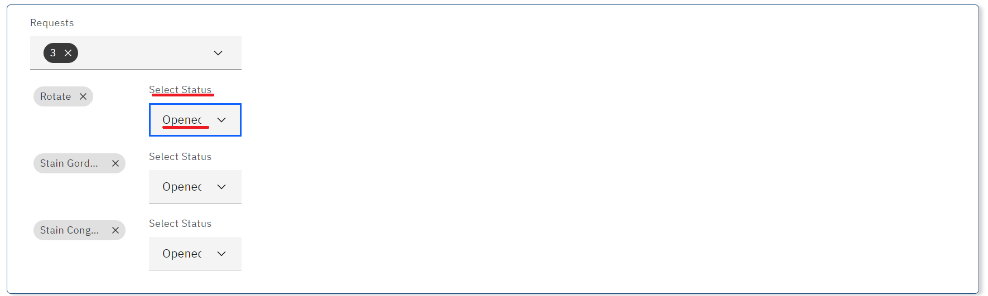

*Request Status*

1. Change the status for the slides to slicing by clicking on the status drop-down menu and selecting **slicing for slides** then click on the **Save** button.

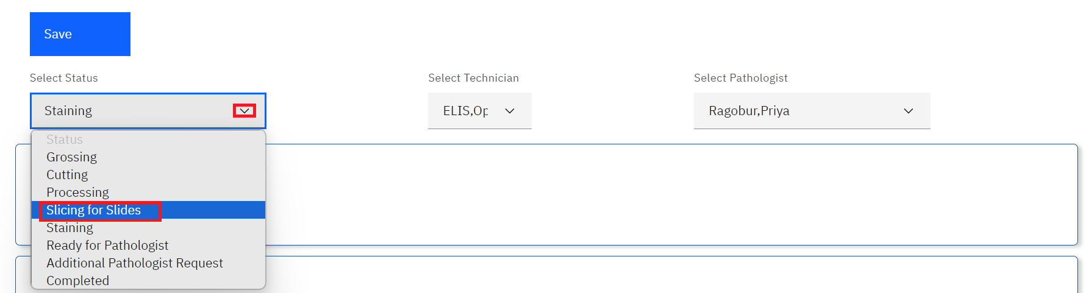

*Select Status and Save*

1. The pathologist will access the case, scroll down to the request section and click the status for the requests to **Completed**.

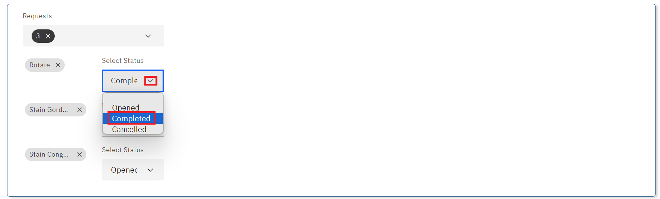

*Changing Request Status*

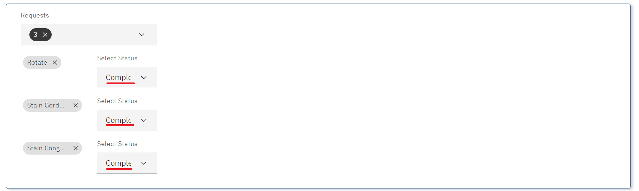

*Status Changed to Completed*

1. Once the status has been changed to completed, the slides are now ready for the pathologists to review the changes. Select **Ready for Pathology** and click on the **Save** button.

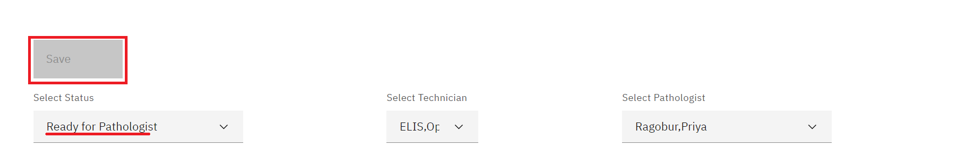

The pathologist can now write up the Gross and Microscopy Exam findings under the

1. Type in the findings for the **Gross Exam** and **Microscopy Exam** findings in the respective rich text boxes.

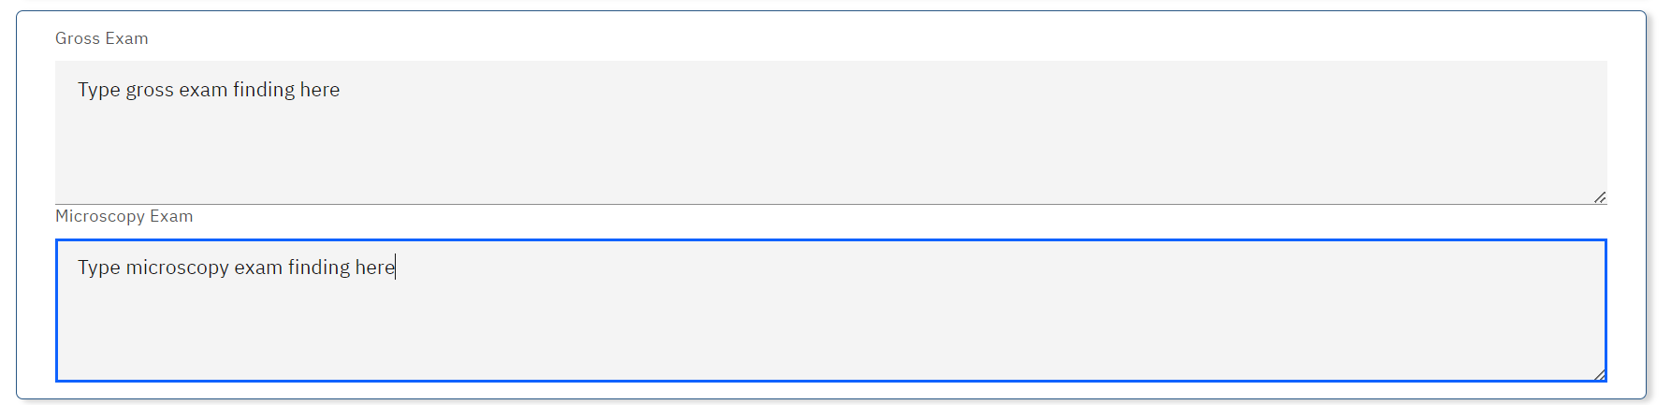

*Gross Exam and Microscopy Exam*

1. Select the conclusion from the drop-down menu by clicking on the drop down menu. The conclusions are hard coded in the system.
2. Click on a checkbox to select the respective conclusion.

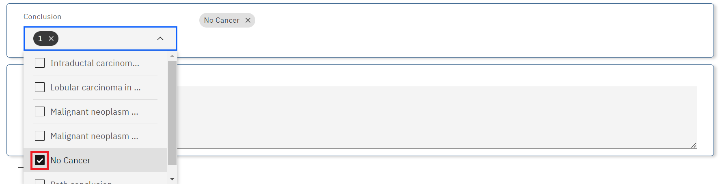

*Select Conclusion*

1. To remove a conclusion, click on the **x** icon to cancel the conclusion



*Remove a Conclusion*

1. Type the text conclusion under the **Text Conclusion** rich text box.

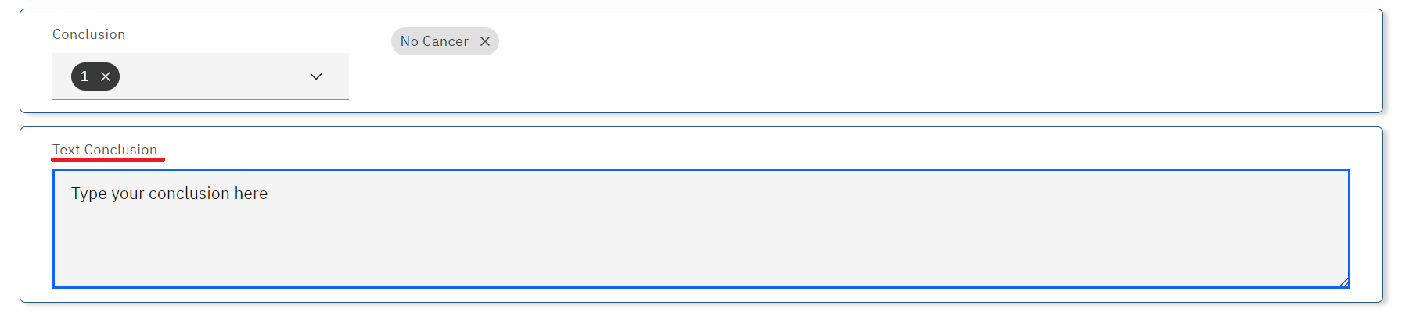

*Text Conclusion*

The results are now ready for release. The lab technician can add a report for the case by uploading the report or generating it from the system.

1. To add a report, click on the **Add Report** button under the report section.

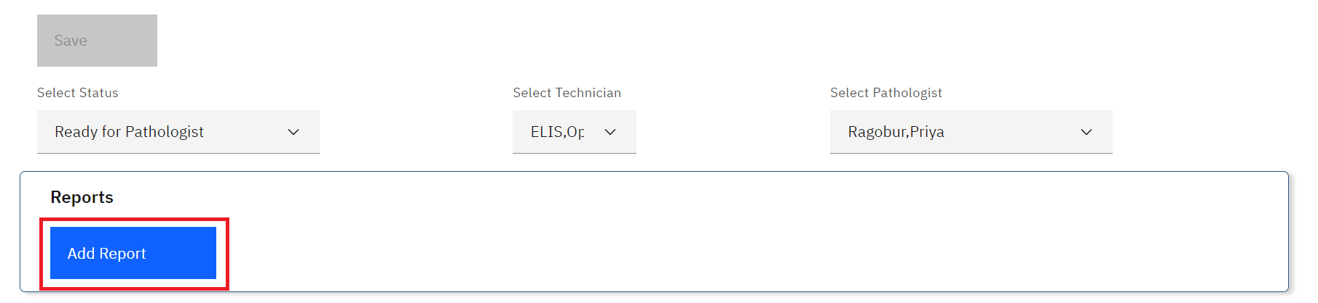

*Click on Add Report Button*

1. At this point, the lab technician can either upload a report or generate it from the system. To upload a report, click on the **Upload file** button.

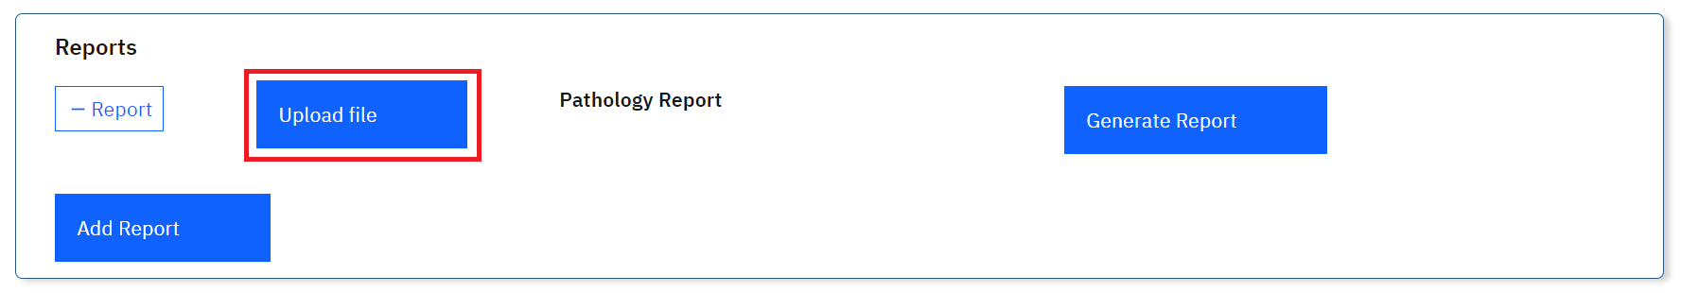

*Click on Upload file Button*

1. Upon clicking on the **Upload file** button, a file upload dialogue will be opened on your workstation. Navigate to the location where you have saved the report. In this illustration, the report file for patient **Casey** was saved under downloads. Click on the report to select it then click on the **Open** button.

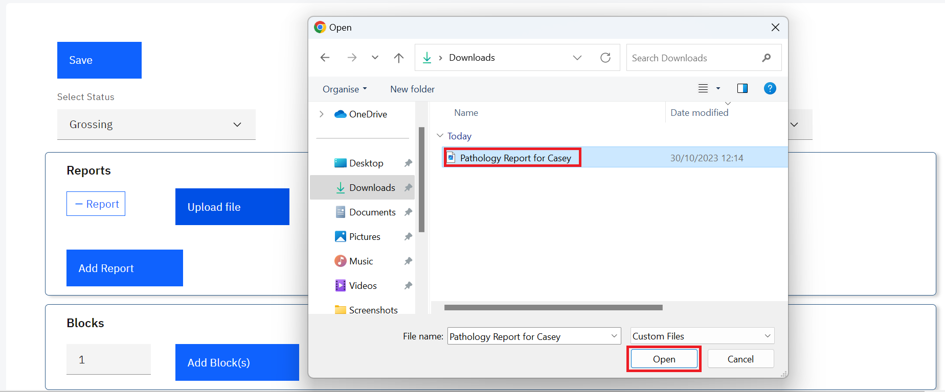

*Upload Report*

Note: upon clicking on the Open button, the report will be uploaded successfully.

1. To remove the report, click on the cancel icon **x.**

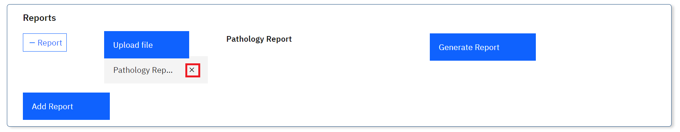

*Canceling an Uploaded Report*

1. To illustrate system generation of a report, click on the **Generate Report** button.

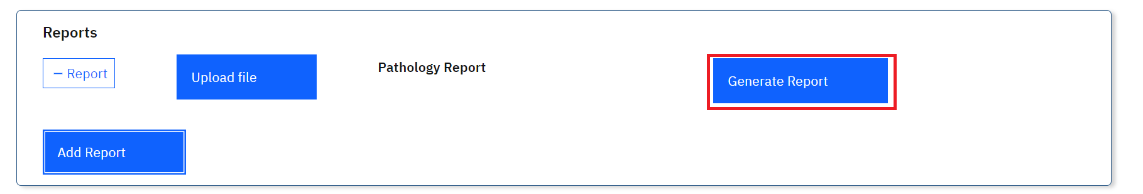

*Click on Generate Report*

A toast message will be displayed at the top right of the screen once the report is generated.

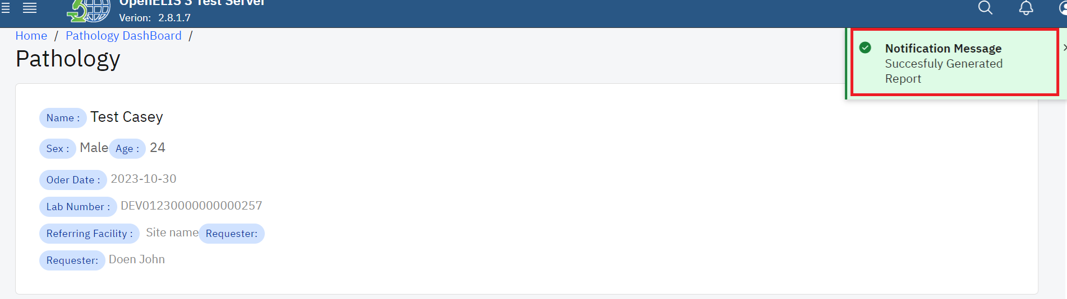

*Successfully Generated Report*

1. The pathology case can now be released. Click on the Ready for Release checkbox

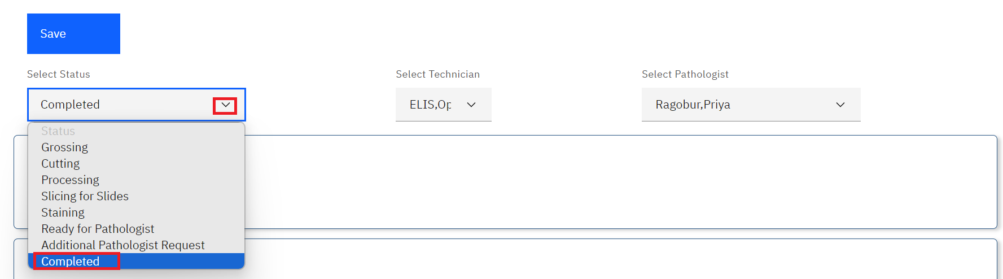

*Select Completed Status*

1. Click on the **Save** button.

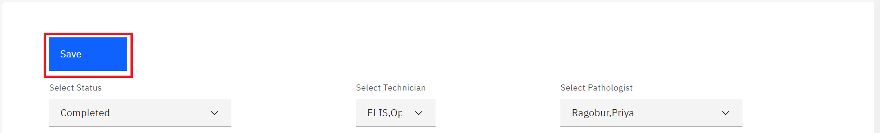

*Click on Save*

1. Scroll to the bottom of the page and click on the ready for release checkbox then click on the **Save** button.

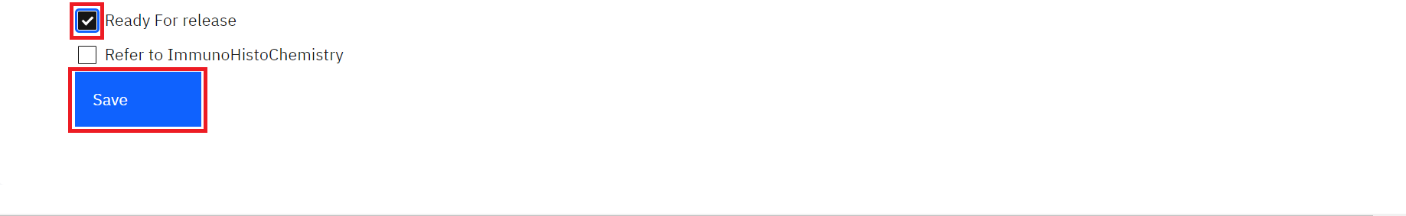

*Click on Ready For Release Checkbox and Save Button*

The pathology case for the patient will be listed as completed under the dashboard.

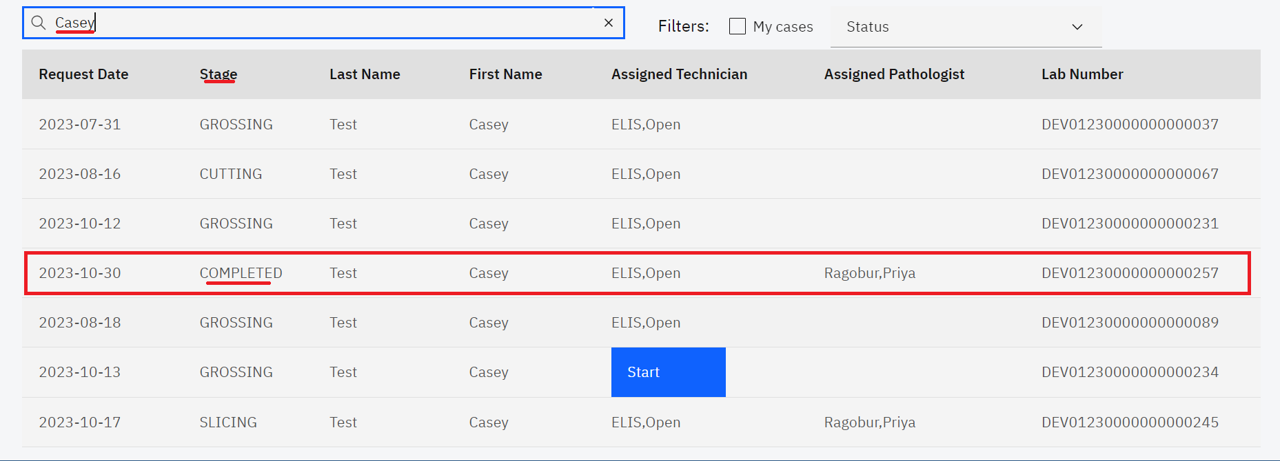

*Pathology Case Completed*

## **How to refer a pathology specimen to immunochemistry.**

1. A pathology case can be referred to immunochemistry for further test. To refer to a pathology test for immunochemistry, click on **Refer to** **ImmunoHistoChemistry** checkbox then click on the Select Test drop-down menu and select a test.

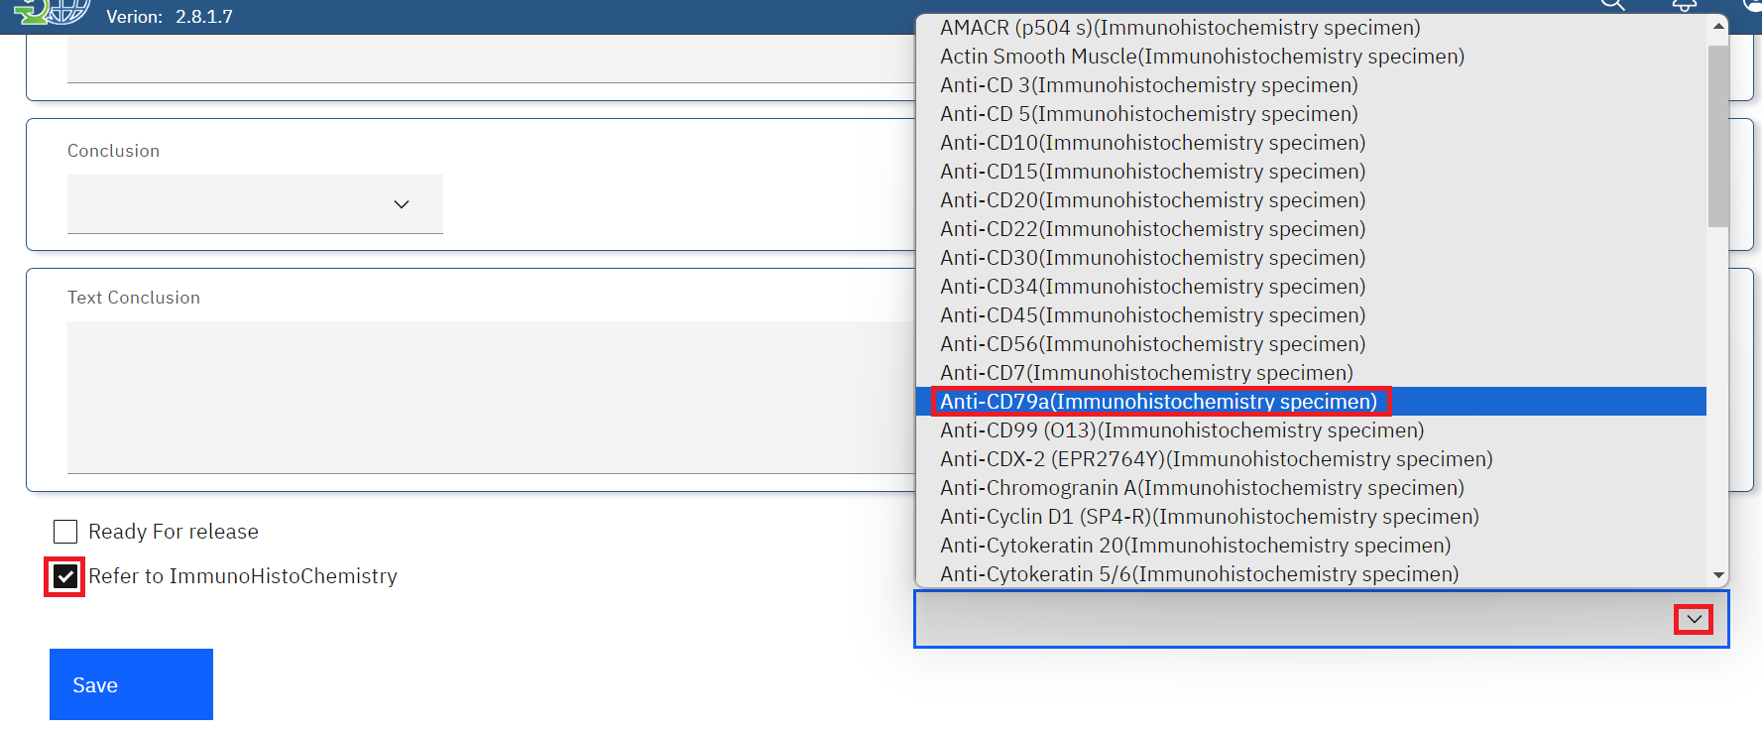

*Refer to ImmunoHistoChemistry*

1. Click on the **Save** button.

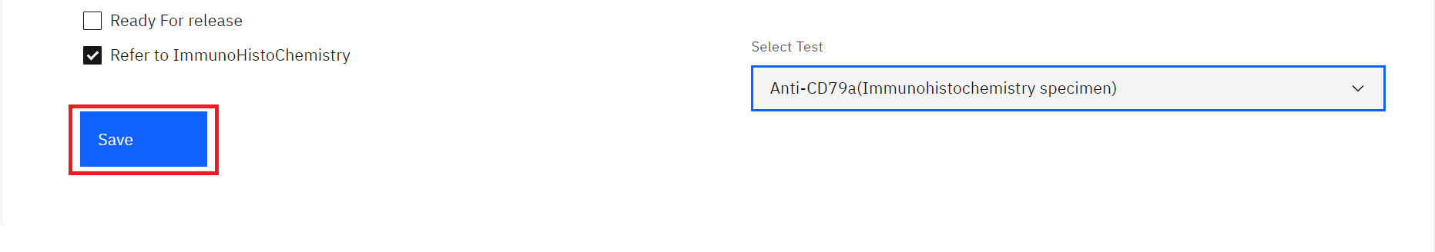

*Click Save*

## **How to upload or generate a pathology report.**

1. Follow steps 1 -3 under How a pathology specimen is processed by a laboratory technician.
2. Click on the desired patient under the dashboard. In this illustration, a patient by the name **Roger Rabbit**  is clicked.

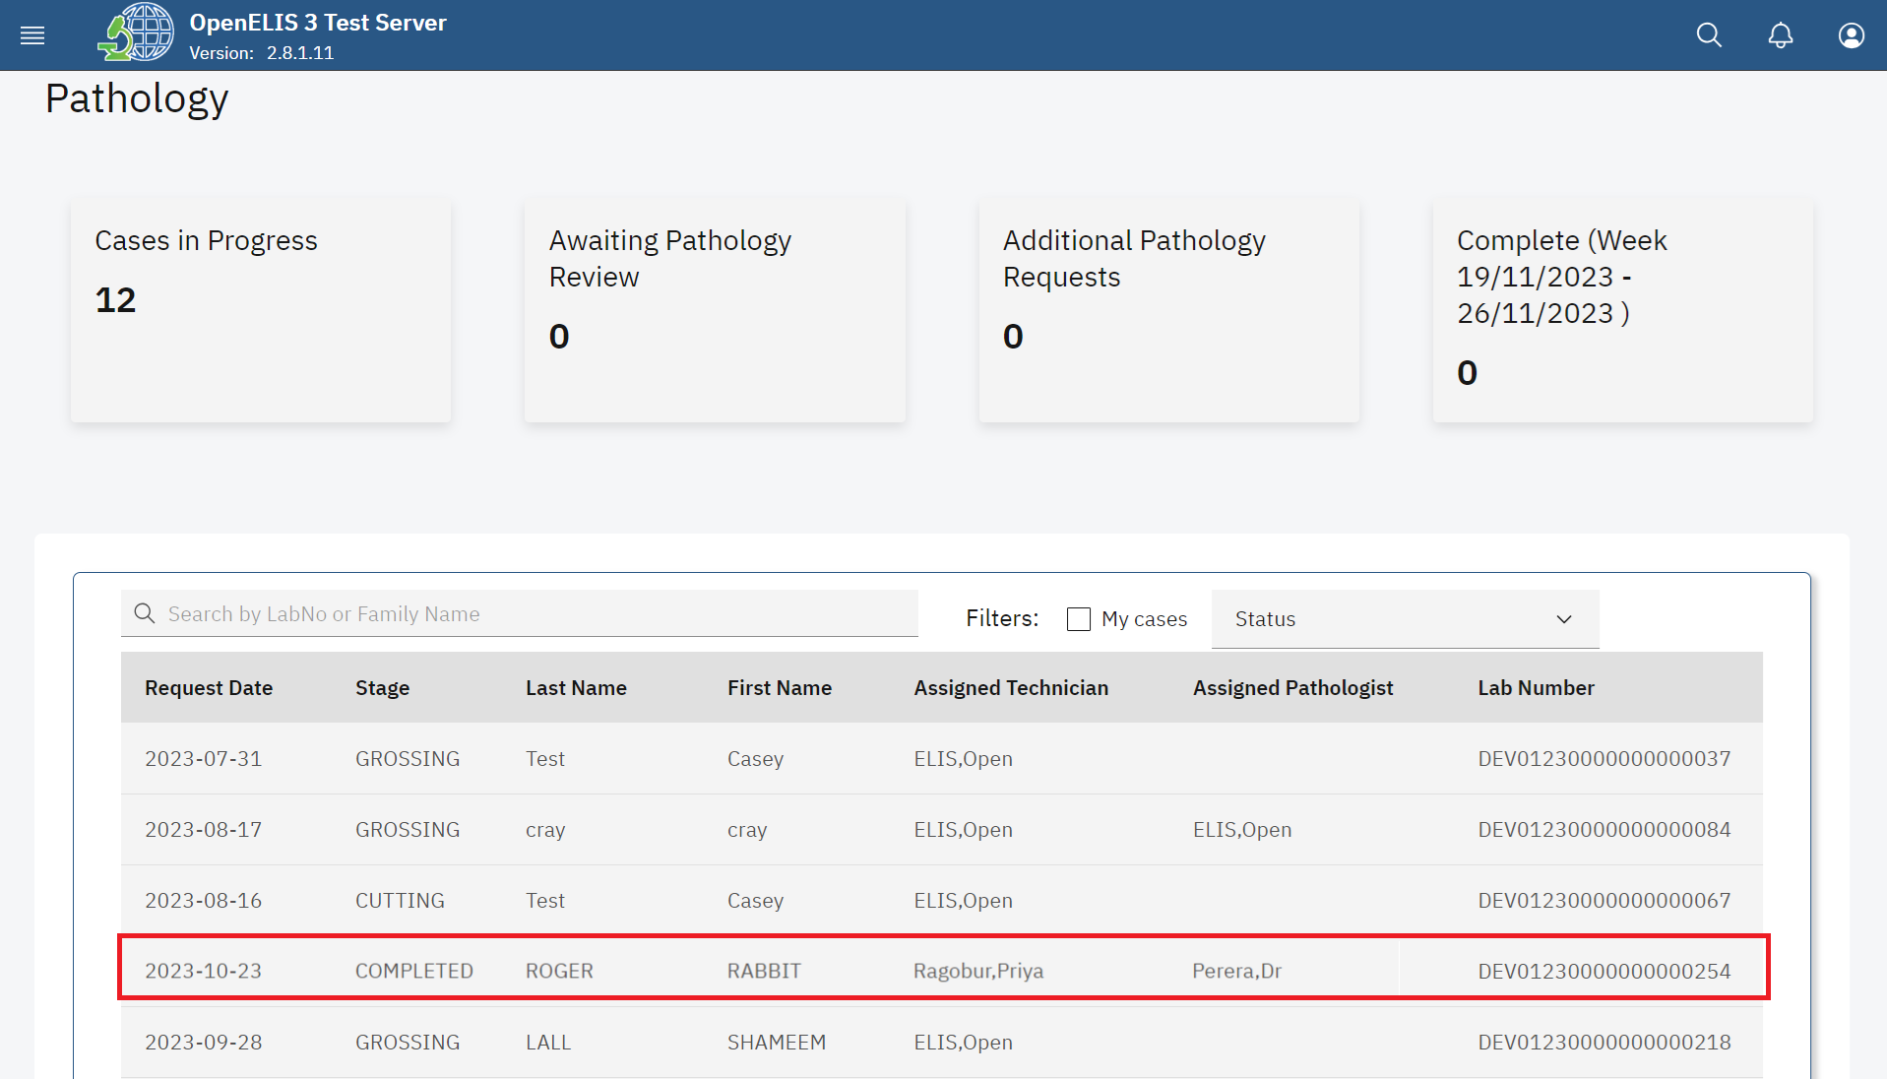

*Click on Patient*

1. Click on the **Add** **Report** button.

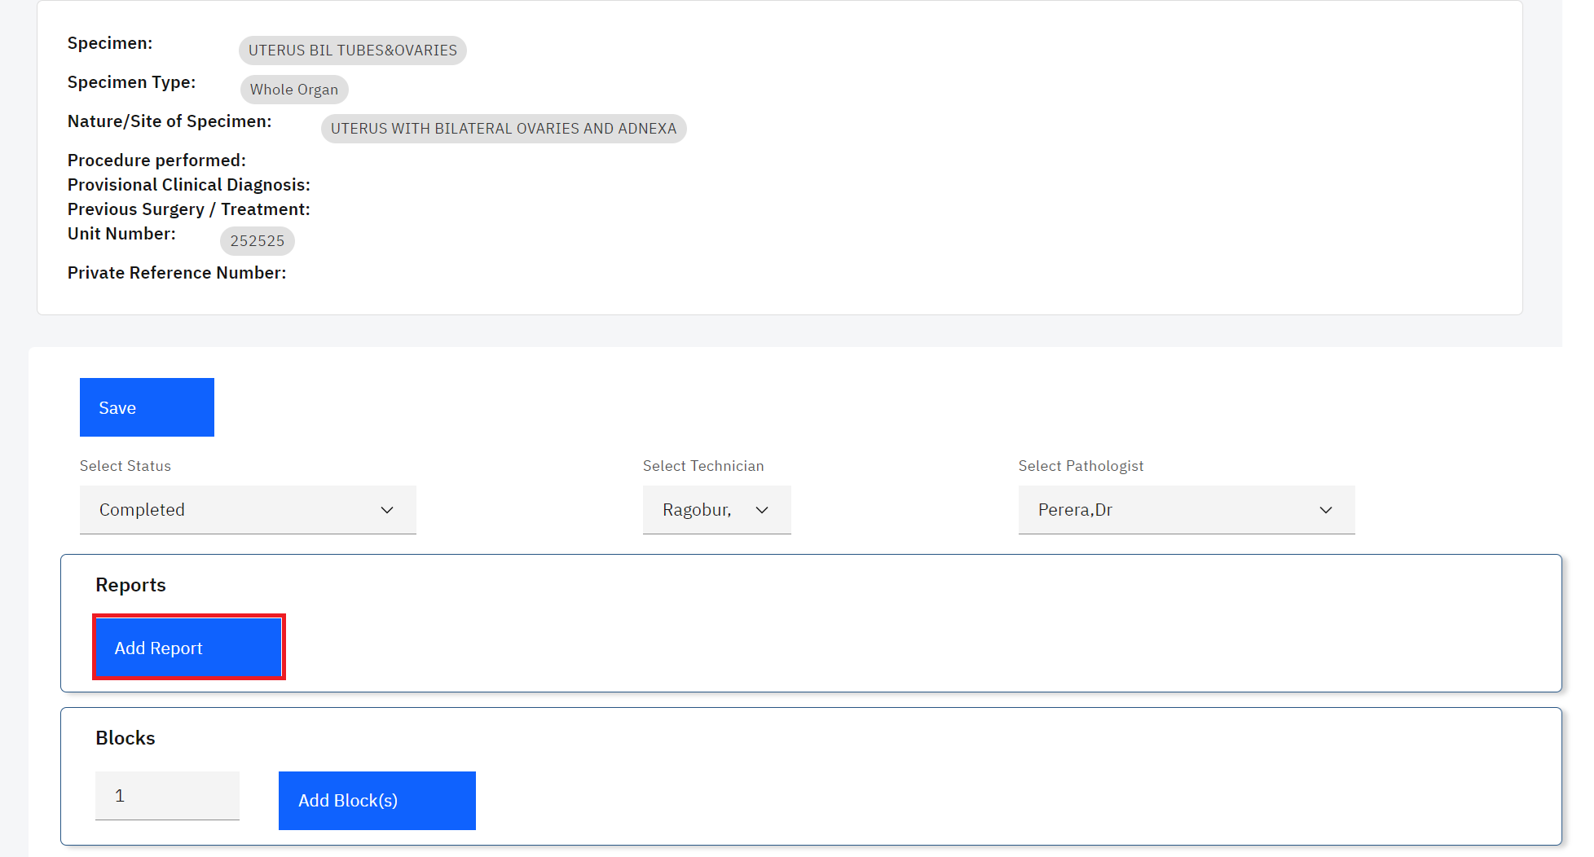

*Click Add Report*

1. Upon clicking on the add report button, you can either upload or generate a report. To upload a report, click on the Upload file button.

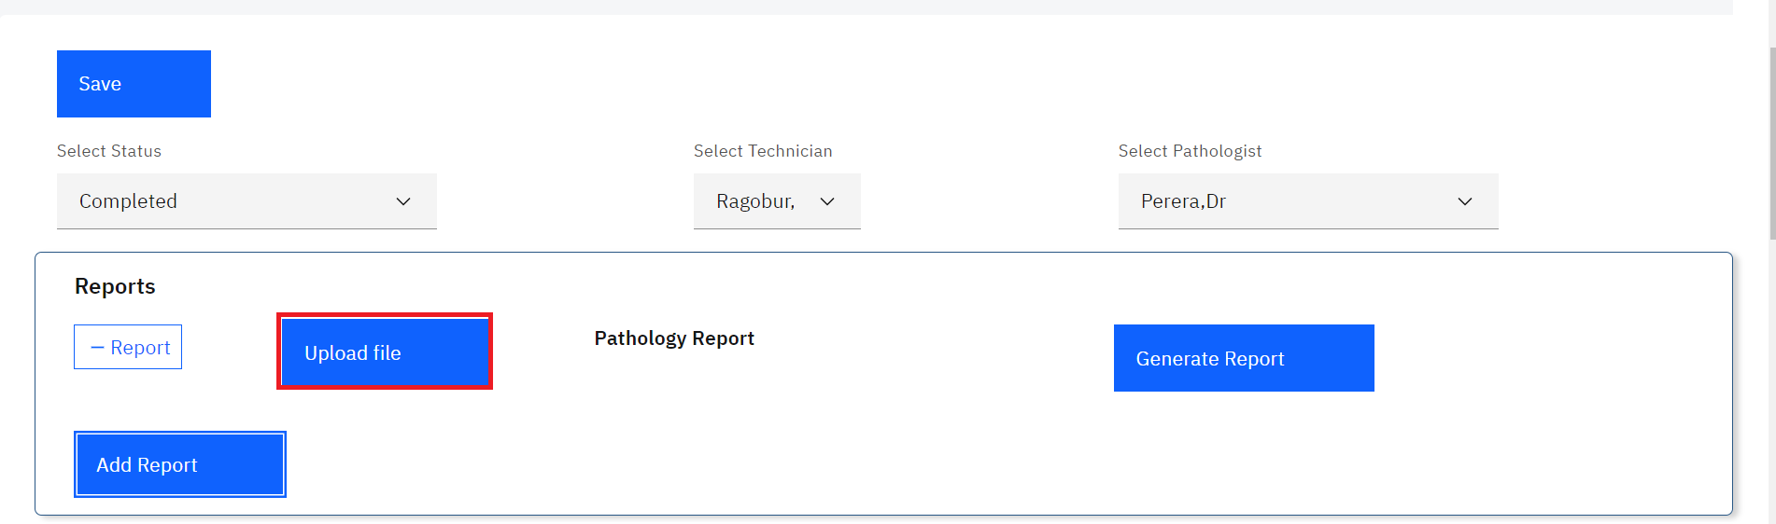

*Click Upload File*

1. Upon clicking on the **Upload file** button, a file upload dialogue will be opened on your workstation. Navigate to the location where you have saved the report for Cytology. In this illustration, the report file for patient **Roger Rabbit** was saved under downloads. Click on the report to select it then click on the **Open** button.

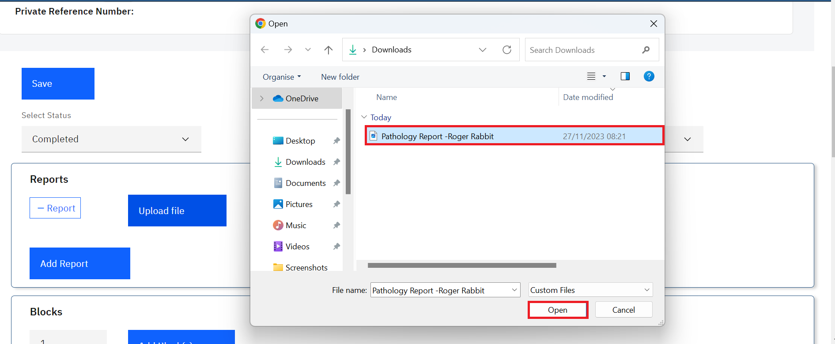

*Upload Report*

Note: upon clicking on the Open button, the report will be uploaded successfully.

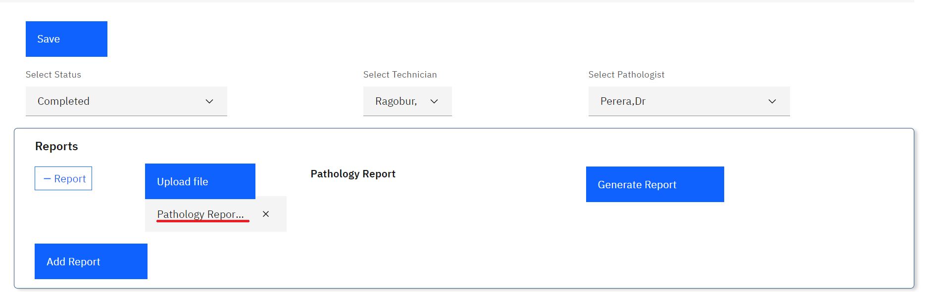

*Report Uploaded Successfully*

1. To remove the report, click on the cancel icon **x.** Otherwise, Click on the **Save** button at the bottom of the page**.**

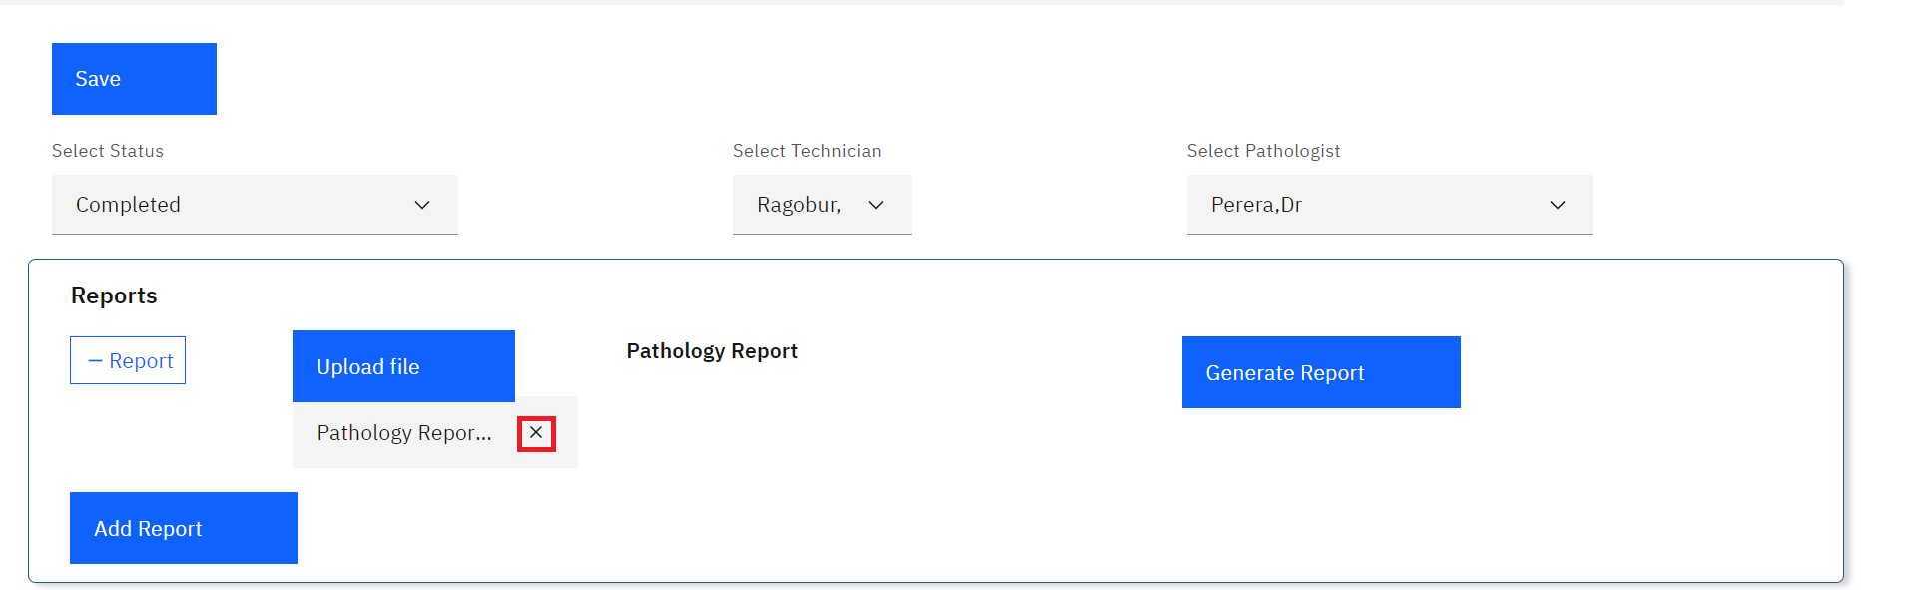

*Removing a Report*

1. As a user, you can generate a report from the system as opposed to uploading one. To do so, Click on the item to **Generate Report** button.

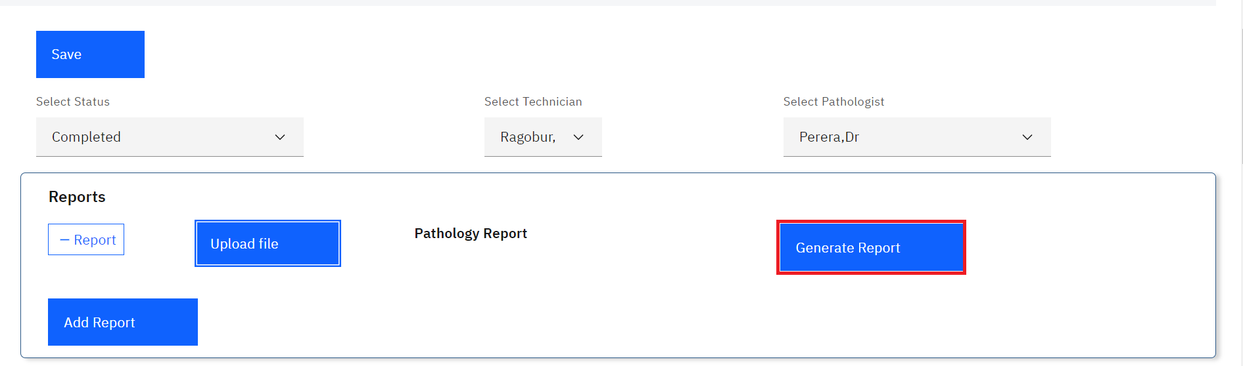

*Generate Report*

Note: a pdf containing the patient report will be generated successfully.

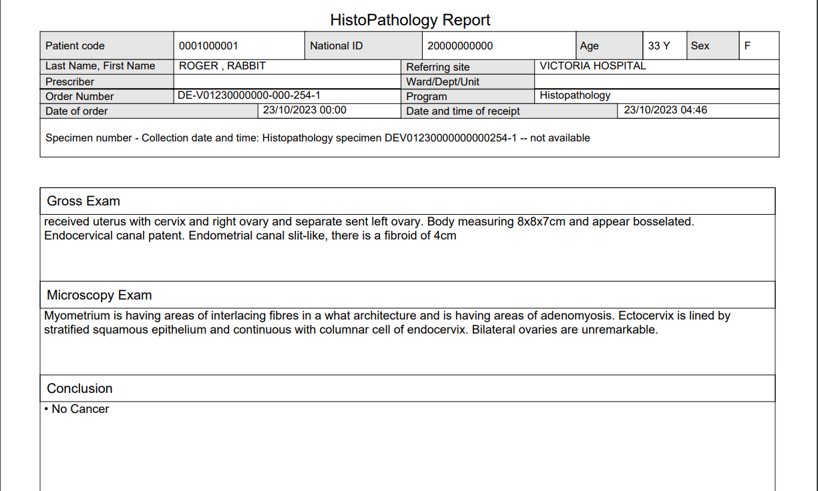

*Sample Pathology Report*

1. Click on the **Save** button.

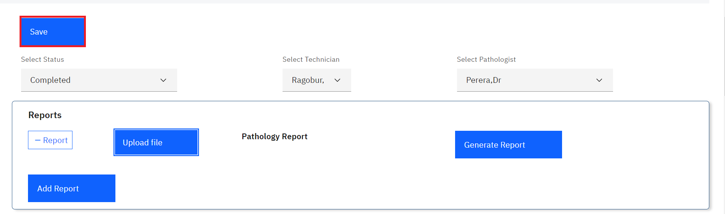

*Click Save*

# **PART 9: IMMUNOCHEMISTRY**

## **How to access the immunohistochemistry module and create an immunohistochemistry test.**

1. To access and create an immunohistochemistry test, follow steps 1 to 9 under How to create a laboratory analysis order for an existing patient.

**Note:** In this illustration, a patient by the name **John Doe** is used to capture an immunohistochemistry test request

1. Upon executing step 1, click on the **Program** drop-down menu.

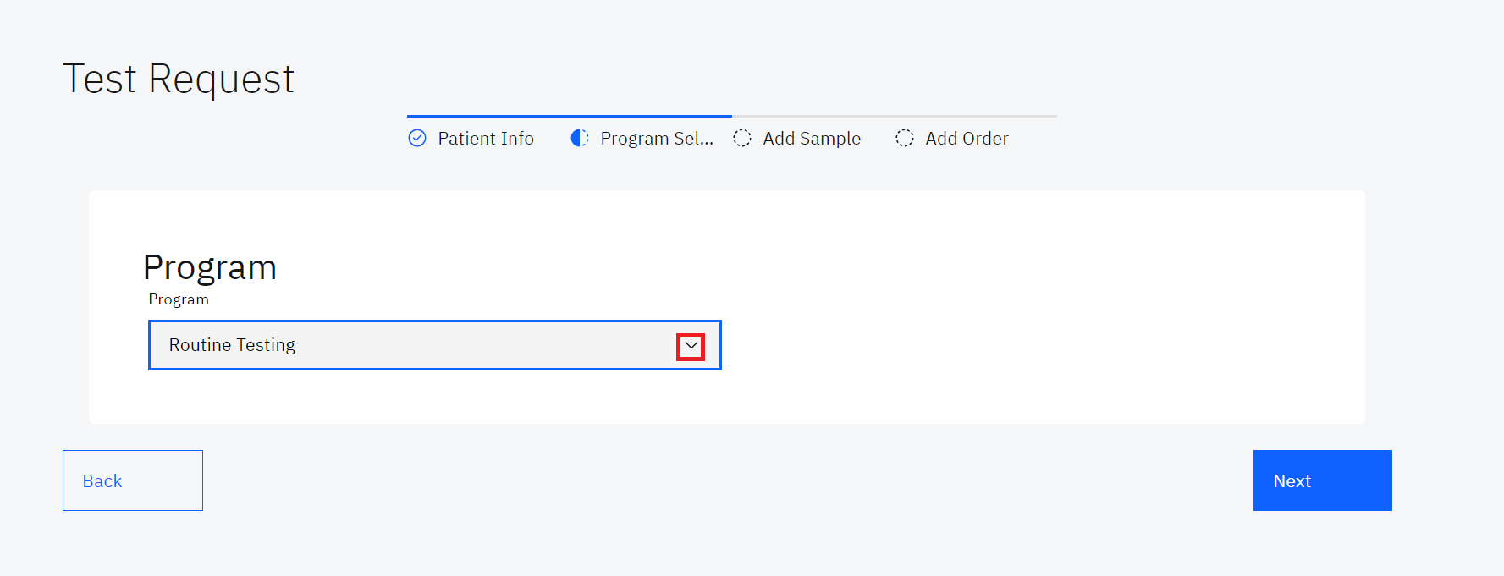

*Click on Program Drop-down Menu*

1. Click on **immunohistochemistry**  the drop-down menu.

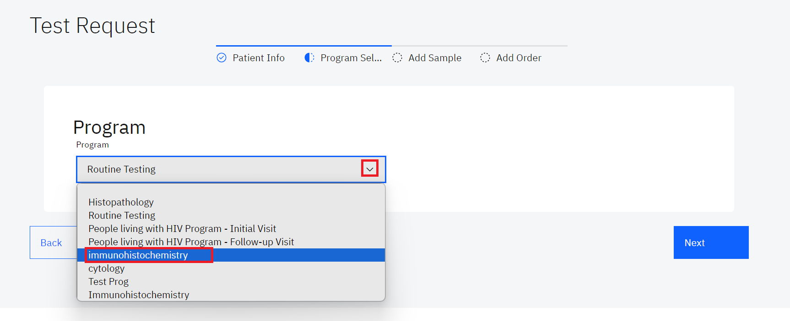

*Select Immunohistochemistry Program*

**Note:** Upon selecting the immunohistochemistry program, OpenELIS will automatically display a page for capturing the specimen details. Therefore, you do not need to click on the next button.

1. Immunohistochemistry is selected by default under the **Program** drop-down. Select an option under the drop-down menu for the fields; **Nature of Specimen**, **Site Specimen**, **Procedure performed**, **Provisional Clinical Diagnosis**, type the **Previous Surgery / Treatment** and click on the **Next** button

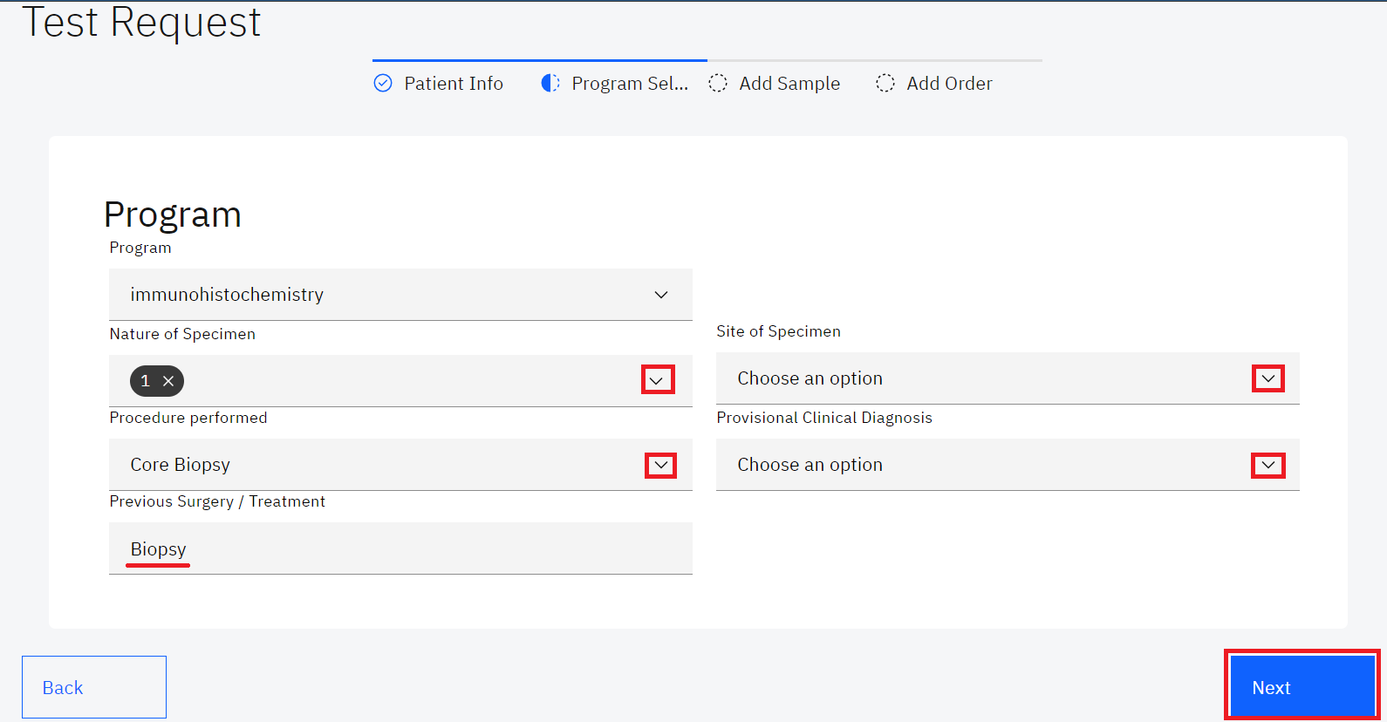

*Fill in Program Details*

1. Click on the Sample drop-down menu and select immunohistochemistry.

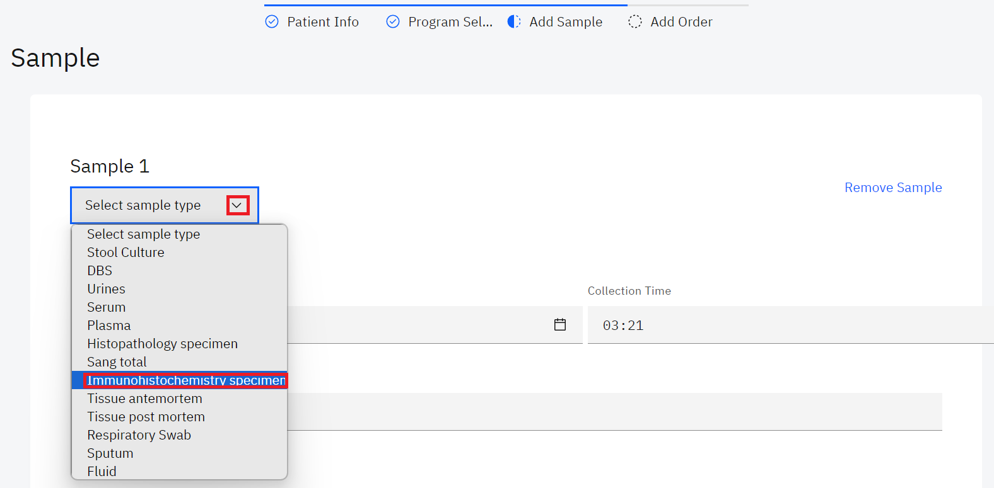

*Select Immunohistochemistry Sample*

1. The date and time are picked from the system. Fill in the **Collector** field, the Order Tests will be populated upon choosing the available immunohistochemistry test. In this illustration, the **AMACR(p 504 s)** and **anti-CD 3** are the selected tests.

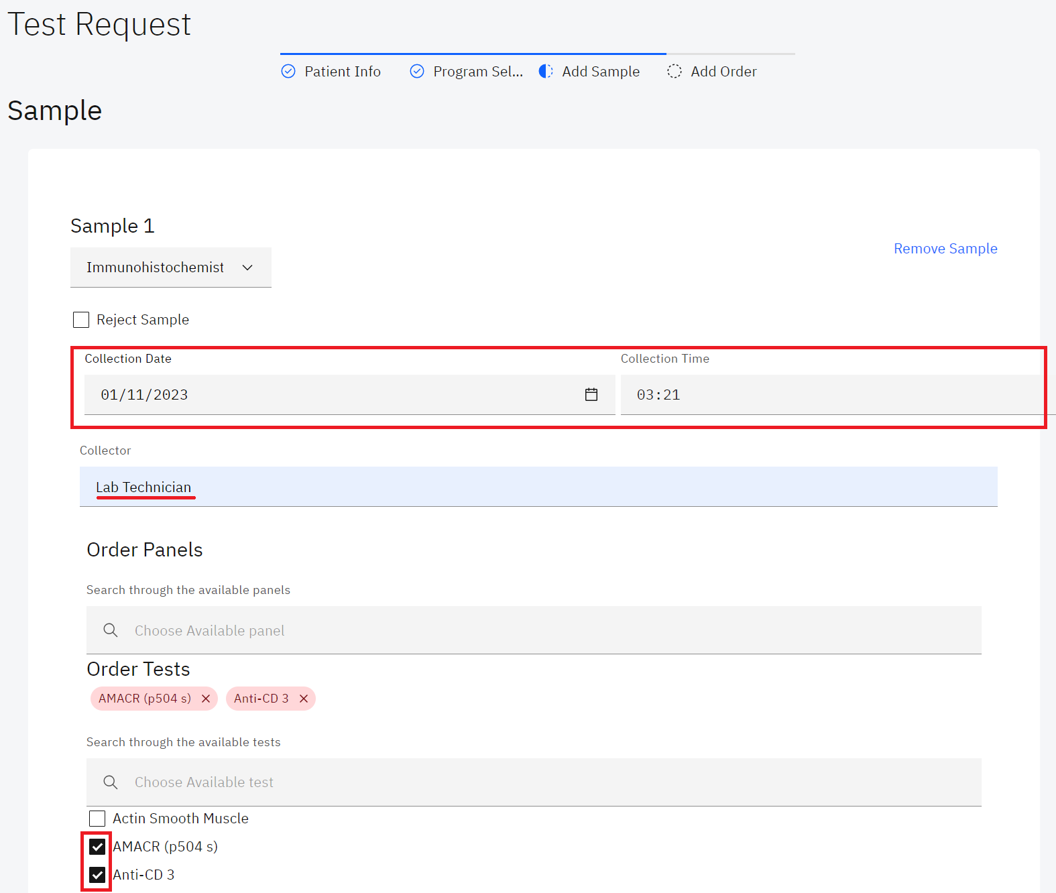

*Fill in Immunohistochemistry Sample Details*

1. To remove an ordered immunohistochemistry test, click the cancel (**x)** icon on the test

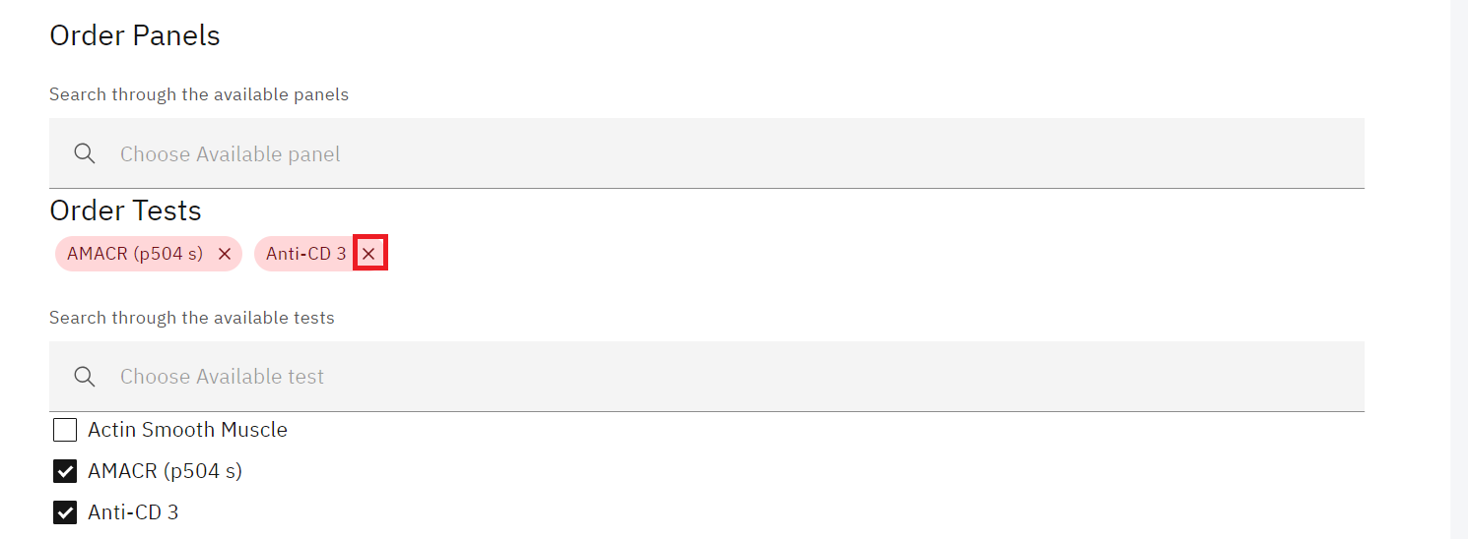

*Removing an Ordered Test*

**Note:** An immunohistochemistry test can be referred to a reference lab by clicking on the **Refer test to a reference lab** checkbox and selecting the **Reason for referral**, **Institute**, and **Sent Date** the **Test Name** is auto populated.

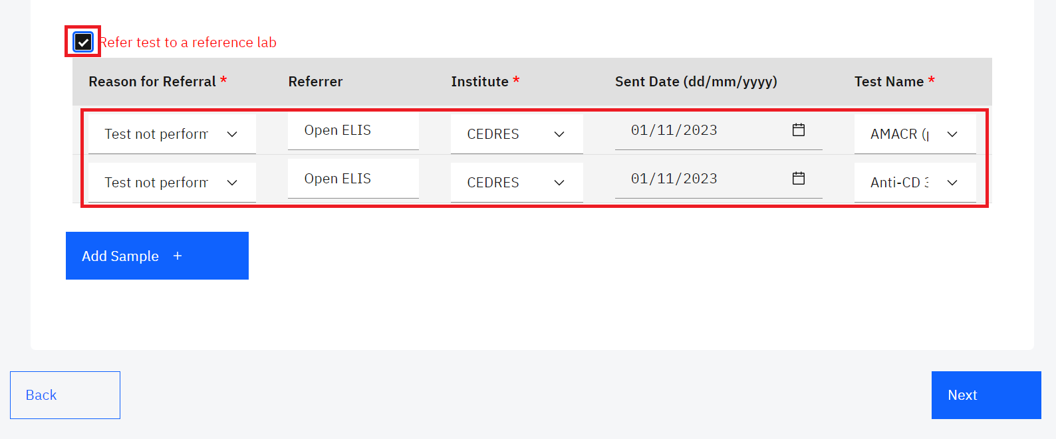

*Refer Test to a Reference Lab*

1. Click on the **Next** button.

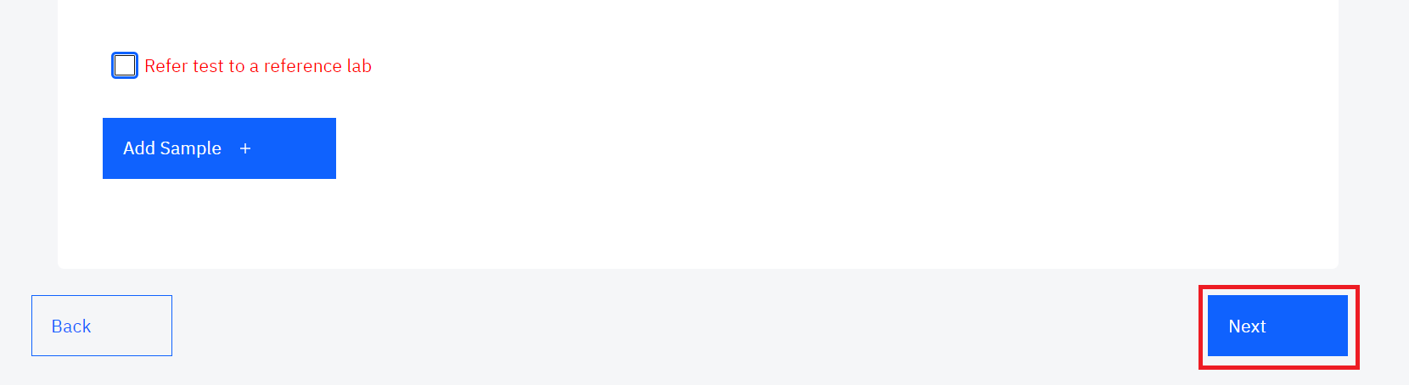

*Click Next*

1. Fill in the order section by Scanning or manually entering the lab number or by clicking on the **Lab Number** text link to generate the lab number. Select the **Priority** from the drop-down menu. Fill in the **Site name**  and the **requester's** details, select the **payment status** from the drop-down menu,select the **Sampling performed for analysis** from the drop-down menu and click on the **Submi**t button.

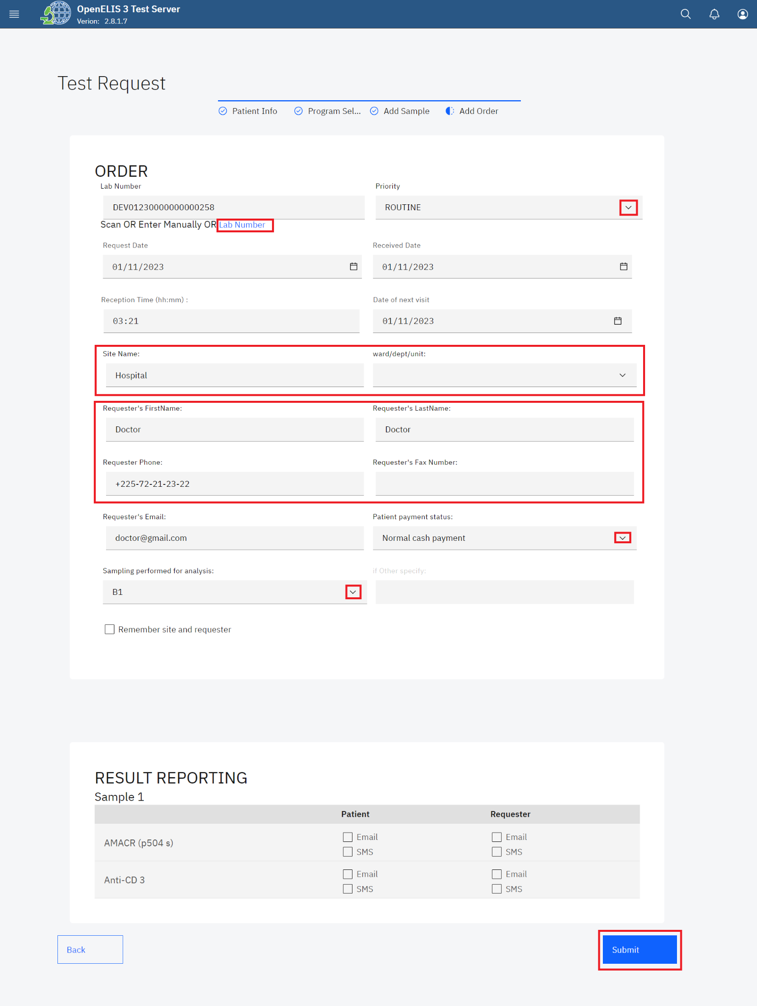

*Add Order*

1. Upon submitting the histopathology lab request, a **Save successful** message will be displayed. You can print the barcode for the test. To print the barcode, click on the print barcode button.

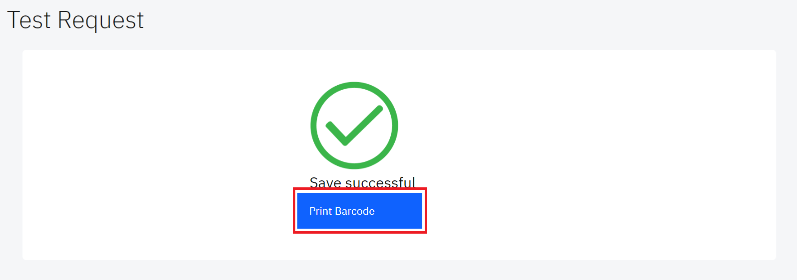

*Print Barcode*

1. You can download the barcode or print it by clicking on either the download icon or the print icon at the top right.

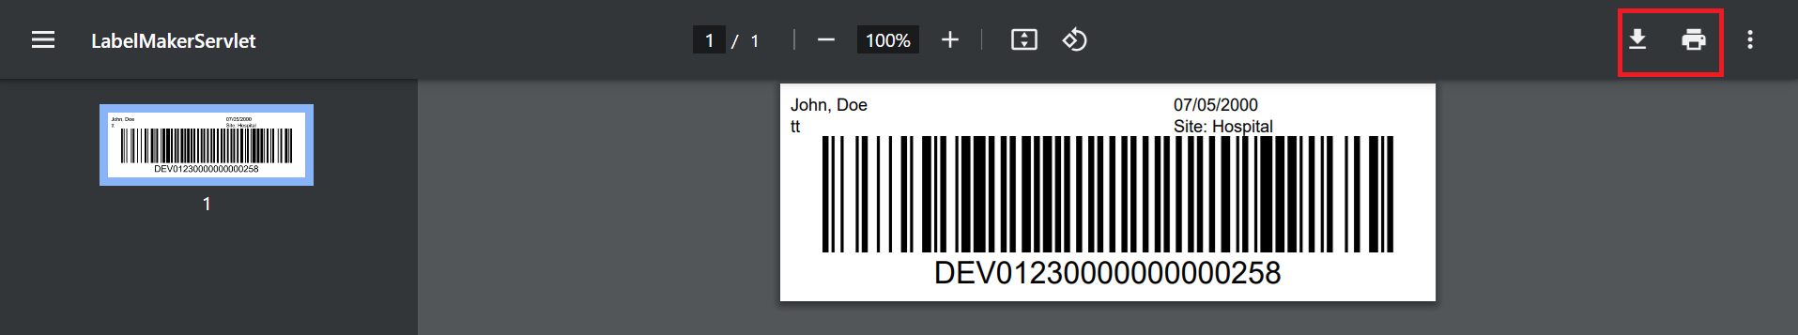

*Download or Print Barcode*

## **How to access and process an immunohistochemistry test.**

1. Hover the mouse over the hamburger icon and click to open the menu.



*Access the OpenELIS menu*

1. Hover the mouse and click on the drop-down menu under the ImmunoHistochemistry module

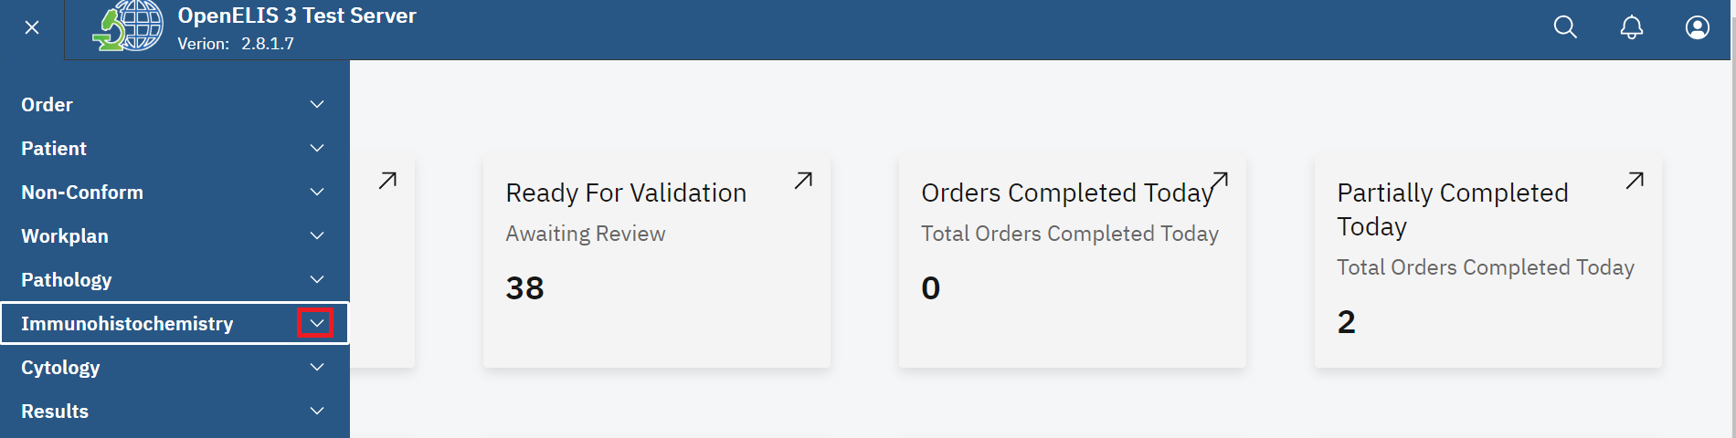

*Click on Immunohistochemistry Drop-down Menu*

1. Click on **Dashboard** sub-menu item.

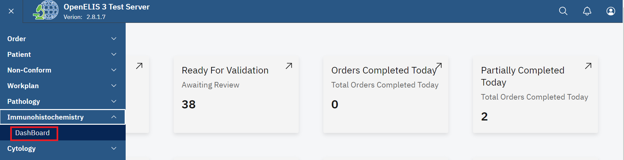

*Click on Dashboard*

The dashboard provides summaries for **Cases in progress**, **Awaiting Pathology Review, Additional Pathology Request** and **Complete** test in a week

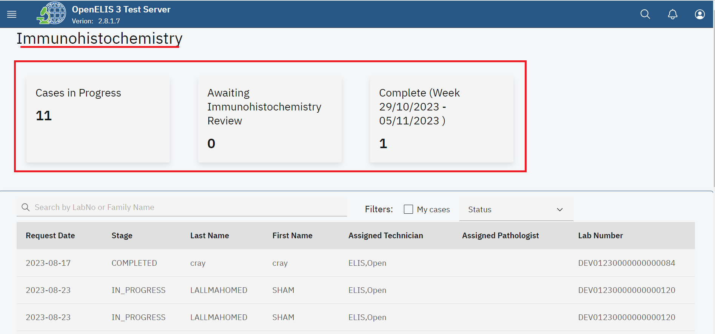

*Immunohistochemistry Dashboard*

All the immunohistochemistry test requests entered under **Add Order** (Test Request) are displayed under a table that displays the **Request Date**, **Stage**, **Last Name**, **Assigned Technician**, **Assigned Pathologist** and **Lab Number**.

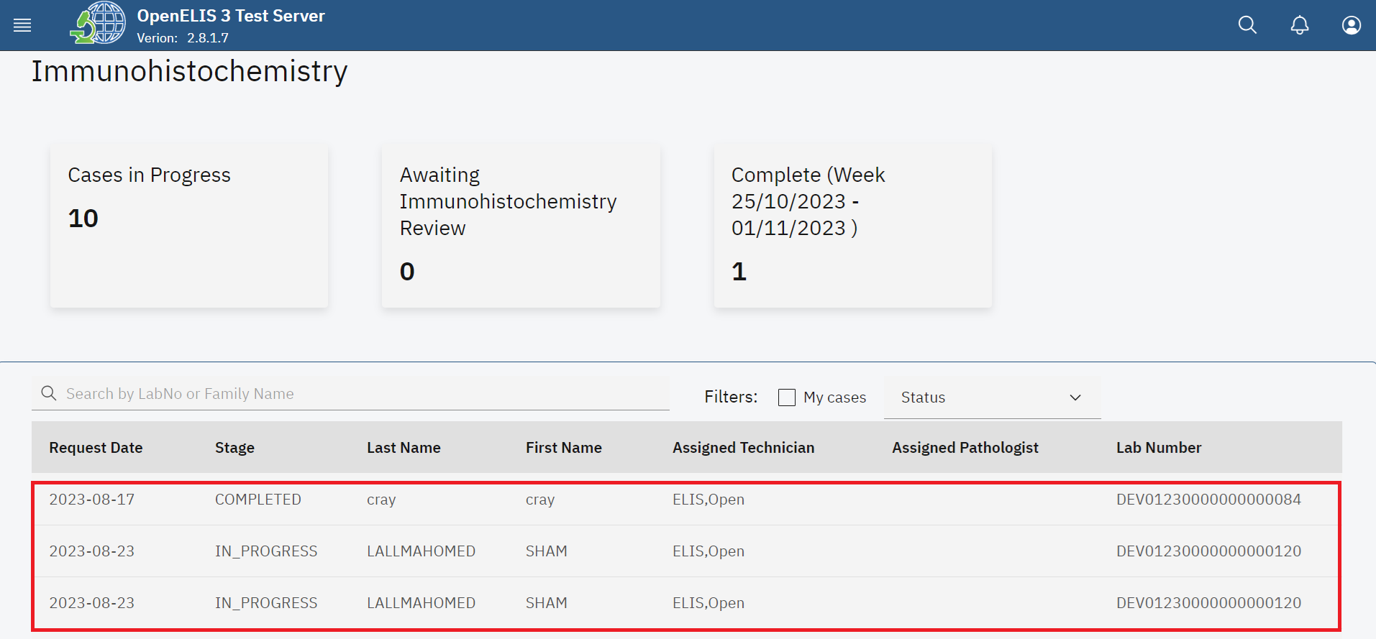

*Immunohistochemistry Requests*

1. The immunohistochemistry module allows you to filter the test request . Click on the My cases checkbox to filter the cases.

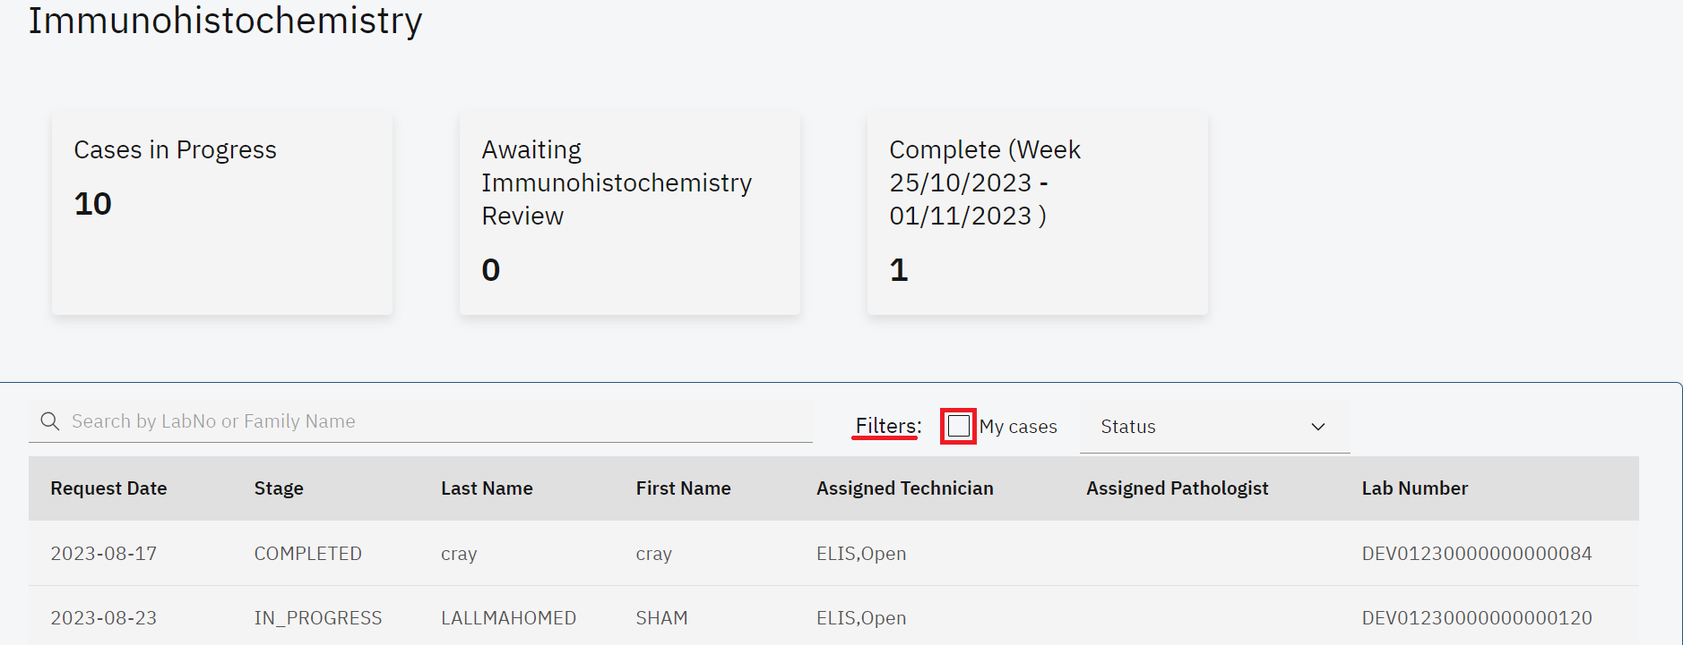

*Filter immunohistochemistry Cases*

1. The Status dropdown menu is used to filter the immunohistochemistry cases by their status. The status can be displayed as **All**, **In Progress**, **Ready for Patholog**y and **Completed.**

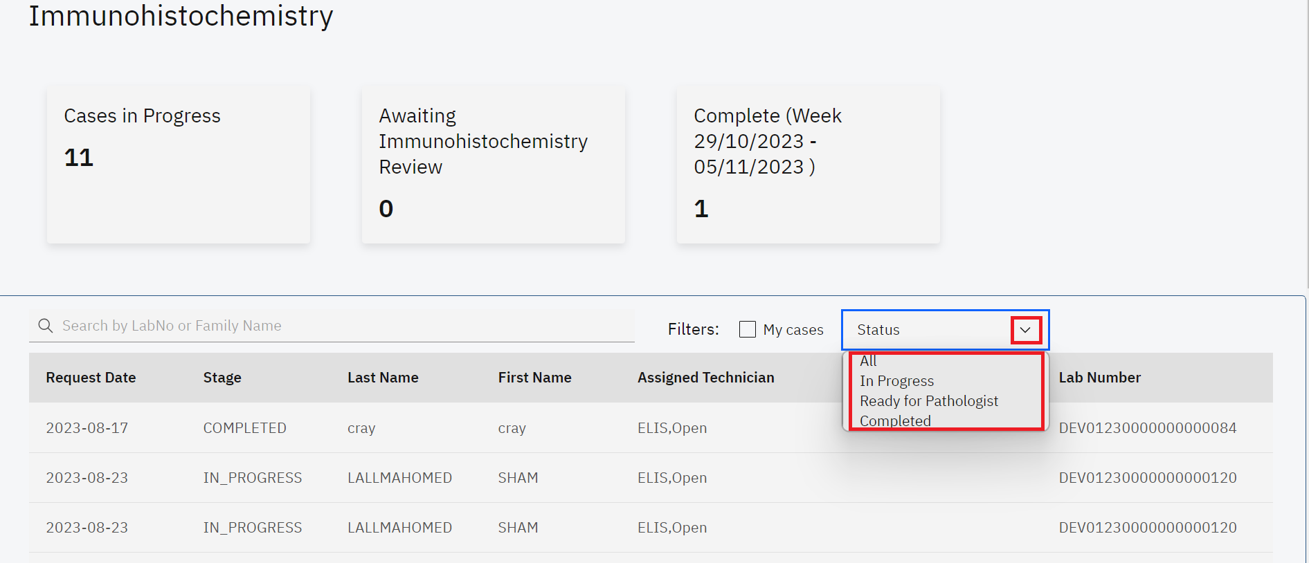

*Status*

1. You can filter the requests in an ascending or descending order for each menu item For instance, click on the **Lab Number** menu item.

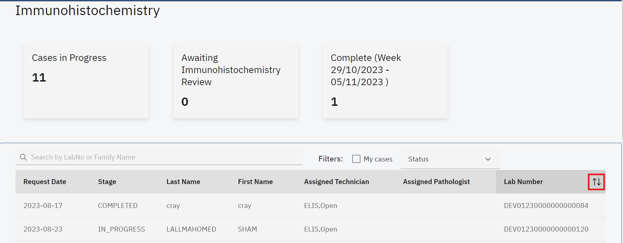

*Filter Request by Ascending or Descending Order*

1. To search for a pathology test, enter the patient name or the lab number under the **Search by LabNo or Family Name** text field. The search results will retort a list of matching patients.The cancel icon **(x)** is used to cancel the search.
2. Click on the desired patient from the search result. In this illustration, the **start** button is clicked.

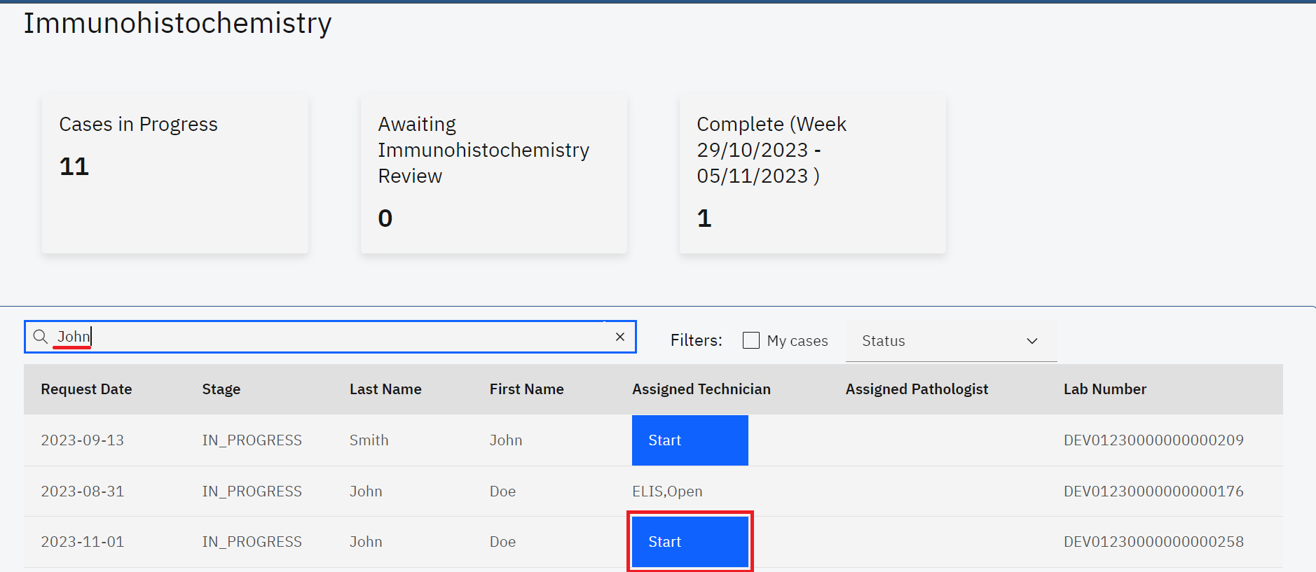

*Search Patient*

**Note**: The top sections of the **Immunohistochemistry** page displays information about the immunohistochemistry case.

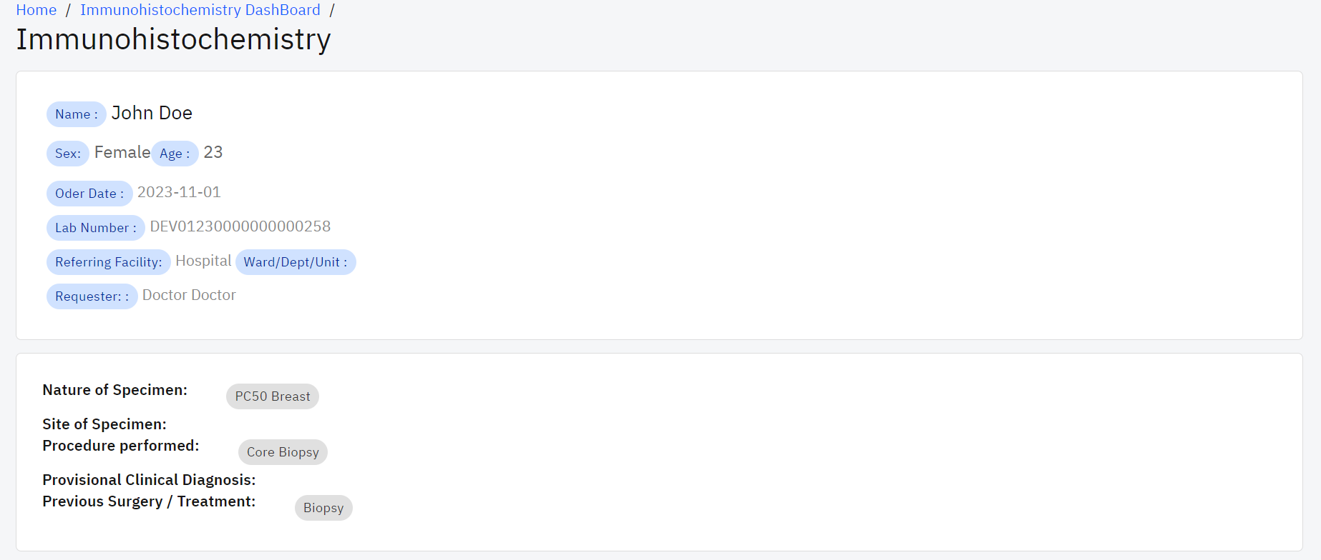

*Immunohistochemistry Test Information*

**Note:** There is a sequence of stages in immunohistochemistry examination. The **Status** drop-down menu provides a list of the different stages. The default stage is **processing**  of the test. The select technician drop down menu allows for the selection of the technician processing the test. This is role based. Anyone with the immunohistochemistry permission will be displayed under this drop-down menu. Similarly, the select pathologist allows for the selection of a pathologist with immunohistochemistry permission.

1. Click on these **select status** drop-down menu and select the status. In this illustration, In Progress is the default status.
2. Click on the **Select Technician** drop-down menu and select the technician.
3. Click on the **Save** button.

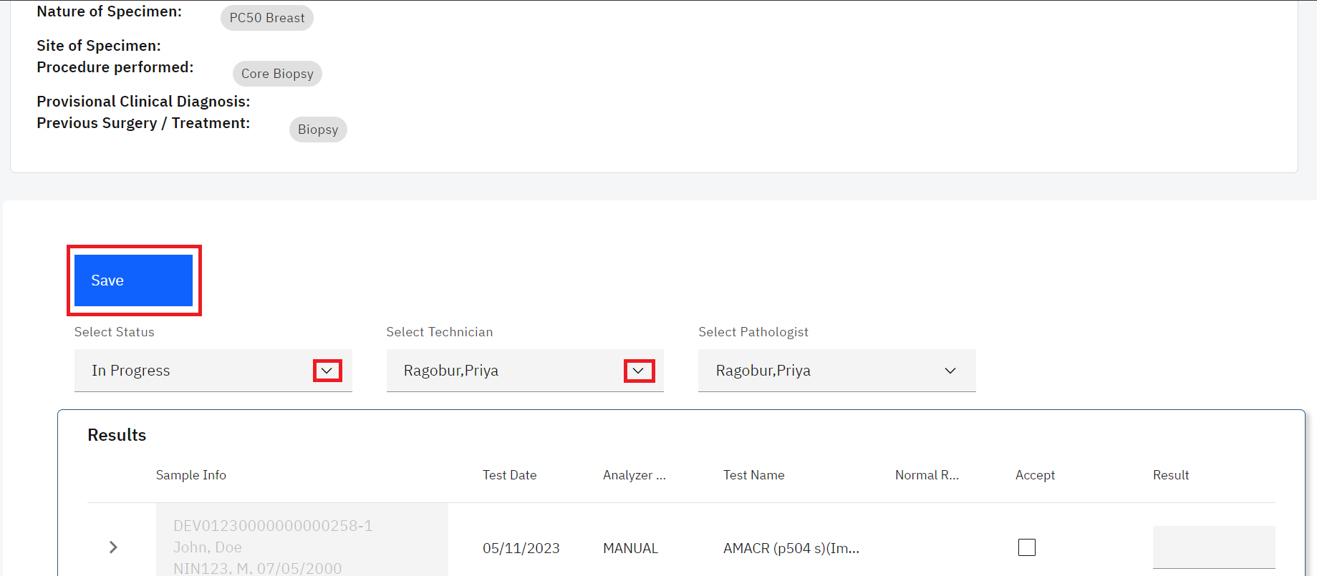

*Select Status, Technician and Save*

The results panel displays the results for the immunohistochemistry case in a table format. The table has the following results field; **Sample info**, **Test Date Analyzer Result**, **Test Name**, **Normal Range**, **Accept**, **Results**, **Current Results** and **Notes**.

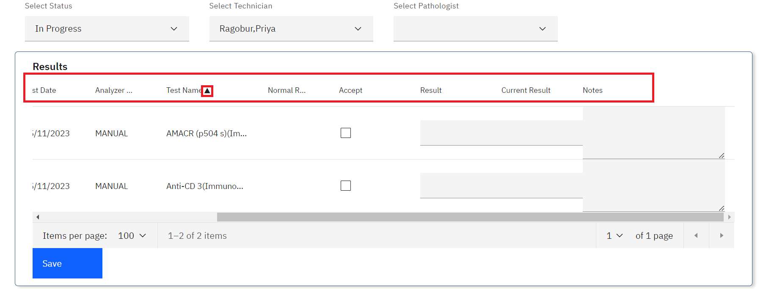

*Results*

1. The laboratory technician can accept the results for the test by checking the checkboxes
2. Upon checking the Accept checkbox, a pop-up with some information will appear. Read the information and click on the **Ok** button.

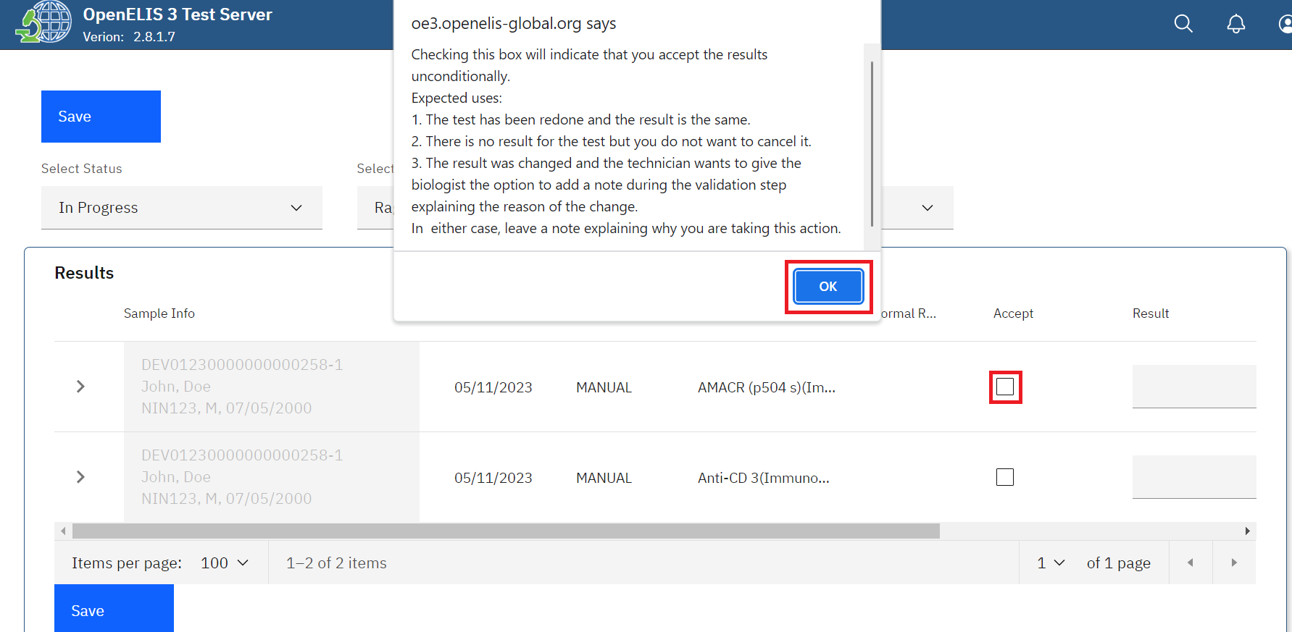

*Accept Results(s) and Click OK*

1. Fill in the Result and Notes text fields and click on the **Save** button under the **Results** section.

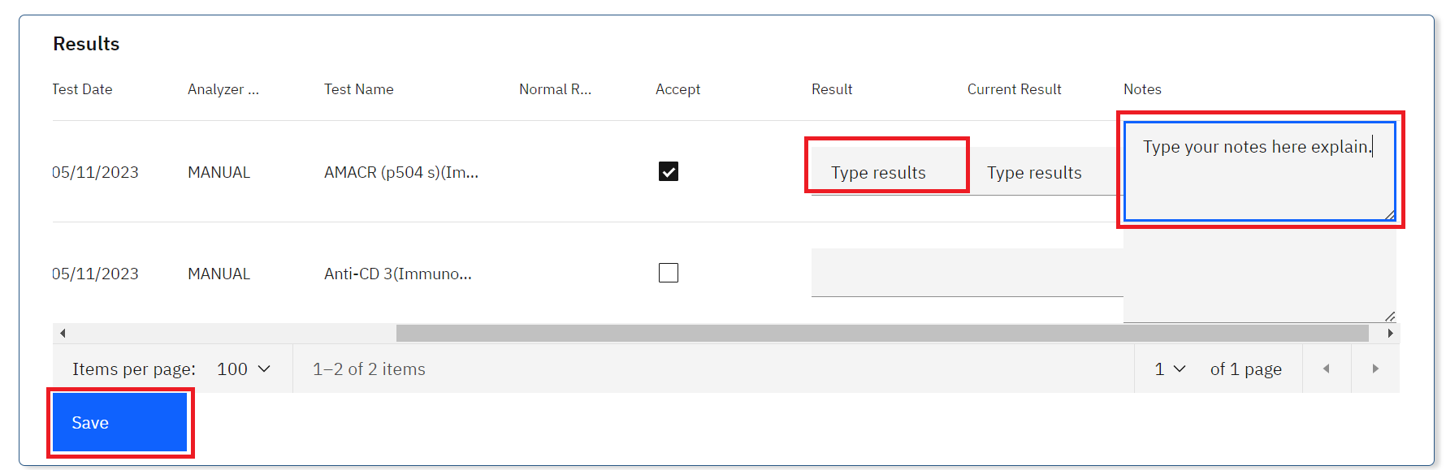

1. Select the **Ready for Pathology** status, select the pathologist under the and click on the **Save** button

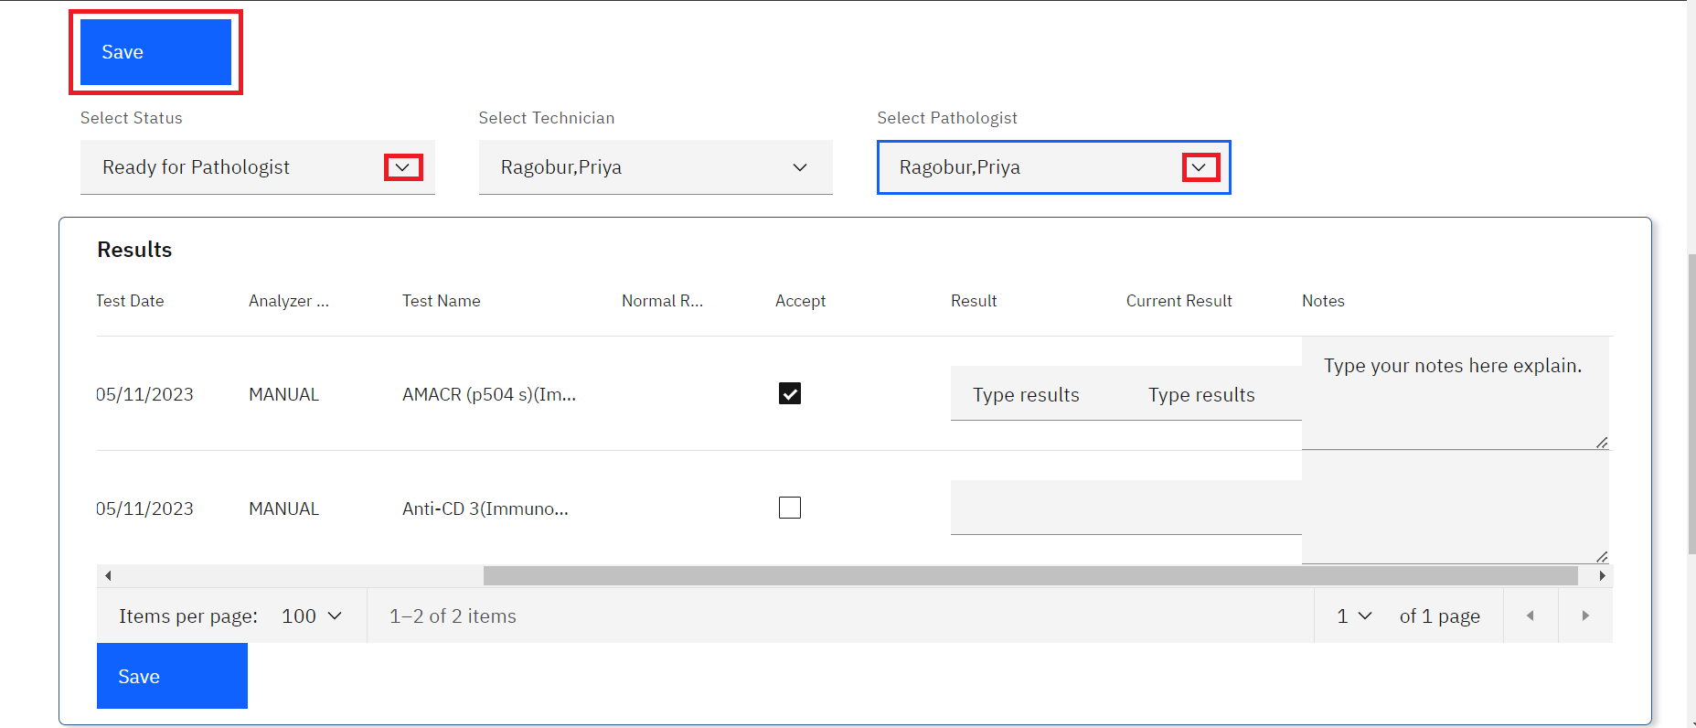

*Select Pathologist and Save*

A quick search of the patient under the immunohistochemistry patient search will reveal a change in stage for the case to READY_PATHOLOGIST

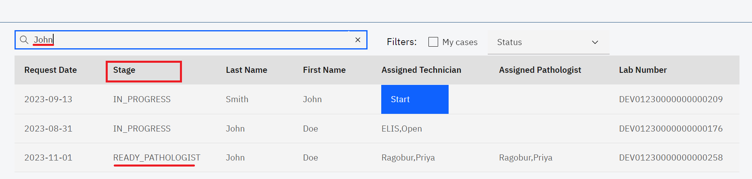

*Case Ready for Pathologist*

1. The pathologist will click on the case to view the results and validate them by checking on the Accept check box, typing in results for pathology review and clicking on the **Save** button.

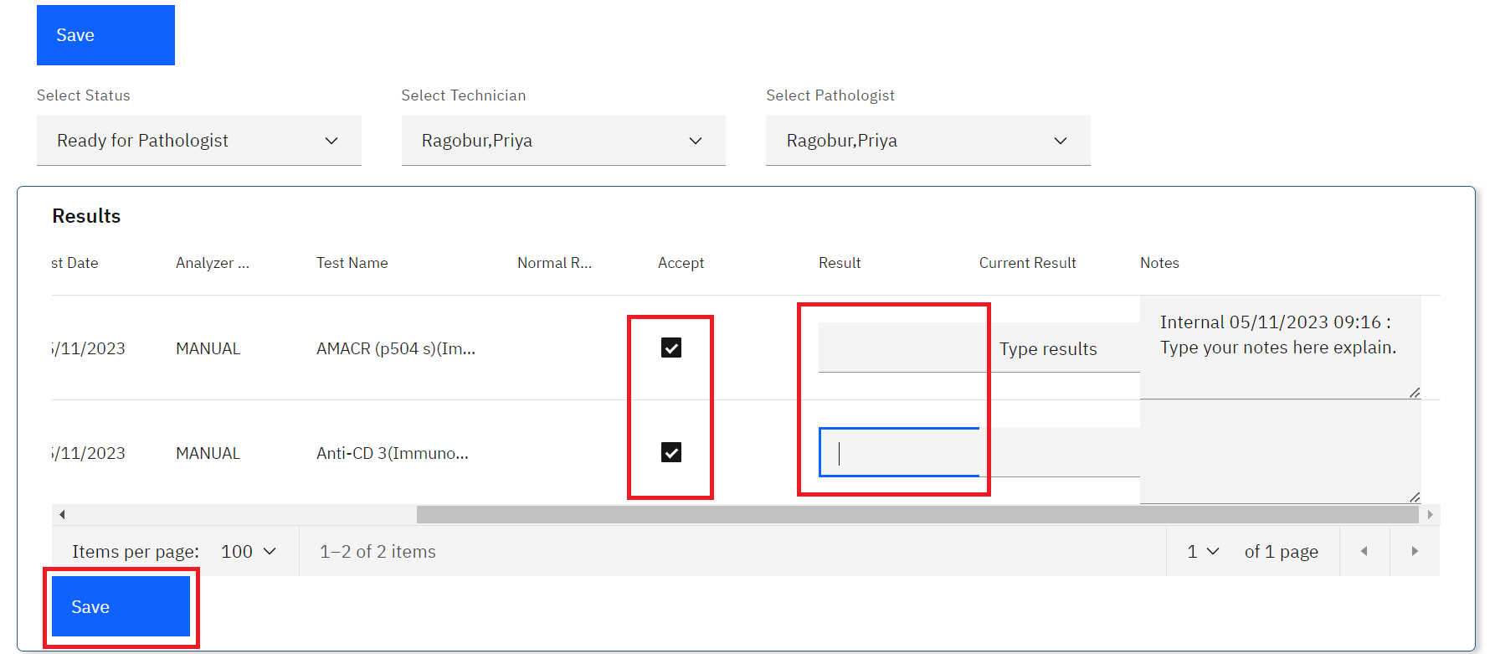

*Pathology Review*

1. The Pathologist will click on the Select Status drop-down and select the Ready for Release status and click on the **Save** button.

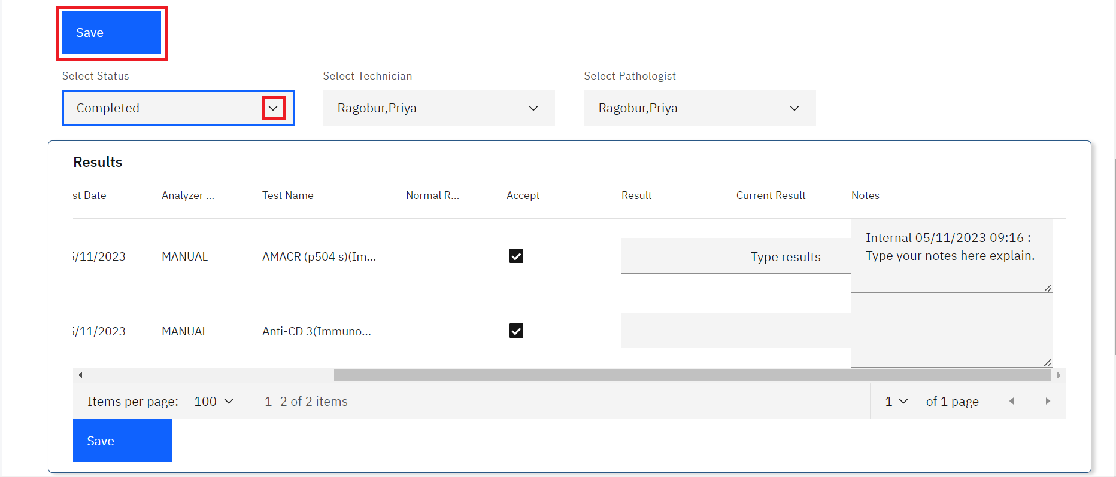

*Immunohistochemistry Case Completed*

The case will be listed as completed under the immunohistochemistry dashboard.

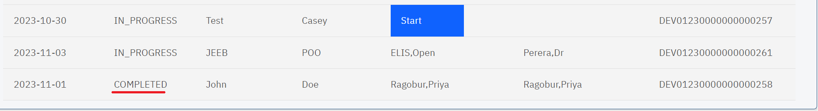

*Case Completed*

1. The lab technician can release the results for the immunohistochemistry case by clicking on the case, scrolling to the bottom of the page, checking the **ready for release** checkbox which signifies the validation of the and clicking on the **Save** button.

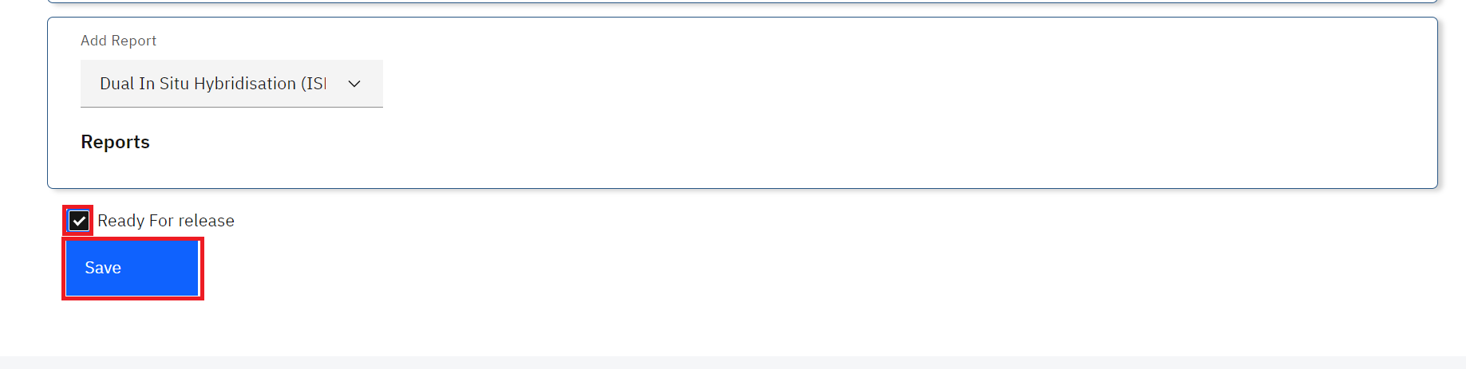

*Ready for Release*

## **How to upload or generate an immunohistochemistry report.**

1. Follow steps 1 to 3 under how to access and process an immunohistochemistry test.
2. Click on the desired patient whose immunohistochemistry state is completed.
3. Click on the desired patient under the dashboard. In this illustration, a patient by the name **Cray Cray** is clicked.

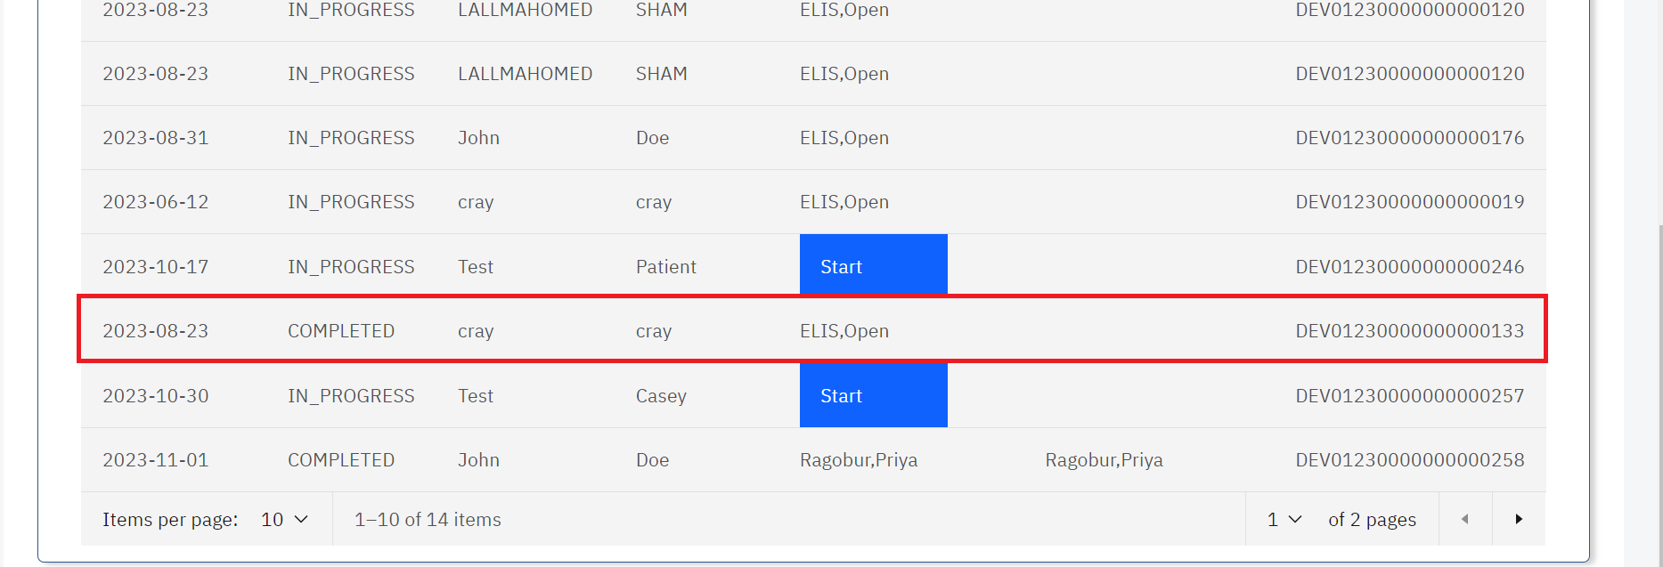

*Click on Patient*

1. Scroll to the report section and click on the drop-down menu under report.

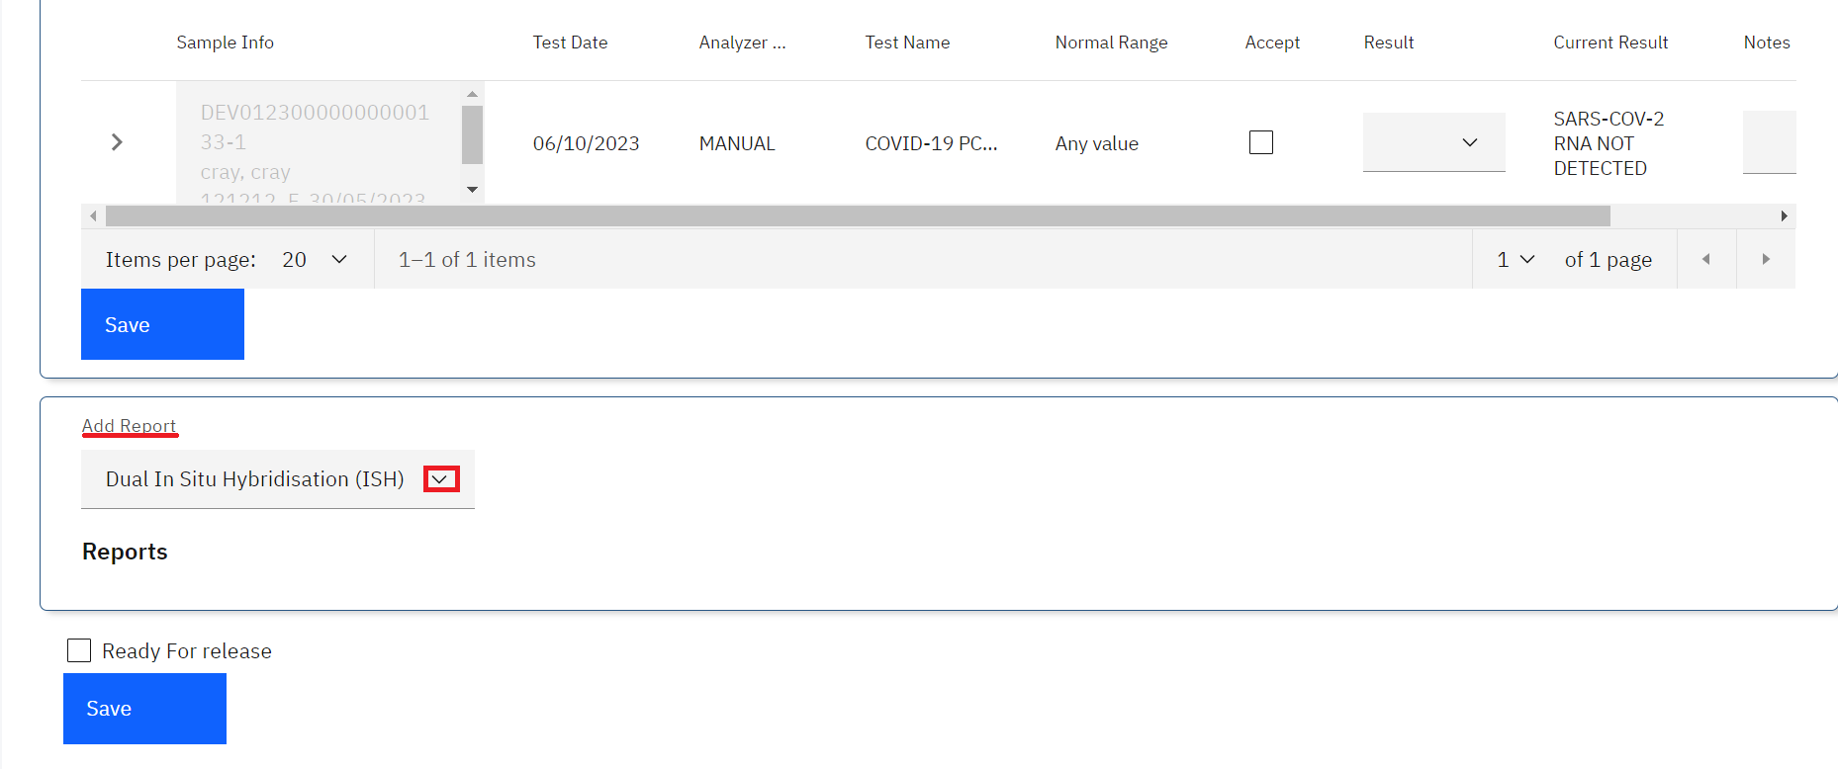

*Click on Add Report Drop-down menu*

1. Click on a report to select from the drop-down menu.

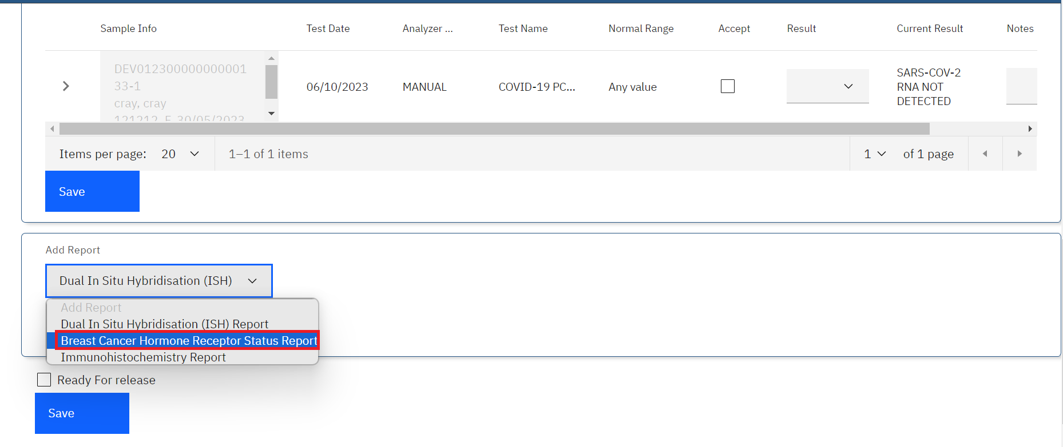

*Select Report*

The report will be selected successfully.

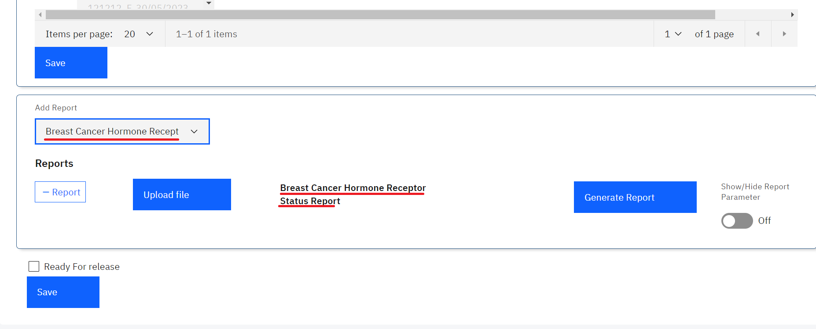

*Report Selected Successfully*

1. To add a report, click on the drop-down menu and select a report. For instance immunohistochemistry.

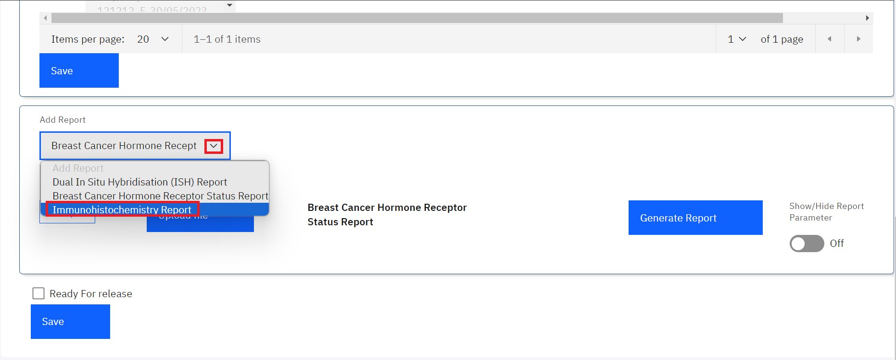

*Adding a Report*

The report will be added successfully

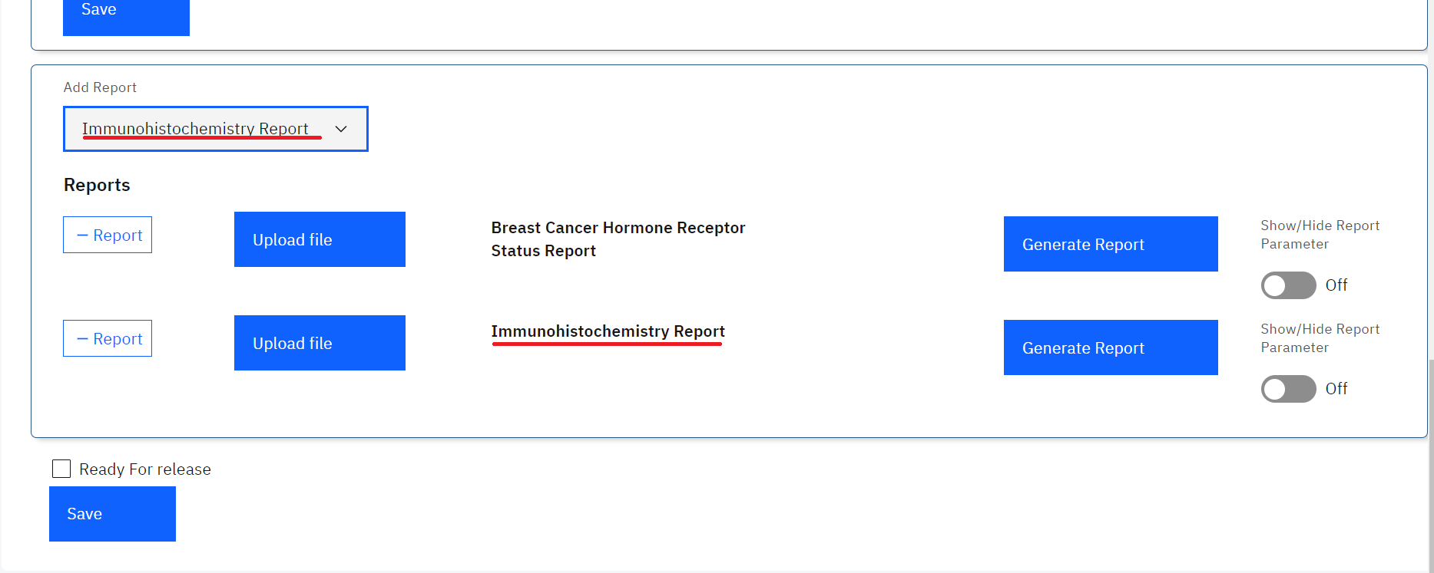

*Report Added Successfully*

1. To remove a report, click on the **- Report** button.

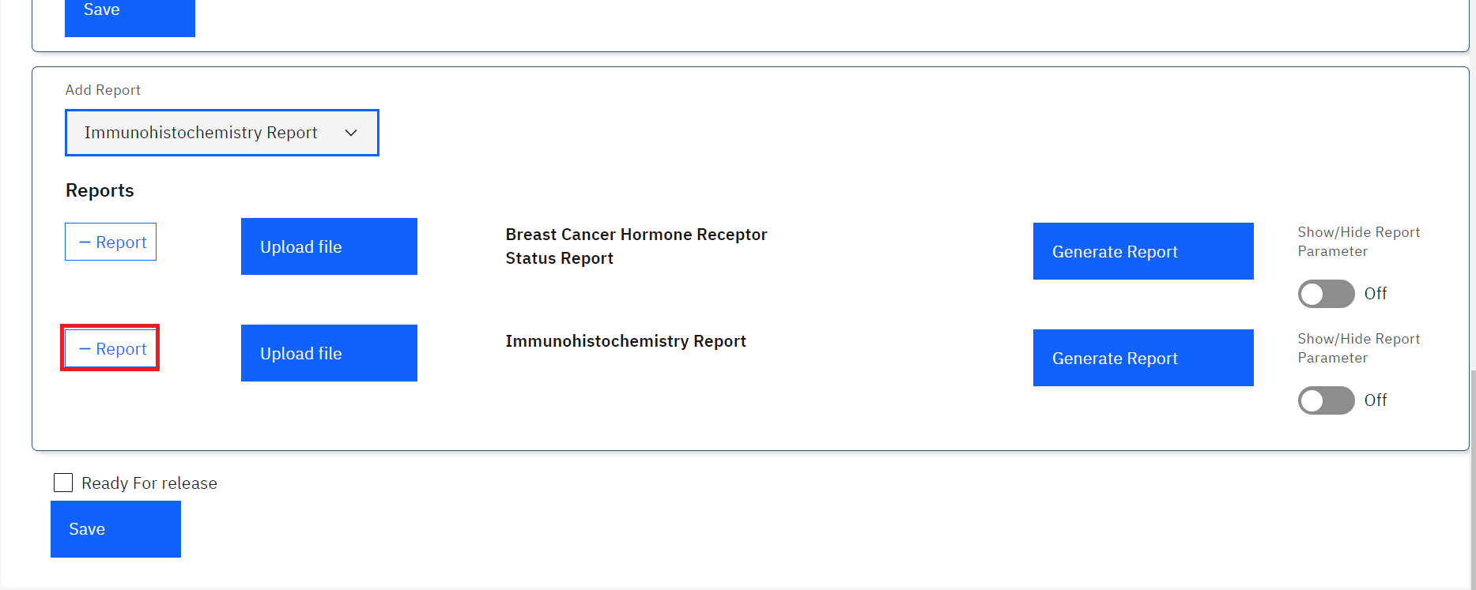

*Removing a Report*

The **Upload file** button is used to upload a report that has been prepared by the pathologist for the added report. In this illustration, we shall upload a report for **Breast Cancer Hormone Receptor Status Report**

1. To upload a report, click on the **Upload file** button.

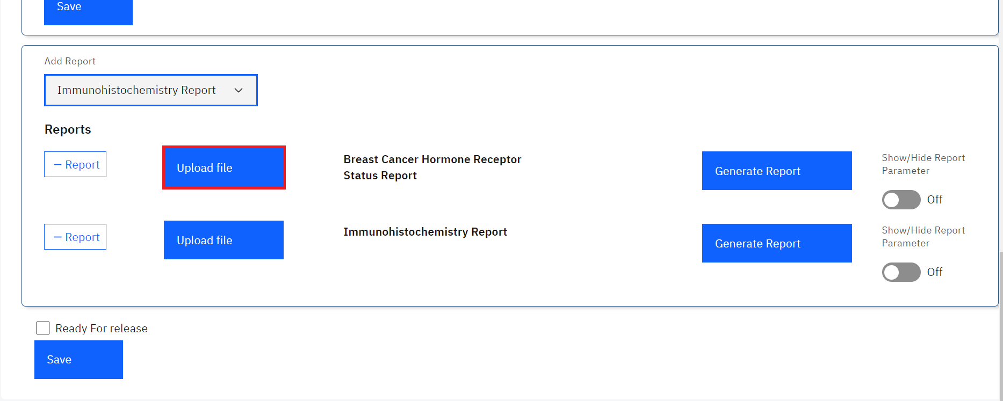

*Upload File*

1. Upon clicking on the **Upload file** button, a file upload dialogue will be opened on your workstation. Navigate to the location where you have saved the report for immunohistochemistry. In this illustration, the report file for patient **Cray Cray**  was saved under downloads. Click on the report to select it then click on the **Open** button.

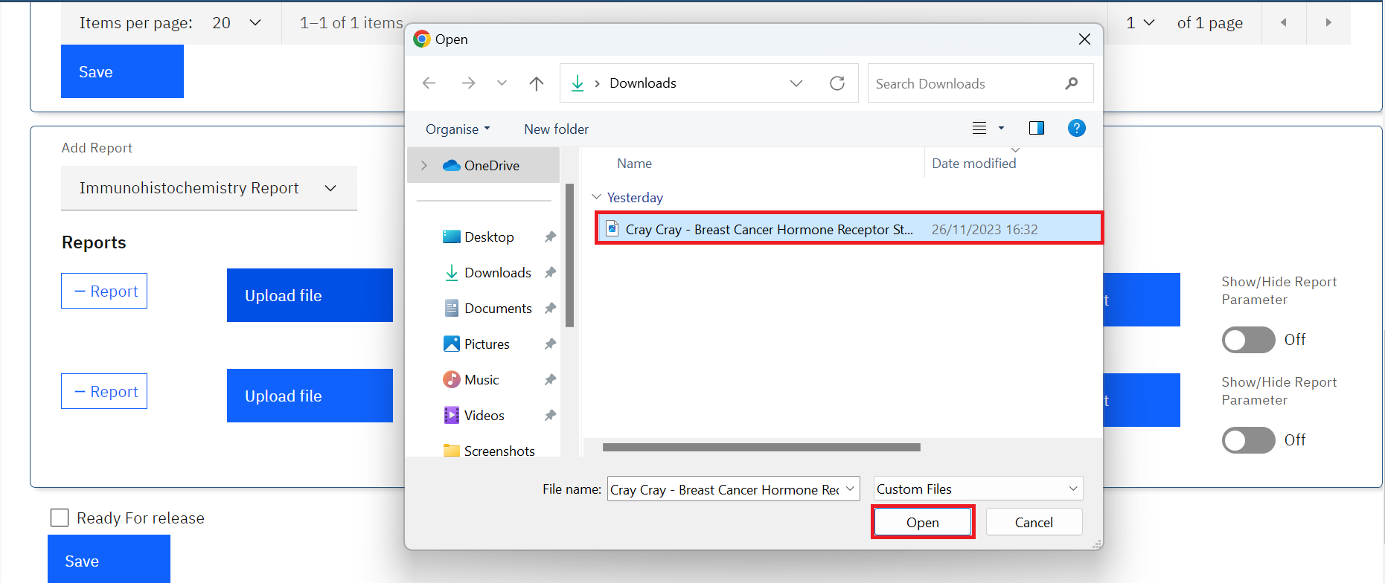

*Upload Report*

Note: upon clicking on the Open button, the report will be uploaded successfully.

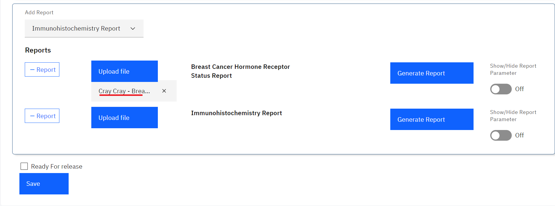

*Report Uploaded Successfully*

1. To remove the report, click on the cancel icon **x.** Otherwise, Click on the **Save** button at the bottom of the page**.**

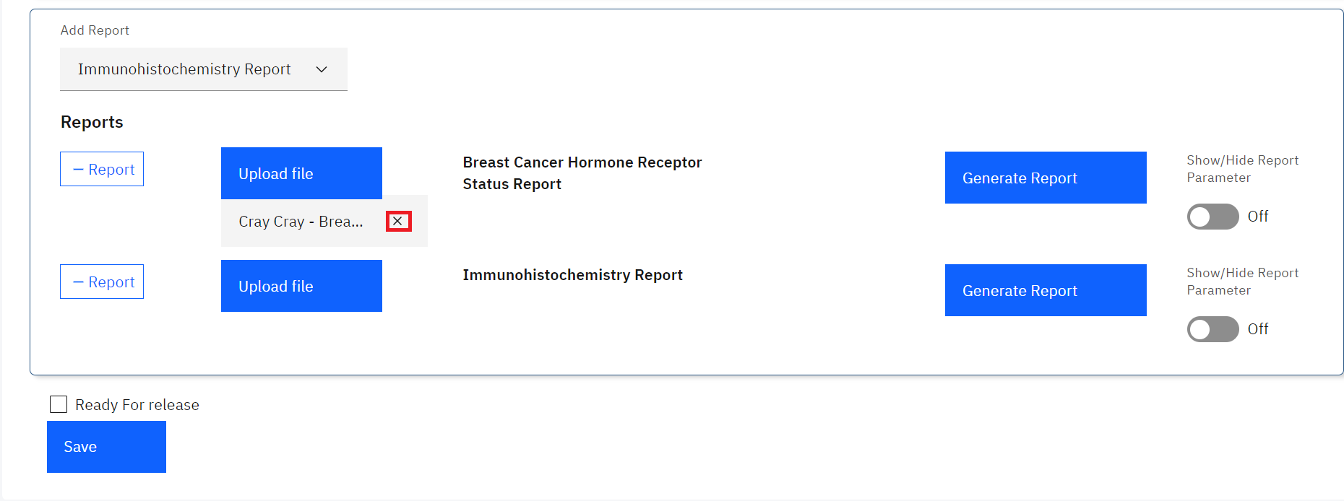

*Removing a Report*

Note: As a user, you can generate a report from the system as opposed to uploading one. To do so, you will need to set parameters for the report.

1. Before you generate a report, toggle the **Show/Hide Report Parameters** toggle switch to **On** so as to S**how Report Parameter** this will allow you to enter the report parameters. The toggle switch is set to **Hide Report Parameters** by default.

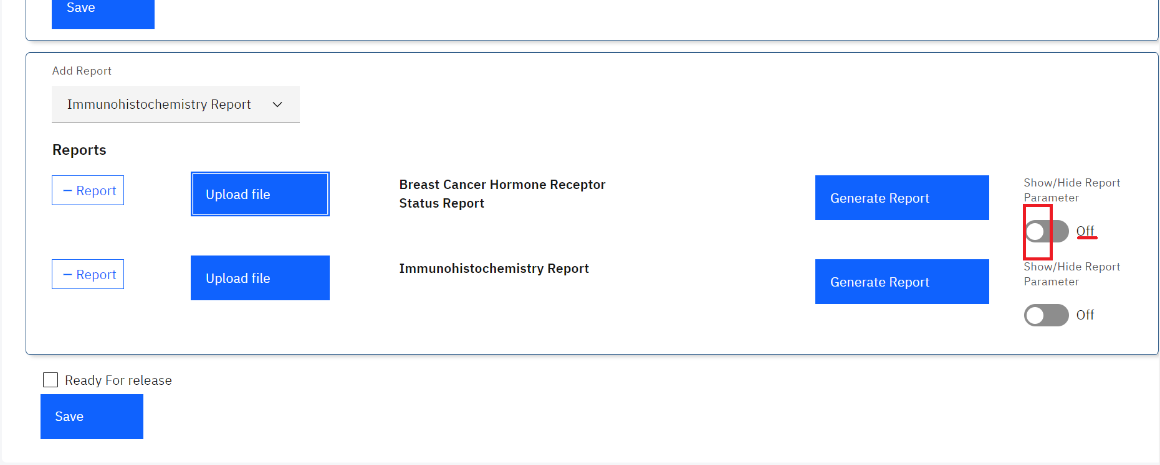

*Default Hide Report Parameter*

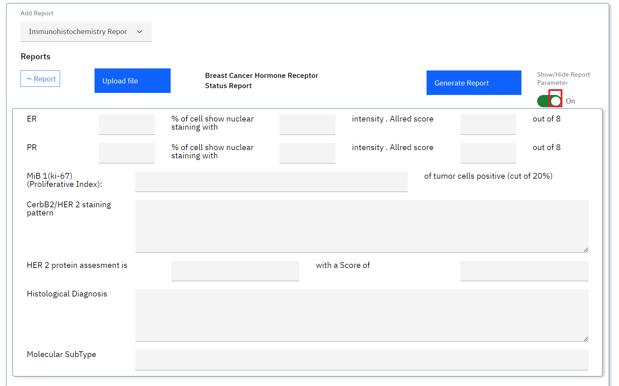

*Show Report Parameter*

1. Enter the parameters.

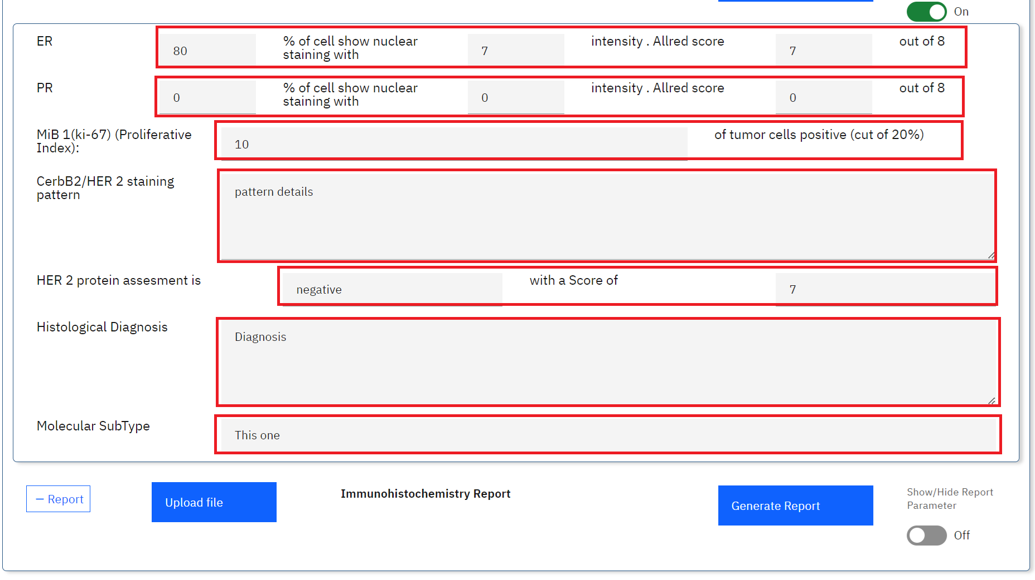

*Enter Report Parameters and Click Generate Report*

1. Click on the **Generate Report** button

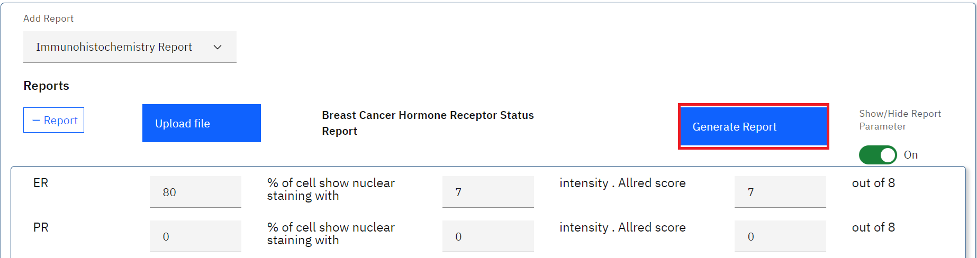

*Generate Report*

Note: a pdf containing the patient report will be generated successfully.

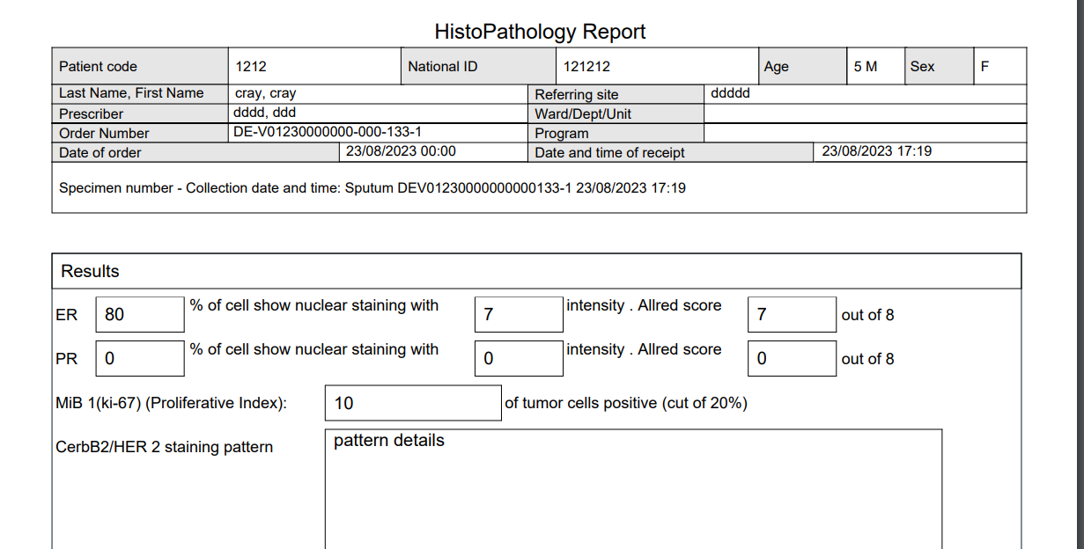

*Sample ImmunoHistochemistry Report*

1. Click on the Save button at the bottom of the page.

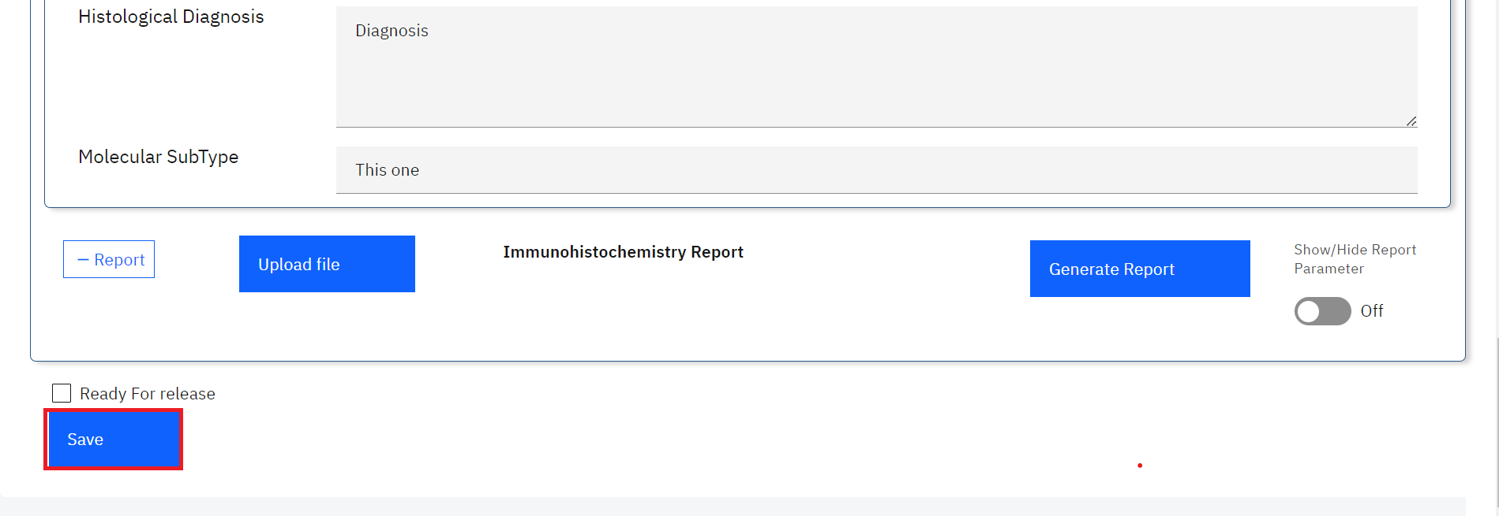

*Click Save*

# **PART 10: CYTOLOGY**

The cytology module allows the laboratory team to determine diagnosis of diseases through the examination of tissue samples.

## **How to create a cytology test order.**

1. To access and create a cytology test, follow steps 1 to 9 under How to create a laboratory analysis order for an existing patient.

**Note:** In this illustration, a patient by the name **Test Casey** is used to capture a cytology test request

1. Upon executing step 1, click on the **Program** drop-down menu.

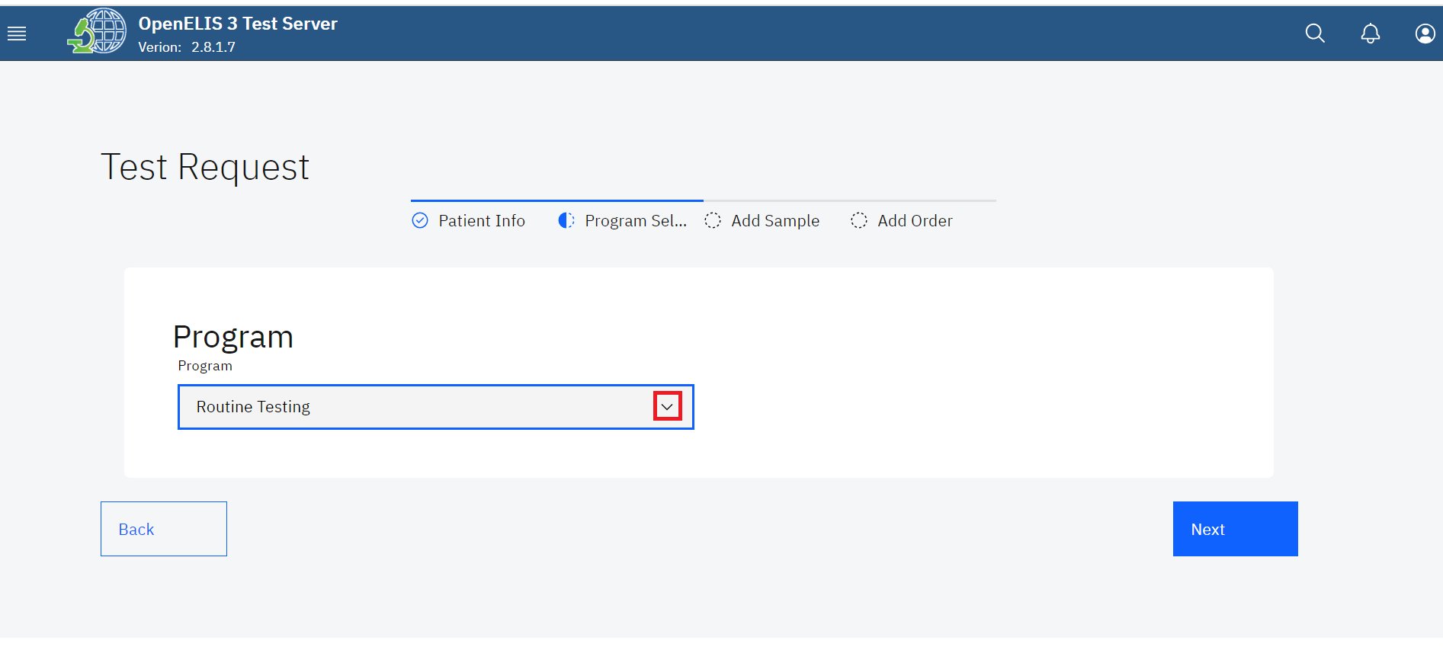

*Click on Program Drop-down Menu*

1. Click on **cytology** under the drop-down menu.

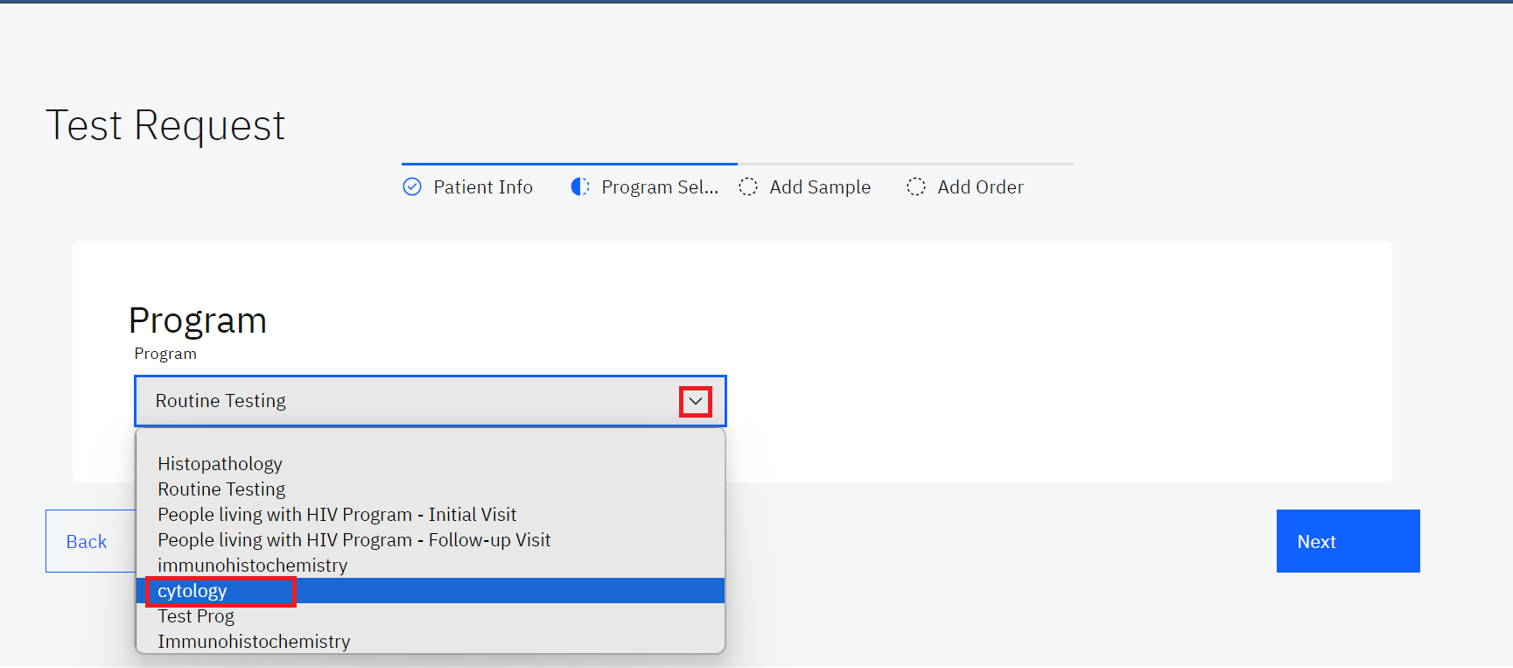

*Select Cytology Program*

1. Click on the **Next** button.

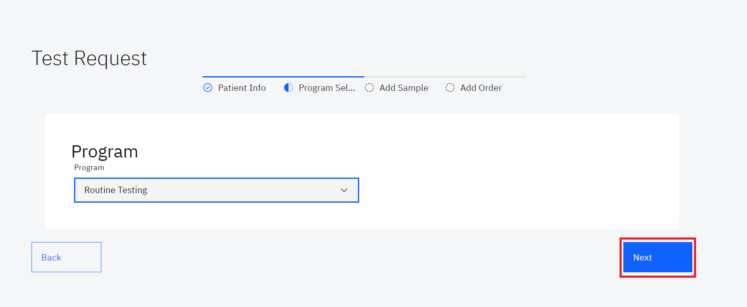

*Click Next*

1. Fill in the fields under the program which include; **nature of specimen**, **site of specimen**, **procedure performed**, **provisional clinical diagnosis** and **previous surgery/treatment** then click on the Next button.and click next

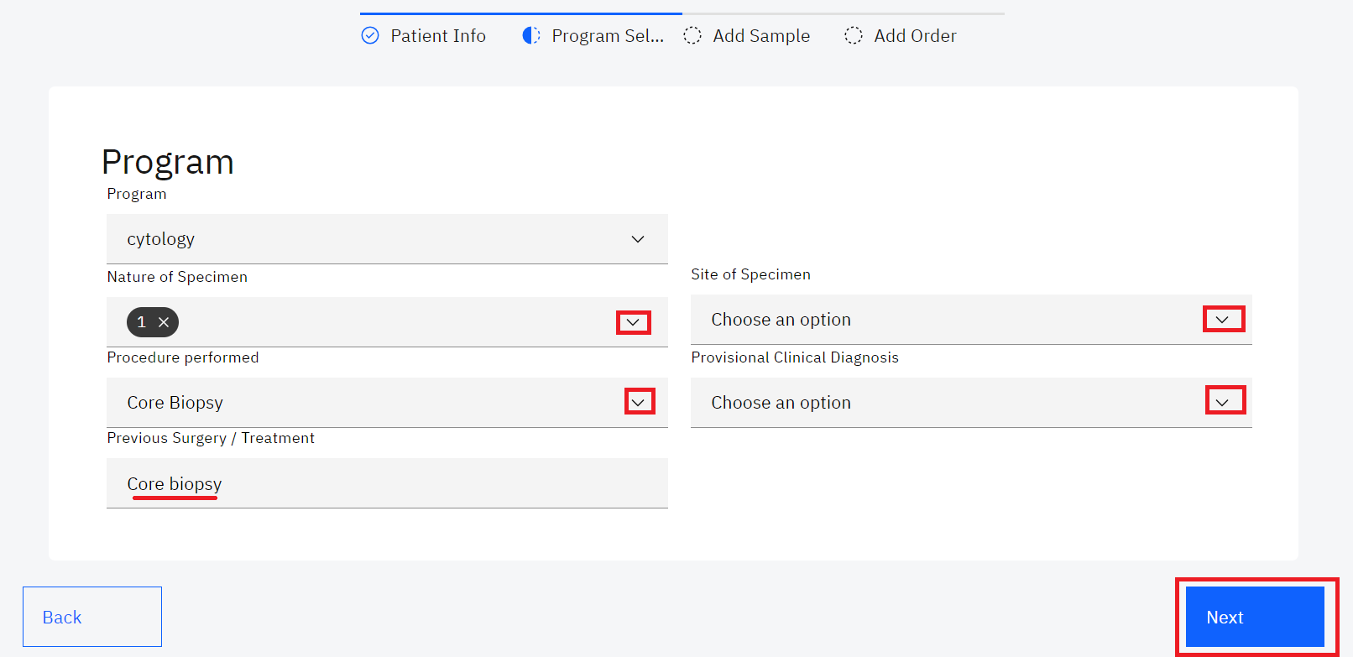

*Fill in Program Fields and Click Next*

1. The **Add Sample** page allows for the addition of samples by selecting a sample type. To Add a sample, click on the **select sample type** drop-down menu item and select the sample In this instance, cytology was selected as a program we have selected **Tissue Antemortem** as the sample.

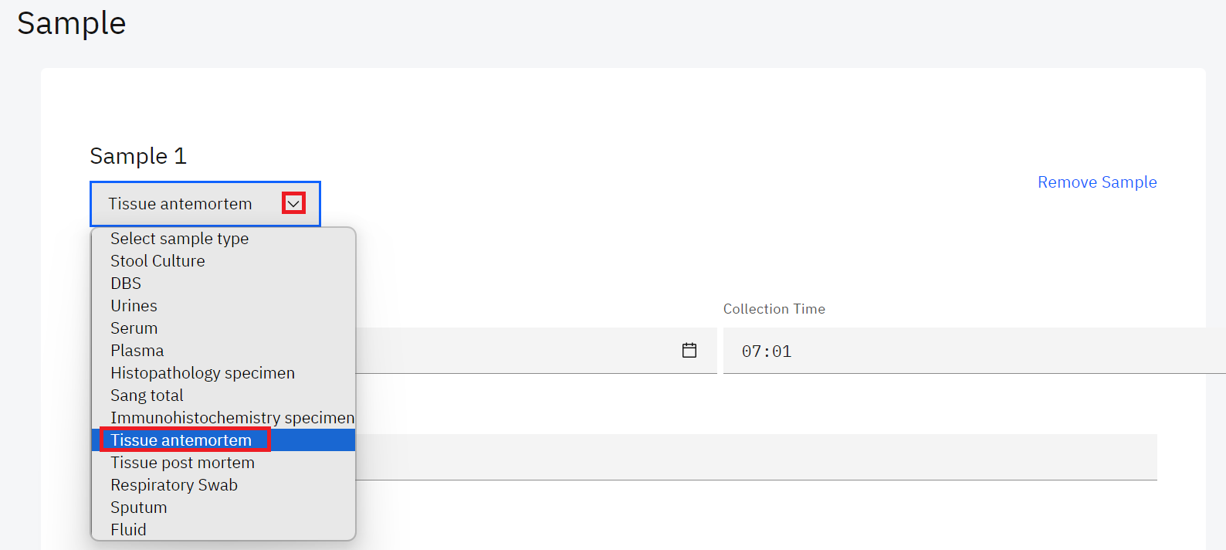

*Select Cytology Sample*

1. The date and time are picked from the system. Fill in the **Collector** field, the Order Tests will be populated upon choosing the available immunohistochemistry test. In this illustration, the **AMACR(p 504 s)** and **anti-CD 3** are the selected tests.

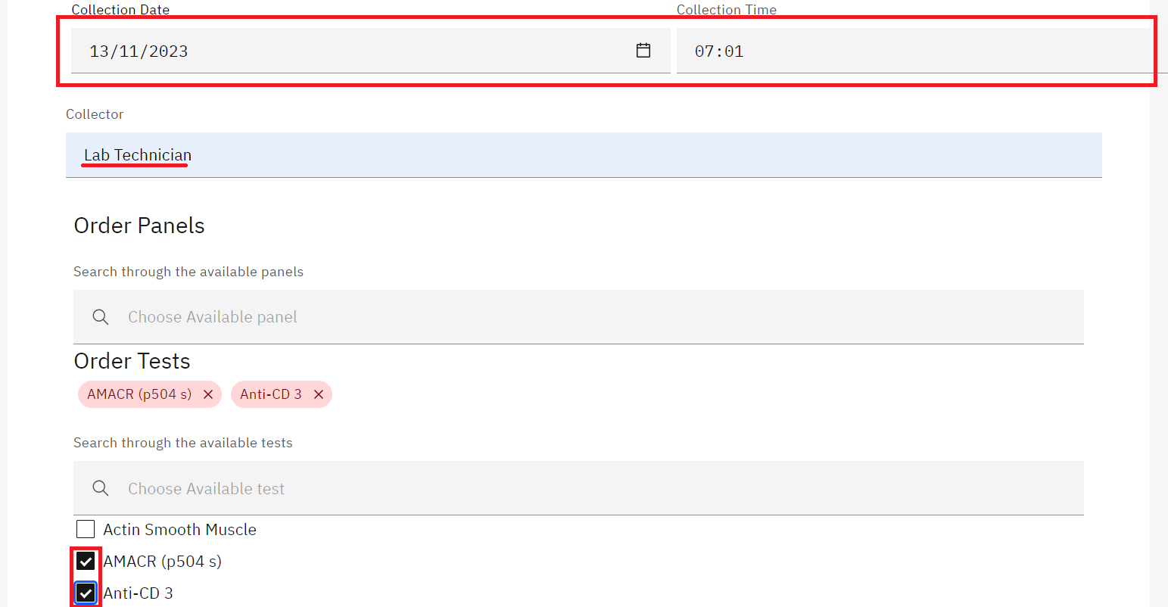

*Fill in cytology Sample Details*

1. To remove an ordered immunohistochemistry test, click the cancel (**x)** icon on the test

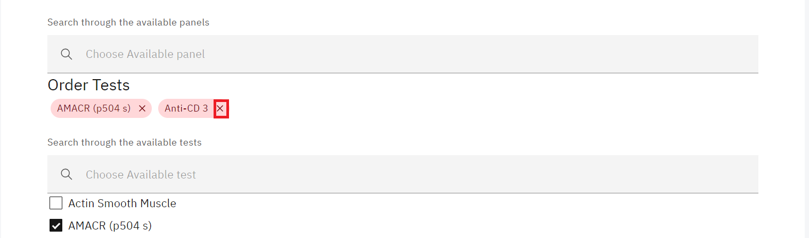

*Removing an Ordered Test*

1. Click on the **Next** button.



*Click Next*

1. Fill in the order section by Scanning or manually entering the lab number or by clicking on the **Lab Number** text link to generate the lab number. Select the **Priority** from the drop-down menu. Fill in the **Site name**  and the **requester's** details, select the **payment status** from the drop-down menu,select the **Sampling performed for analysis** from the drop-down menu and click on the **Submi**t button.

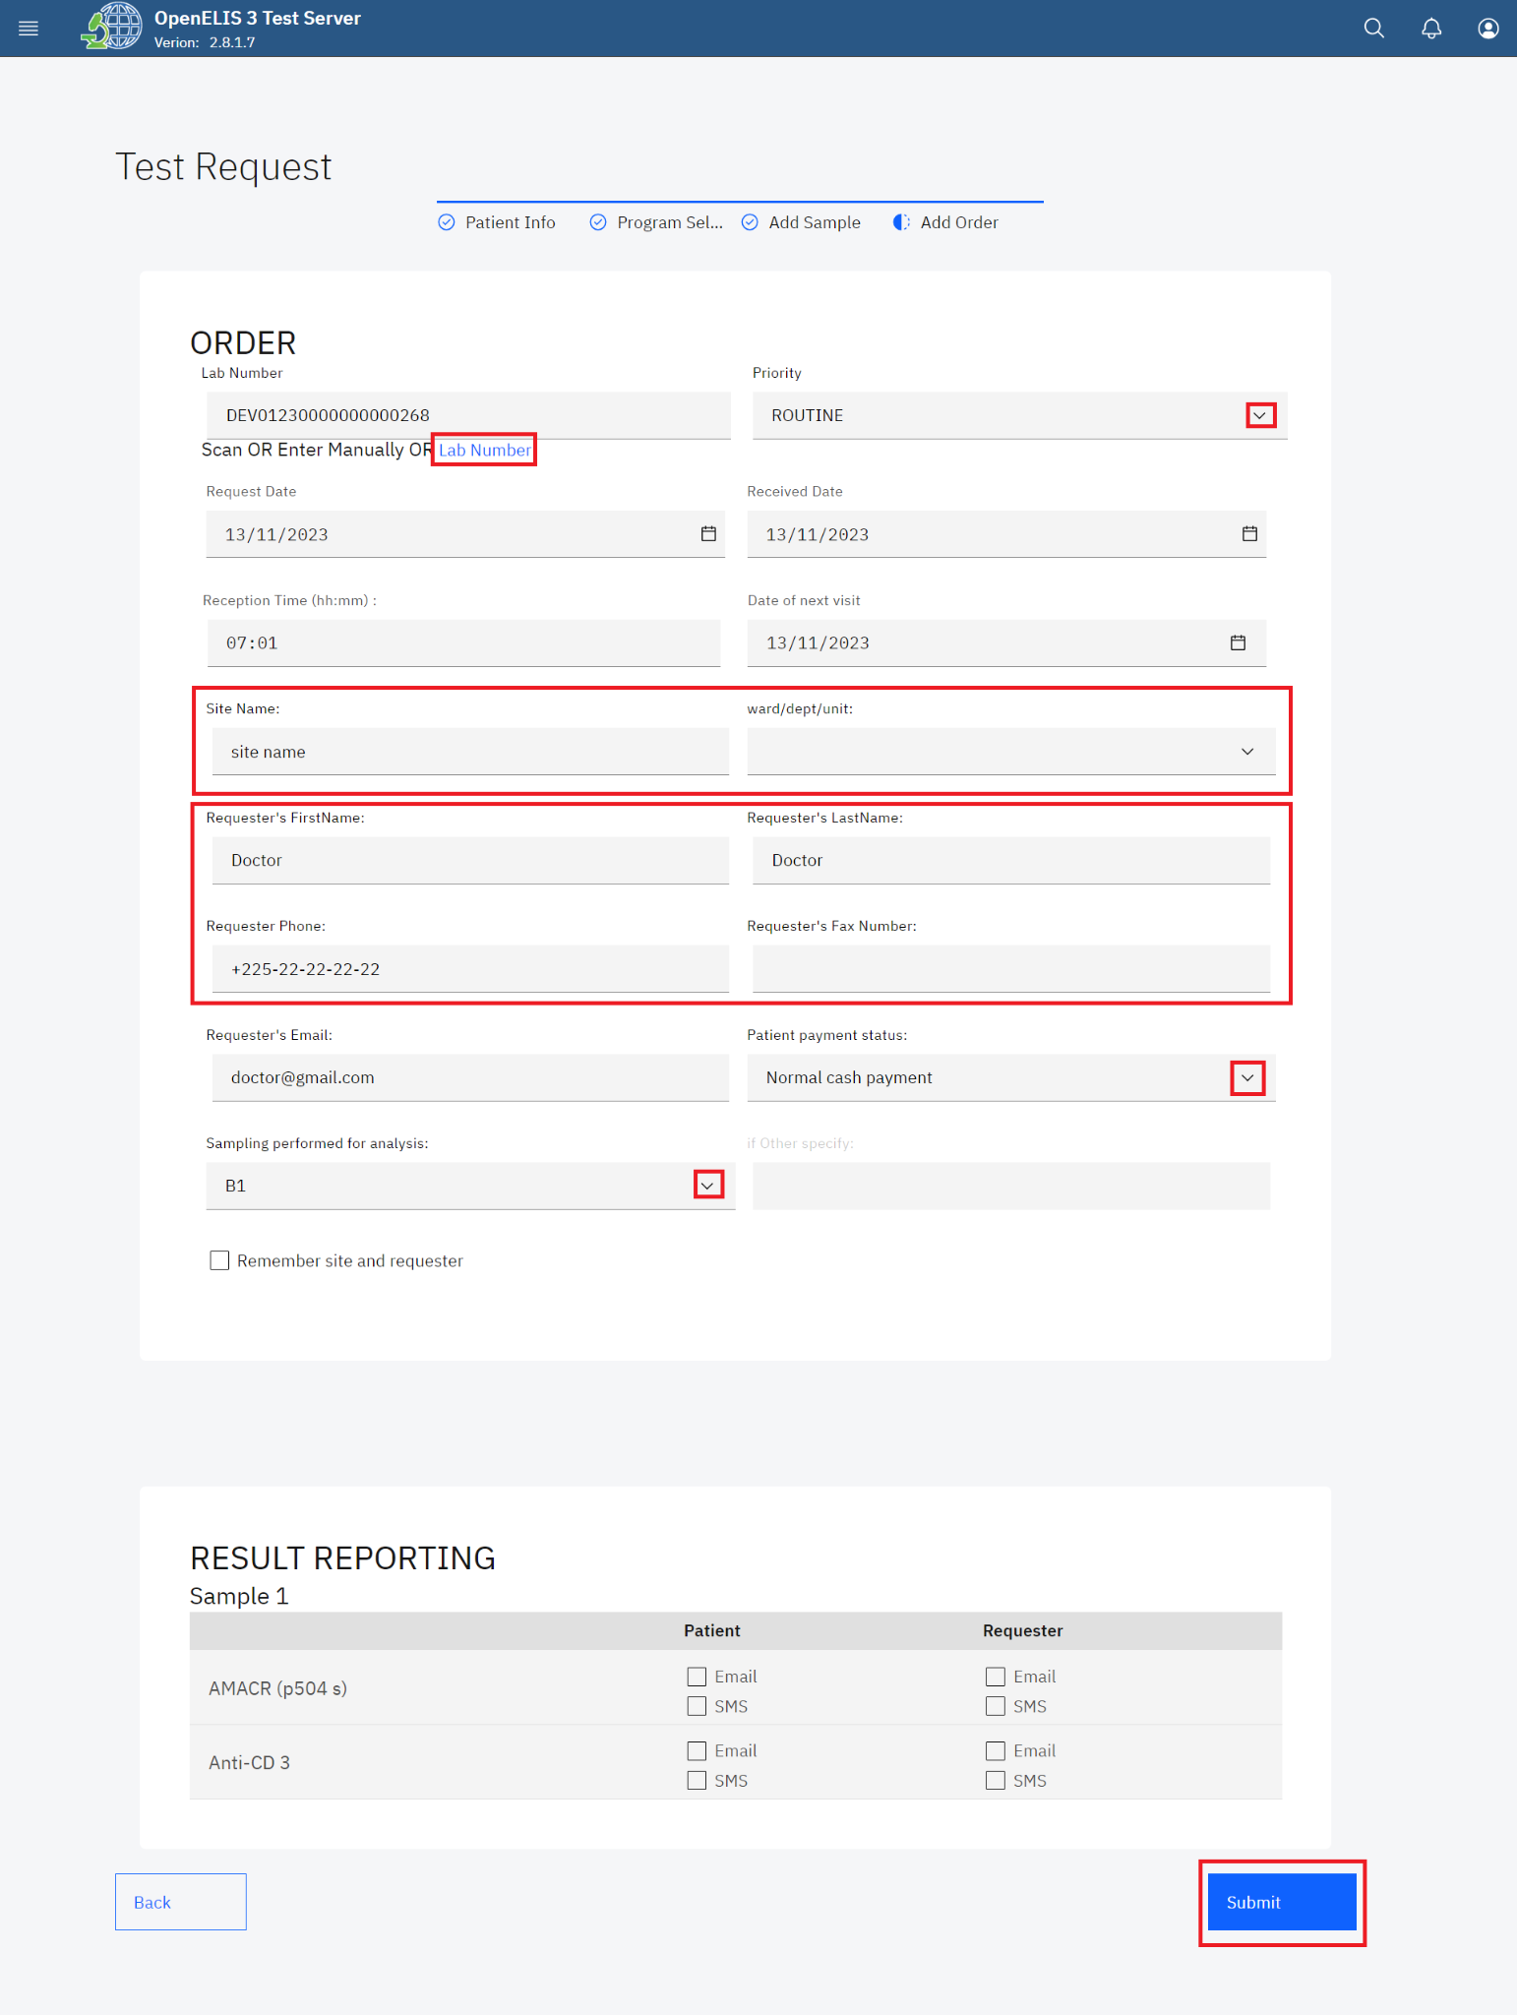

1. Upon submitting the histopathology lab request, a **Save successful** message will be displayed. You can print the barcode for the test. To print the barcode, click on the print barcode button.



*Print Barcode*

## **How to access the cytology module and process a test.**

1. Hover the mouse over the hamburger icon and click to open the menu.



*Access the OpenELIS menu*

1. Hover the mouse and click on the drop-down menu under the cytology module.

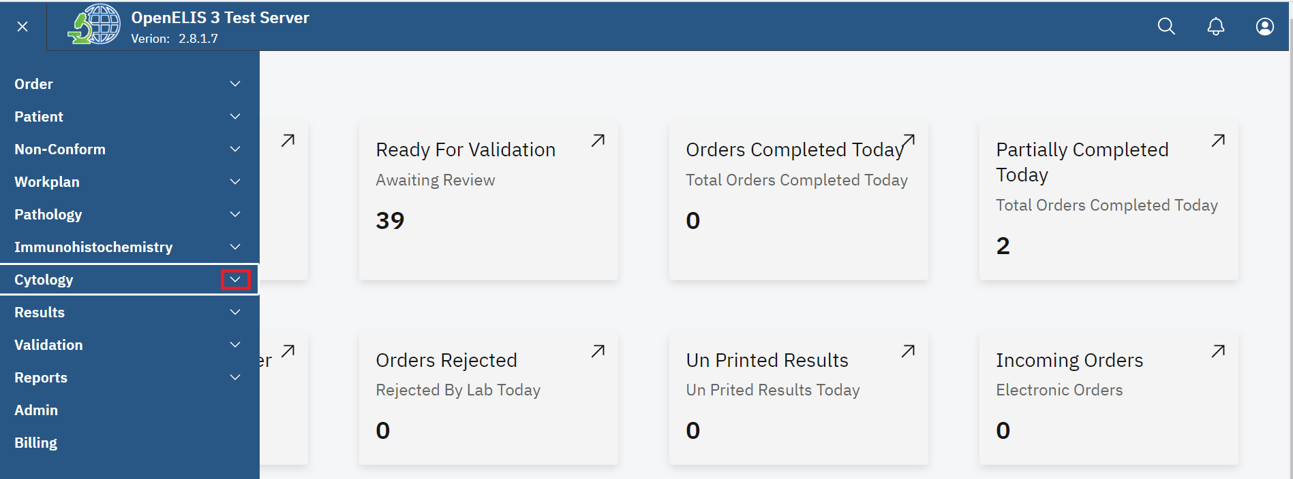

1. Click on **Dashboard** sub-menu item.

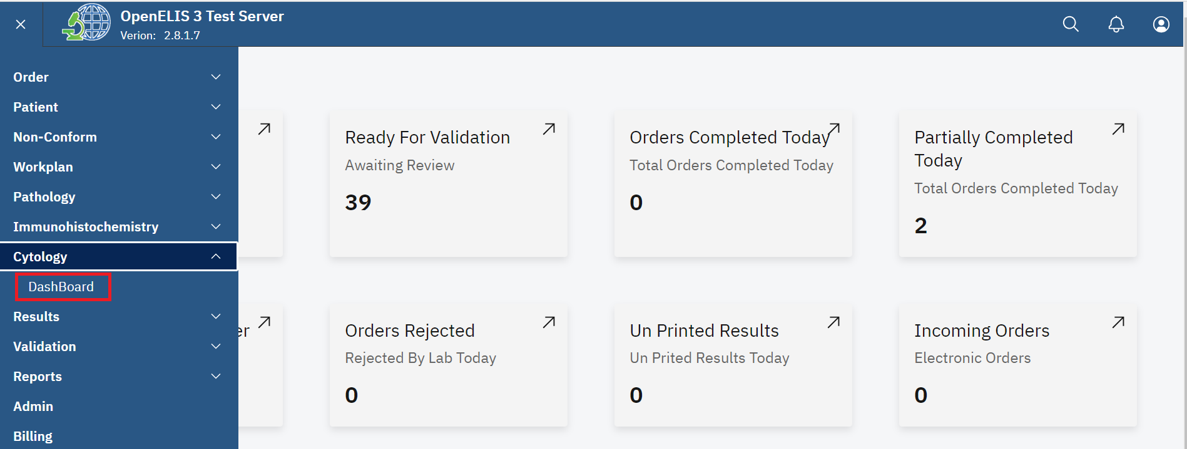

*Click on Dashboard*

The dashboard provides summaries for **Cases in progress**, **Awaiting Pathology Review, Additional Pathology Request** and **Complete** test in a week

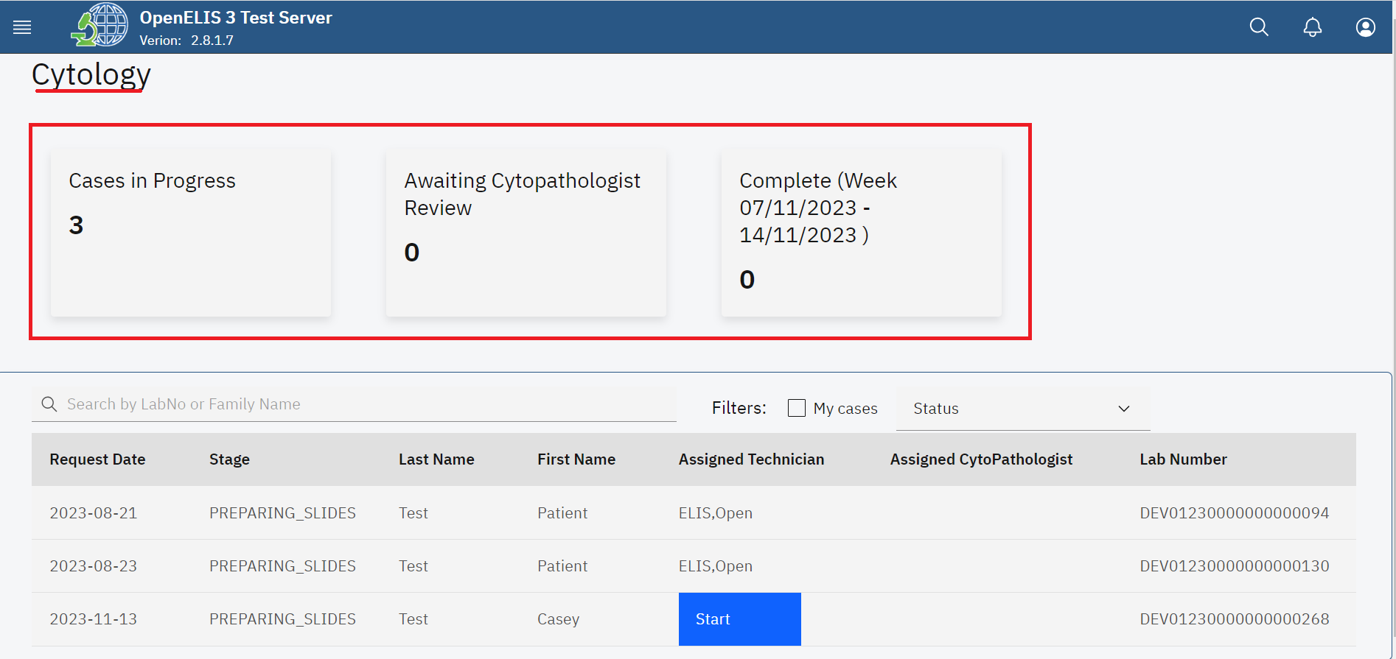

*Cytology Dashboard*

All the cytology test requests entered under **Add Order** (Test Request) are displayed under a table that displays the **Request Date**, **Stage**, **Last Name**, **Assigned Technician**, **Assigned Pathologist** and **Lab Number**.

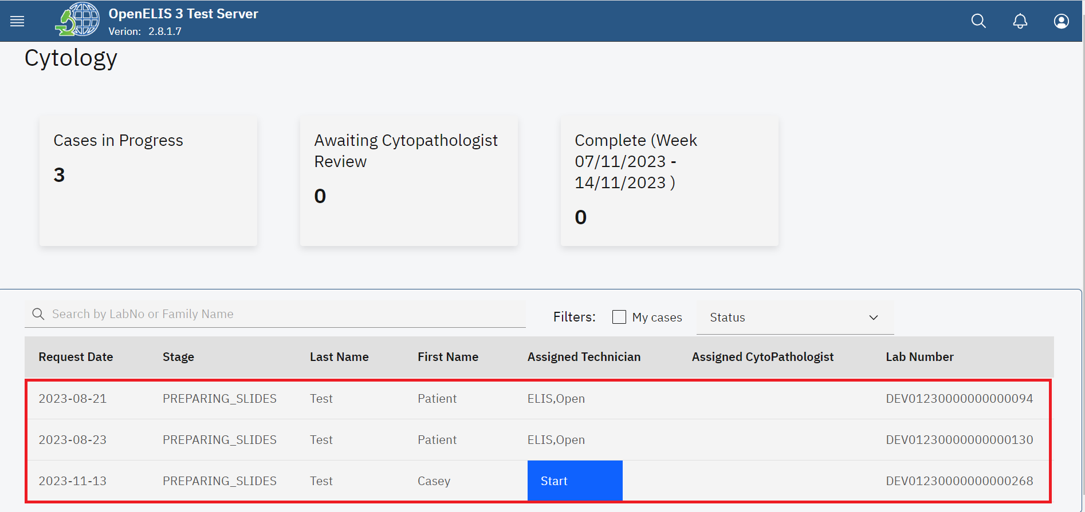

*Cytology Requests*

1. The cytology module allows you to filter the test request . Click on the My cases checkbox to filter the cases.

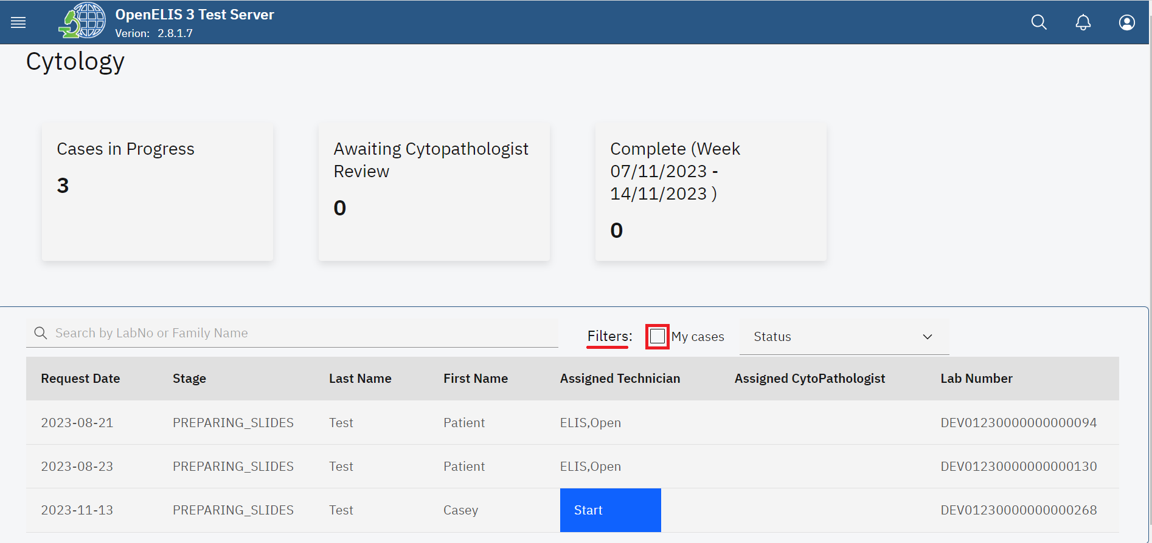

*Filter cytology Cases*

1. The Status dropdown menu is used to filter the immunohistochemistry cases by their status. The status can be displayed **All**, **In Progress**, **Ready for Patholog**y and **Completed.**

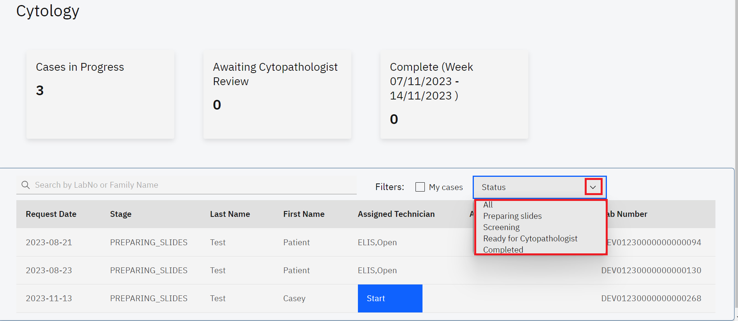

*Status*

1. You can filter the requests in an ascending or descending order for each menu item For instance, click on the **Lab Number** menu item.

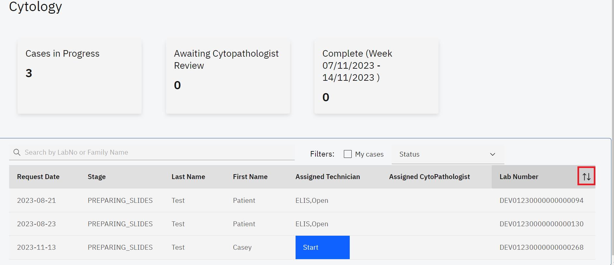

*Filter Request by Ascending or Descending Order*

1. To search for a pathology test, enter the patient name or the lab number under the **Search by LabNo or Family Name** text field. The search results will retort a list of matching patients.The cancel icon **(x)** is used to cancel the search.
2. Click on the desired patient from the search result. In this illustration, the **start** button is clicked.

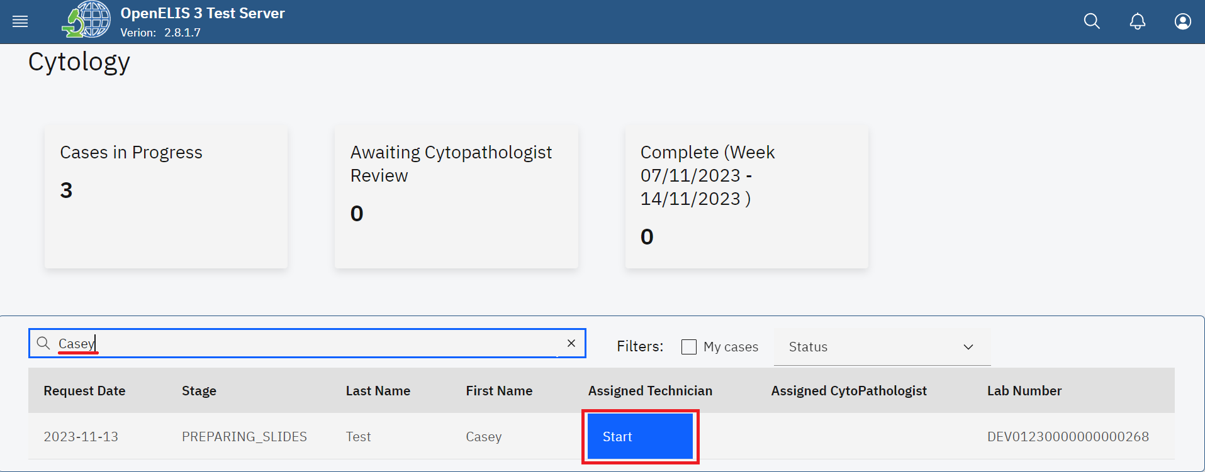

*Search Patient*

**Note**: The top section of the **cytology** page displays information about the immunohistochemistry case.

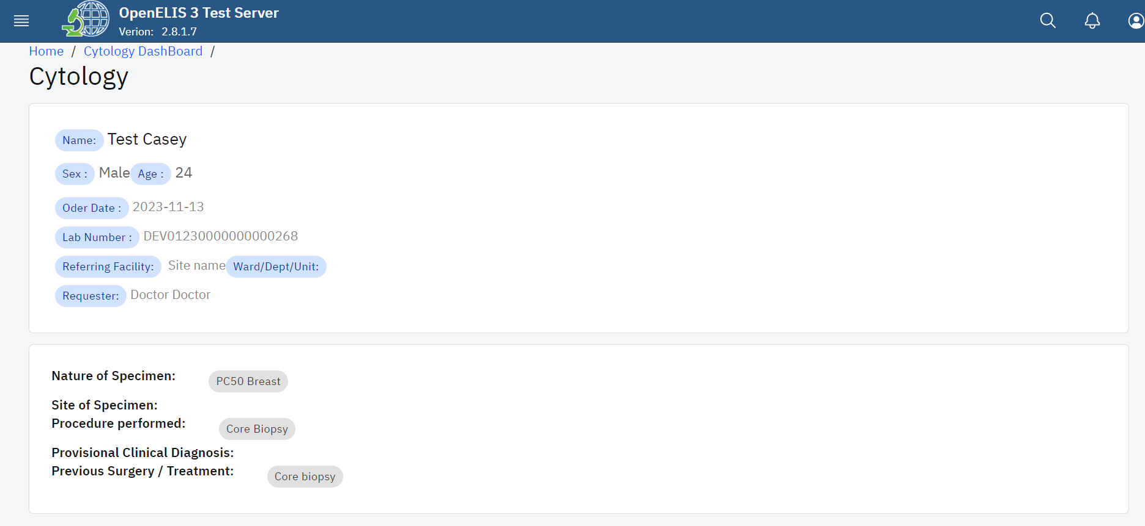

*Cytology Test Information*

**Note:** There is a sequence of stages in a cytology examination. The **Status** drop-down menu provides a list of the different stages. The default stage is **preparing slides**  for the test. The select technician drop down menu allows for the selection of the technician conducting the test. This is role based. Anyone with the cytology permission will be displayed under this drop-down menu. Similarly, the select pathologist allows for the selection of a cytopathologist with cytology permission.

1. Click on these **select status** drop-down menu and select the status. In this illustration, Preparing slides is the default status.
2. Click on the **Select Technician** drop-down menu and select the technician.

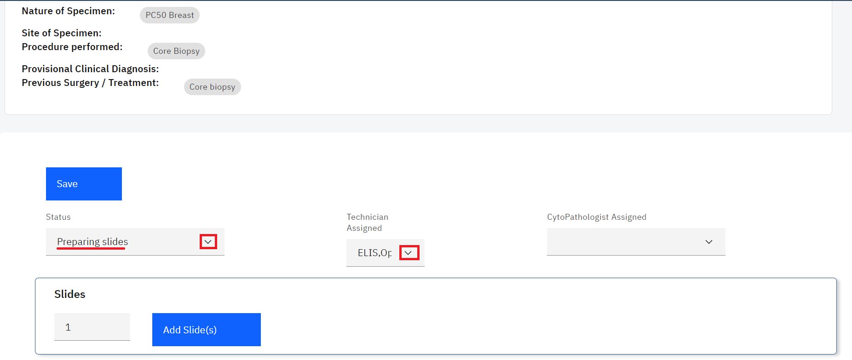

*Select Status and Technician*

1. The Slides section allows you to add the number of slides that will be used for specimen processing. Click on the upward facing arrow to add the number of slides then click on the Add Block button. In this illustration, two slides will be added.

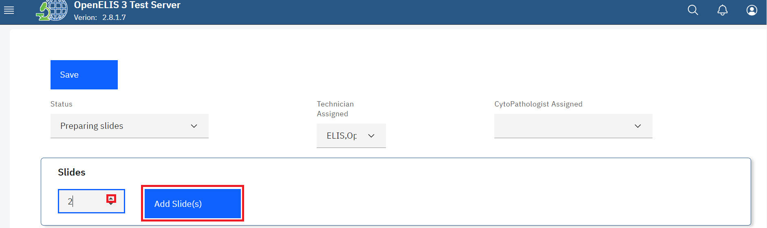

*Add Slides*

1. Upon clicking on the Add Slides button, Fill in the locations for the slides. These could be racks where the specimens are stored.

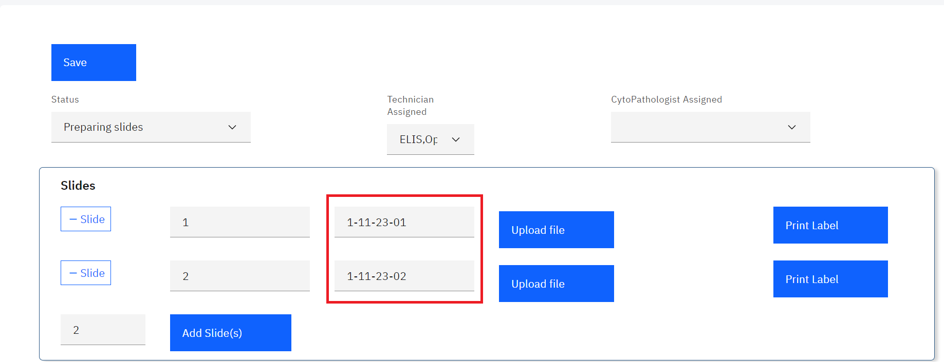

*Slides Location*

1. You can upload a scanned slide by clicking on the **Upload file** button. A file upload dialogue will be opened on your workstation. Navigate to the location where you have saved the scanned slide. In this illustration, the scanned slide for patient **Casey** was saved under downloads. Click on the filet to select it then click on the **Open** button.

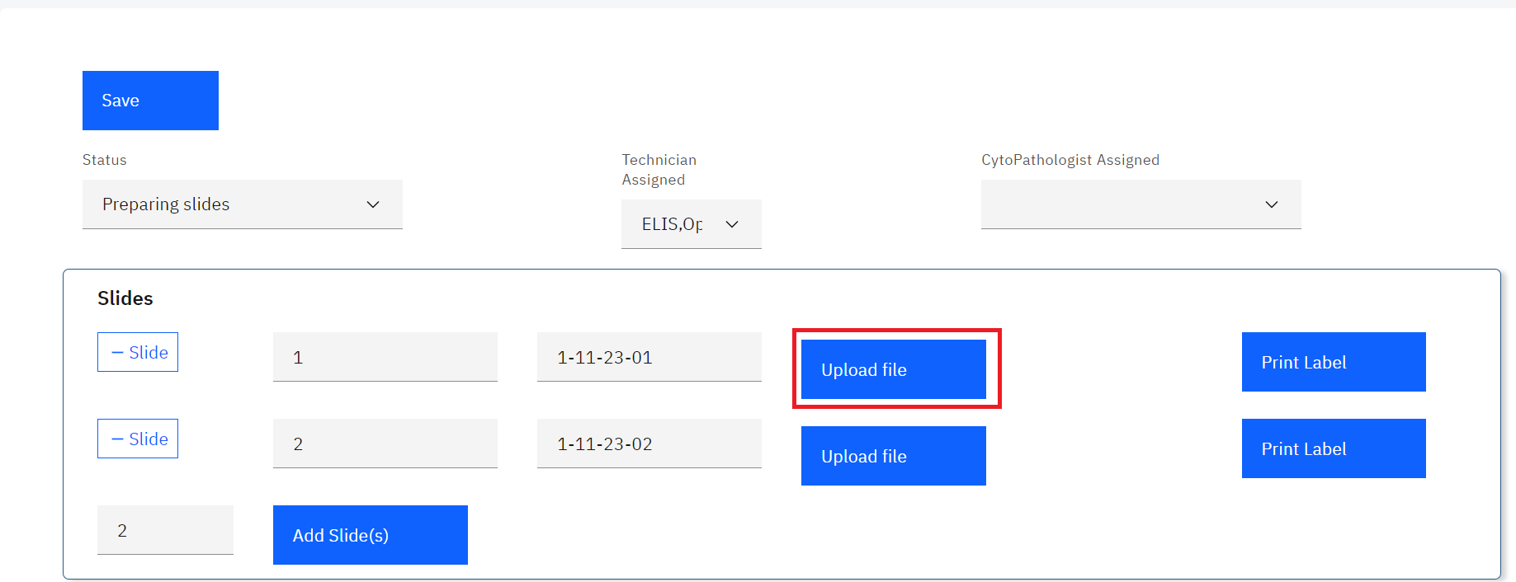

*Upload a File*

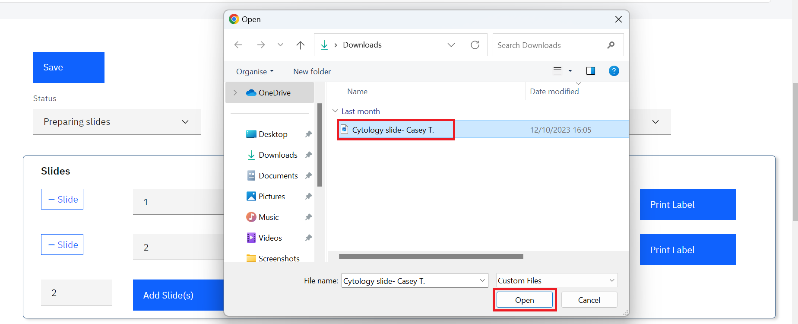

*Cytology Slide Upload*

Note: upon clicking on the Open button, the report will be uploaded successfully.

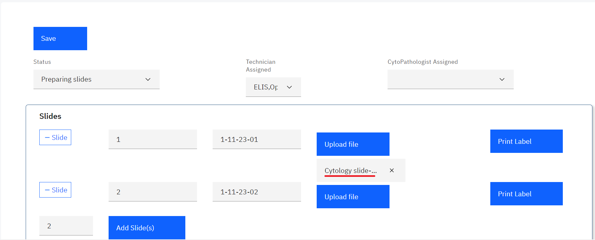

*File Uploaded Successfully*

1. You can print labels for the slide by clicking on the **Print Label** button. A new tab will be opened on your browser you can download and or print the label to attach on the sample.

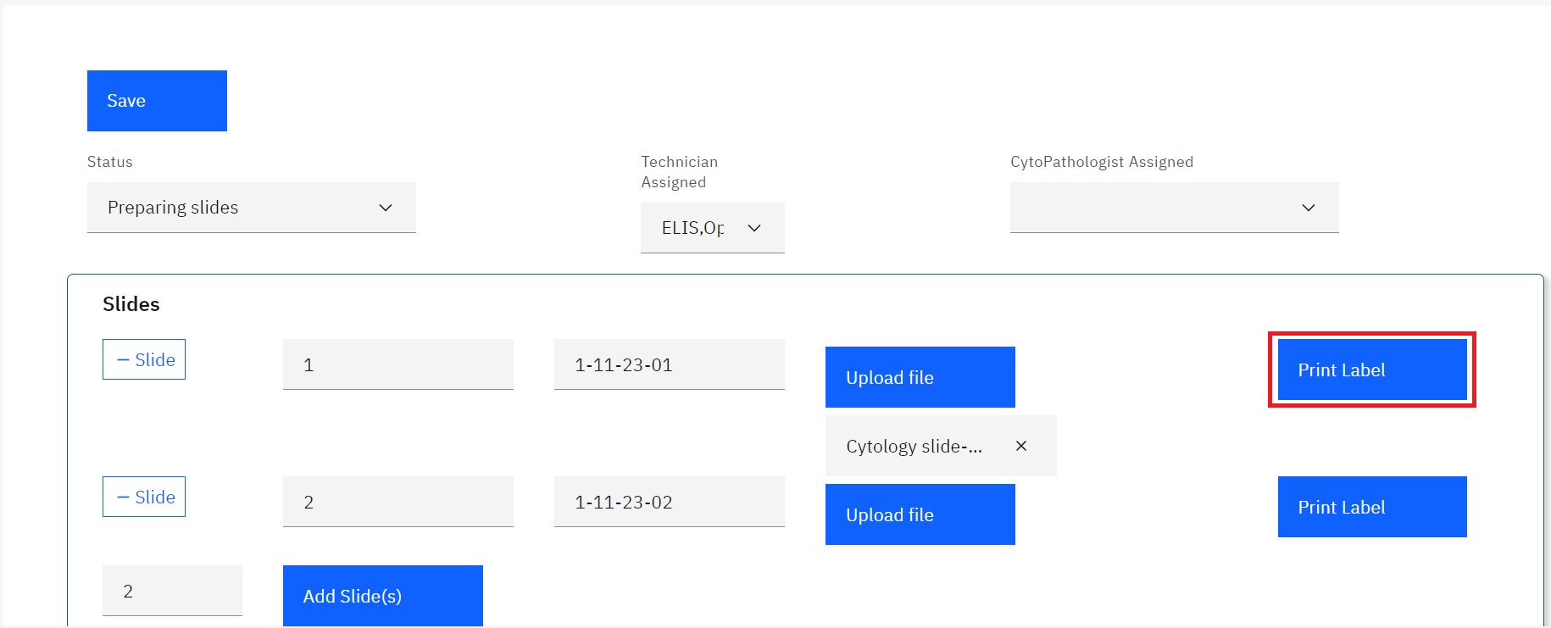

*Click on Print Label*

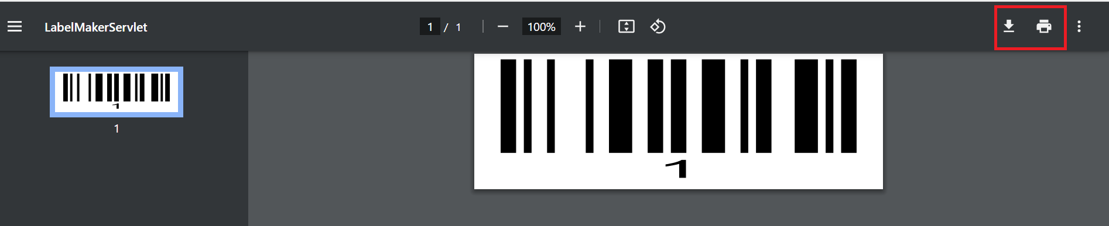

*Download or Print Label*

Note: To remove the uploaded scanned slide file, click on the cancel icon **x.**

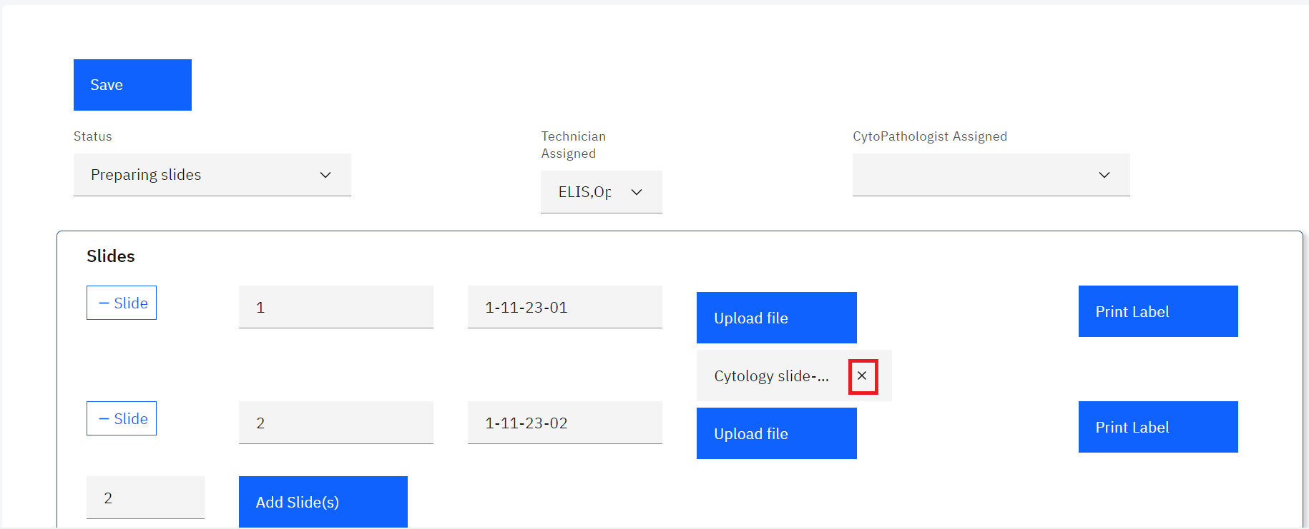

*Removing a Slide*

1. Click on the Save button upon uploading the prepared slide(s).

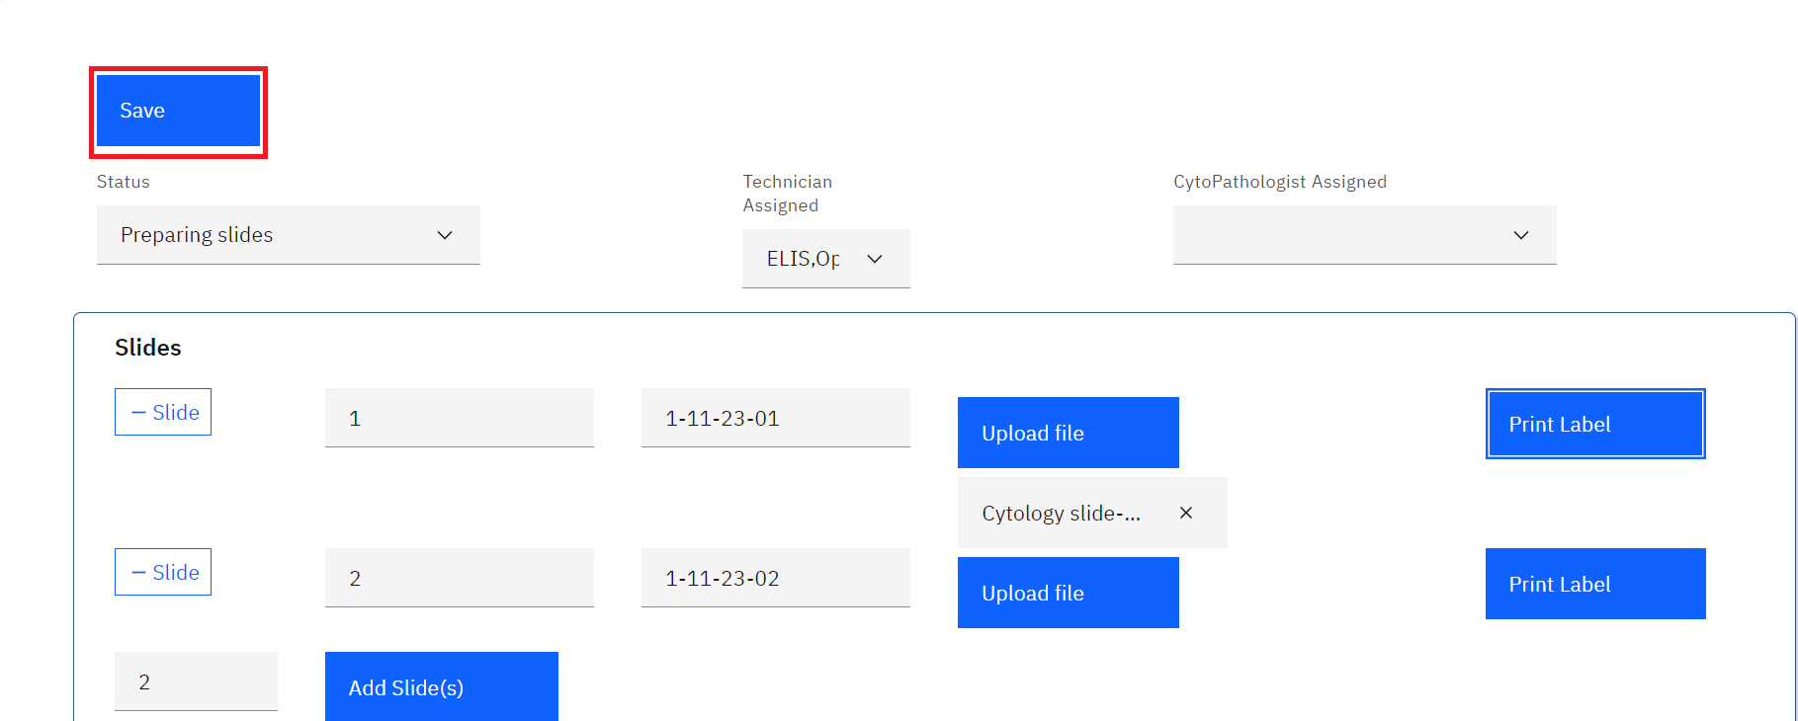

*Saving Prepared Slides*

Note: Upon saving the prepared slide(s) a save successful message will be displayed

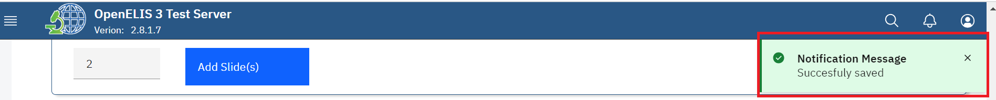

*Slide Saved Successfully.*

1. The slide(s) can now be screened by changing the status to screening. Click on the request under the cytology dashboard page.

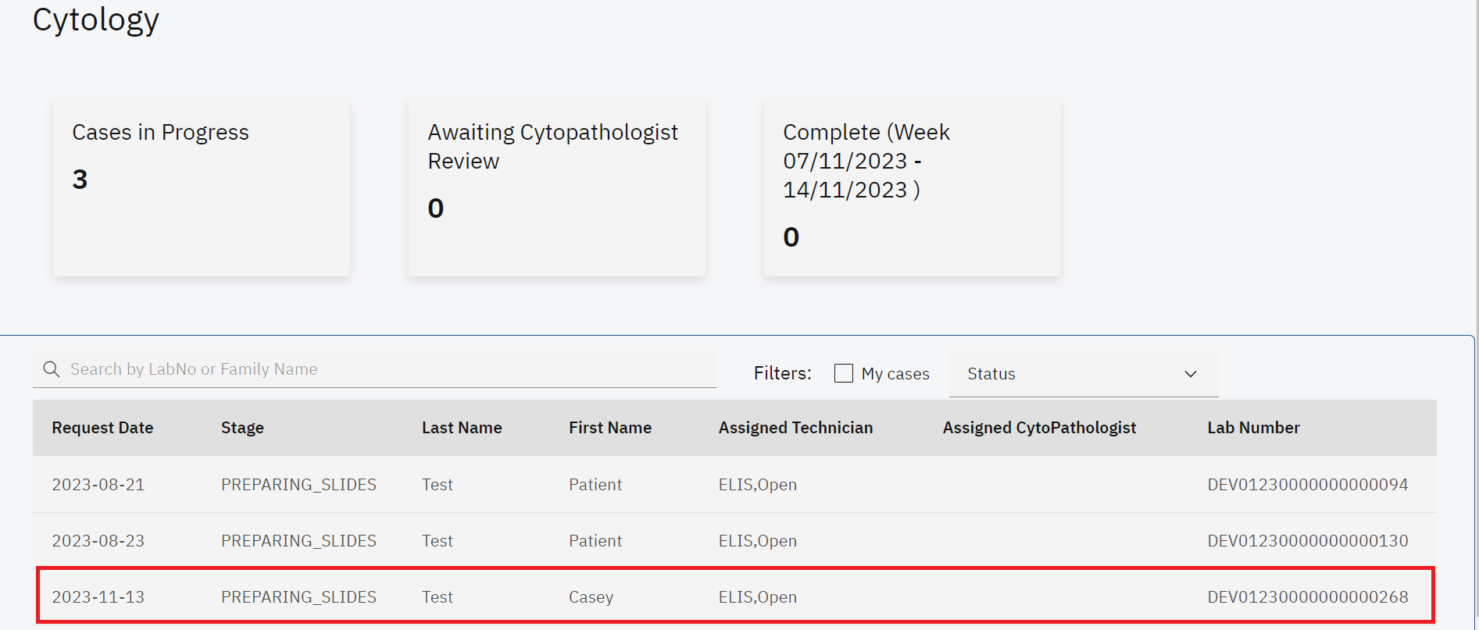

*Click on Request*

1. Click on the **Status** drop-down menu, select screening.
2. Click on the **Technician Assigned** drop-down menu and select the technician then click on the **Save** button. The status will be saved successfully.

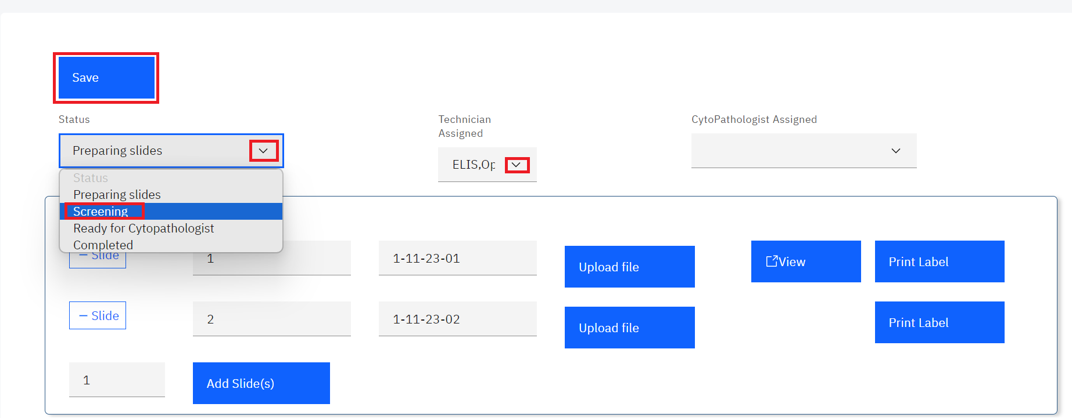

*Change Status and Technician*

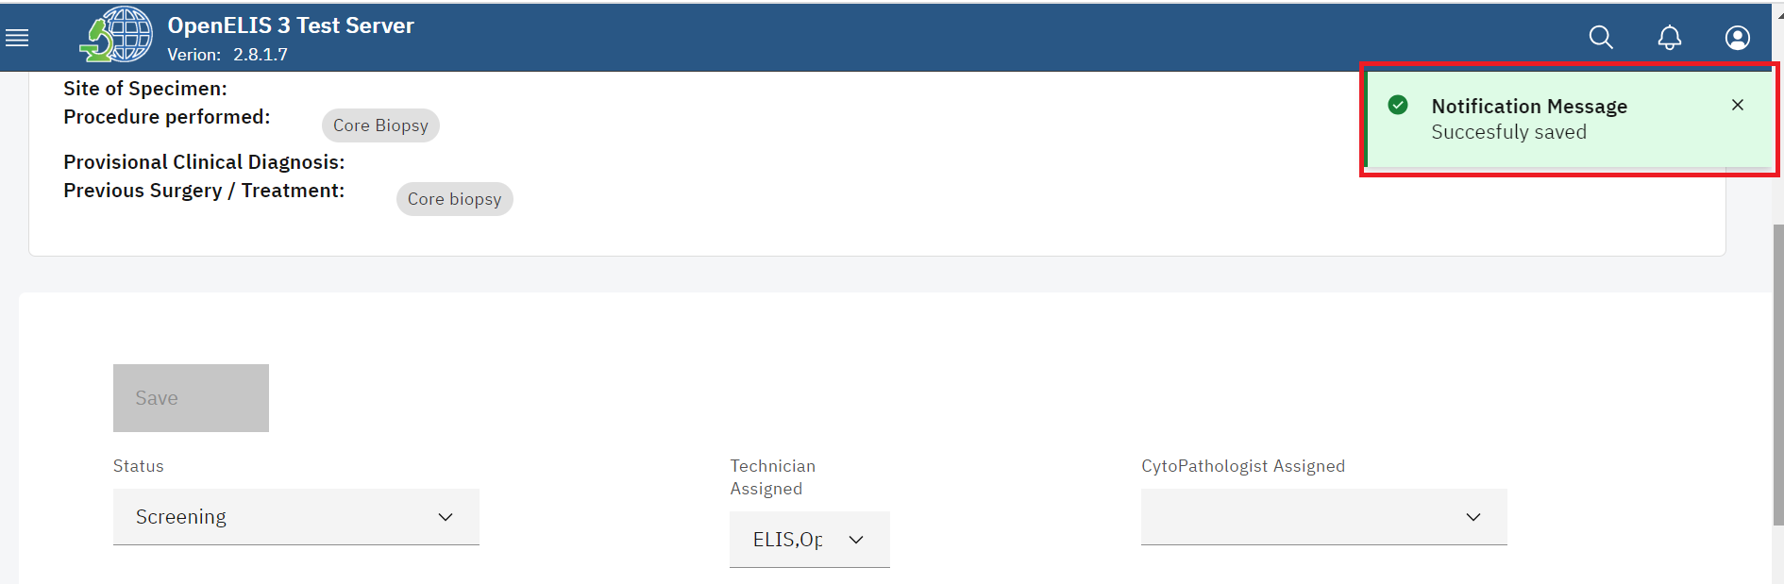

*Status Saved Successfully*

Note: The status for the cytology request will be changed to screening under the list of tests in the dashboard page.

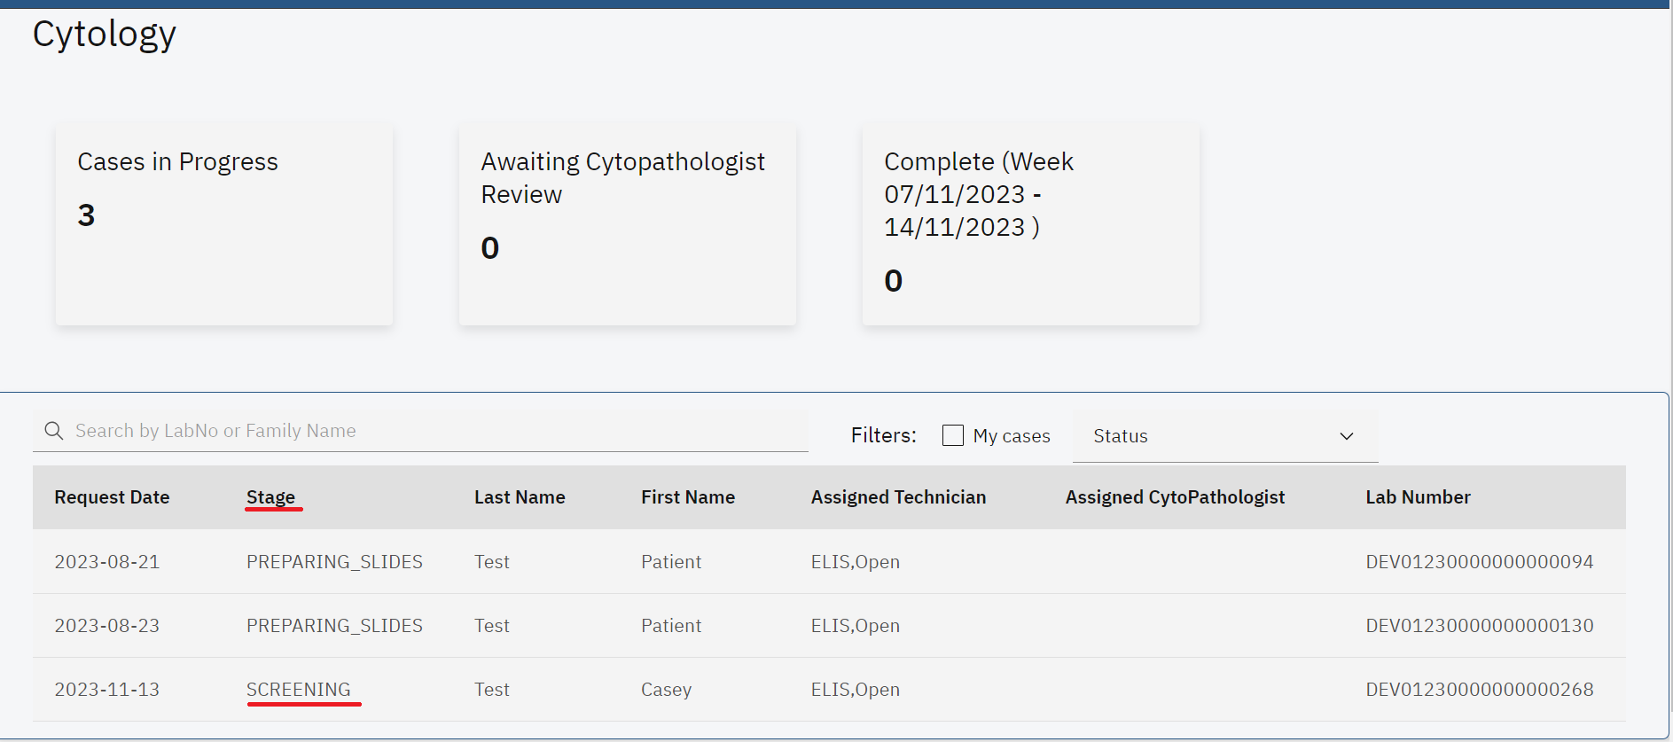

*Slides Status: Screening*

1. The technician can conduct screening for the slides by clicking on the request under the list of tests in the dashboard page.

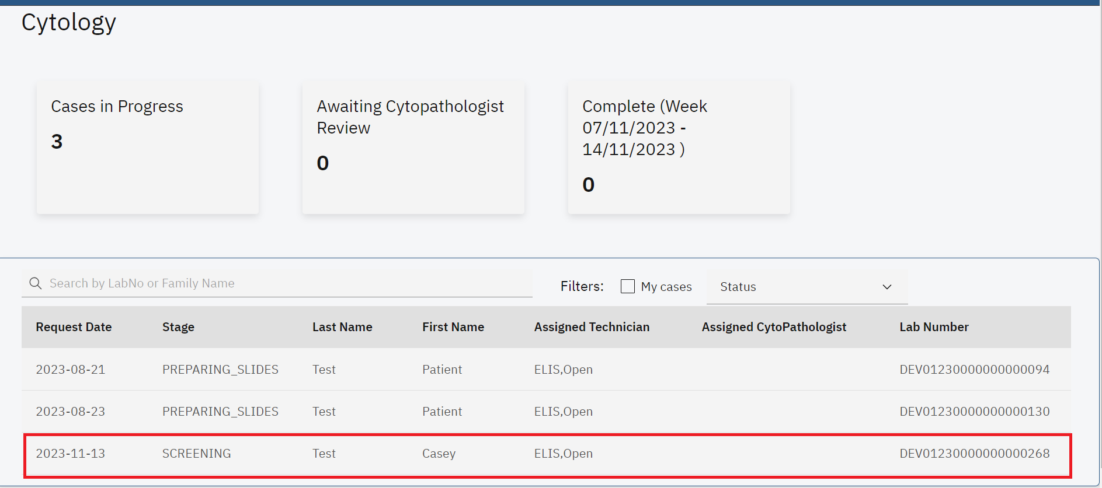

*Click on Request*

Upon clicking on the patient, the cytology test page will be displayed. The laboratory technician can conduct screening on the slides and change the status to Ready for CytoPathologist. The view button will display the uploaded scanned slide in the event the laboratory technician is not physically available in the laboratory.

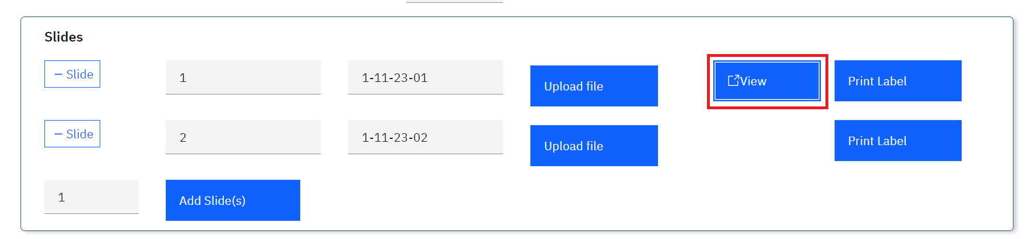

*View Uploaded Slide*

1. To change the status to Ready for CytoPathologist click on the status drop down menu and select Cytopathologist.

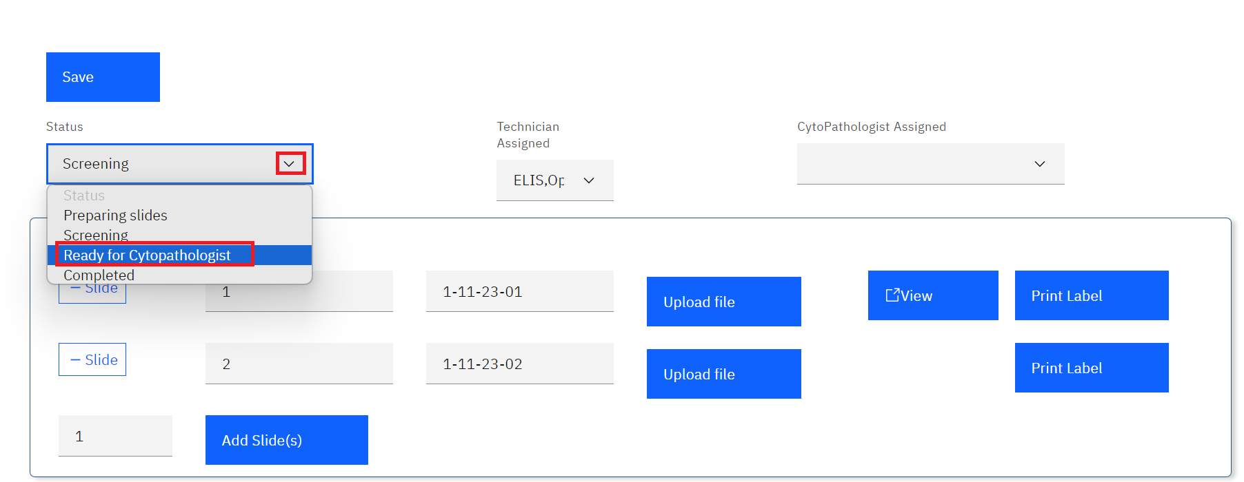

*Ready For Cytopathologist*

1. Click on the CytoPathologist Assigned drop-down menu and select a CytoPathologist.

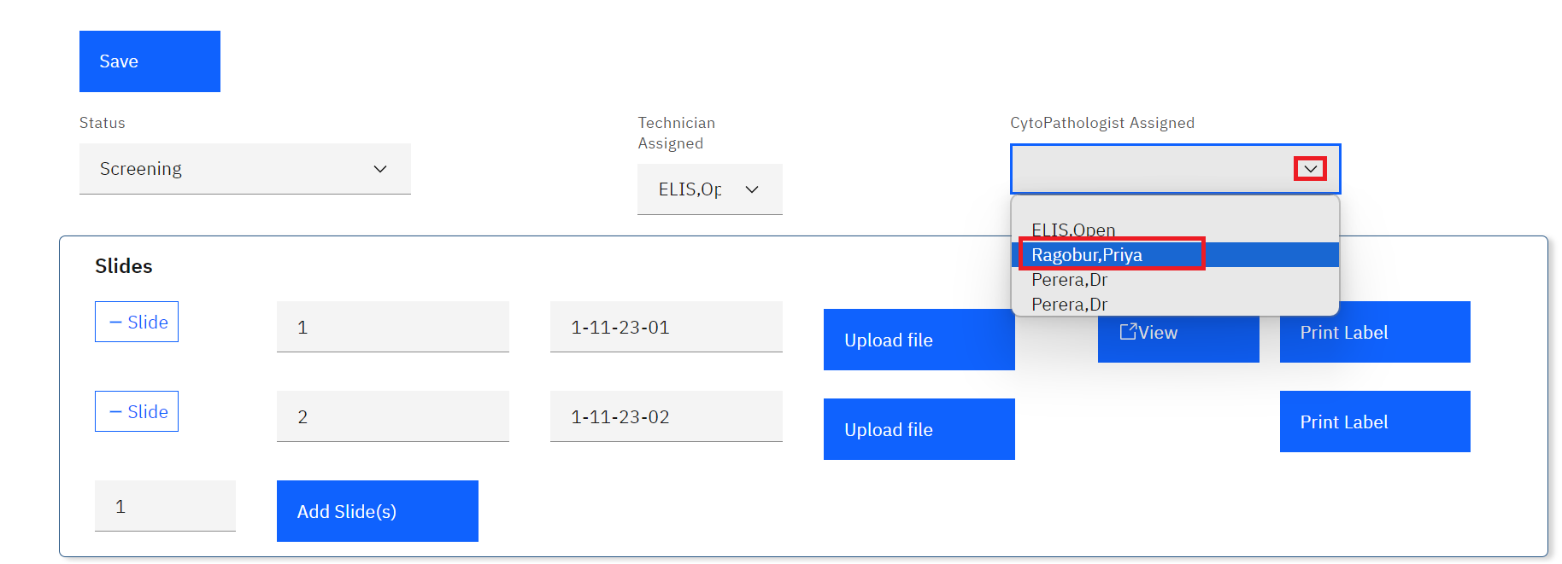

*Select Pathologist*

1. Click on the **Save** button. The status will be saved successfully.

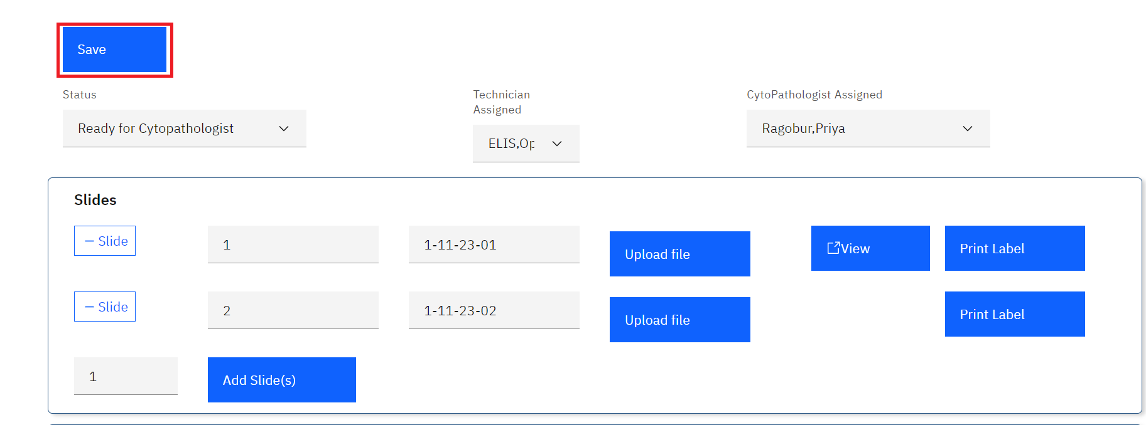

*Click Save*

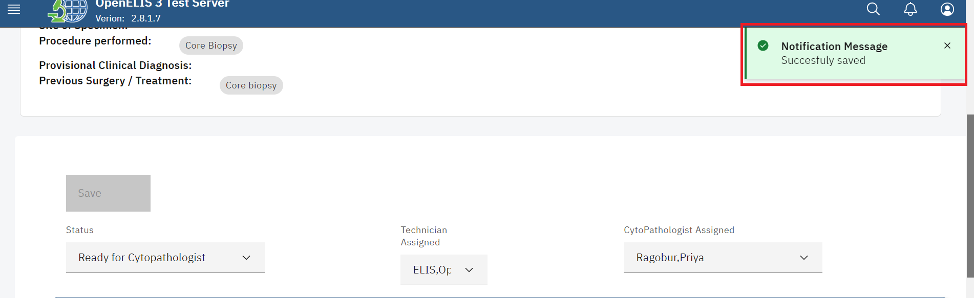

*Status Saved Successfully*

Note: The status for the cytology request will be changed to CytoPathologist under the list of tests in the dashboard page.

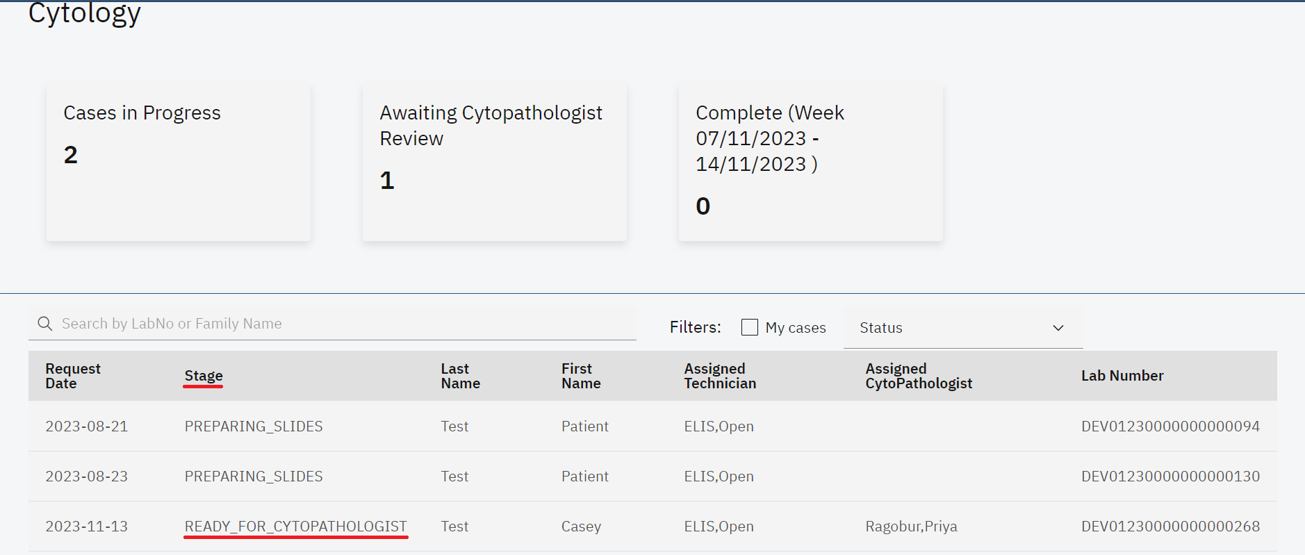

*Ready for Cytopathologist*

1. The slide(s) can now be reviewed by the assigned CytoPathologist. The Cytopathologist will click on the test request under the cytology dashboard page.

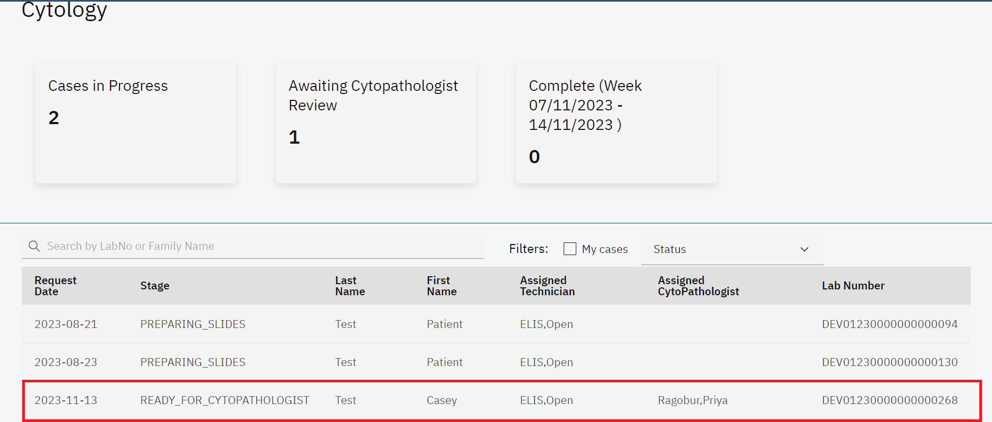

*Click on Request*

1. Upon clicking the test request and accessing the request page, the CytoPathologist will review the test request by scrolling to the bottom of the page and clicking on the **Specimen Adequacy** drop-down menu.

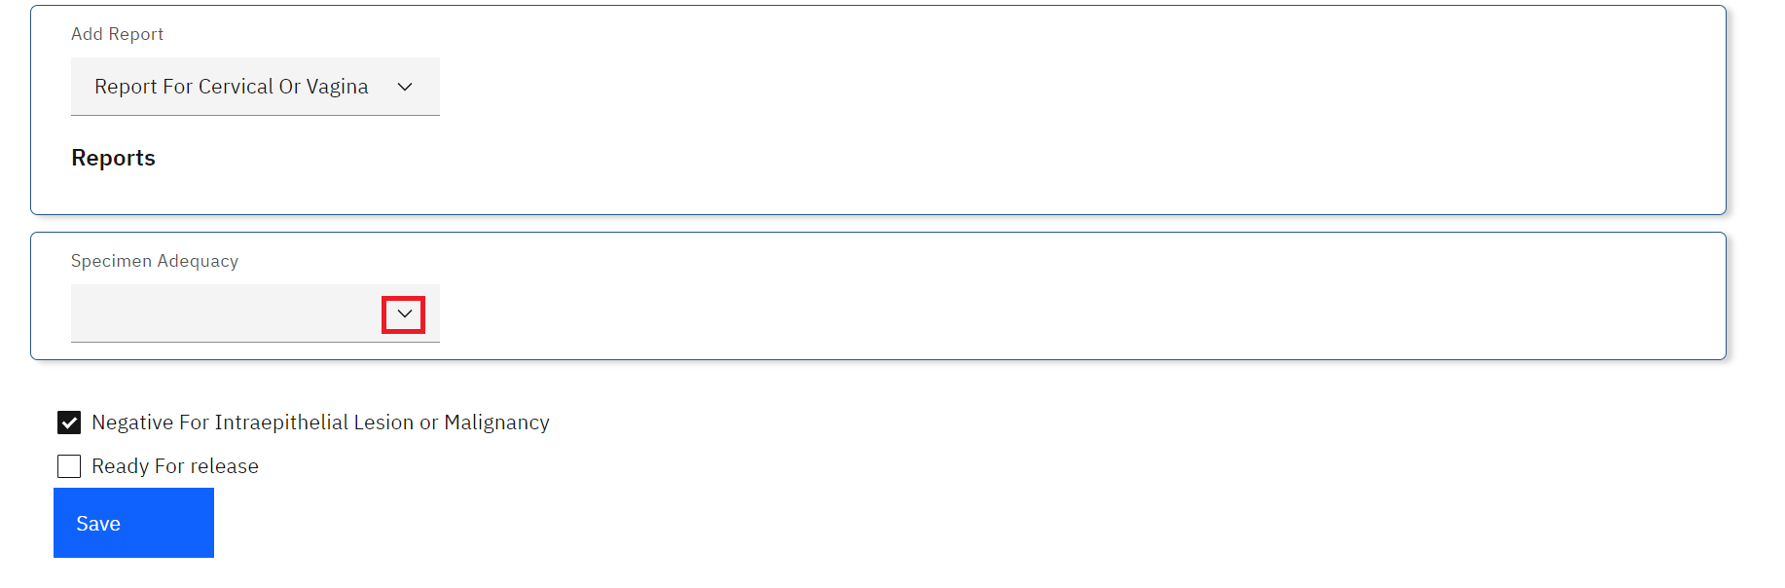

*Click on Specimen Adequacy Drop-down Menu*

1. Upon clicking on the **Specimen Adequacy**, select the appropriate option. In this illustration, the **satisfactory for evaluation** is selected. The selection of **Un Satisfactory for evaluation** under the Specimen Adequacy drop-down menu will display a drop-down menu from which two checkbox options can be selected.

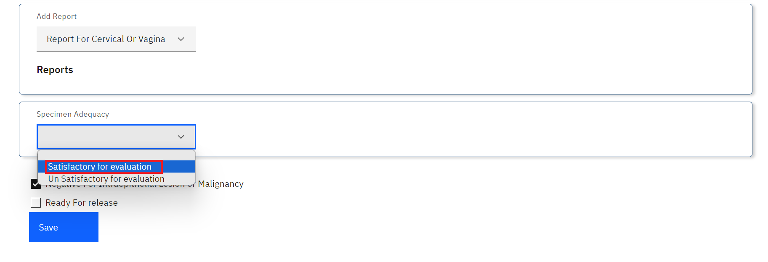

*Satisfactory For Evaluation Option Selection*

1. Upon selection satisfactory for evaluation, two radio buttons will be displayed to select either of the two. In this illustration, the first radio button is selected.

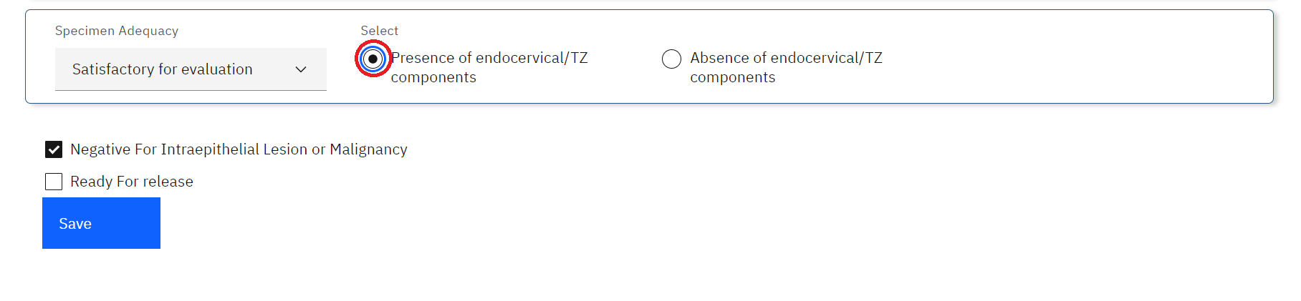

*Presence of endocervical/TZ Component Radio-button*

Note: The Negative For Intraepithelial Lesion or Malignancy checkbox is checked by default. If this is the case with the cytology test request, the reviewer would proceed and validate the results by checking the Ready For Release checkbox and clicking on the Save button.

1. In this illustration, the **Negative For Intraepithelial Lesion or Malignancy** checkbox is checked, click on the **Ready for Release** checkbox then click on the **Save** button.

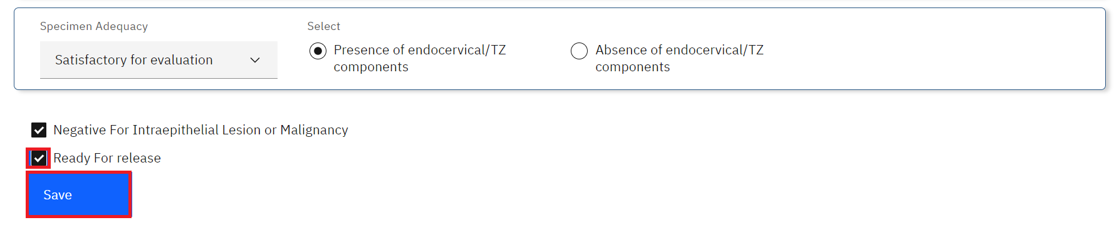

*Validate and Save*

Note: The following workflow is presented when there is **Intraepithelial Lesion or Malignancy**.

1. In the event the **Intraepithelial Lesion or Malignancy** is not negative, uncheck the check-box. This will expand drop-down sections for **Epithelial Cell Abnormality**, **Non-neoplastic cellular variations**,**Reactive cellular changes**,**Organisms** and **Other Diagnosis Result.**

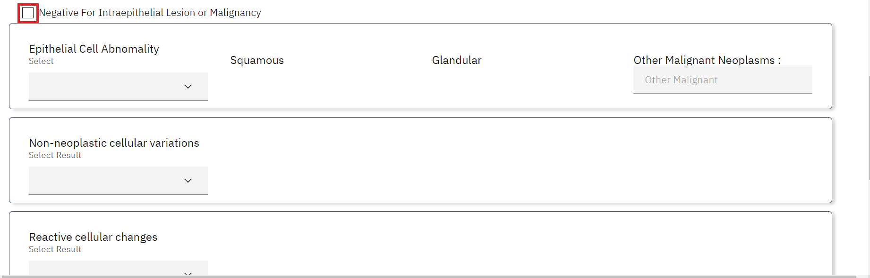

*Intraepithelial Lesion or Malignancy Checkbox Unchecked*

1. Click on the **Epithelial Cell Abnormality** drop-down menu and select the applicable checkbox(s).

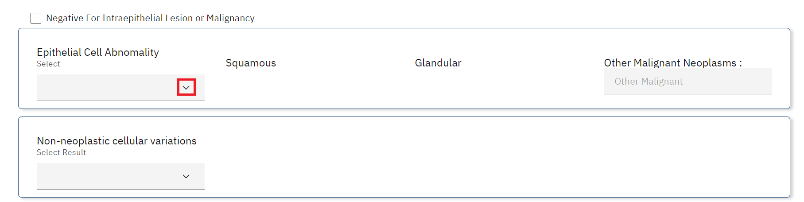

*Select Epithelial Cell Abnormality Drop-down Menu*

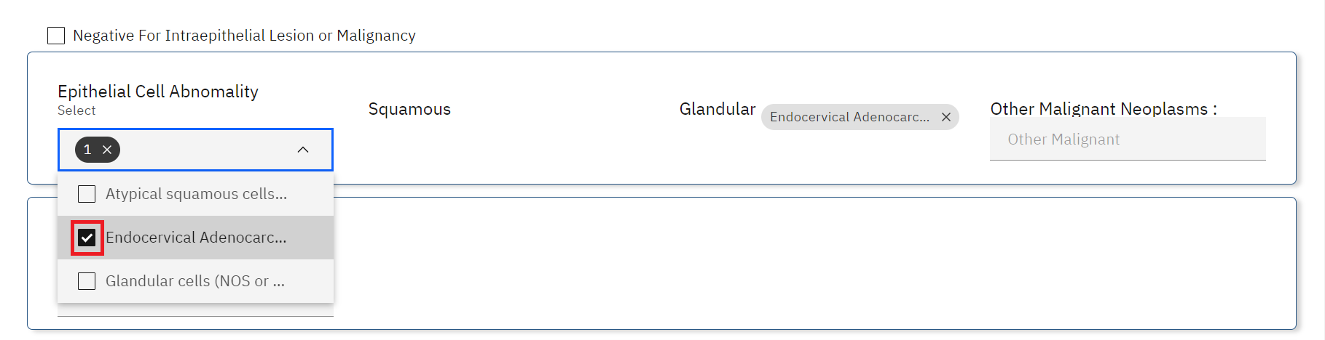

*Select Applicable Checkbox(s)*

1. Fill in the Neo Malignancy text field.

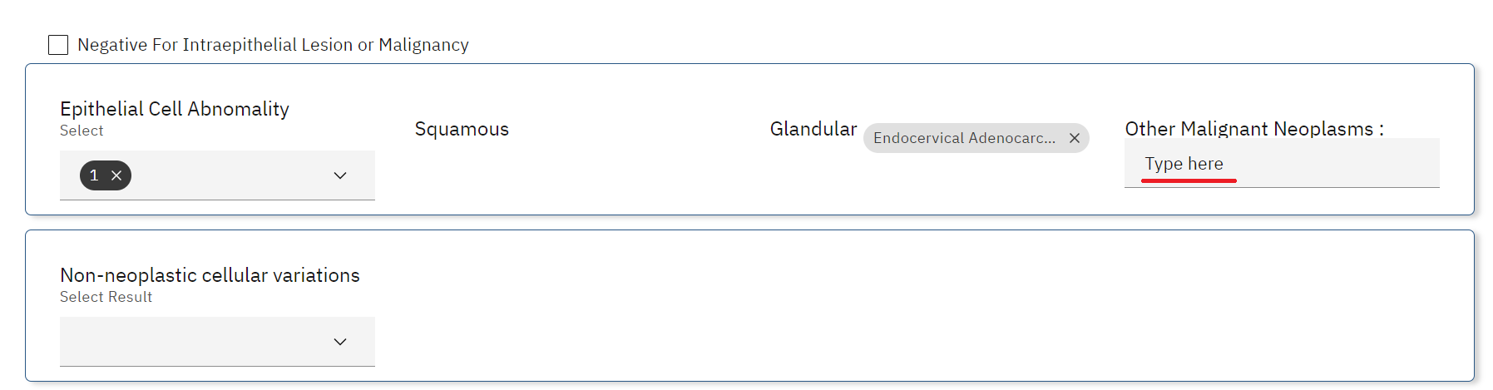

*Other Malignant Neoplasms*

1. Fill in the **Non-neoplastic cellular variations** fields by selecting the options from the checkboxes.

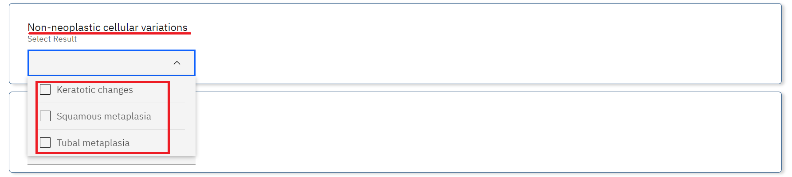

*Non-neoplastic cellular variations*

1. Fill in the **Reactive cellular changes**  fields by selecting the options from the checkboxes.

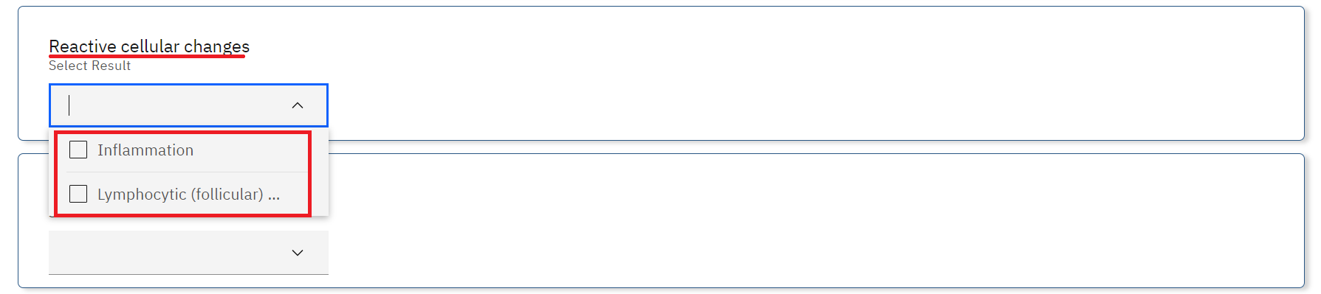

*Reactive cellular changes*

1. Fill in the **Organisms** fields by selecting the options from the checkboxes.

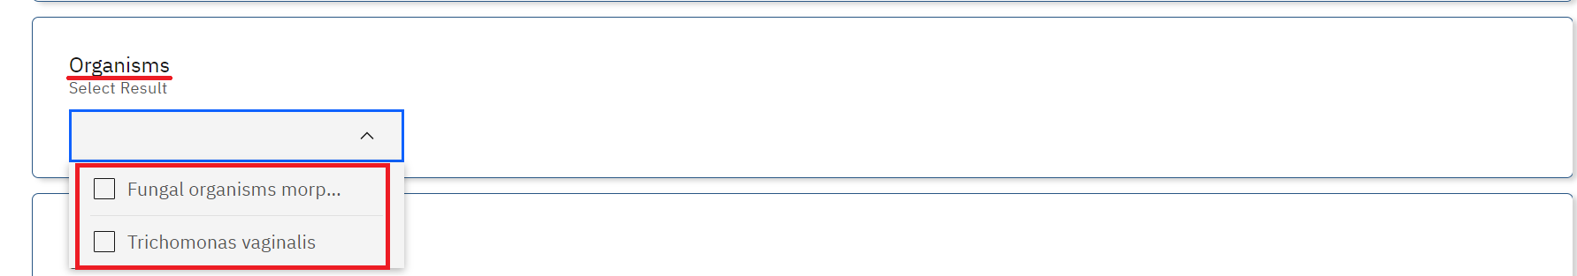

*Organisms*

1. Fill in the **Other Diagnosis Result** fields by selecting the options from the checkboxes.

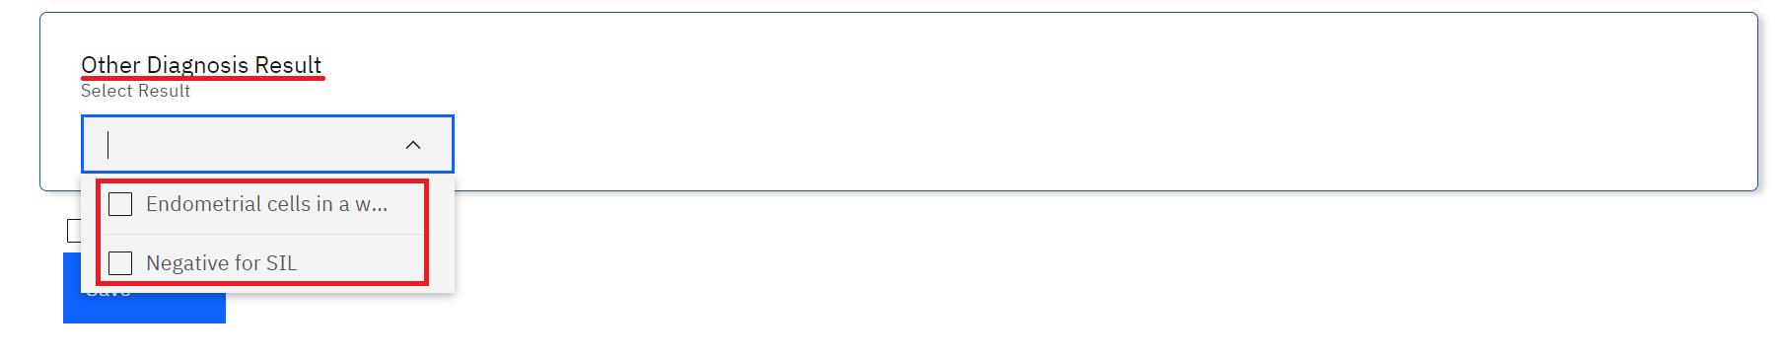

*Other Diagnosis Result*

1. Click on the **Ready for Release** checkbox then click on the **Save** button.

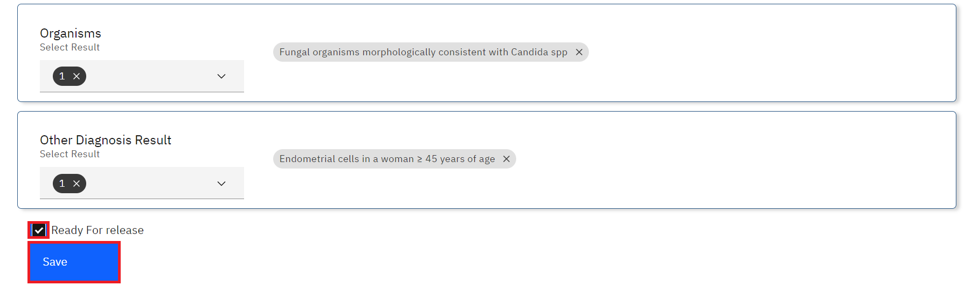

*Validate and Save*

1. Upon Saving, the laboratory technician can mark the cytology test as complete. Click on the test request under the Cytology dashboard.



*Click on Request*

1. To change the status to Completed, click on the status drop down menu and select Completed.

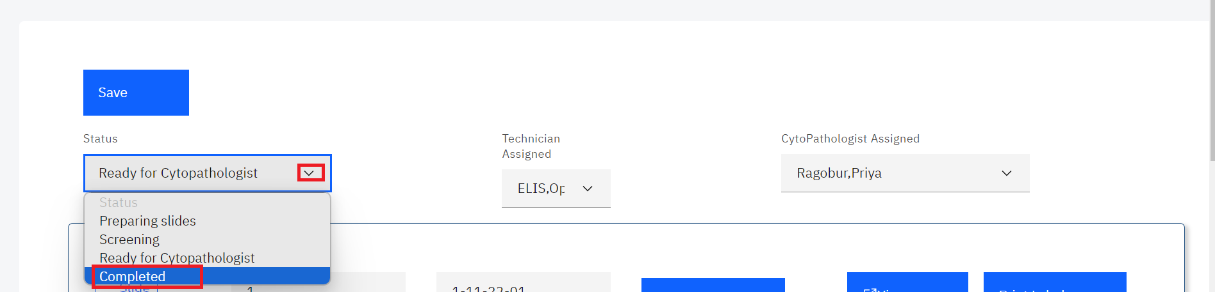

*Status Completed*

1. Click on the **Save** button. The status will be saved successfully.

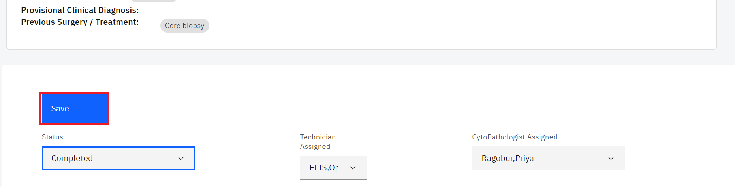

*Click Save*

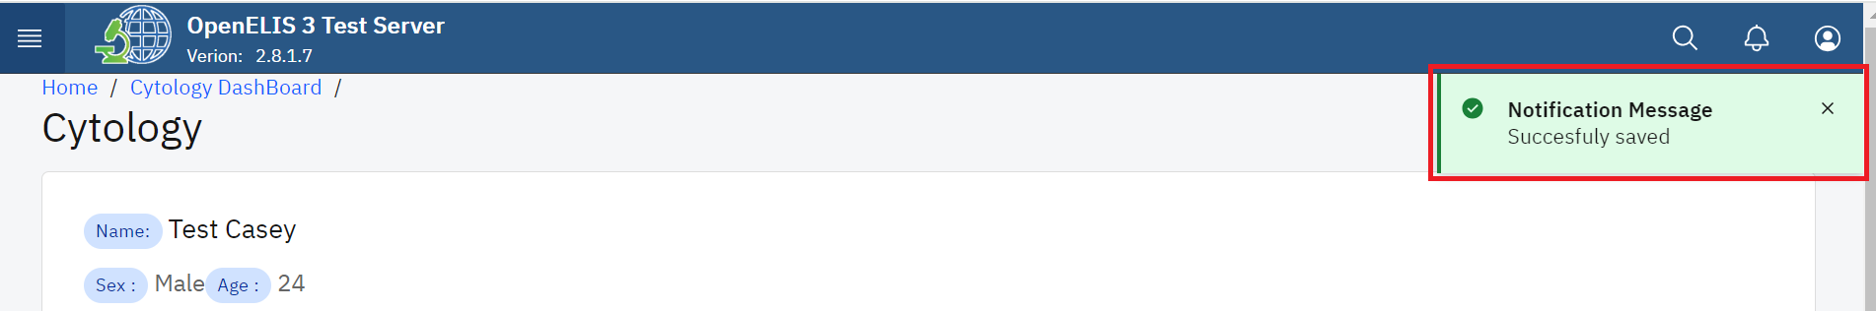

*Save Successful*

The test request will be marked as Completed under the Cytology dashboard

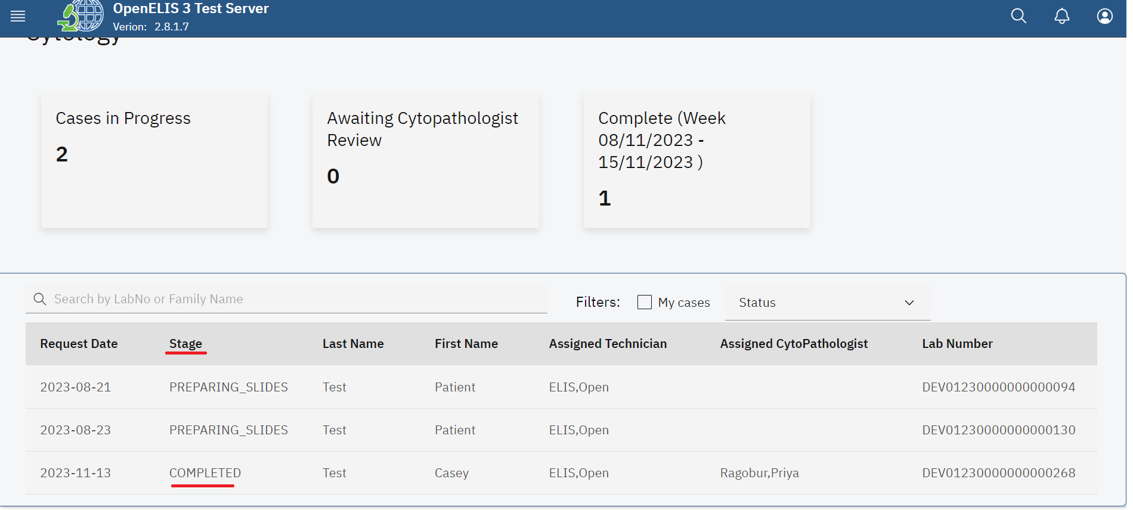

*Status Completed*

## **How to upload or generate a cytology report.**

1. Follow steps 1 -3 under How to access the cytology module and process a test.
2. Click on the desired patient under the dashboard. In this illustration, a patient by the name **Test Casey**  is clicked.

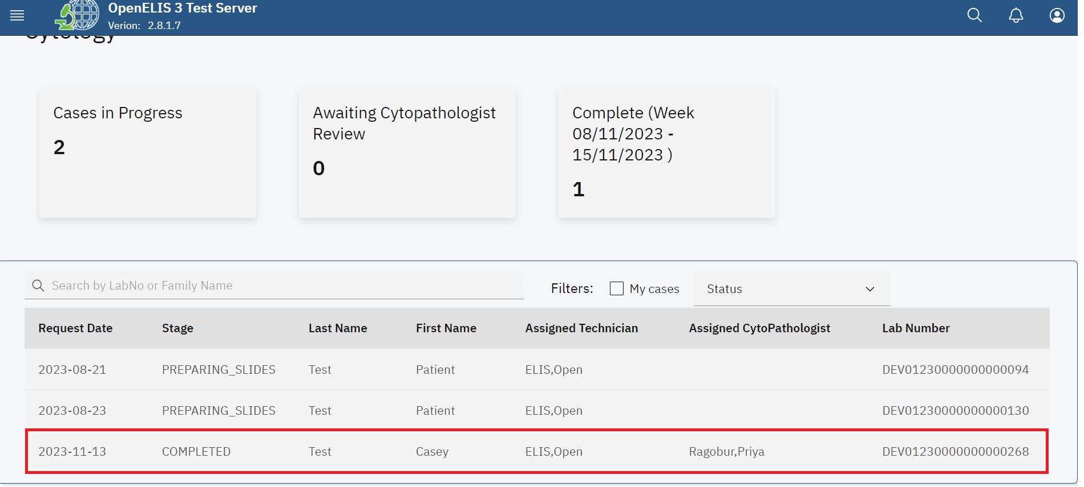

*Click on Patient* 

1. Scroll to the report section and click on the drop-down menu under report.

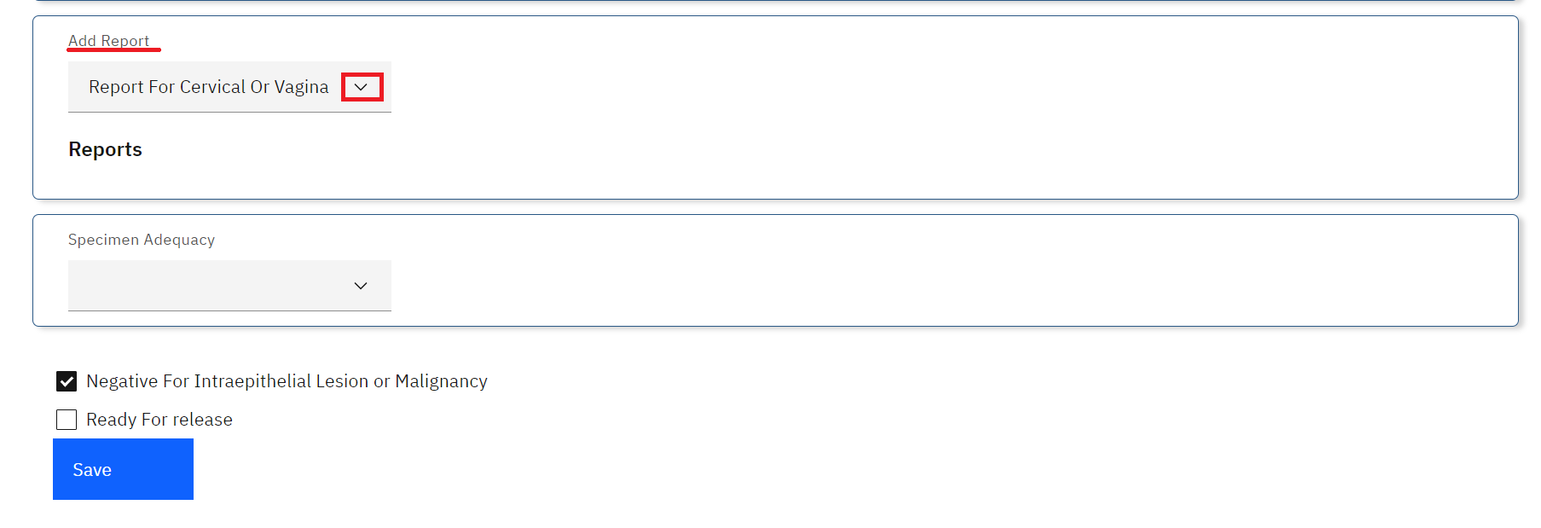

*Click on Add Report Drop-down Menu*

1. Click on the item to generate report

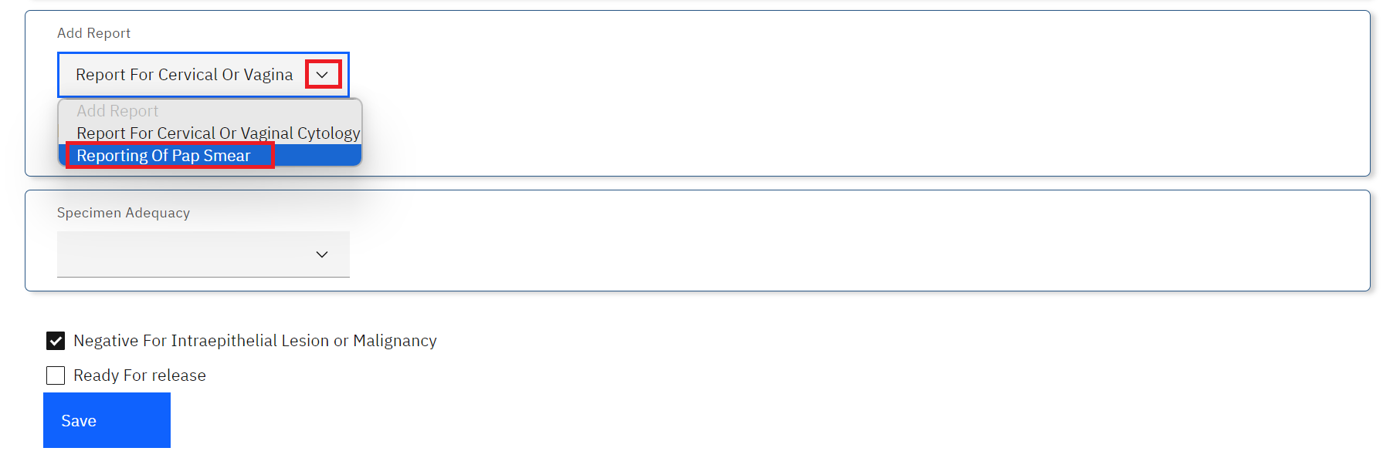

*Select Reporting Item*

1. Upon selecting the item to report on, you can either upload or generate a report. To upload a report, click on the Upload file button.

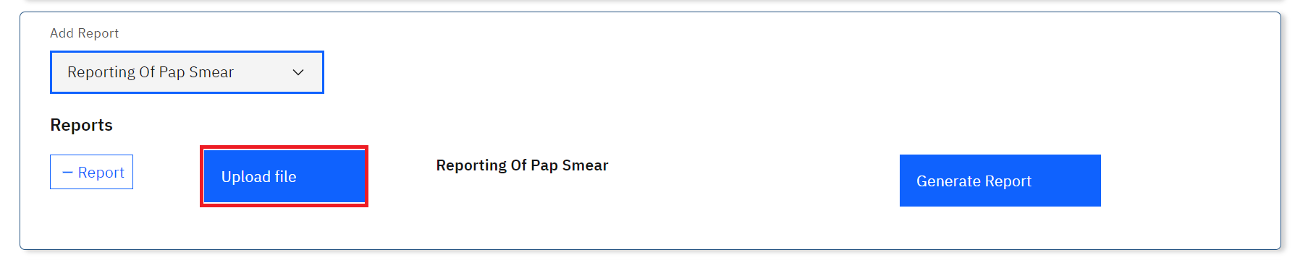

*Click Upload File*

1. Upon clicking on the **Upload file** button, a file upload dialogue will be opened on your workstation. Navigate to the location where you have saved the report for Cytology. In this illustration, the report file for patient **Casey Test** was saved under downloads. Click on the report to select it then click on the **Open** button.

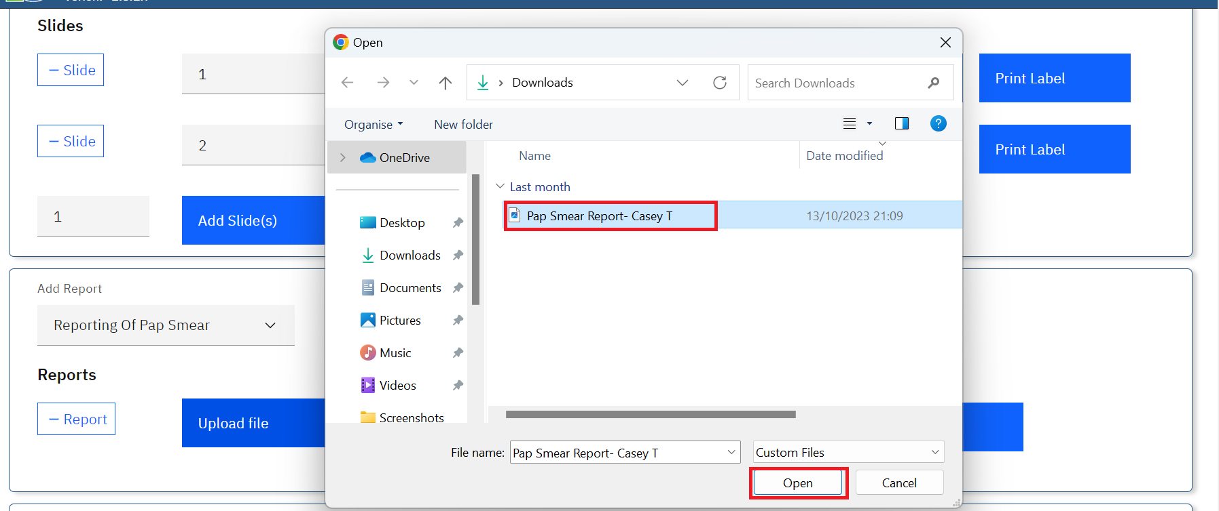

*Upload Report*

Note: upon clicking on the Open button, the report will be uploaded successfully.

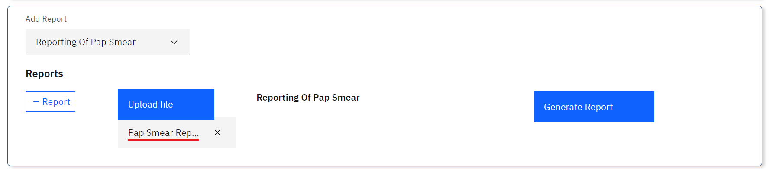

*Report Uploaded Successfully*

1. To remove the report, click on the cancel icon **x.** Otherwise, Click on the **Save** button at the bottom of the page**.**

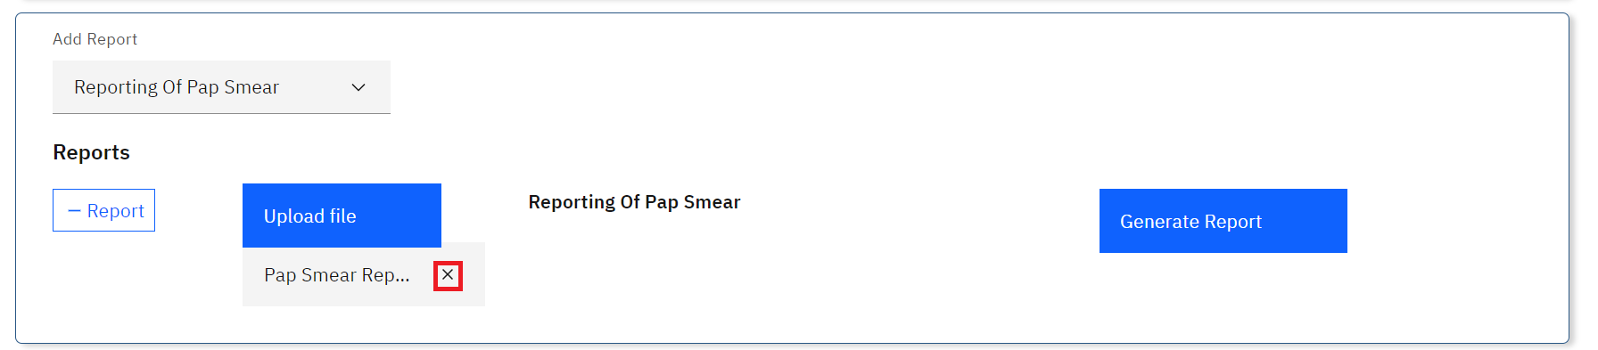

*Removing a Report*

1. As a user, you can generate a report from the system as opposed to uploading one. To do so, Click on the item to generate report under the Add Report drop-down menu



*Select Reporting Item*

1. Click on the **Generate Report** button. The report will be generated successfully.

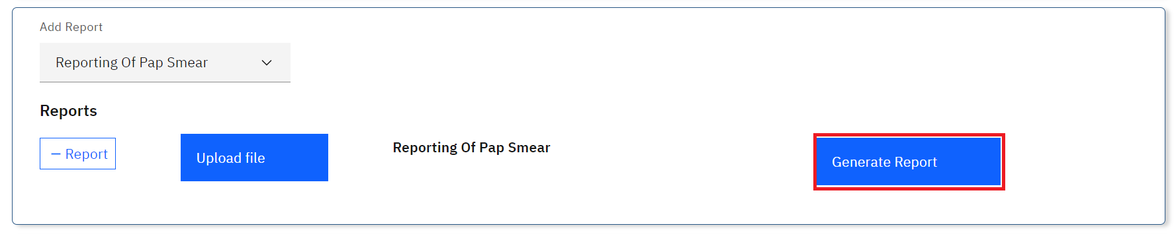

*Generate Report*

Note: a pdf containing the patient report will be generated successfully.

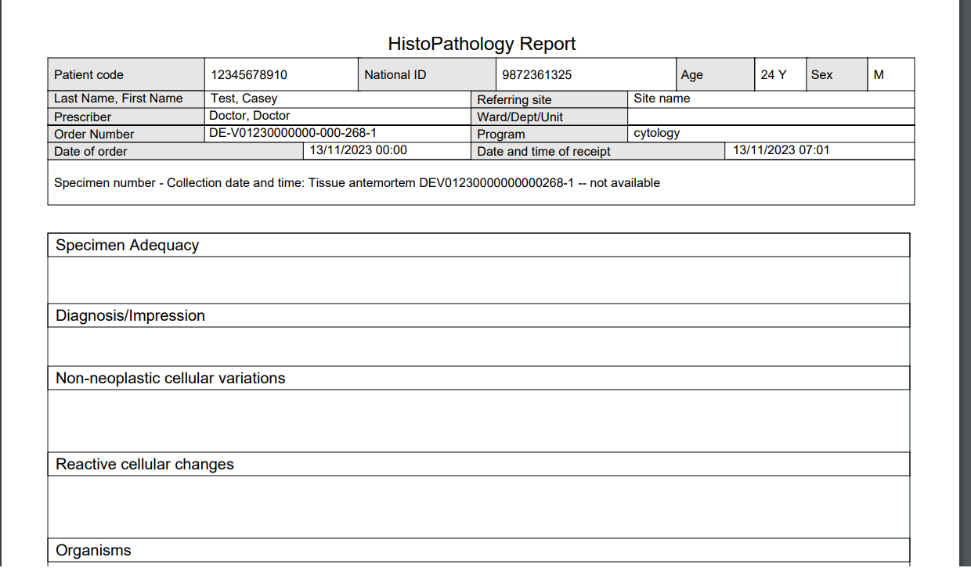

*Sample Cytology Report*

1. Click on the Save button at the bottom of the page

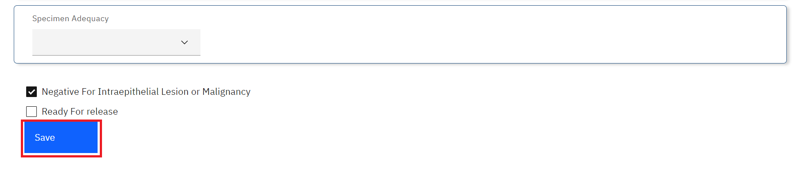

*Click Save*

# **PART 11: NON CONFORMING EVENTS**

A non-conforming event (NCE) or non-conformity is defined as a non-fulfillment of a requirement. An NCE occurs when there is a deviation from established policies and procedures. In the laboratory, examples of NCEs may include:

1. Unlabeled/mislabeled specimens
2. Missing specimens
3. Specimen preparation errors
4. Delay in turnaround times
5. Incorrect delivery of reports
6. Corrected reports

It is essential for quality assurance in the lab that staff and managers log all NCEs and their follow-up.

Non-Conforming Event management consists of four steps with the following guides:

1. Reporting a NCE
2. Creating a Corrective Action Plan
3. Monitoring the Corrective Action Plan
4. Closing an NCE Report

## **How to report a non-conforming event (NCE)**

1. Hover the mouse over the hamburger icon and click to open the menu.



*Access the OpenELIS menu*

1. Hover the mouse and click on the drop-down menu under the **Non Conform** module.

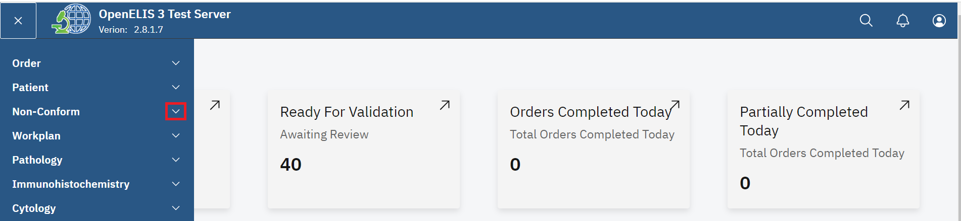

*Click on Non-Conform Drop-down Menu*

1. Click on **Report Non-Conforming Event** sub-menu item.

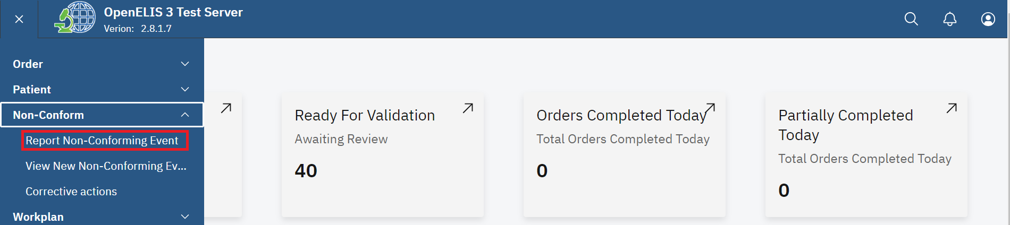

*Click on Report Non-Conforming Event Sub-menu*

1. Hover the mouse over the Non-Conforming Events tab and select Report Non-Conforming Event.

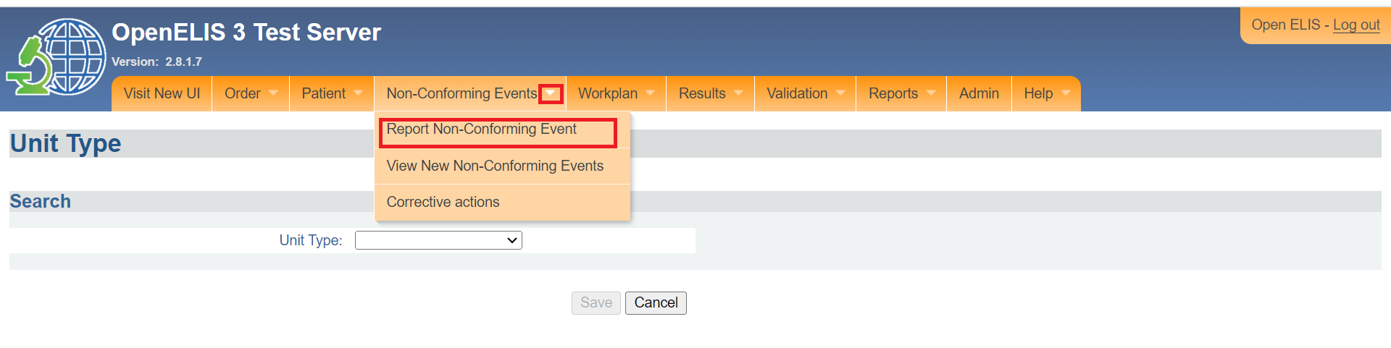*Click on Report Non-Conforming Event Sub-Menu*

1. Search for the lab number associated with the non-conforming event by selecting your search term from the drop-down menu and entering the number or name in the search field. Then click **Search**.

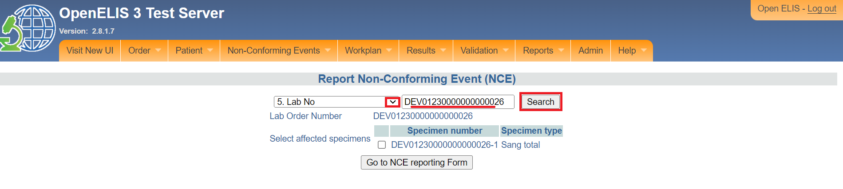*Search by Laboratory Number*

1. The order and its samples will display. Check the box next to the sample implicated in the NCE. If the NCE is not associated with a specific sample, check all the samples. Click the **Go to NCE Reporting Form** button.

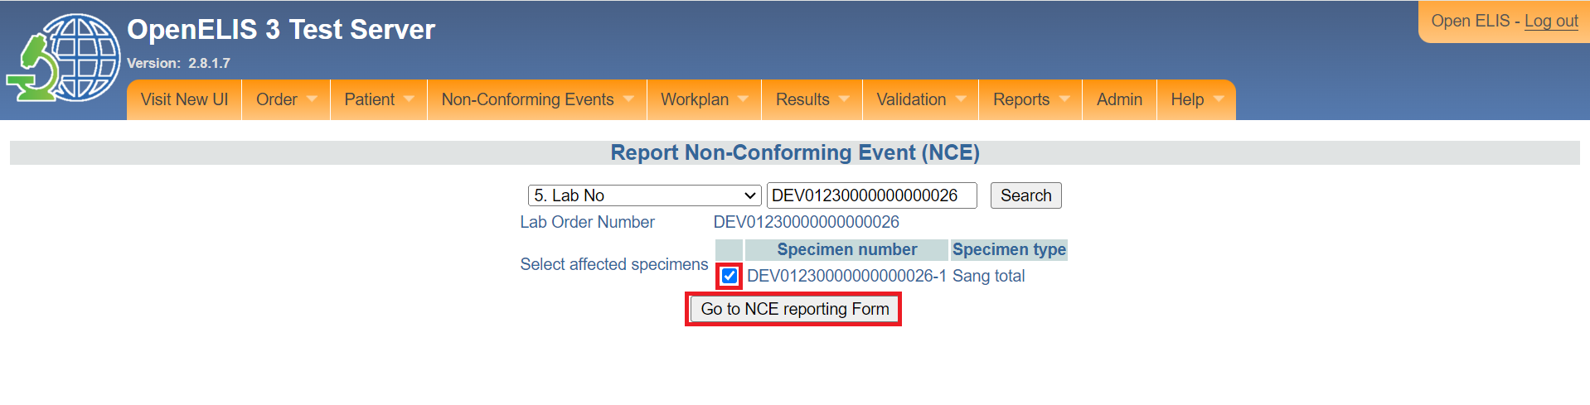*Check Implicated Sample and Click Go to NCE Reporting Form* 

1. Verify the details that are automatically displayed: NCE report date (should be the current date), Name, and the lab order number, and specimen number.
2. Fill in the Name of person reporting if different, if needed.

**Note:**Name refers to the person filling this form. The staff member filling out the NCE reporting form may not be the same person who noticed or observed the NCE and reported it. Use the Name of person reporting (if different) for the person who first observed the NCE. OpenELIS will automatically assign an NCE Number to the report.

1. Fill in the date of the NCE (this may be different from the report date).

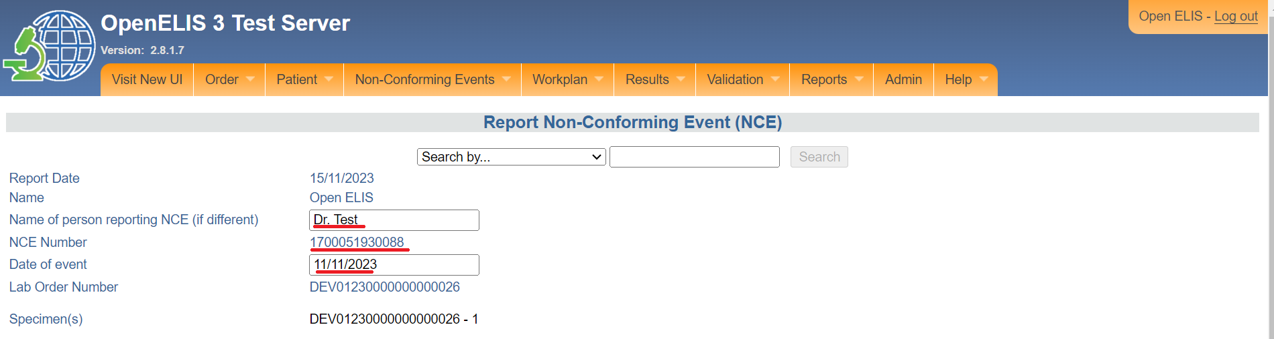

*Fill in Name of Reporting Person and Date*

1. Select the Reporting Unit.
2. Enter a Description of the NCE.
3. Enter the Suspected Cause of the NCE.
4. Enter the Proposed Action.
5. Click the **Submit** button.

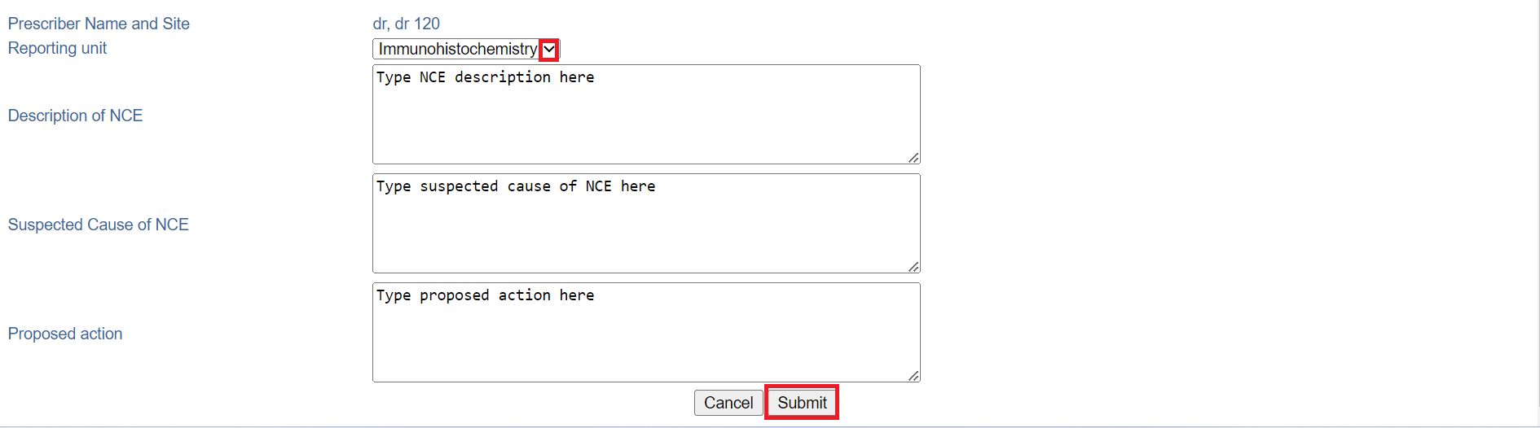*Fill Fields on Form and Click Submit*

A message will show that the form has been saved.

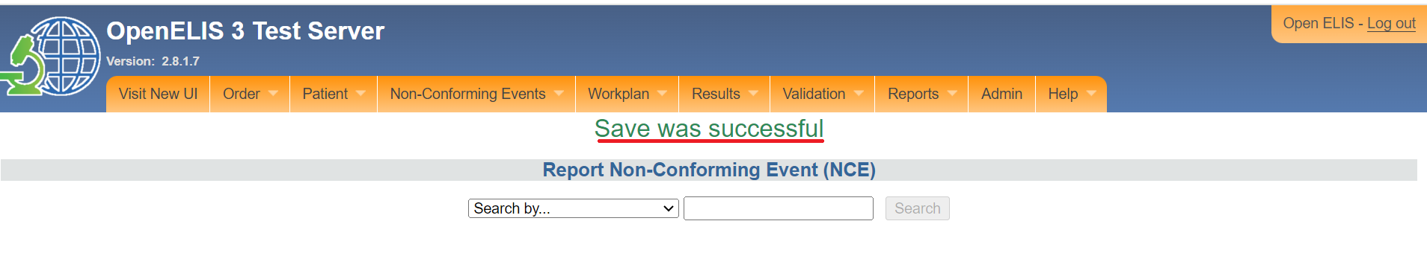*Save Successful*

## **How to create a NCE Corrective Action Plan**

After the NCE reporting form has been filled, the next step is to fill the NCE Follow-Up Form. This may be done at a later date, per laboratory procedures.

1. Select View New Non-Conforming Event from the menu under the Non-Conforming module

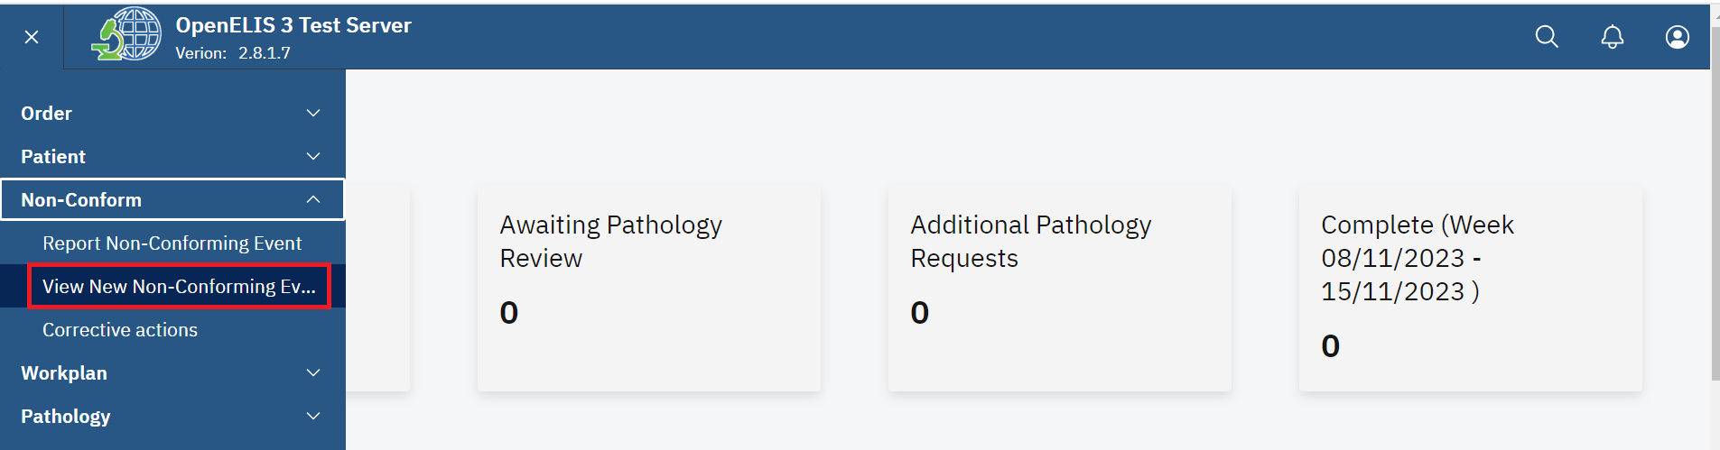*View New Non Conforming Event*

1. Hover the mouse over the Non-Conforming Events tab and select View New Non-Conforming Event.

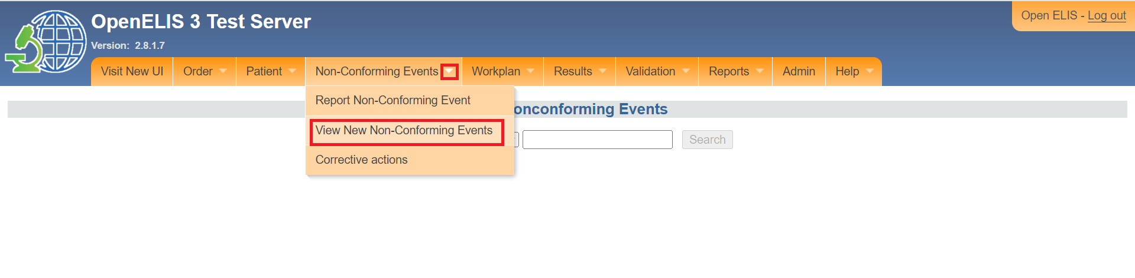*Click View Non-Conforming Events*

1. Select **Lab Number** or **NCE Number** as your search term and enter the number in the search field. Click the **Search** button. In this illustration the lab number DEV12300000000000126 is typed.

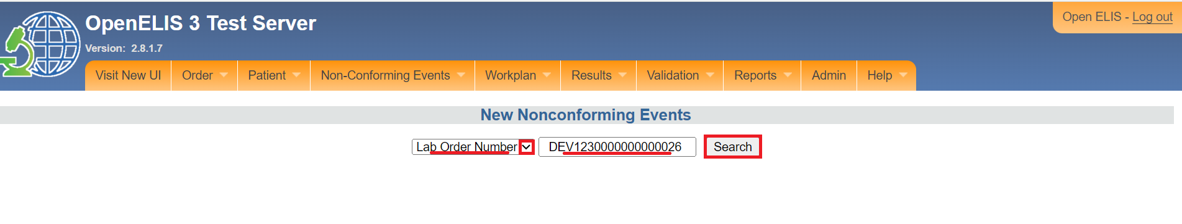

Note: The NCE Follow-up Form has two parts: The NCE description section and the Corrective Action Plan.

**NCE Follow-up Form: Part 1- NCE Description**

1. Verify the details of the NCE in the form. Fill in the remaining elements of the form using the dropdown lists.

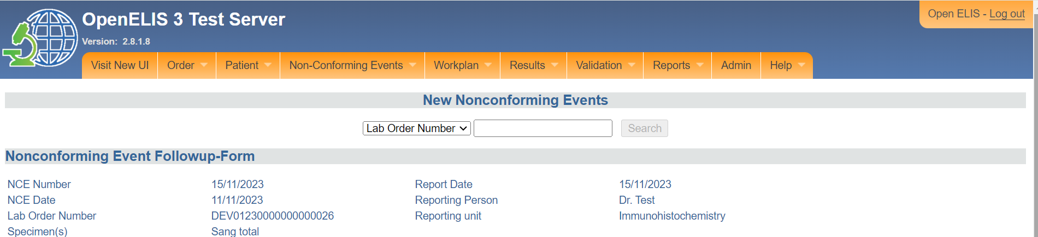

*Verify the Details*

1. Select the Laboratory Component (the NCE concerns which component of the lab).
2. Select the NCE Category.
3. Select the CE Type
4. Select the Severity
5. Select the Likely recurrence

The Severity Score is automatically calculated.

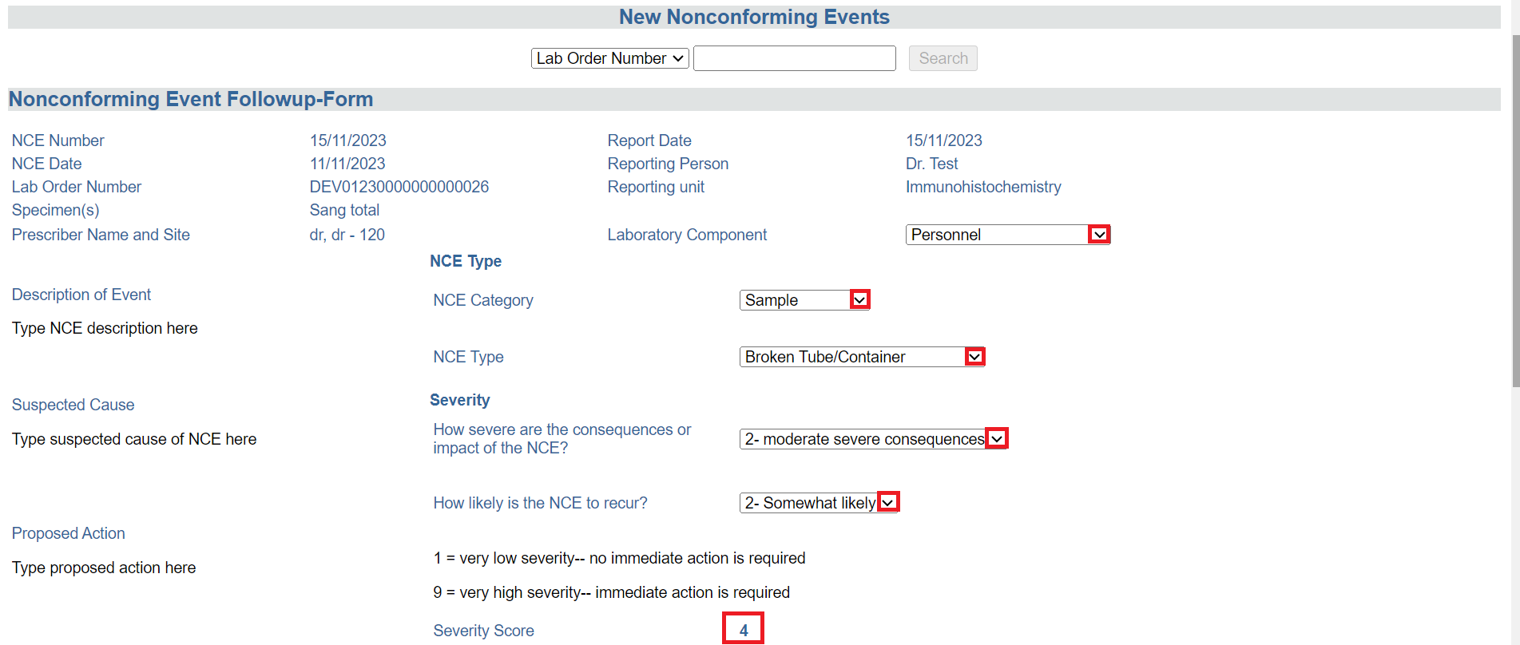*NCE Details*

**NCE Follow-up Form: Part 2- Corrective Action Plan**

1. Enter the Description of the Corrective Action, the Preventive Action or Concurrent Control Action, and any Comments in the designated text boxes of the form.
2. Click on the Submit button.

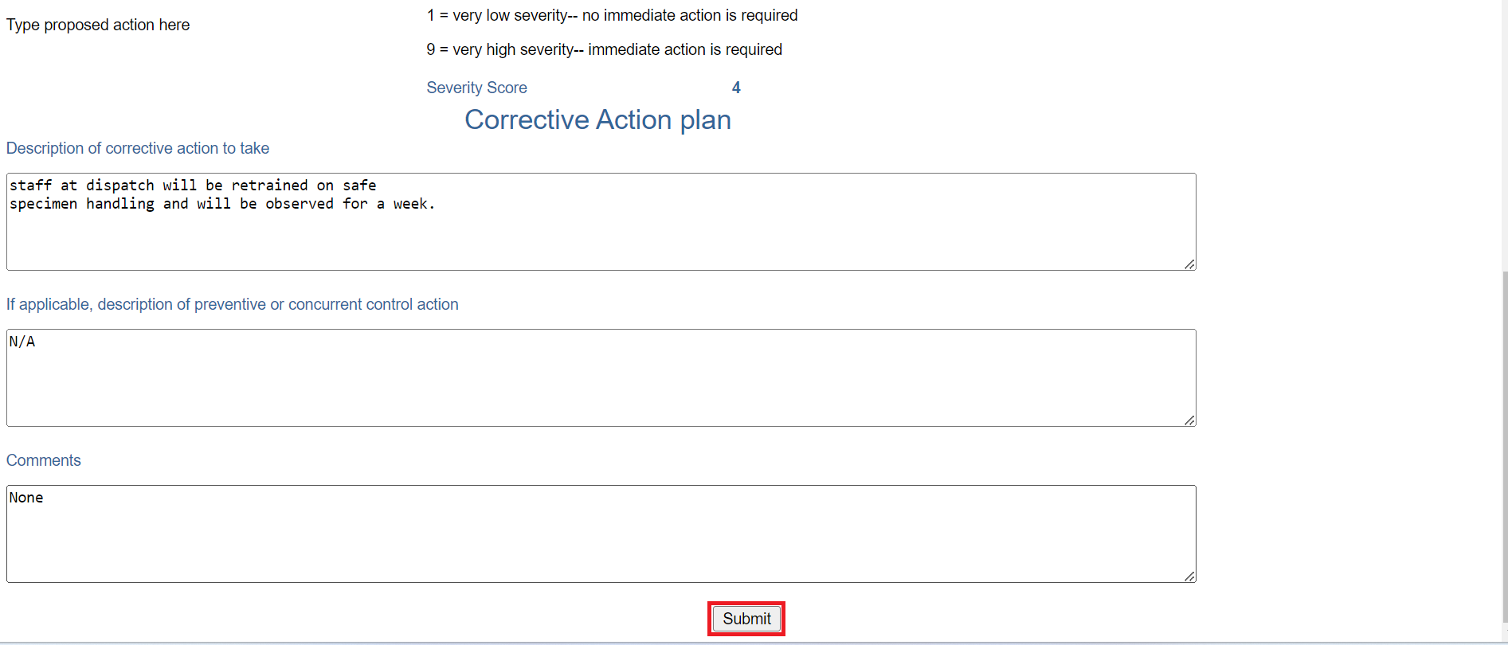

*Enter Corrective Action Plan*

Upon clicking on the Submit button, a success message will be displayed at the top of the page.

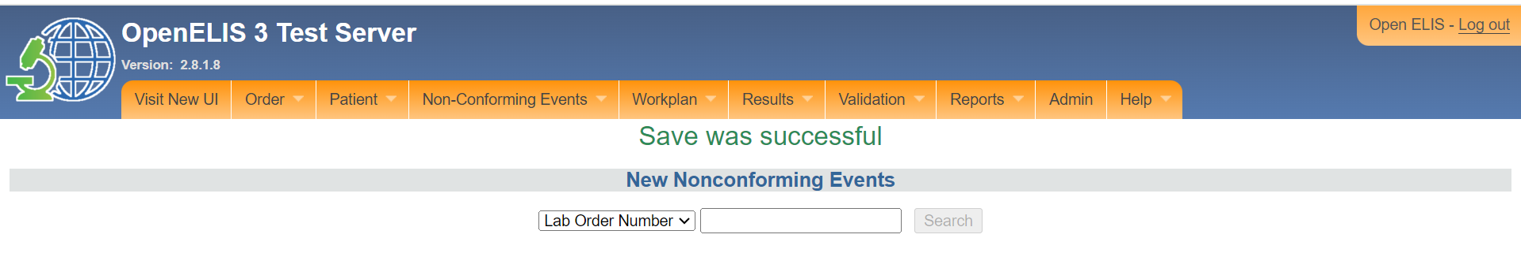

*Saved Successfully*

## **How to monitor an NCE Corrective Action Plan**

After the NCE follow-up form has been filled, activities related to corrective action or closing the NCE report should be logged in the Corrective Actions form, per laboratory procedures.

1. Select **Corrective Actions** from the menu under the Non-Conforming module

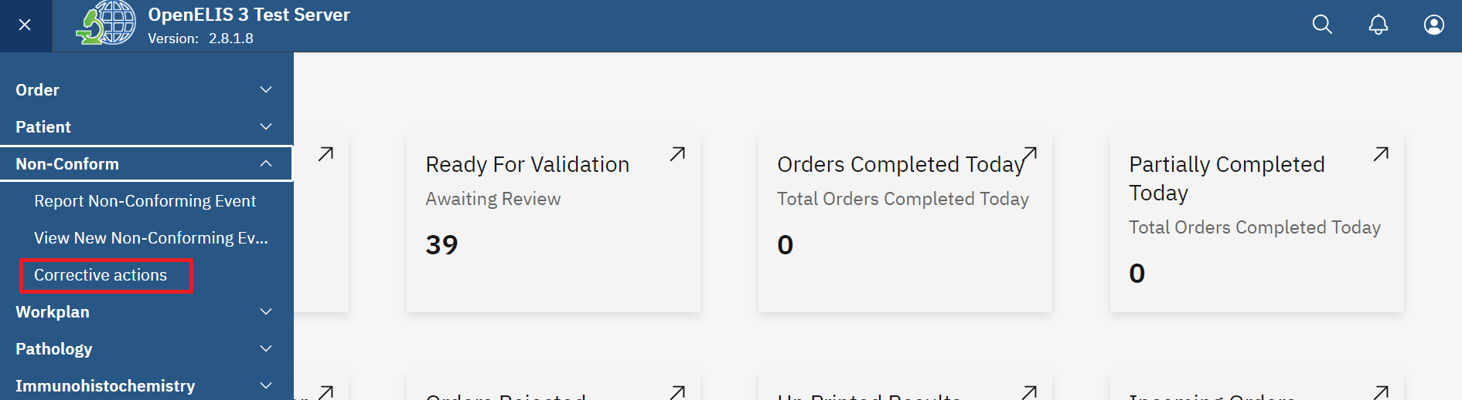*Select Corrective Actions*

1. Hover the mouse over the Non-Conforming Events tab and select **Corrective Actions** .

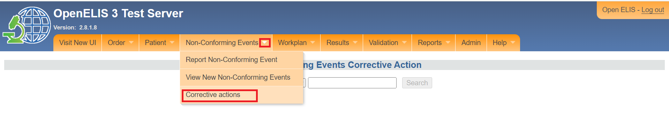*Select Corrective Actions*

1. Select **Lab Number** or **NCE Number** as your search term and enter the number in the search field. Click the **Search** button.

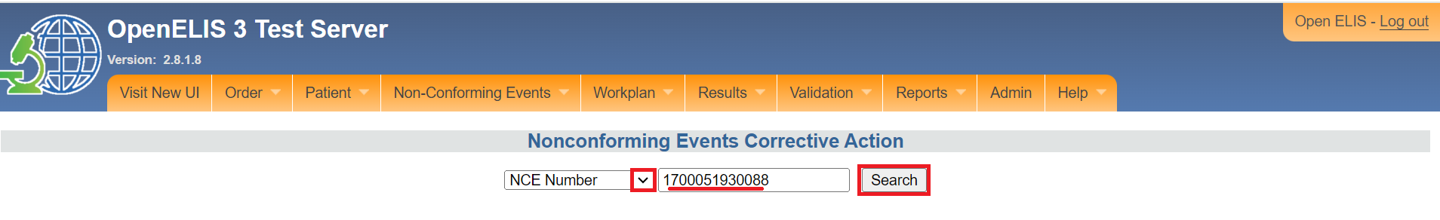*Select Lab Number or NCE Number Enter and Search*

Note: The NCE Corrective Action form has three parts: the NCE description; the corrective action log section; and the NCE Resolution section.

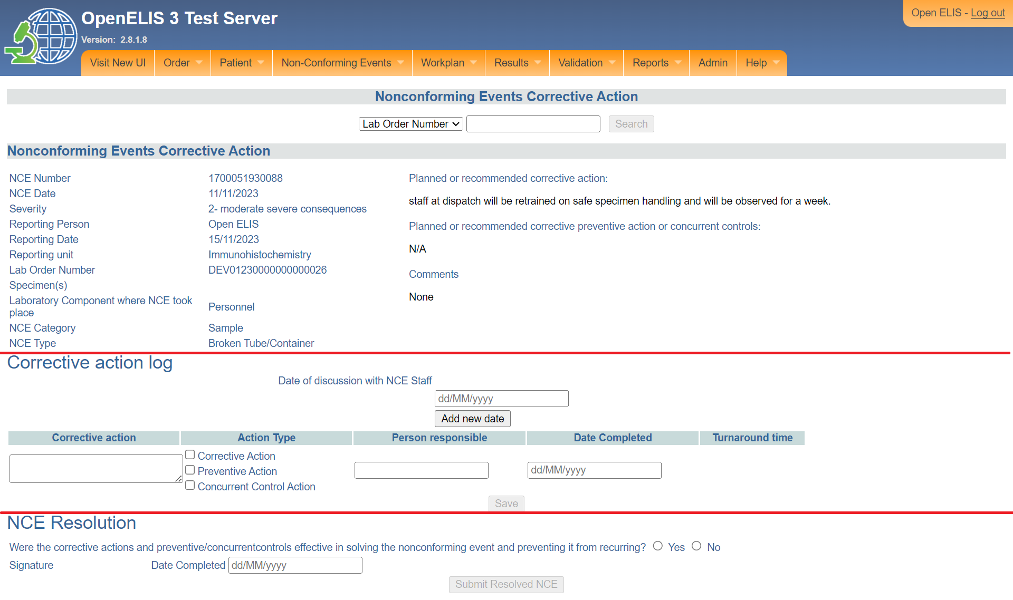*Corrective Action Form*

**NCE Corrective Action form: Part 1- NCE Description**

This section is view only. Verify that the information is correct.

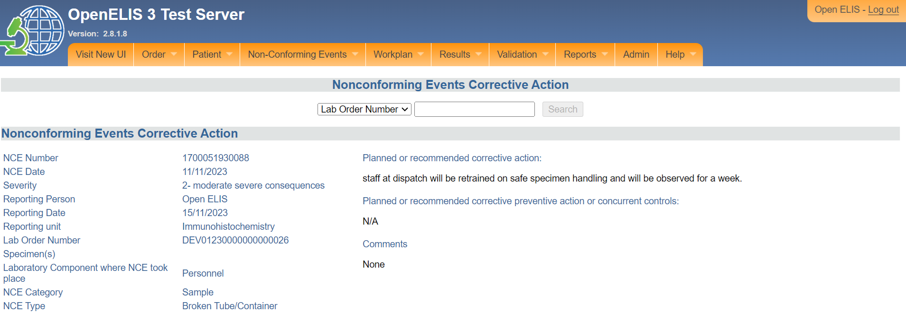

*NCE Corrective Action form: Part 1- NCE Description*

**NCE Corrective Action Form: Part 2- Corrective Action Log**

1. For each discussion with staff regarding the NCE, enter the **Date of Discussion** and click **Add New Date** button. The date will appear above the entry field. You may enter more than one date of discussion.
2. Enter text describing any **Corrective Action** taken and check the box next to the Action Type.
3. Check the respective checkbox for **Action Type**.
4. Enter the name of the **Person Responsible** for the corrective action and the Date Completed (the date the corrective action took place).

**Note: Turnaround Time** is automatically calculated.

1. Click the **Save** button to record the corrective action in the lo**g.** 

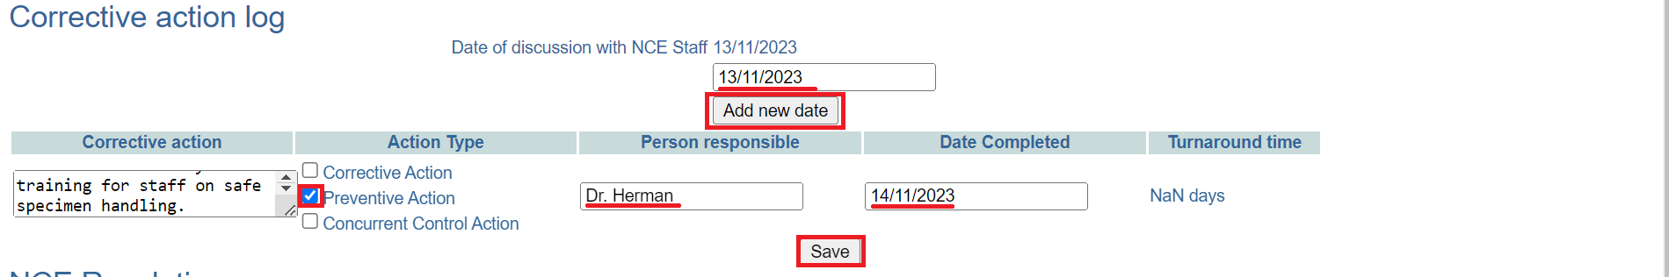

*Corrective Action Log*

You may now navigate to a new page. When you need to add additional corrective actions to the log, repeat steps 1-5.

## **How to close a resolved NCE**

When all corrective action has been completed and the lab manager considers the NCE to be resolved, the NCE report should be closed, per laboratory procedures.

1. Select **Corrective Actions** from the menu under the Non-Conforming module

*Select Corrective Actions*

1. Hover the mouse over the Non-Conforming Events tab and select **Corrective Actions** .

*Select Corrective Actions*

1. Select **Lab Number** or **NCE Number** as your search term and enter the number in the search field. Click the **Search** button.

*Select Lab Number or NCE Number Enter and Search*

1. Scroll down to the **NCE Resolution** section.

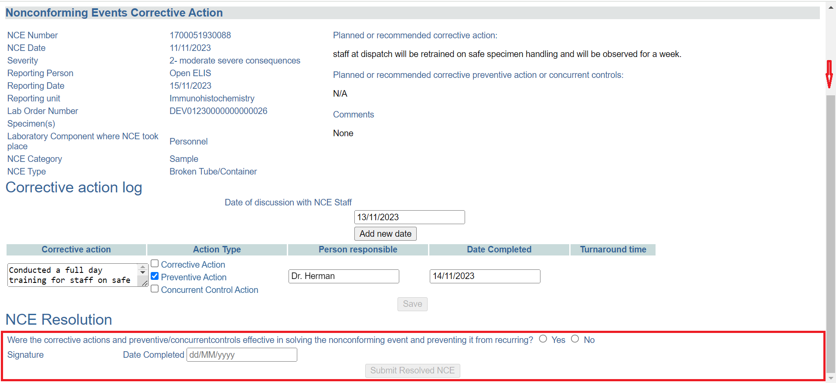*Scroll to NCE Resolution Section*

1. If the corrective actions were sufficient to resolve the NCE, click the **Yes** radio-button and enter the **Date Completed** (the date the NCE was considered resolved).

*Click Yes and Enter Date*

1. Click the **Submit Resolved NCE** button to close the NCE report. The report will be closed successfully.

*Click Submit*

# **PART 12: ENTERING LAB TEST RESULTS**

Once the samples and patients exist in the system, it is possible to record the results of analyzes made from the samples. It is at this stage that the lab technician plays an important role in the functioning of the information system. There are several ways to capture the results of laboratory tests for a patient: enter results by type of laboratory analysis, or search results by patient, lab number or the status of the analysis (conducted or not made).

This section includes the following guides:

1. How to get to the results entry page.
2. How to enter results.
3. How to refer tests to an external laboratory for additional analysis.
4. How to enter the results of tests referred to an external laboratory

All samples reported as non-compliant will have a red flag side of their results.

## **How to get to the results entry page**

1. Hover the mouse over the hamburger icon and click to open the menu.



*Access the OpenELIS menu*

1. Hover the mouse and click on the drop-down menu under the Results module.

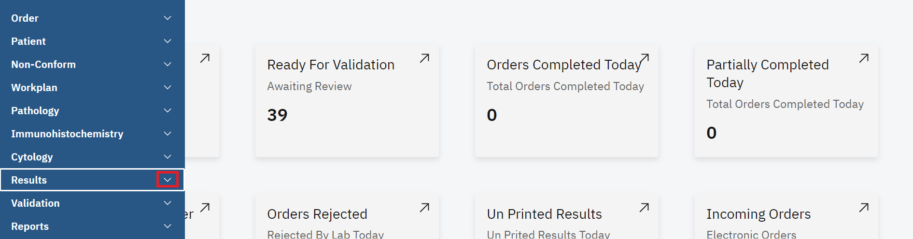

*Click on Results Drop-down Menu*

Results can be entered by

1. Lab Unit.
2. Patient.
3. Laboratory Order Number.
4. Range of Order Number
5. Date sample was collected

IMPORTANT: If you select **Lab Unit**, all tests not yet resulted in that unit are displayed. If you select by **Patient** or by **Lab Number,** *all* tests for that patient or laboratory order will be displayed, including tests that already have results entered.

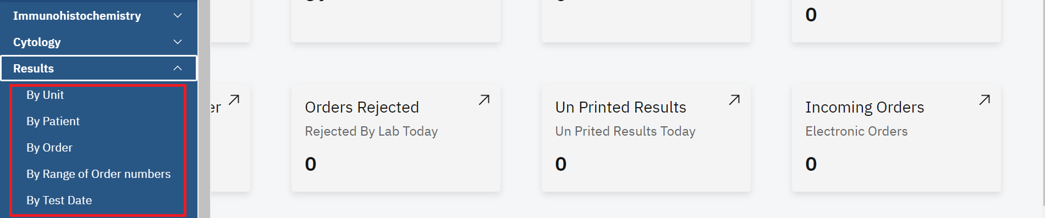

*Results Entry Options*

## **How to enter results by unit**

1. To enter results by Unit click on **By Unit** under the Results module.

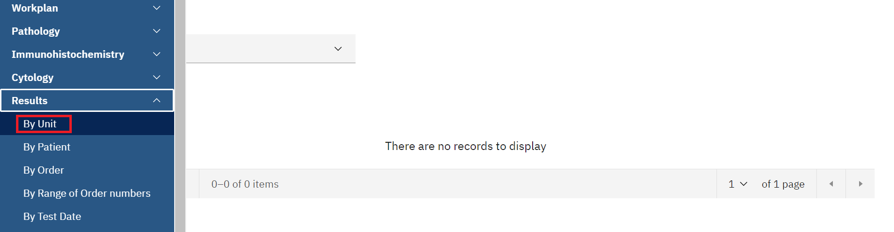

*Click on By Unit*

1. Click on the **Select Test Unit** drop-down menu.

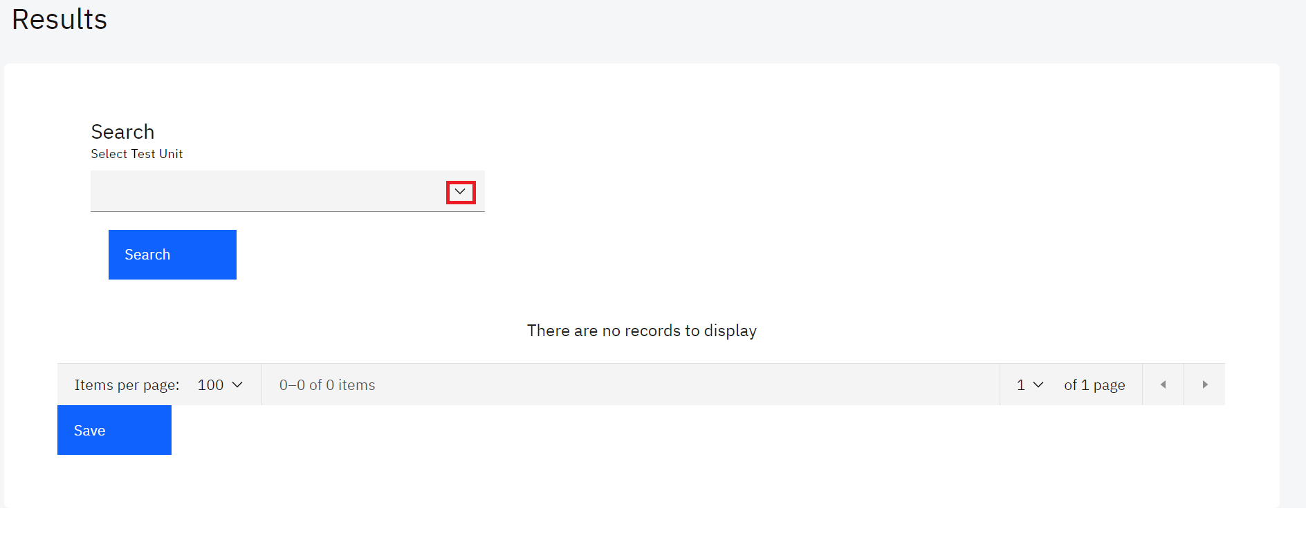*Select Test Unit*

1. Click the laboratory unit for which you want to enter results.

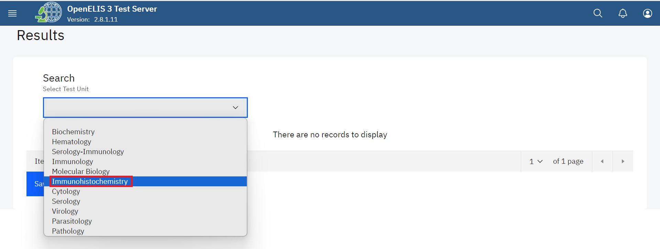

*Click on Laboratory Unit*

1. Click on the Search button.

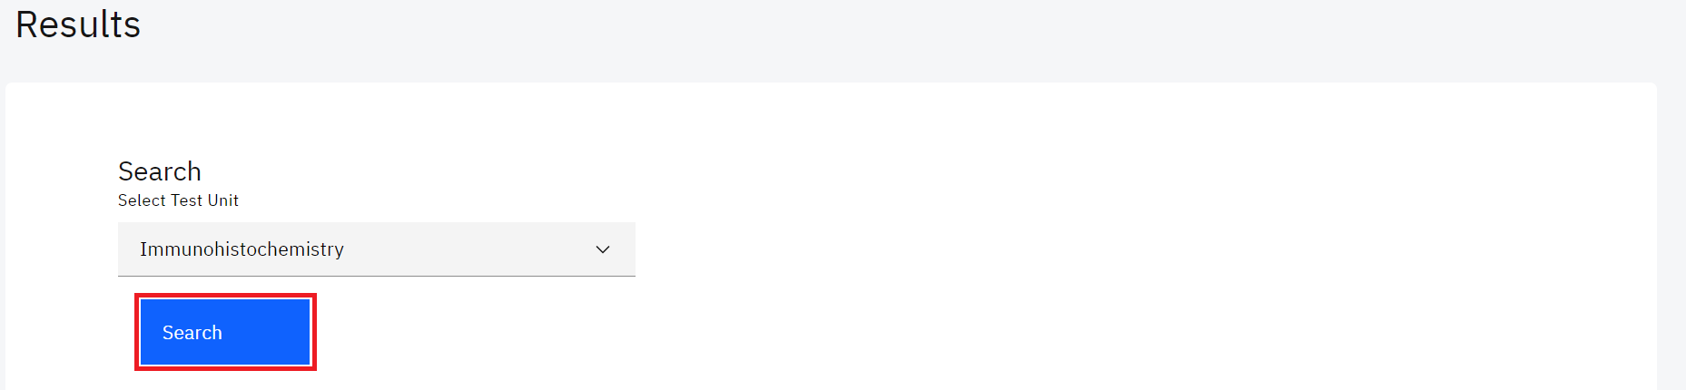

*Click Search*

Upon clicking on the search button, the system will conduct a search for the selected unit and return the results in a tabular format that allows you to enter the results.

Note: A **Red Flag** next to an order indicates that either the sample or order has been reported for a non-conforming event.

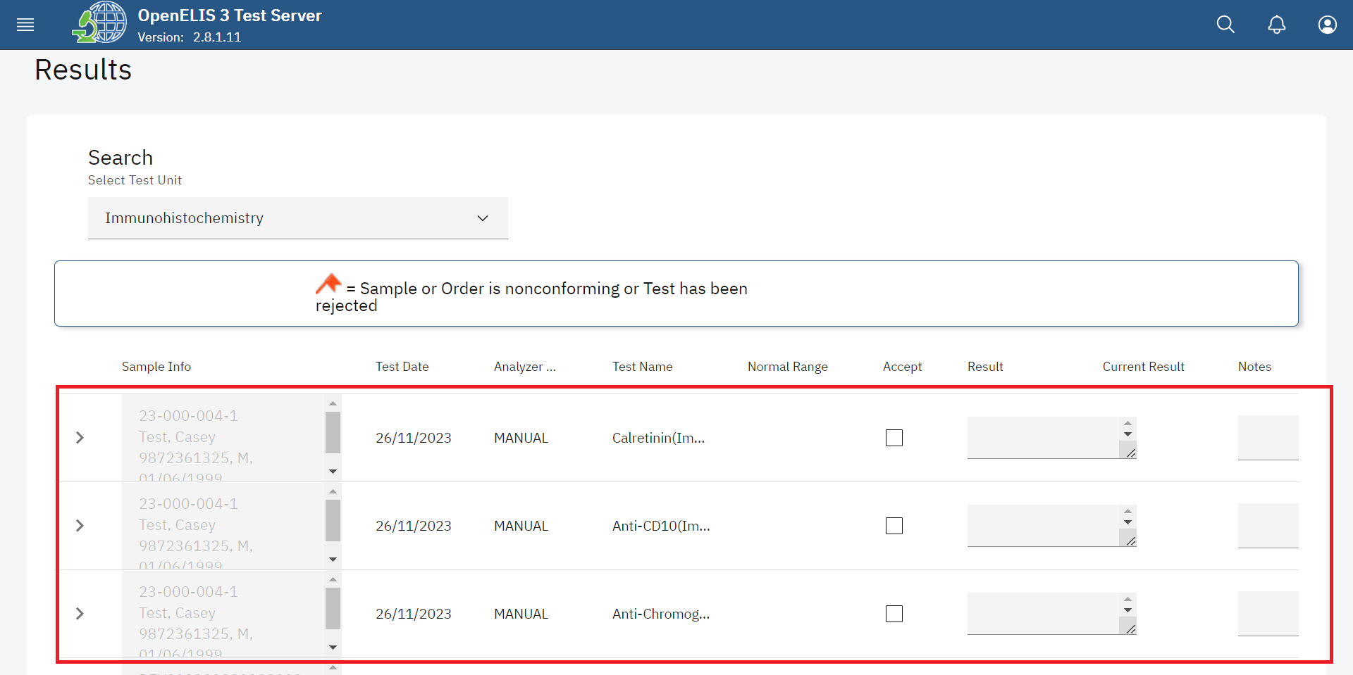

*Searched Results*

## **How to enter results by Patient**

1. To enter results by Unit click on **By Patient** under the Results module.

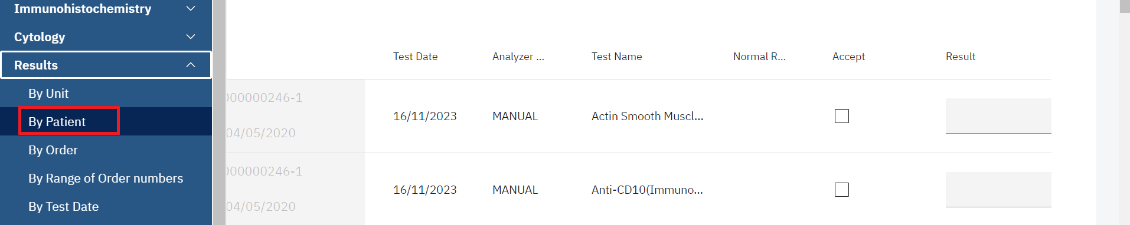*Click on By Patient*

1. Type in the parameter to search the patient. This can be the **Patient Id**, **Previous**  **Lab Number**, **Last Name** or **First Name.**

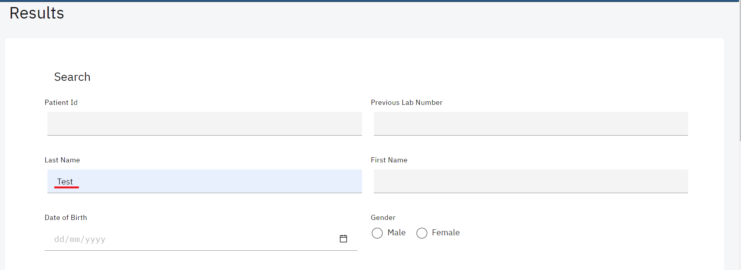*Patient Search Parameter*

1. Click on the Search Button.

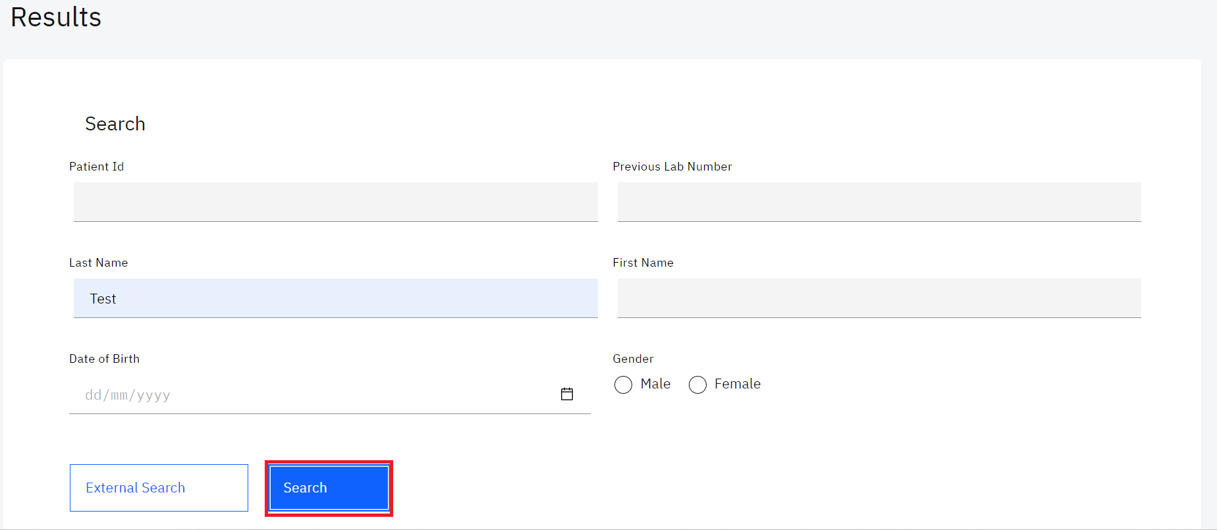*Click on Search*

Upon clicking on the search button, the system will conduct a search for the patient and return matching results.

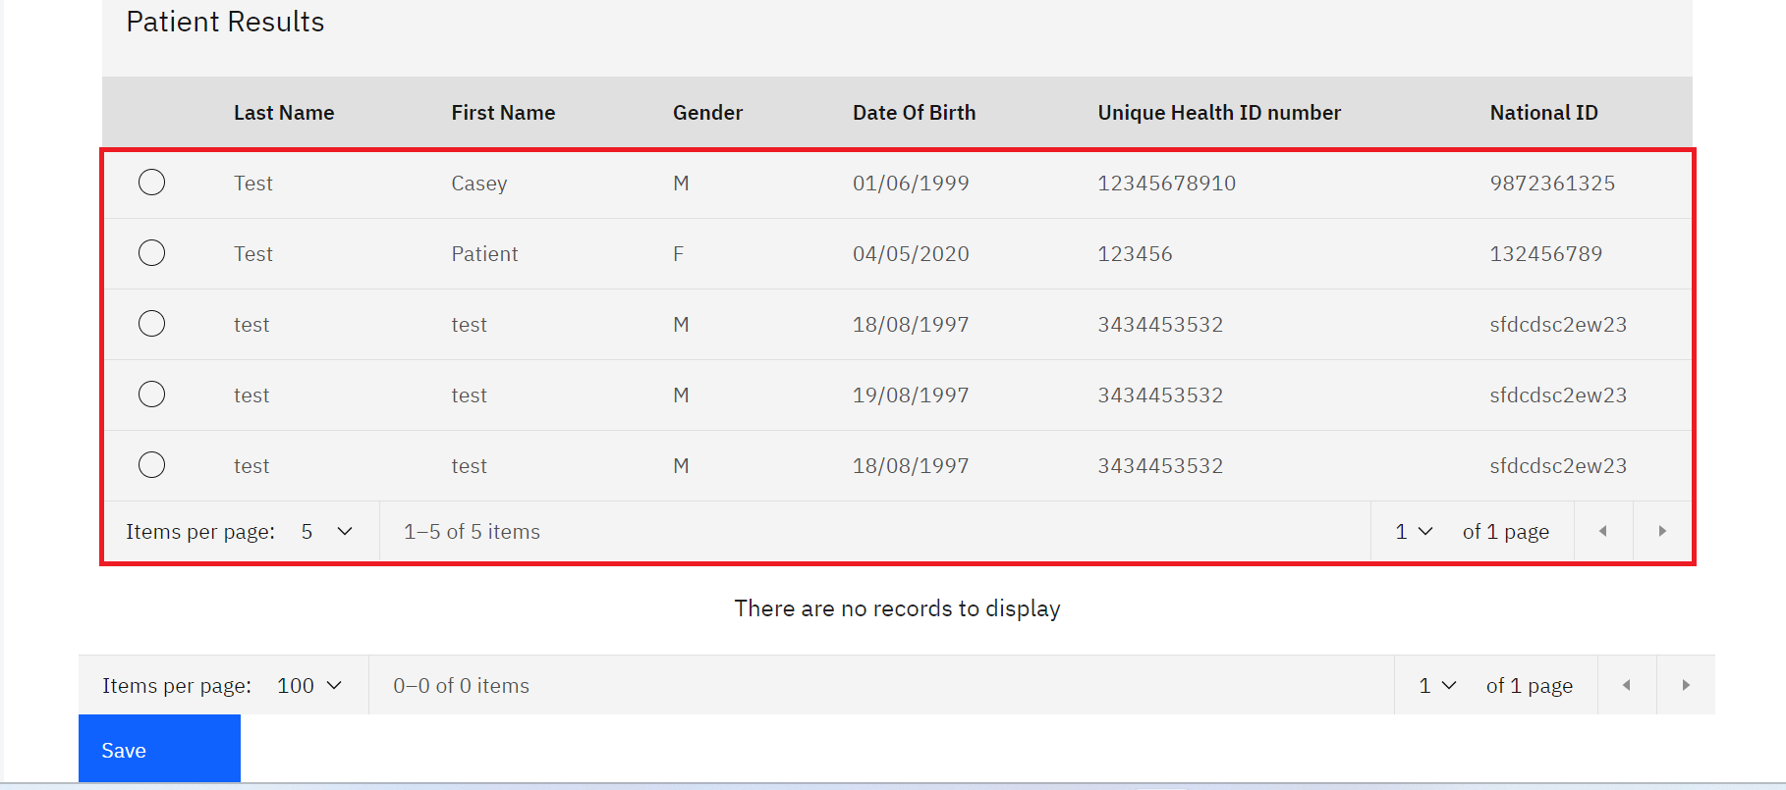

*Search Results*

1. Click on the radio button next to the desired patient.

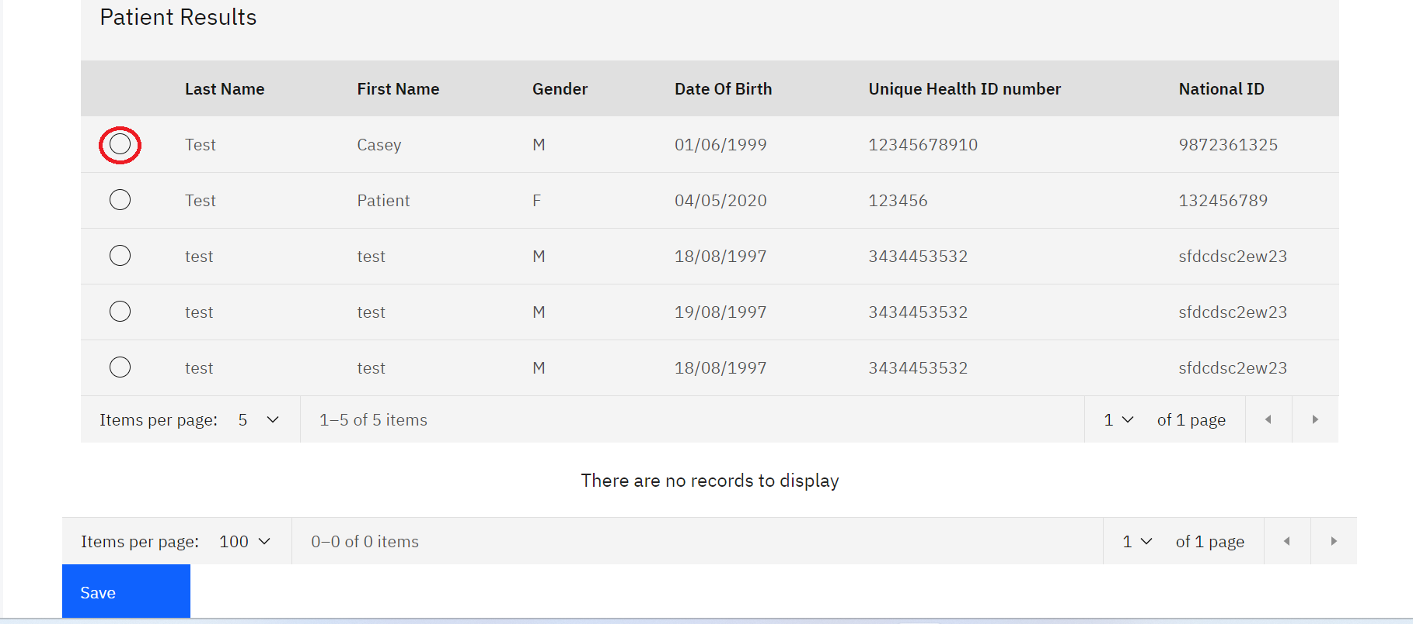*Click on a Patient*

Upon clicking on the desired patient, the system will expand a table format that allows you to enter the results. Use the scroll bar to navigate the page up and down so as to see all the tests for the patient which you can enter results.

Note: A **Red Flag** next to an order indicates that either the sample or order has been reported for a non-conforming event.

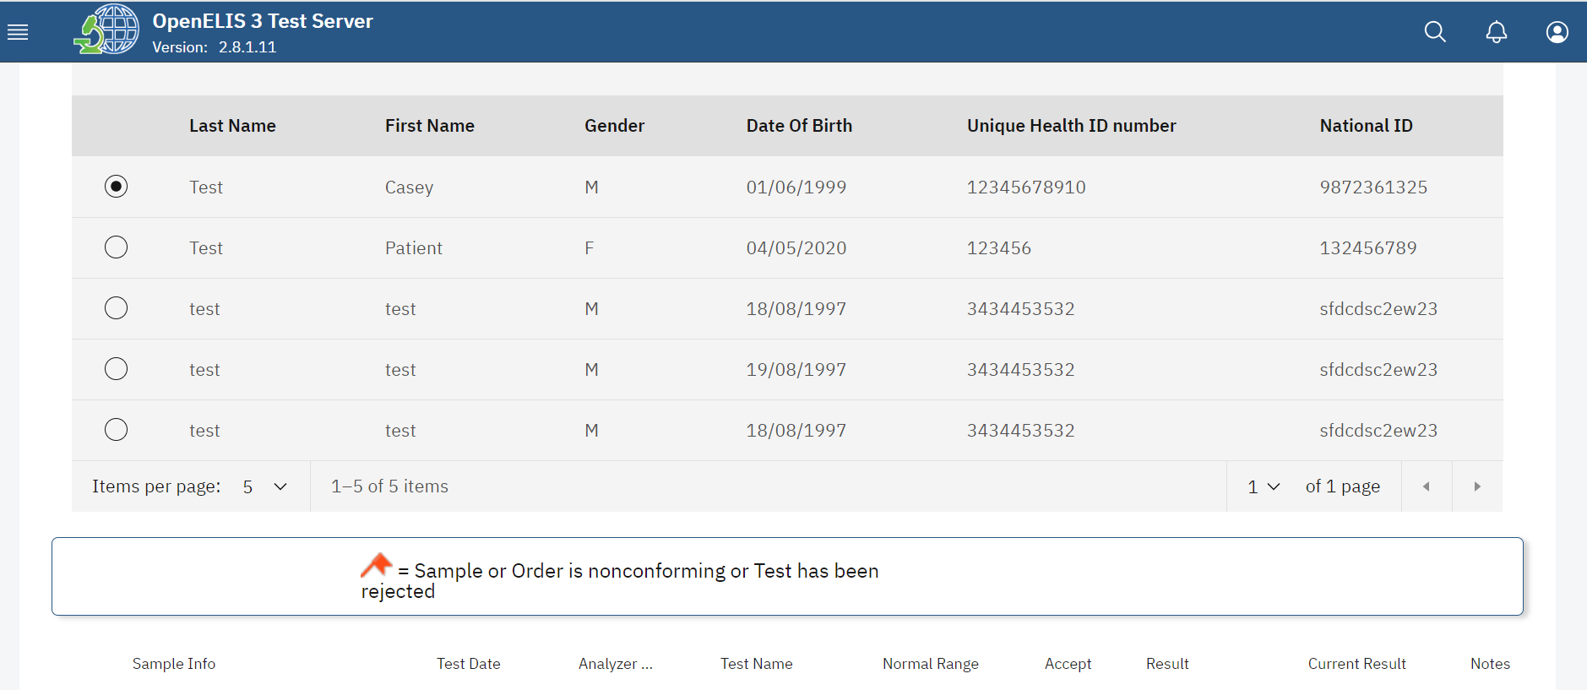

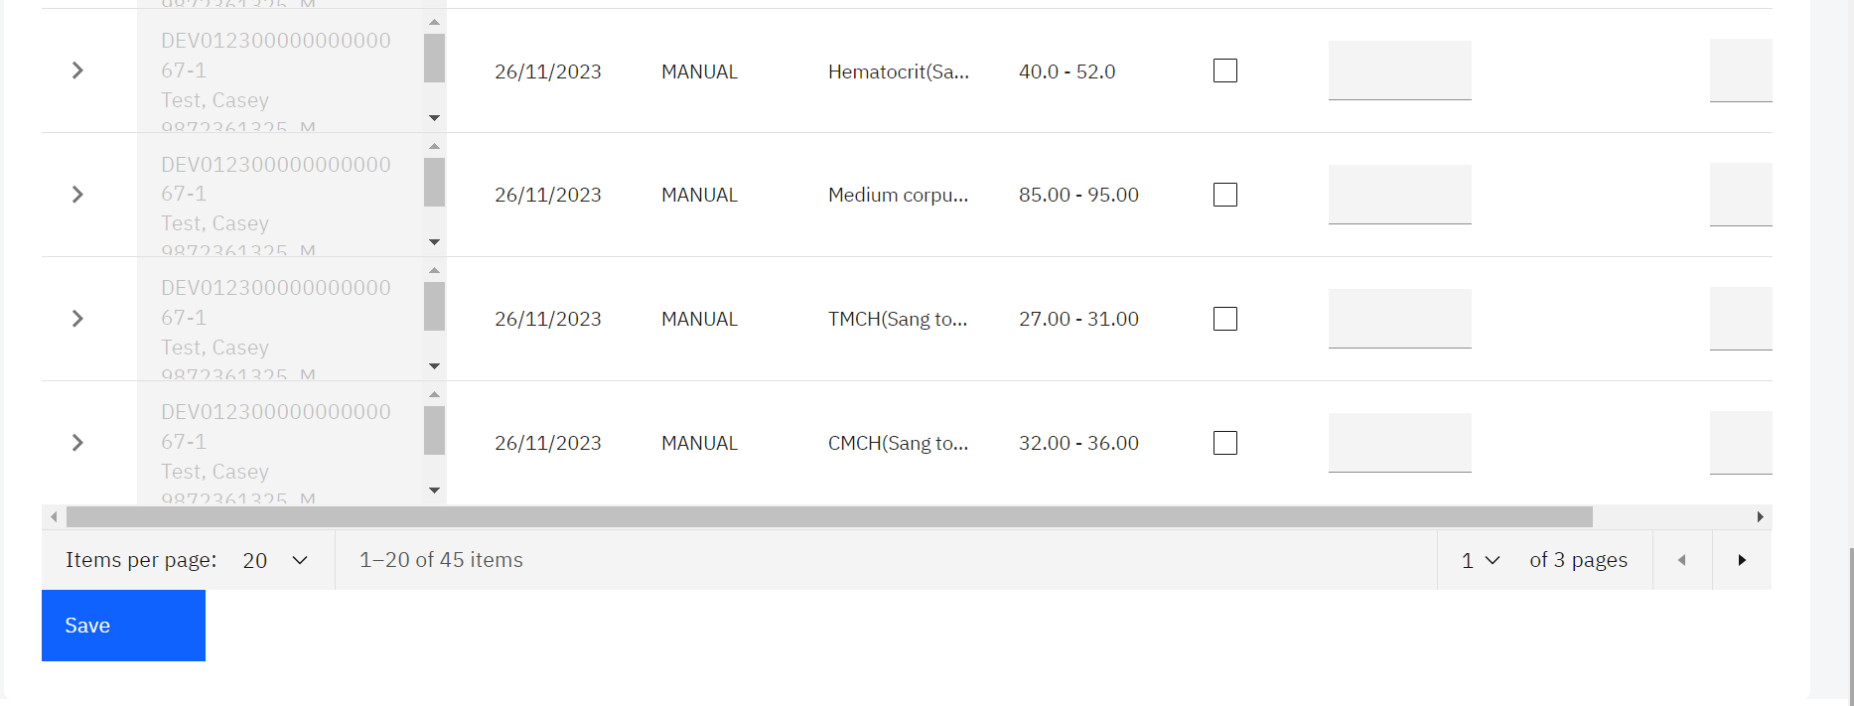

*Results Entry*

## **How to enter results by Order**

1. To enter results by Unit click on **By Order** under the Results module.

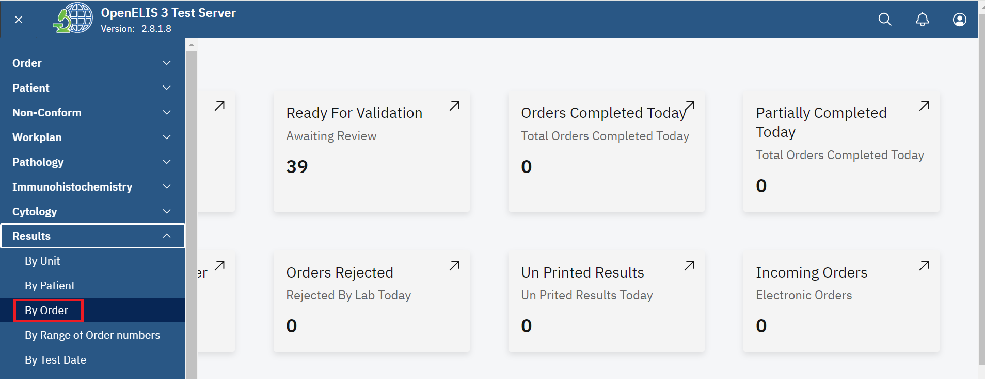*Click on By Order*

1. Enter the Accession number and click on the Search button.

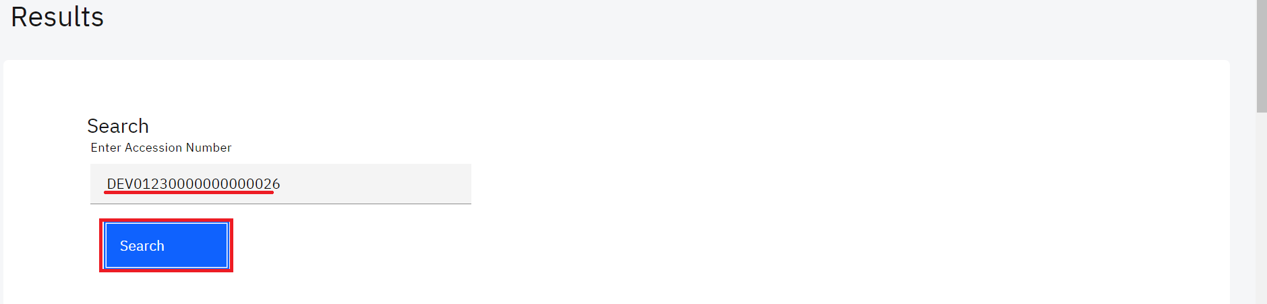*Enter Accession Number and Search* 

Upon clicking on the search button, the system will expand a table that allows you to enter the results. Use the scroll bar to navigate the page up and down so as to see all the tests for the patient which you can enter results.

Note: A **Red Flag** next to an order indicates that either the sample or order has been reported for a non-conforming event.

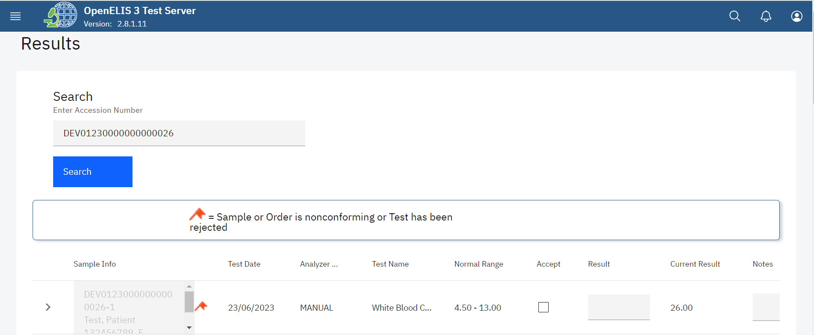

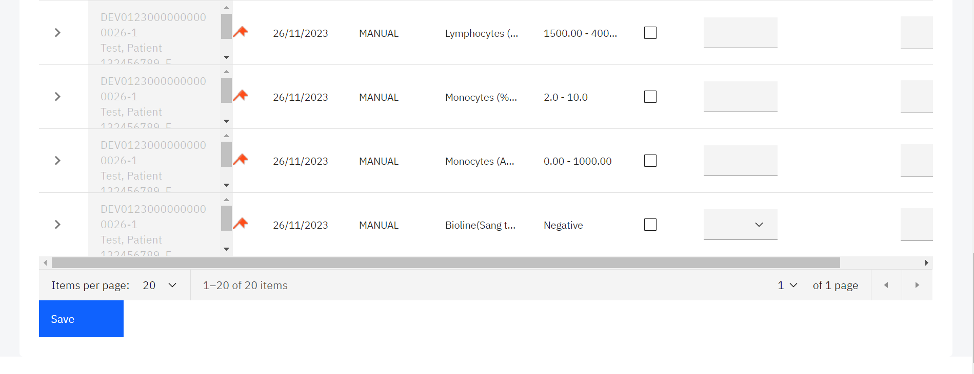*Results Entry*

## **How to enter results by Range of Order Number**

1. To enter results by Unit click on **By Range of Order Number** under the Results module.

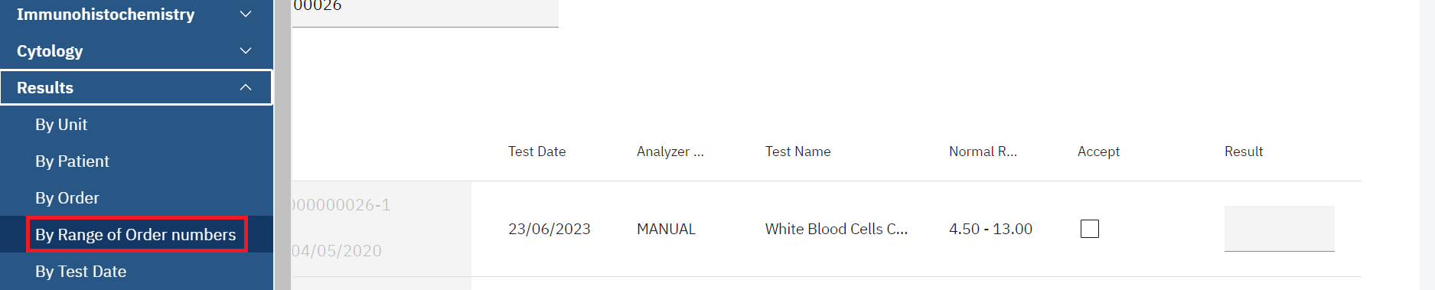

*Results By Range of Order numbers*

1. Enter the range of the accession numbers in order to limit your search.
2. Click on the Search button.

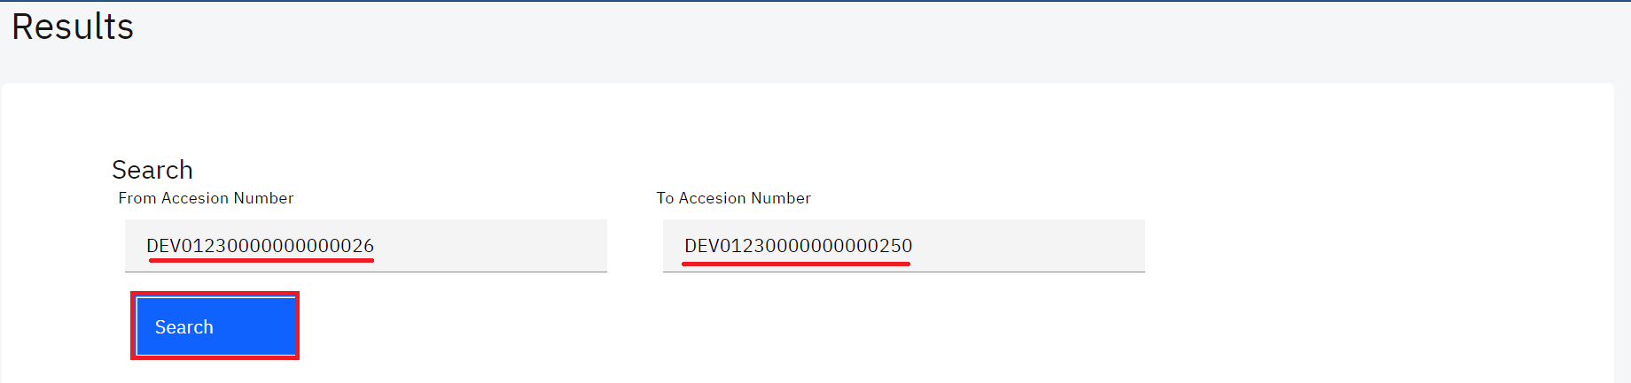

Upon clicking on the search button, the system will expand a table that allows you to enter the results for the filtered accession number range. Use the scroll bar to navigate the page up and down so as to see all the tests for the patient which you can enter results.

Note: A **Red Flag** next to an order indicates that either the sample or order has been reported for a non-conforming event.

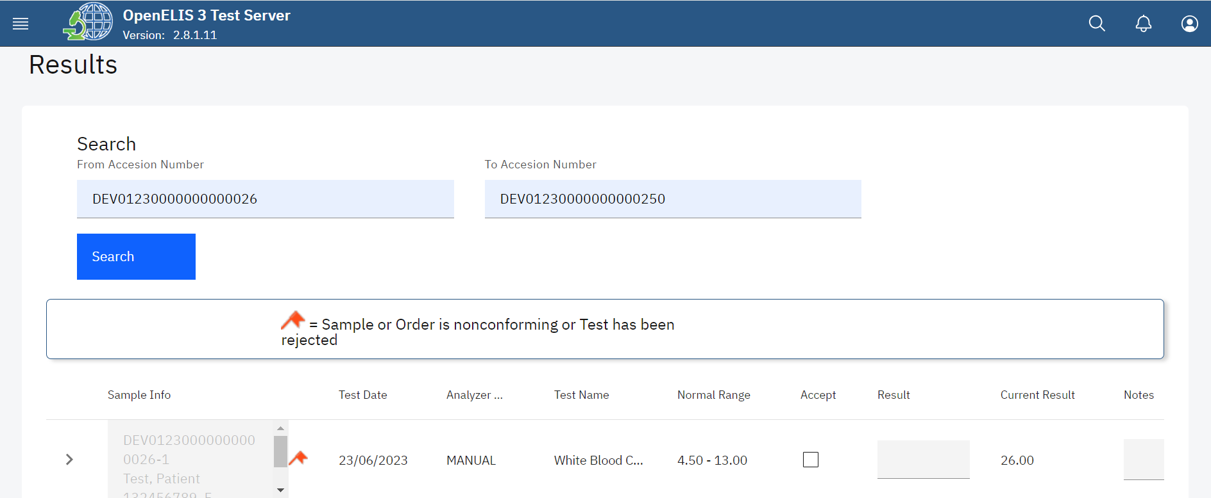

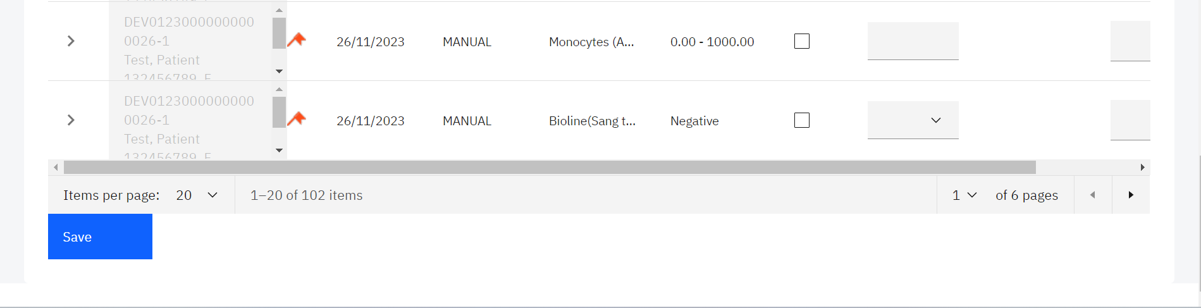

*Result Entry*

## **How to enter results By Test Date**

1. To enter results by Unit click on **By Test Date** under the Results module.

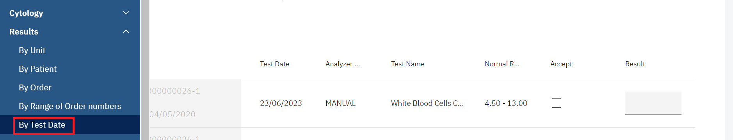*Click on By Test Date*

1. Enter any of the parameters in order to limit your search.

NOTE:Collection date and received date should be in the format dd/mm/yyyy.

1. Select the **Test Name, Test (Analysis)Statu** or **Sample Status** from the respective drop-down lists. A results entry section will be expanded on the page.

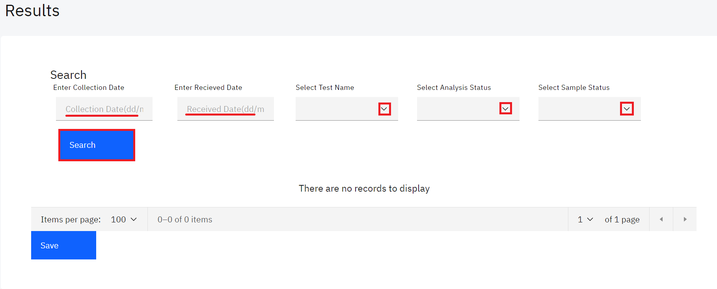*Enter Parameters and Search*

## **How to fill the result entry section.**

The result entry section allows you to enter the results whether By Unit, By Patient, By order, By Range of Order Numbers or By Test Date. Each test displays the following information:**Lab Sample Info, Test Date, Analyzer, Test Name, Normal Range, Accept, Results, Current Result and Notes.** In this illustration, we shall demonstrate a **By Patient** result entry by following steps 1- 4 under how to enter results by patient.

Upon clicking on the desired patient, the system will expand a table format that allows you to enter the results. Use the scroll bar to navigate the page up and down so as to see all the tests for the patient which you can enter results.

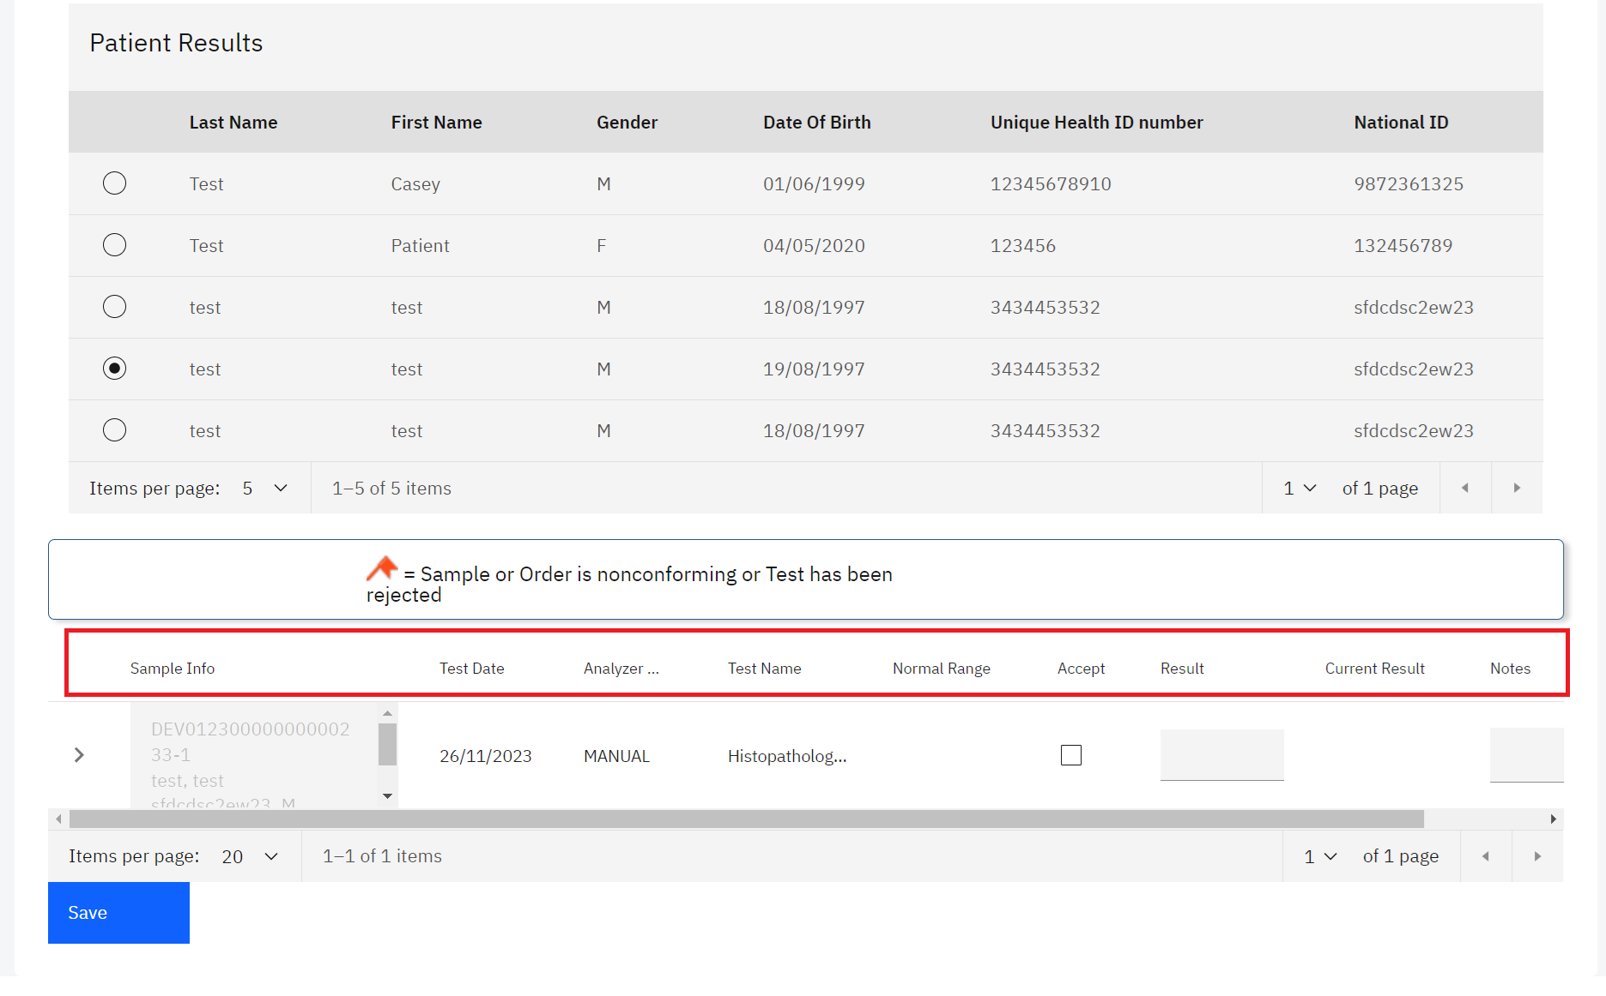

*Results Fields*

Note:The results entry columns from left to right include: **Lab Sample Info, Test Date, Analyzer, Test Name, Normal Range, Accept, Results, Current Result** and **Notes.**

1. In this illustration, we shall enter the results for the test by clicking on the Accept checkbox.

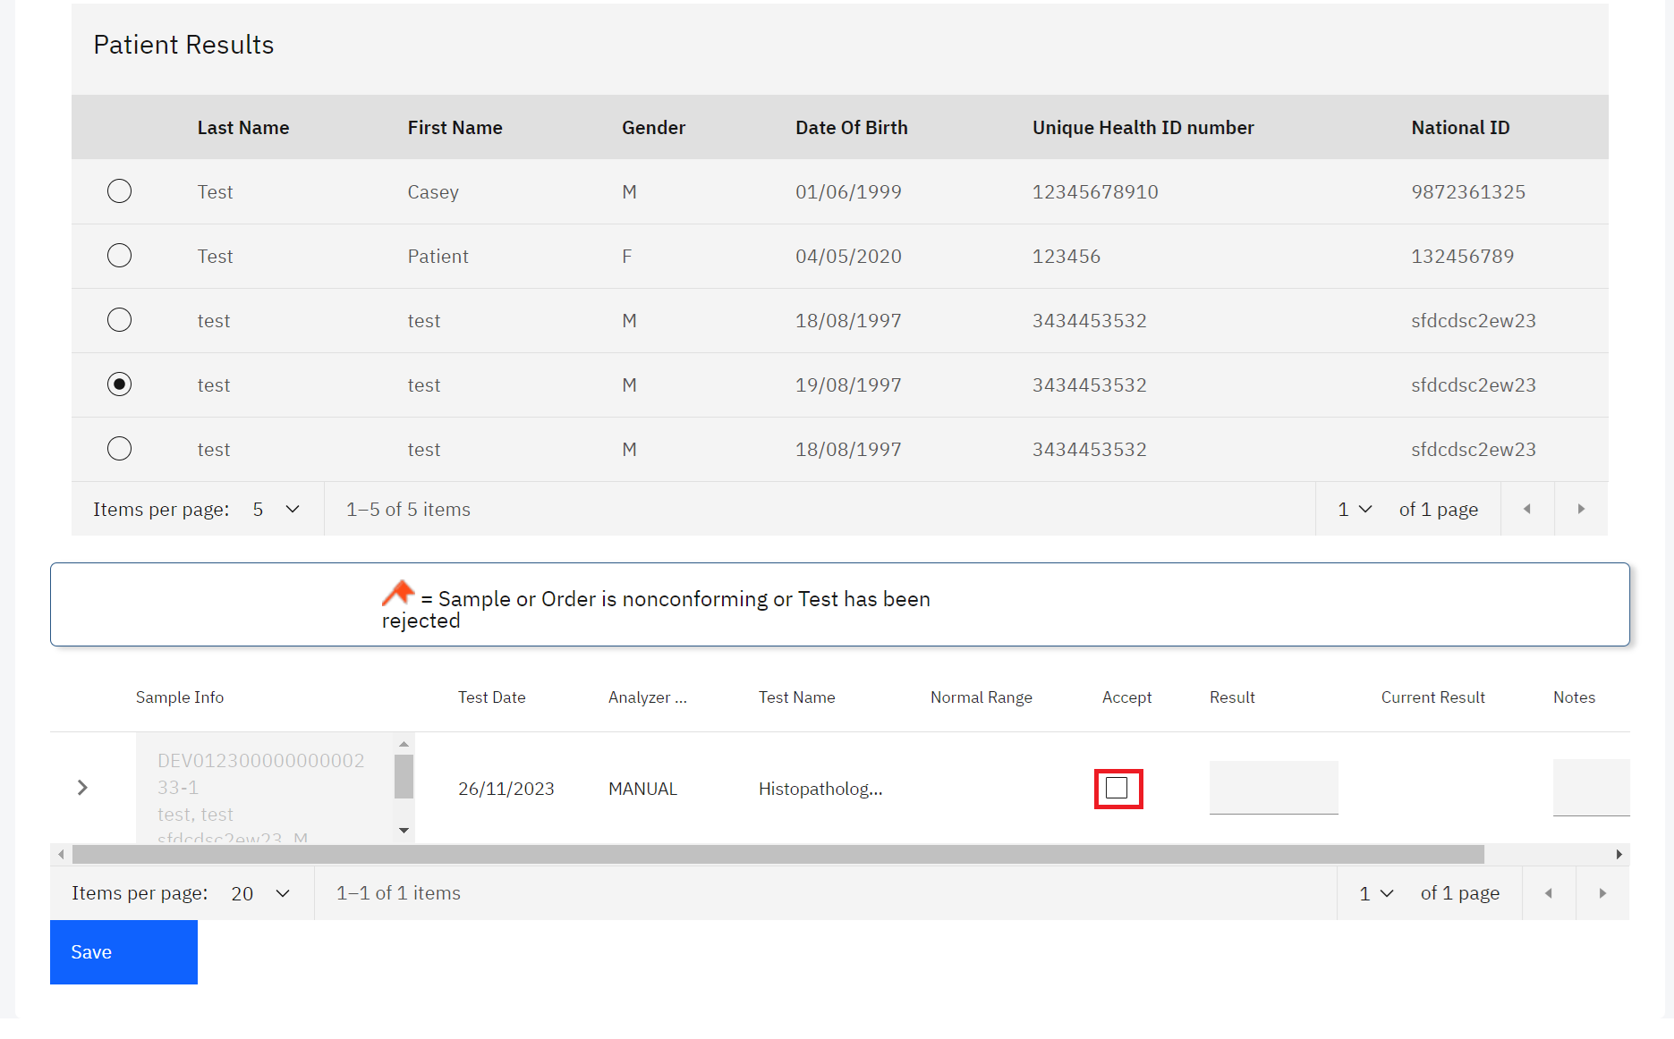

*Click on Accept Checkbox*

Note: The Accept checkbox should be clicked when the results are accepted unconditionally. The Checkbox has the following expected uses;

1. The test has been redone and the results is the same
2. There is no results for the test but you do not want to cancel it.
3. The results was changed and the laboratory technician wants to give the biologist the option to add a note during the validation step explaining the reason for the change.
4. Click on **OK** on the pop-up dialogue if the test results are accepted unconditionally.

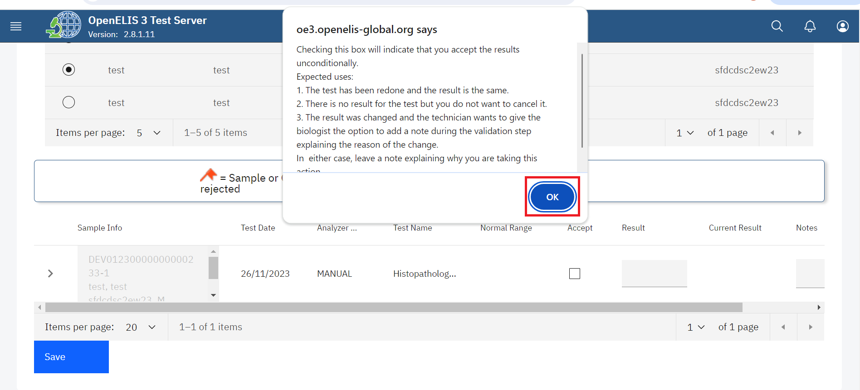

*Click Ok*

**Note:** For numerical results, type in the result. For other types, select the result from the drop-down list or type the result in the text field area

1. Enter the Results in the results text field.

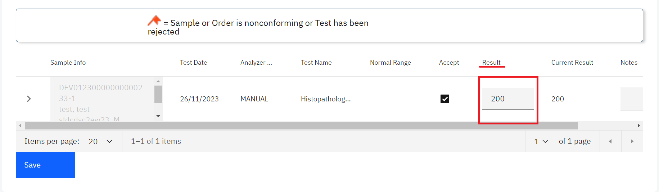

*Enter Results*

1. Leave a note explaining why you are taking the action above then click on the **Save** button.

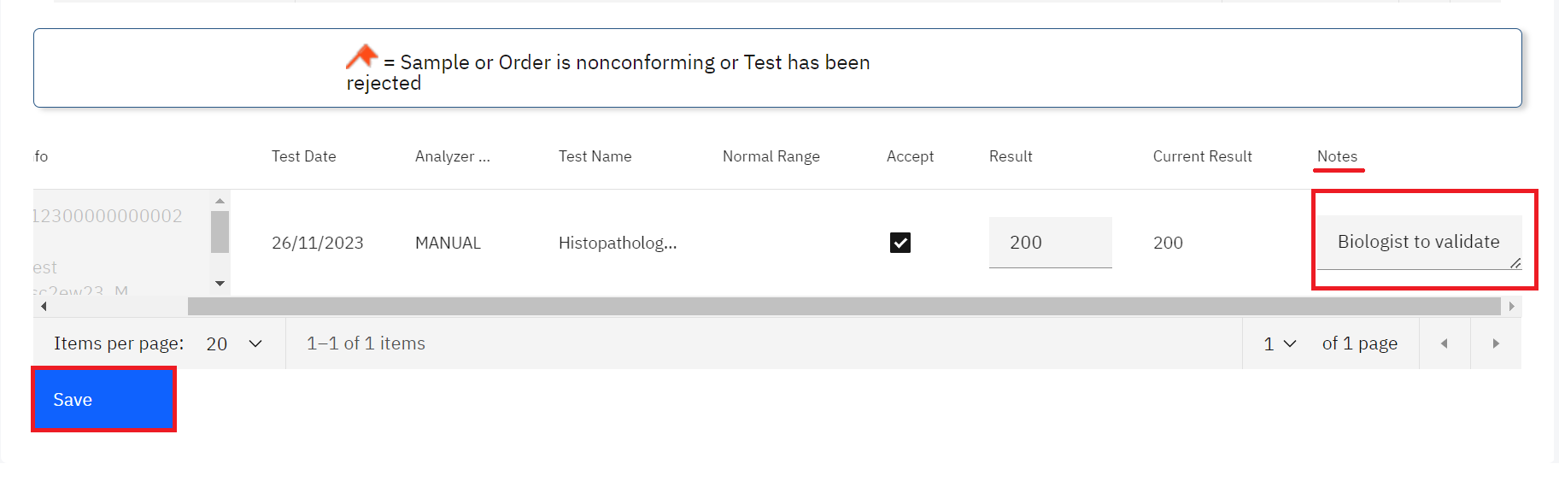

*Enter Notes and Click Save*

A saved successful message will be displayed at the top of the page.

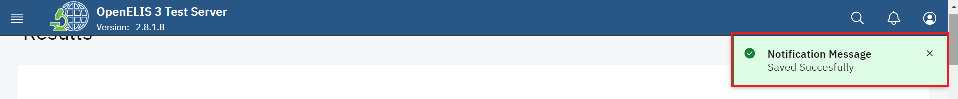

*Saved Successfully*

## **How to refer a test to another laboratory**

1. If the technician identifies a reason for referring the sample to another laboratory for confirmatory or other additional testing, they will click on the > arrow on the test to expand the test referral section. In this illustration, a test from the previous section is used.

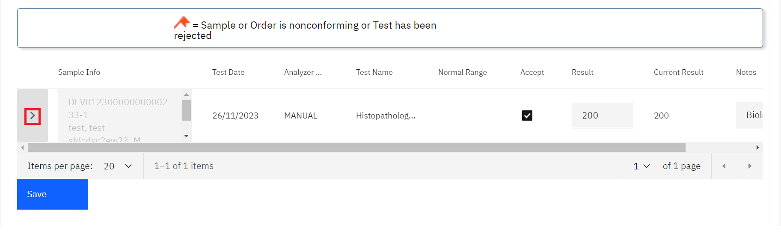

*Click on a Test to Expand Referral Section*

1. Enter the **Method**, **Referral Reason**, **Institute**, **Test to perform** and **Sent Date** then click on the  **Save** button.

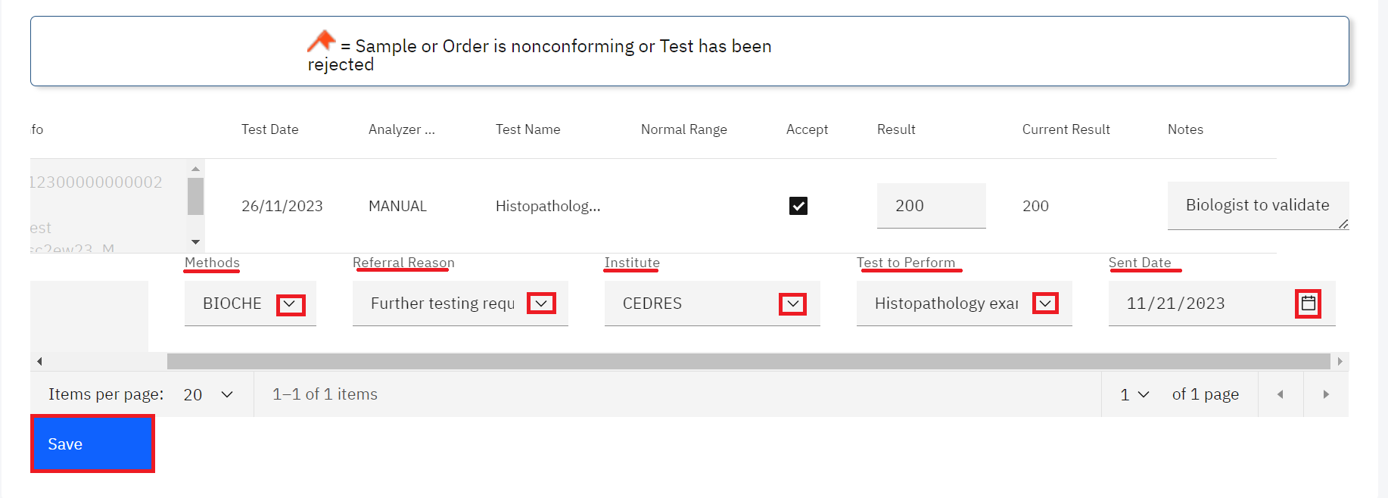

*Enter Referral Details and Click Save*

A saved successful message will be displayed at the top of the page.



*Saved Successfully*

# **PART 13: RESULTS VALIDATION (BIOLOGICAL VALIDATION)**

After results are entered by the lab technician, the biologist must review and validate the results. OpenELIS Global displays all results by laboratory unit, listed by laboratory number order. The biologist can then accept or reject the result. Accepted results appear on the patient report. Rejected results return to the lab unit for re-testing or other verification.

## **How to get to the results validation page**

1. Hover the mouse over the hamburger icon and click to open the menu.



*Access the OpenELIS menu*

1. Hover the mouse and click on the drop-down menu under the Results module.

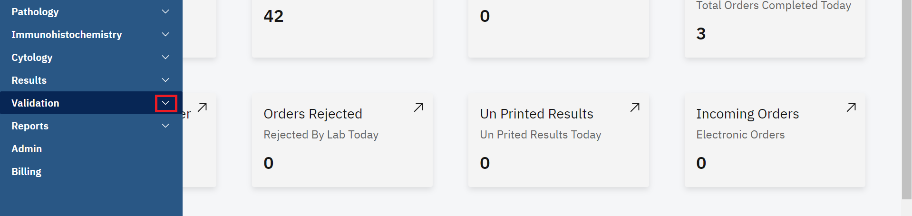

*Click on Validation dropdown Menu*

Results can be validated through;

1. Search by Routine.
2. Search by Study
3. Search by Order
4. Search by Test Date
5. Search by Order Numbers

## **How to validate results By Routine Search**

1. To validate results routinely, click on **Search By Routine** under the Validation module.

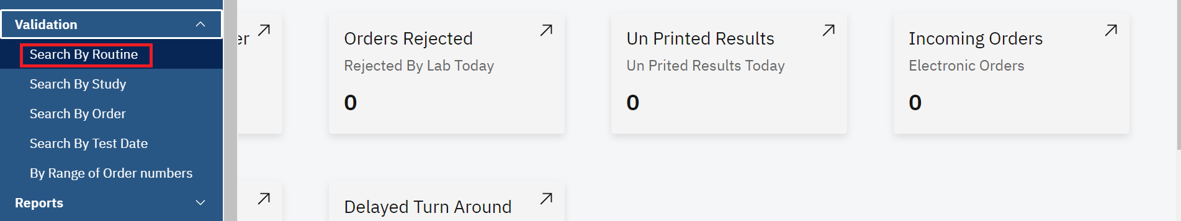*Click Search By Routine*

1. Click on the **Select Test Unit** drop-down menu.

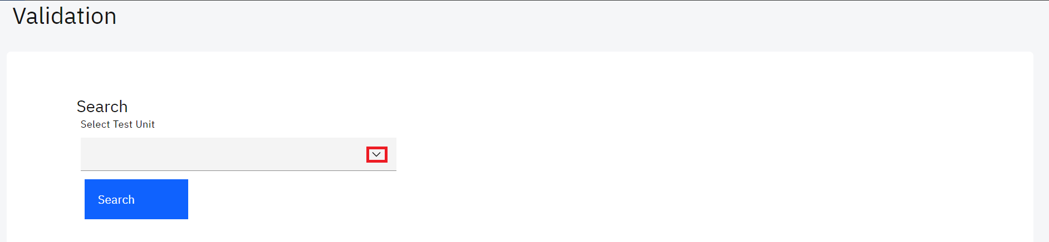*Select Test Unit*

1. Click the laboratory unit for which you want to validate results.

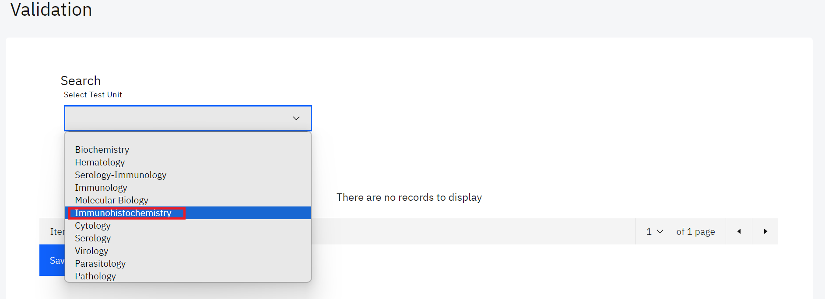

*Click on Laboratory Unit*

Note: Upon clicking on the laboratory unit, the system will conduct a search.A list of all the results ready for validation in the laboratory is displayed.

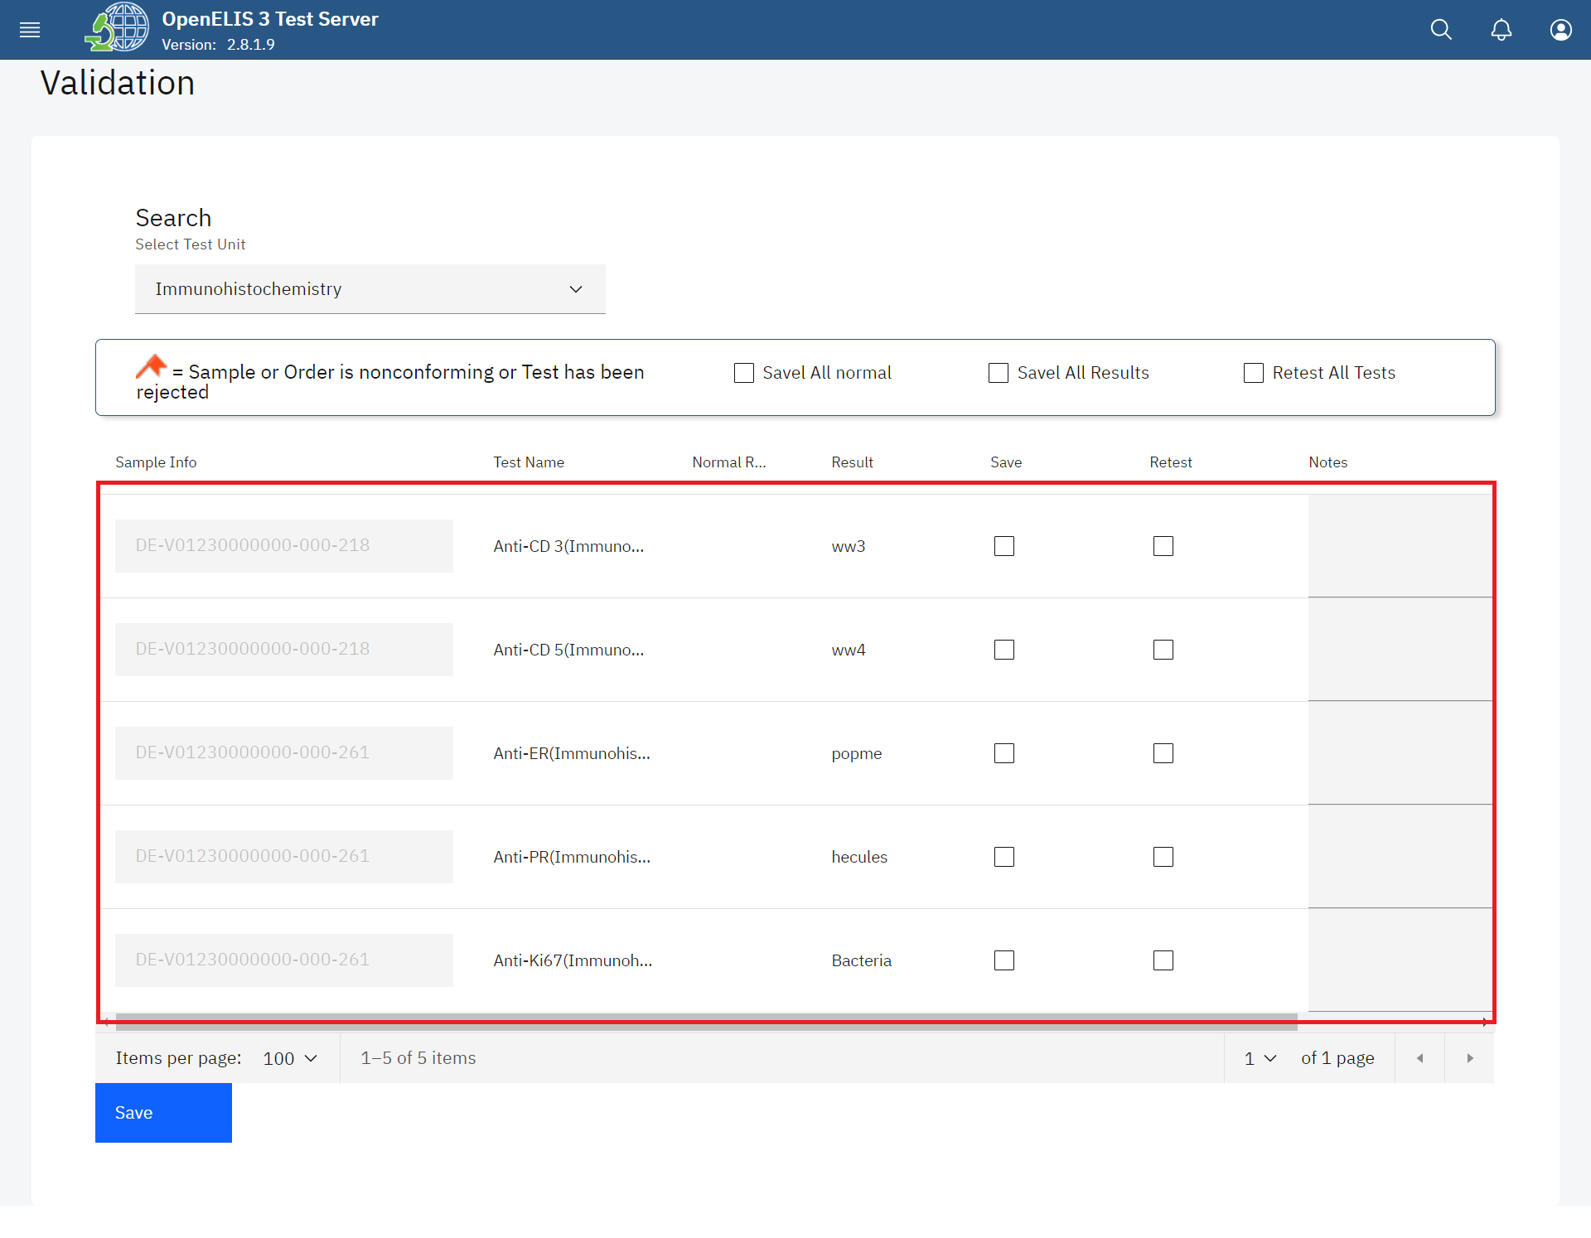

*Searched Results*

1. If there are results that are within normal range of acceptance, you can check the box **Save All Normal** to validate the normal results on the page at once. Click on the **Save** button.

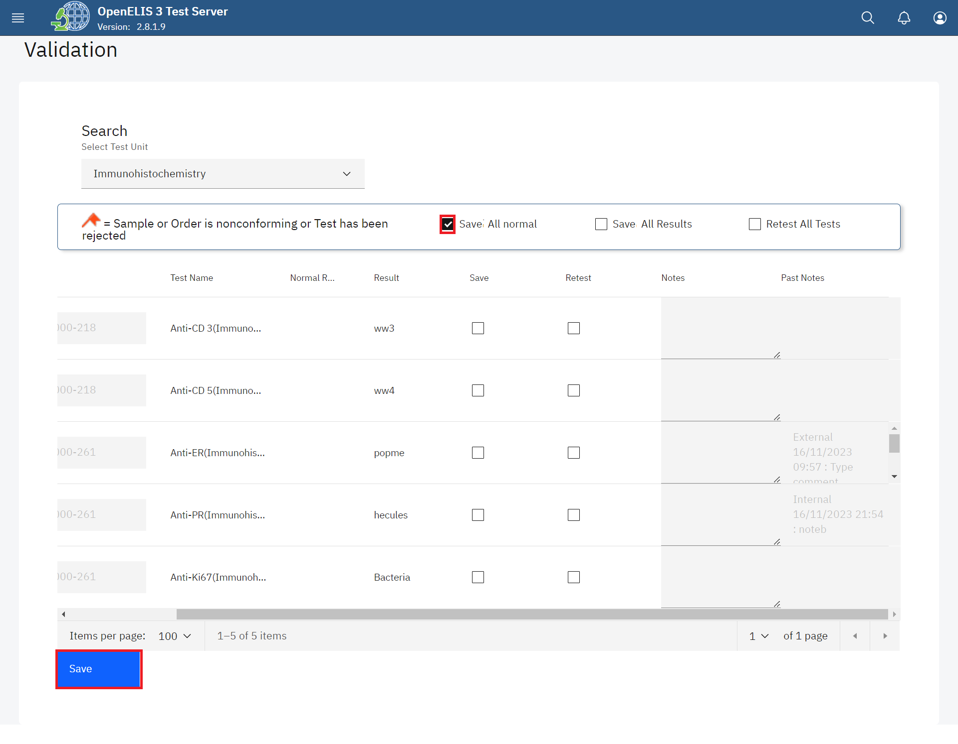*Save All Normal Results*

The normal results will be validated and saved successfully.

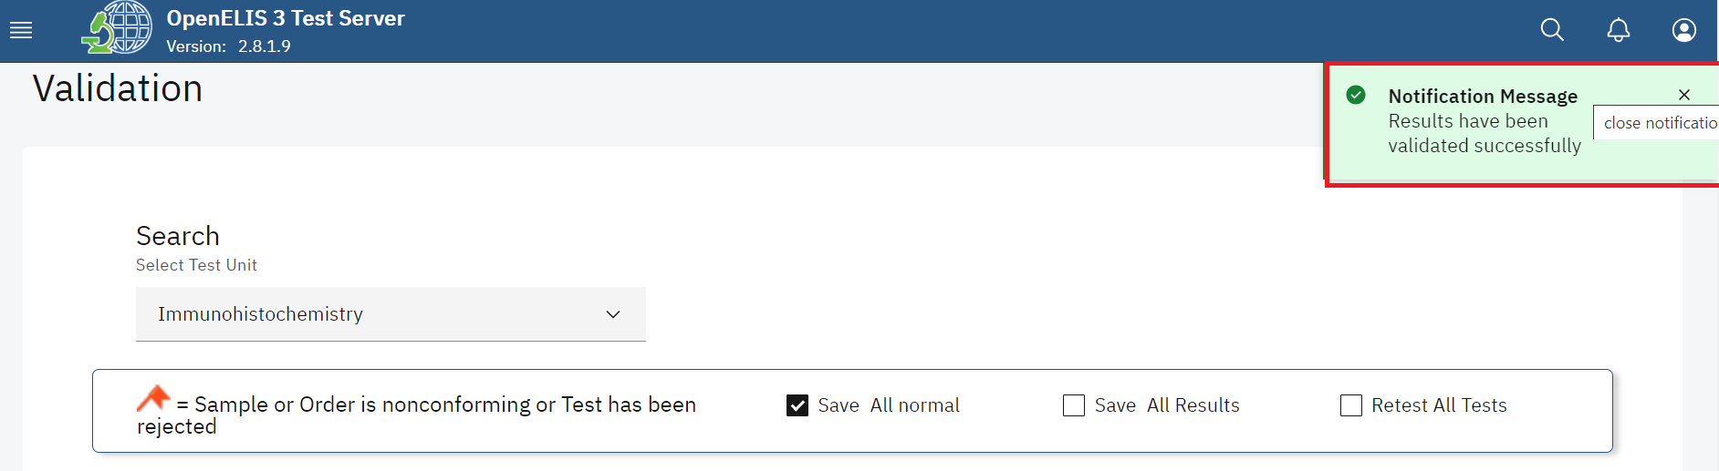*Normal Results Validated Successfully*

1. If all results are valid, you can check the box **Save All Results** to validate all results on the page at once.

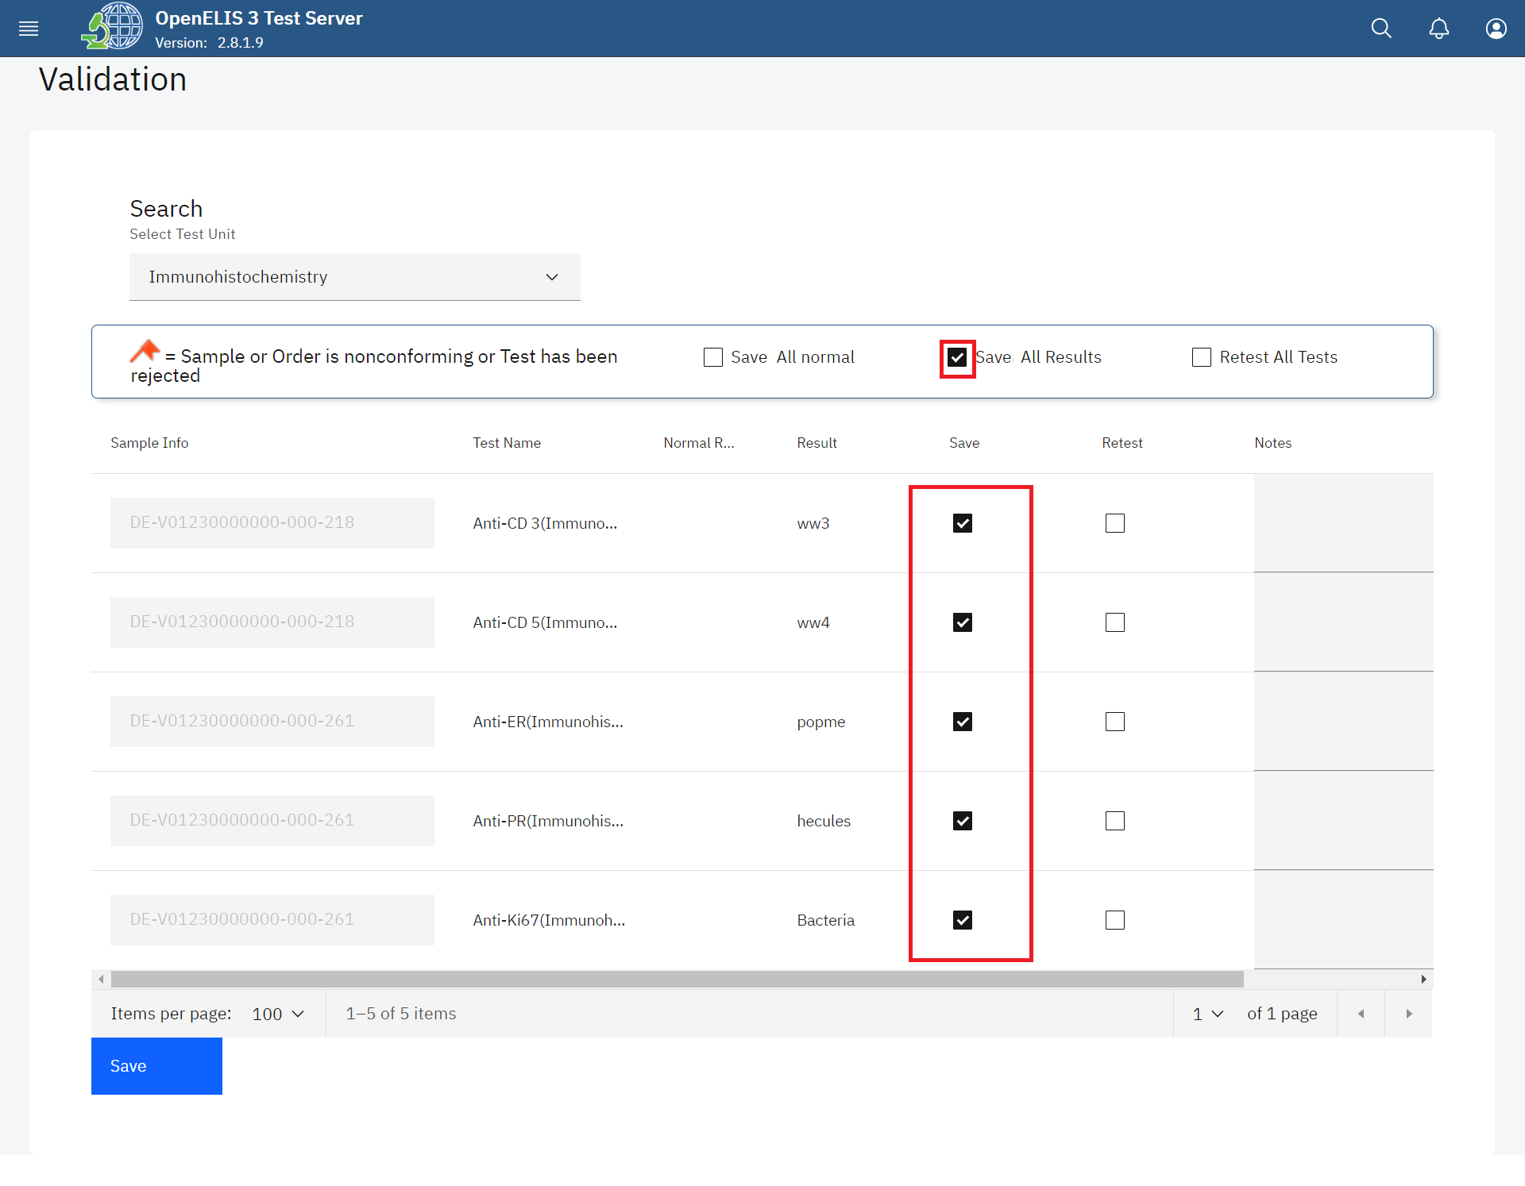

*Click Save Checkbox for Valid Result*

1. If none of the results are valid, use the checkbox **Retest All Results**  to reject all of the results at once.

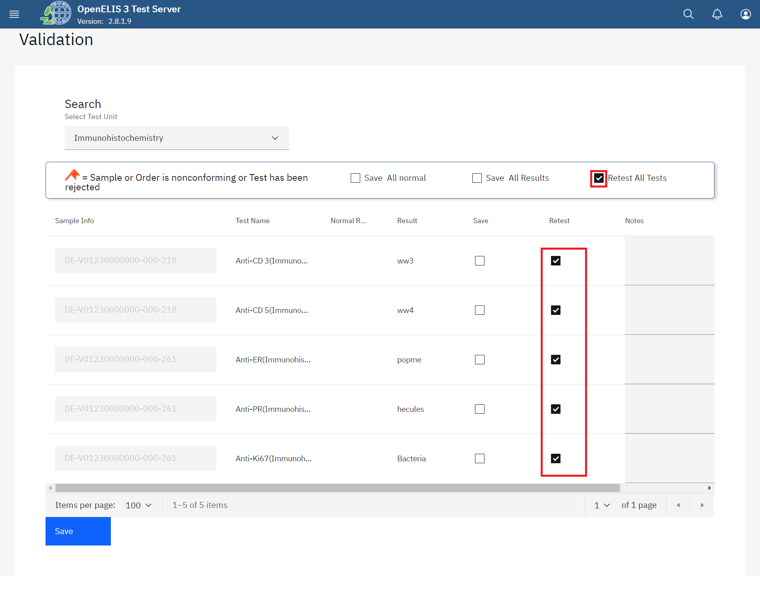*Click Retest Checkbox for Invalid Result* 

**Note:** you can check the box under the appropriate column—Save for validate, Retest for reject—next to each test result.

1. For *valid results*, enter any comments for the patient or provider that should accompany the test results. These comments will appear on the patient report. For *invalid results*, enter any comments for the lab technician regarding the validation of results and any required follow-up. These comments appear only for the lab and do not appear on the patient report.

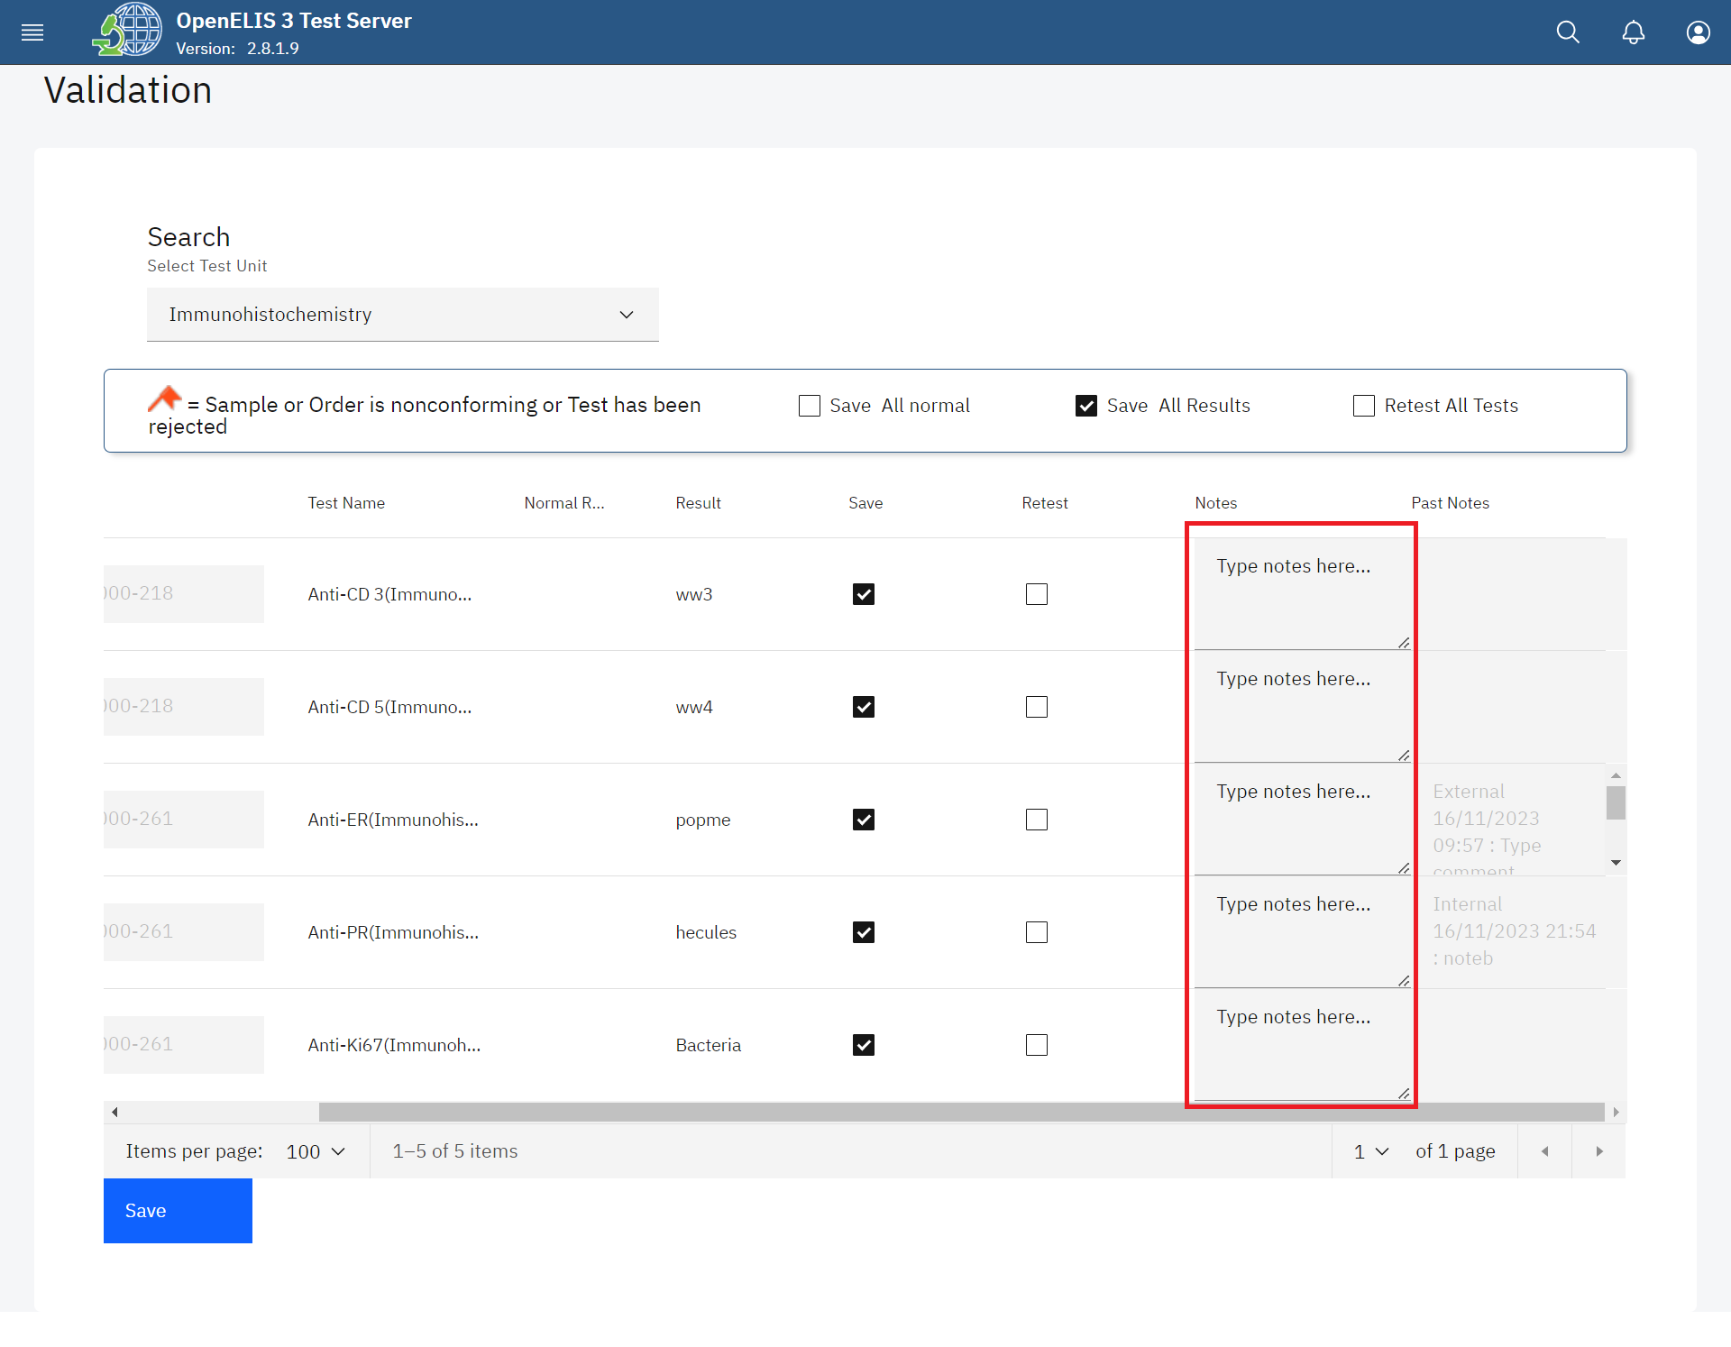*Enter Comments under Notes*

The Past Notes are displayed in the last column.

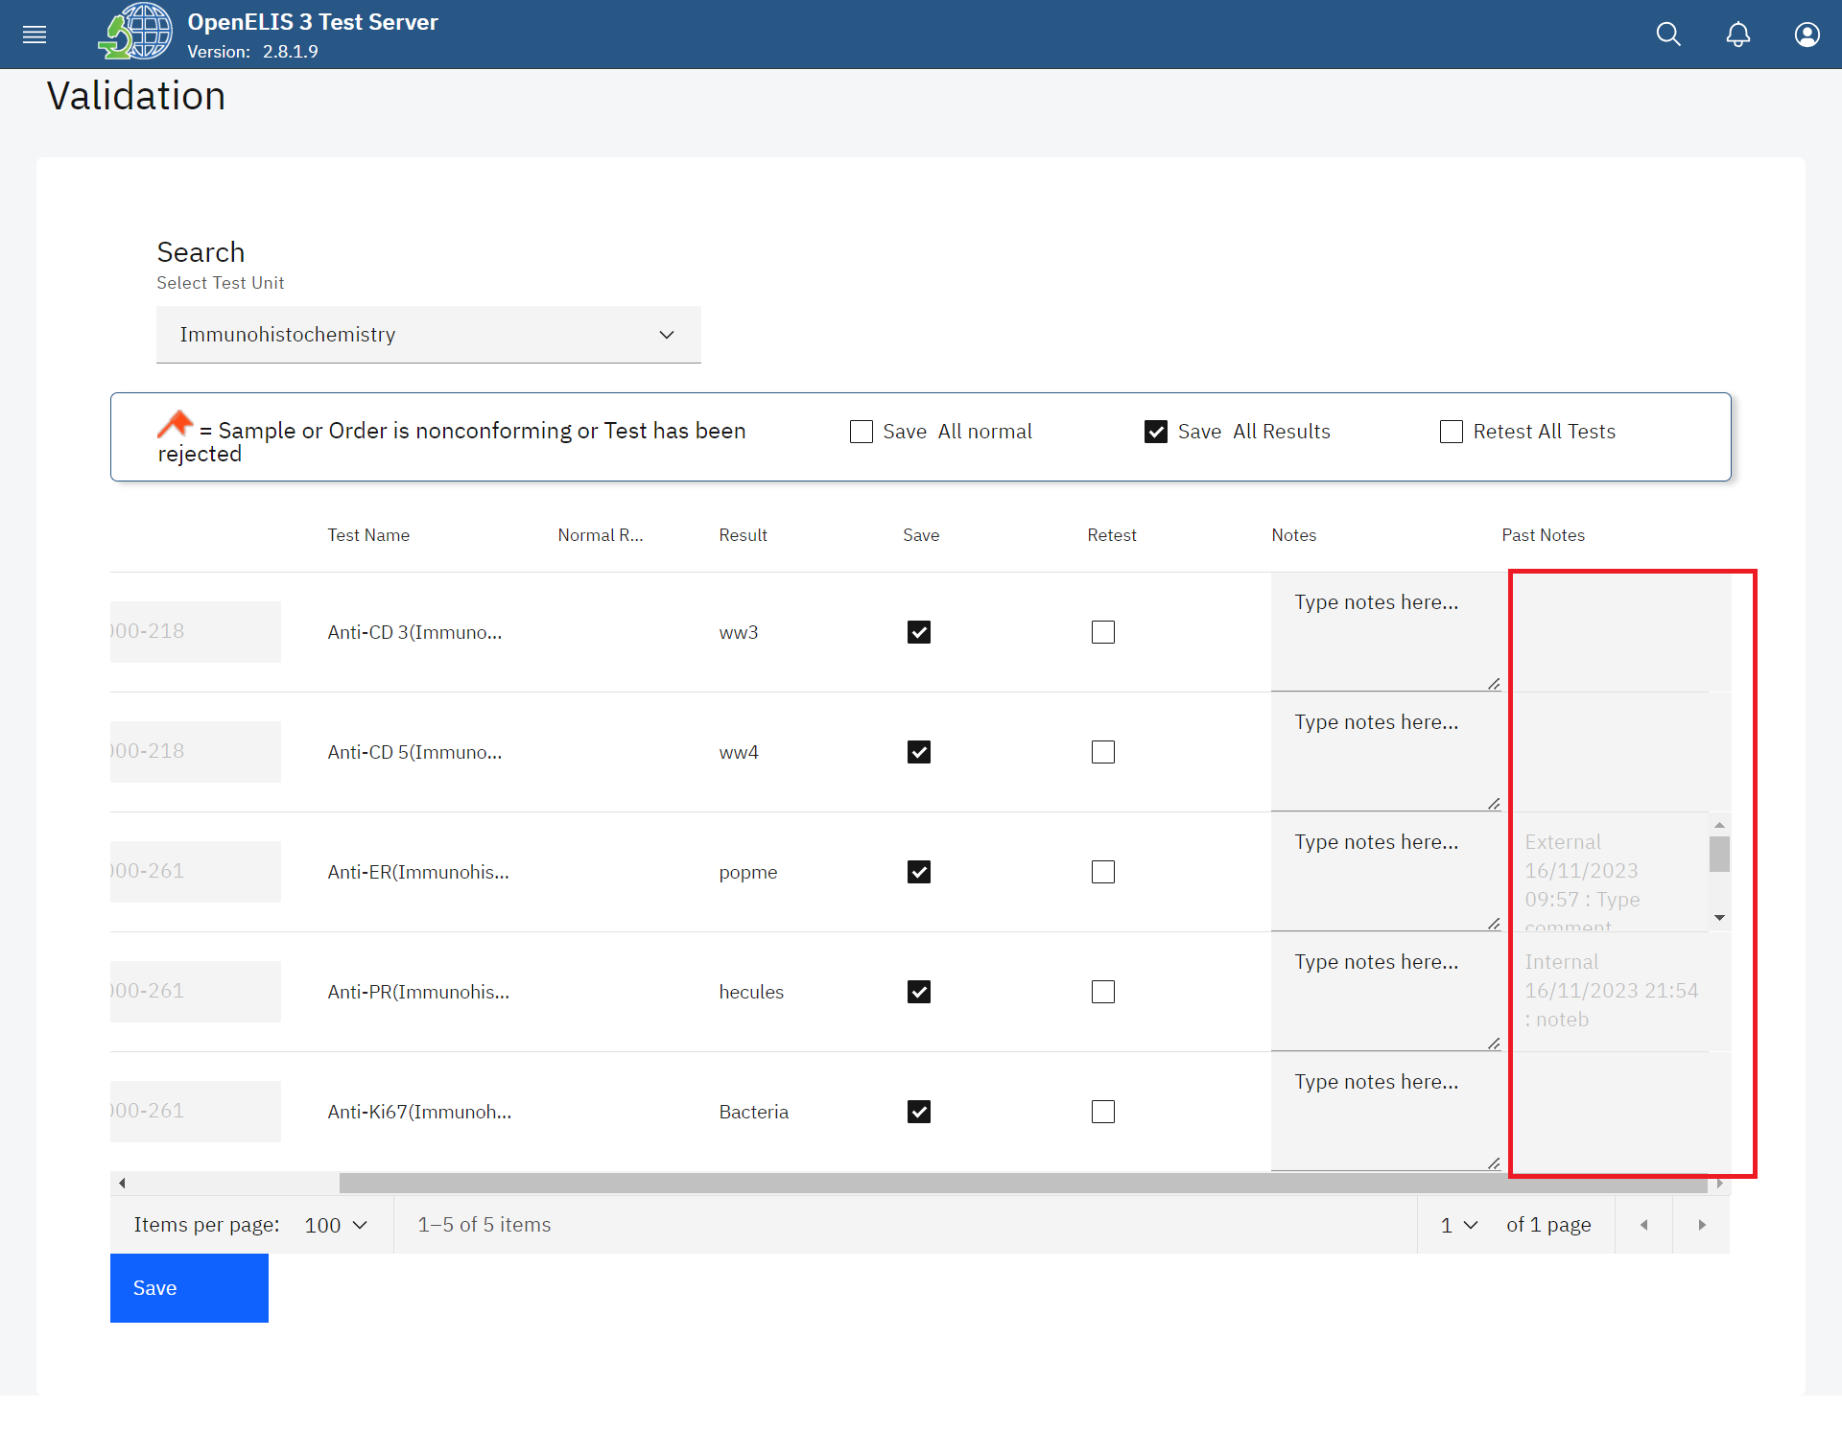*Past Notes*

1. Once you have entered all the results, go to the bottom of the page and click the **Save**  button.

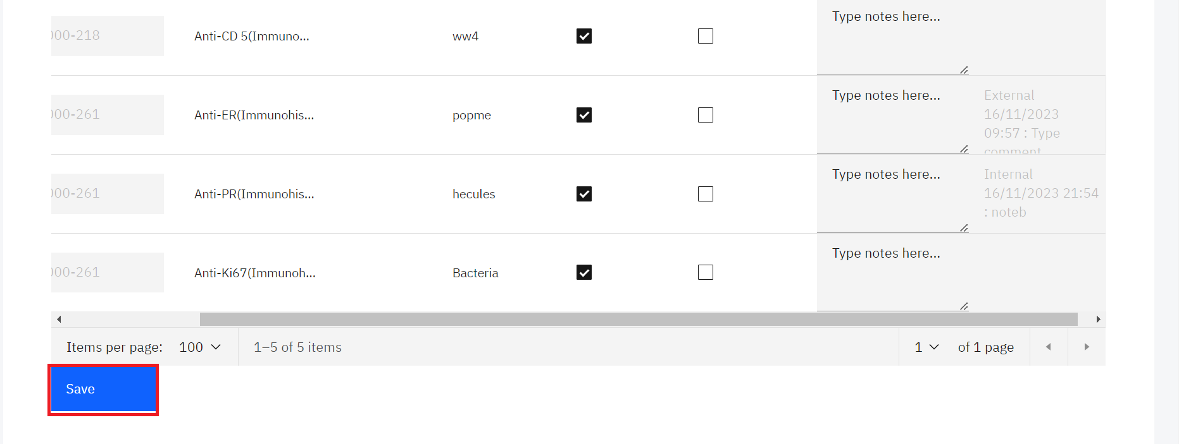

*Click Save*

A successful message will be displayed at the top of the page.

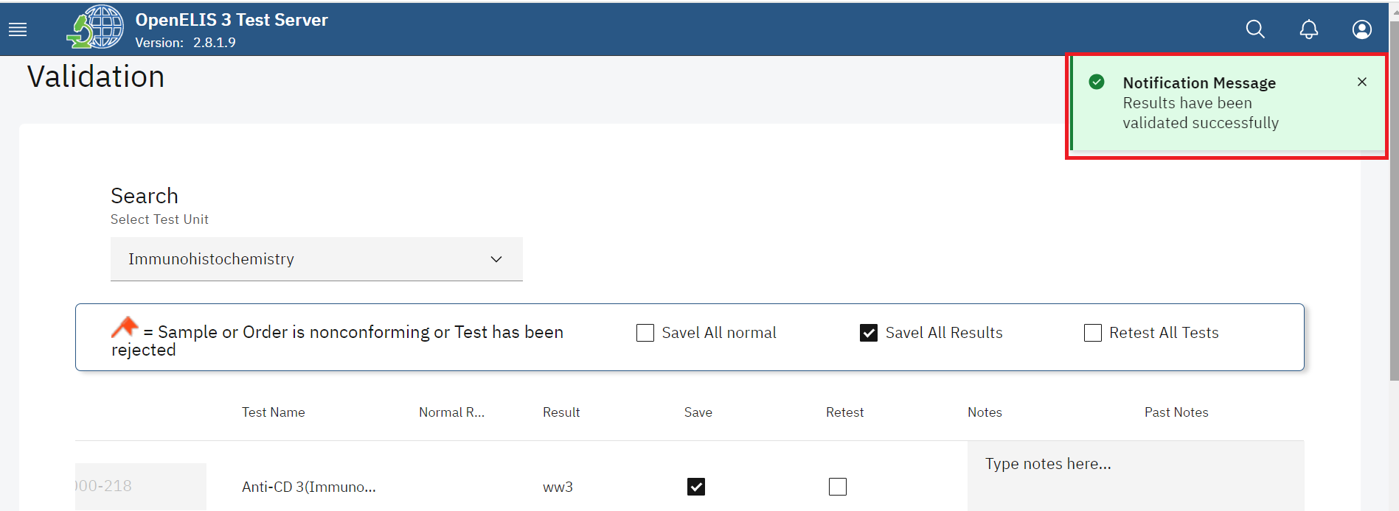

*Results Validated Successfully*

## **How to validate results By Order**

1. To validate results by order, click on **By Order** under the Validation module.

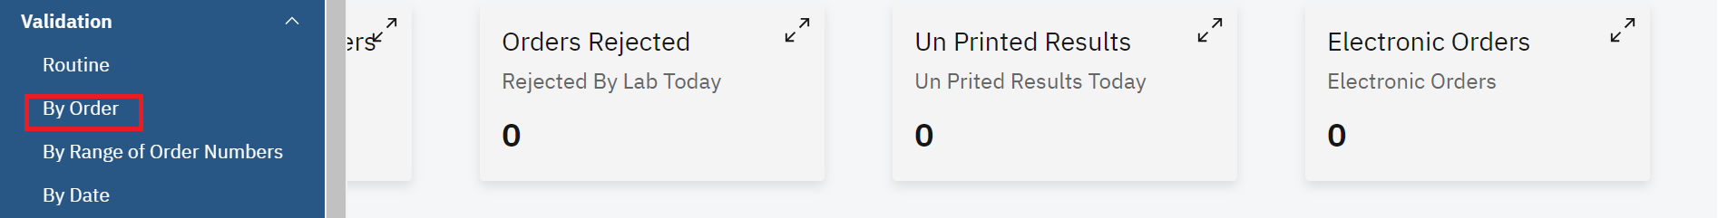

*Click Order*

1. Enter the accession number in the text box

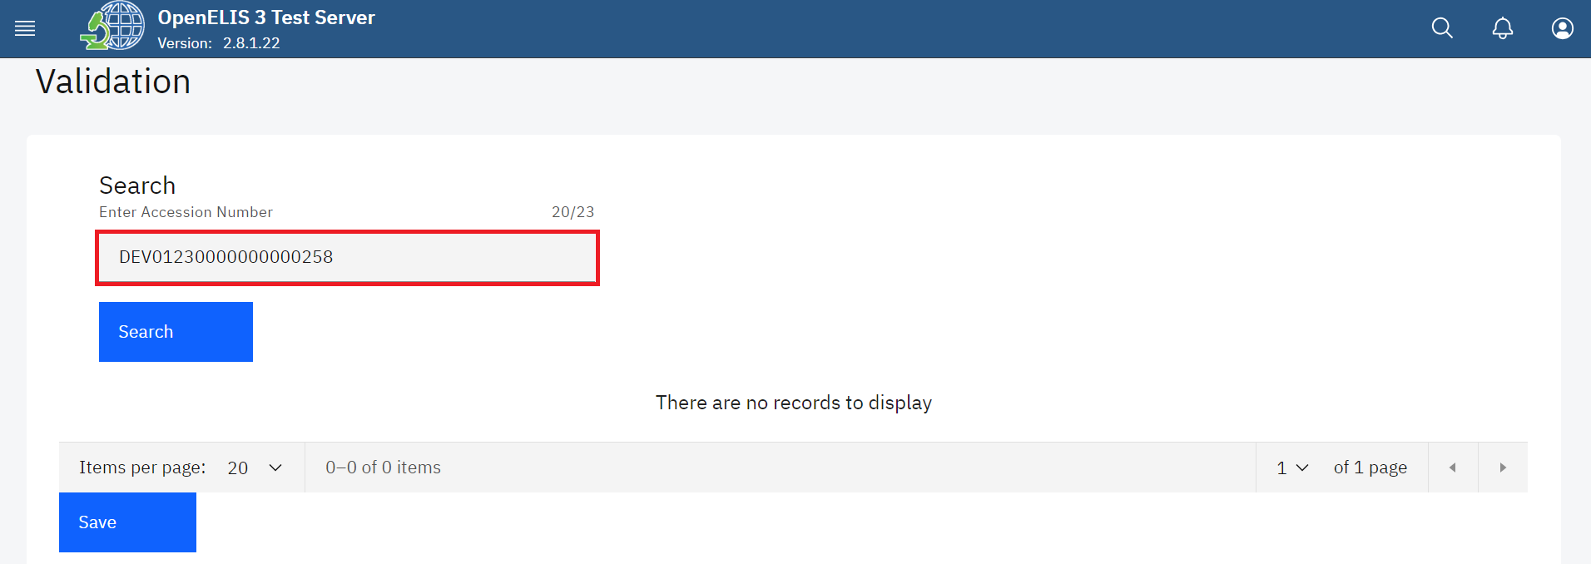

*Enter accession number*

1. Click on the **search** button.

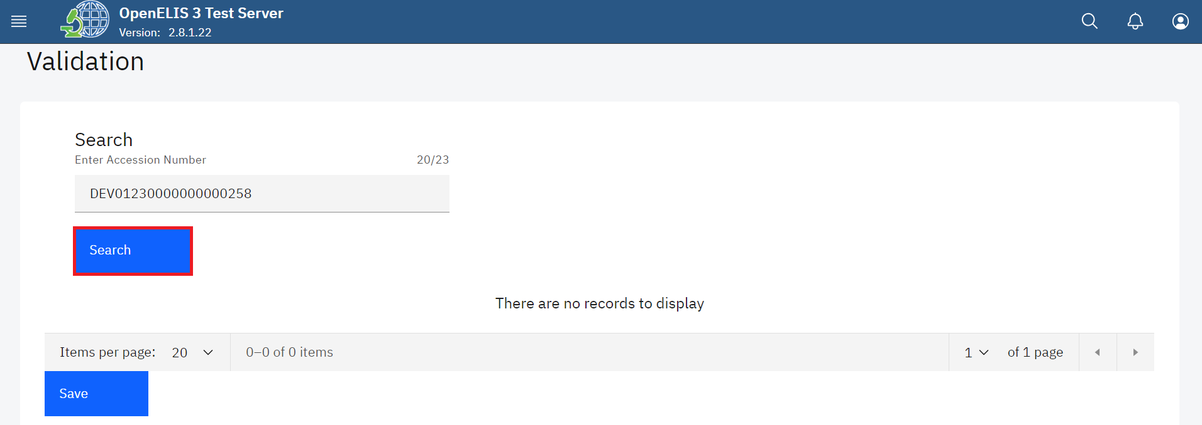

*Click search*

Upon clicking on the search button, the system will conduct a search.A list of all the results ready for validation in the laboratory is displayed.

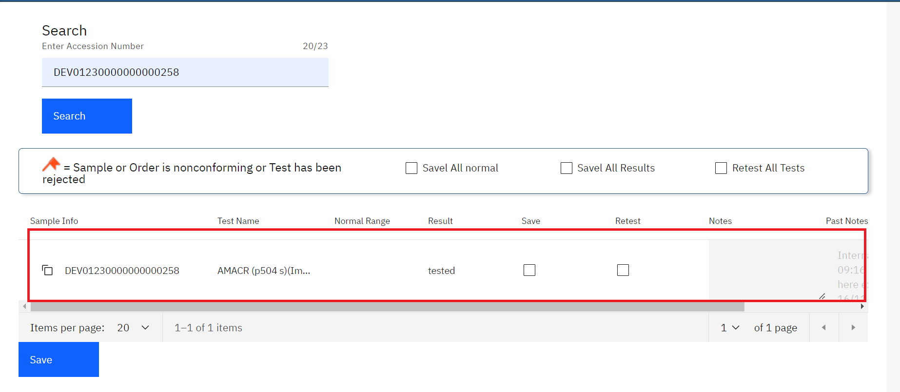

*Searched Results*

1. If there are results that are within normal range of acceptance, you can check the box **Save All Normal** to validate the normal results on the page at once. Click on the **Save** button.

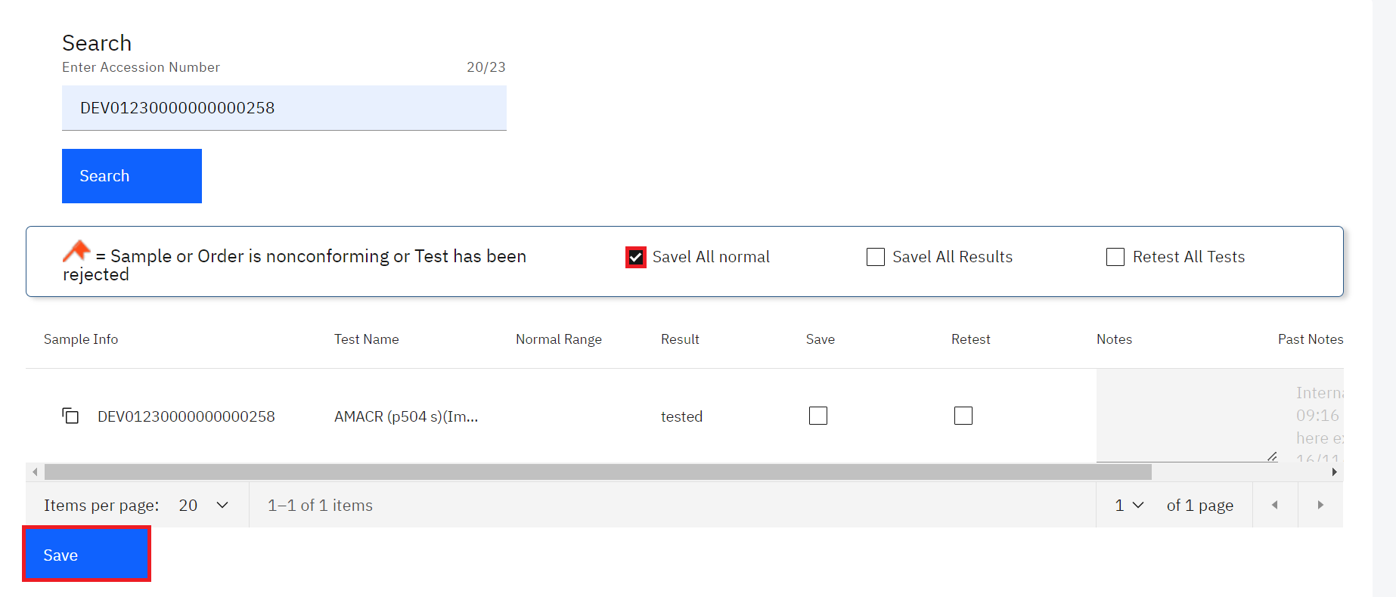

*Save All Normal Results*

The normal results will be validated and saved successfully.

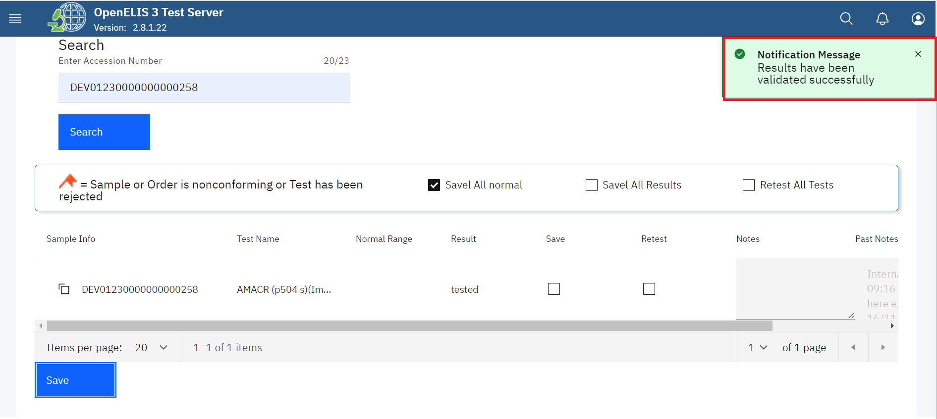

*Normal Results Validated Successfully*

1. If all results are valid, you can check the box **Save All Results** to validate all results on the page at once then click on the **Save** button.

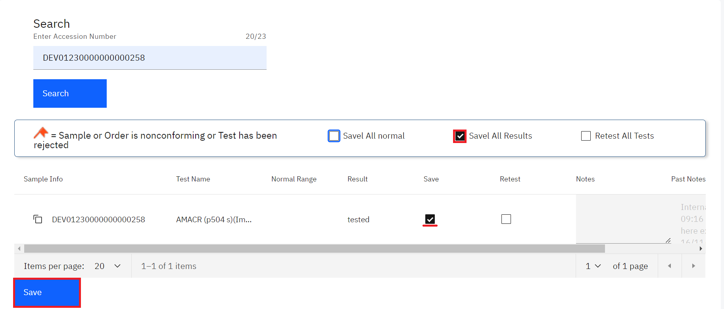

*Save all results*

1. If none of the results are valid as illustrated below, use the checkbox **Retest All Results**  to reject all of the results at once.

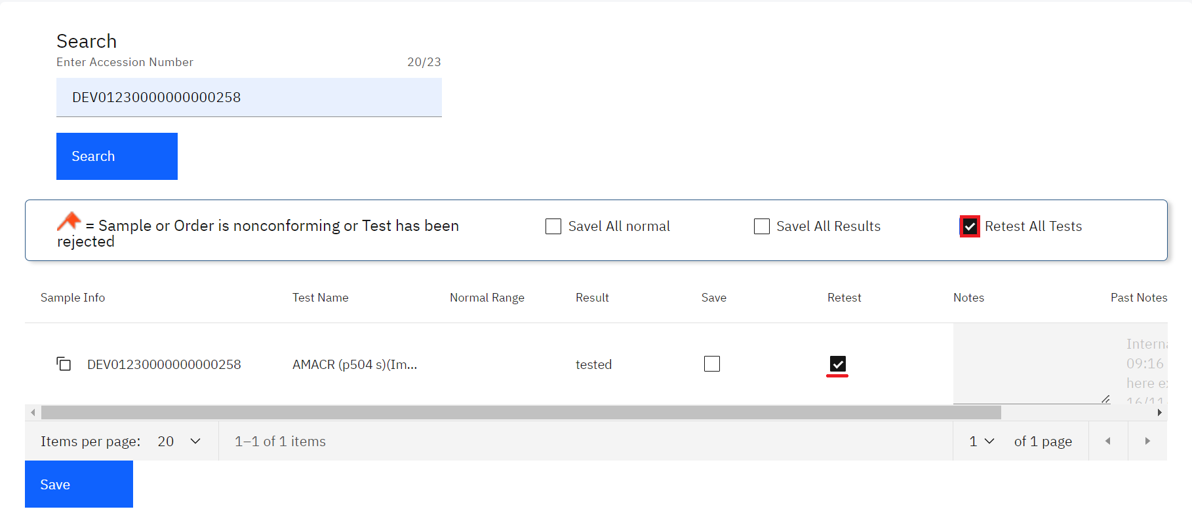

*Click Retest Checkbox for Invalid Result*

**Note:** you can check the box under the appropriate column—Save for validate, Retest for reject—next to each test result.

1. For *valid results*, enter any comments for the patient or provider that should accompany the test results. These comments will appear on the patient report. For *invalid results*, enter any comments for the lab technician regarding the validation of results and any required follow-up. These comments appear only for the lab and do not appear on the patient report.

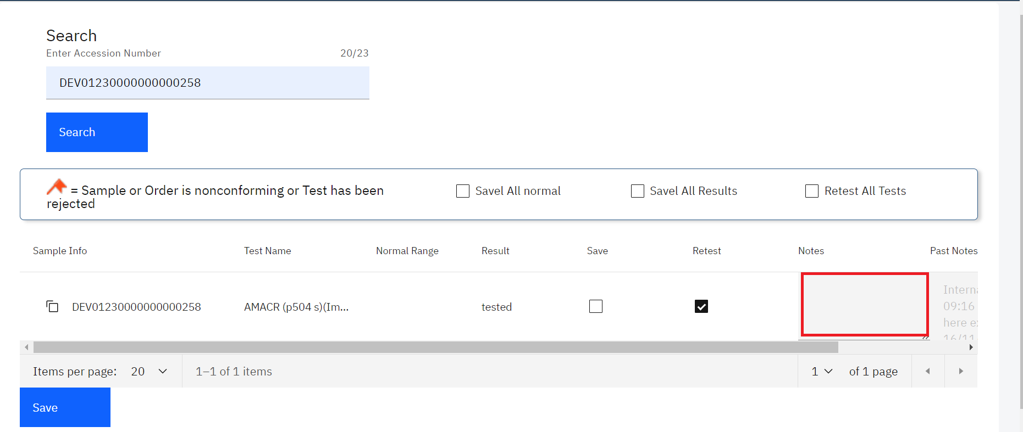

*Enter Comments under Notes*

The Past Notes are displayed in the last column. Use the horizontal scroll bar to scroll.

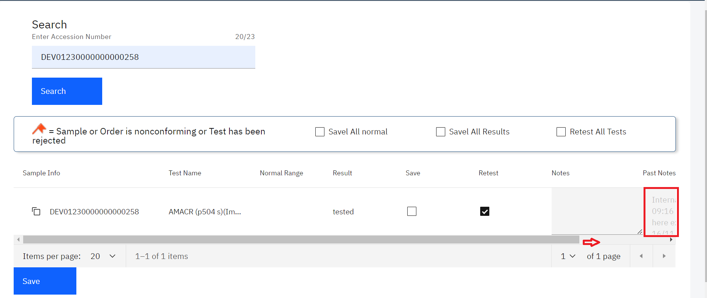

*Past notes*

1. Once you have entered all the results, go to the bottom of the page and click the **Save**  button.

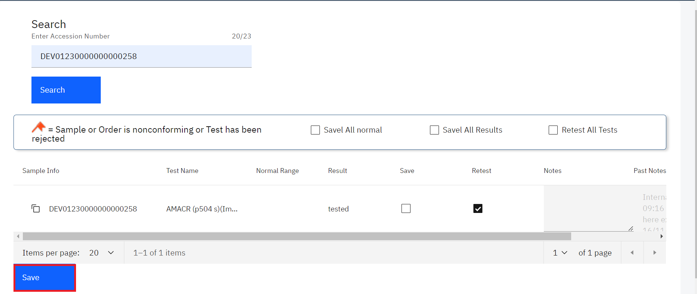

*Click Save*

A successful message will be displayed at the top of the page.

## **How to validate results By Range of Order Numbers**

1. To validate results by order, click on **By Range of Order Numbers** under the Validation module.

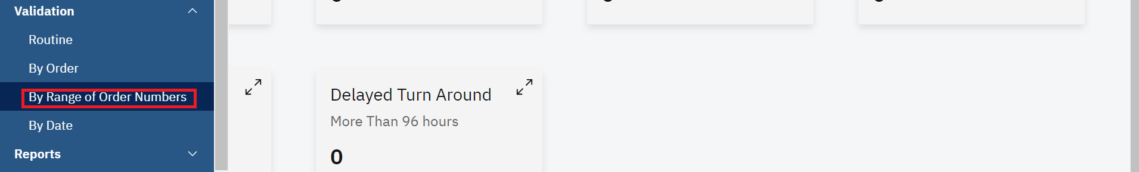

*Click by range of order numbers*

1. Enter the laboratory number to load the next 99 records starting at that laboratory number

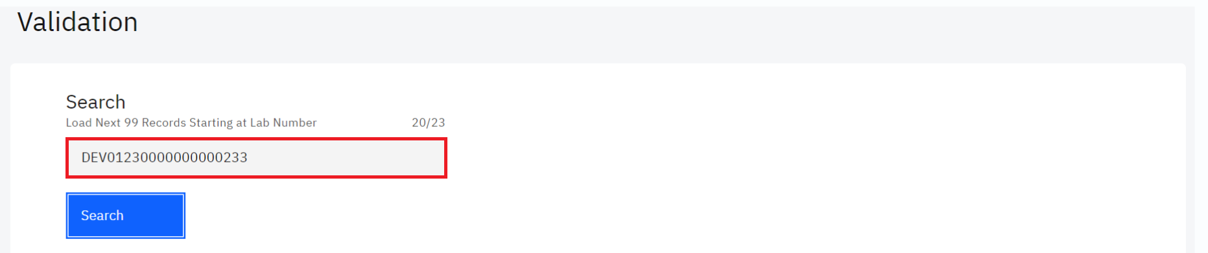

*Enter laboratory number*

1. Click on the **Search** button

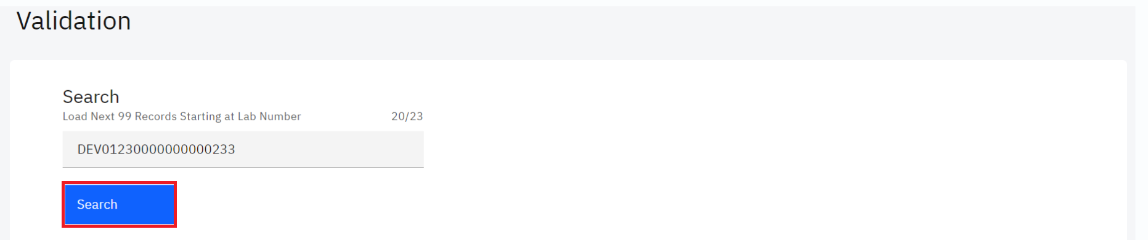*Click search*

Upon clicking on the search button, the system will conduct a search.A list of all the results ready for validation in the laboratory is displayed.

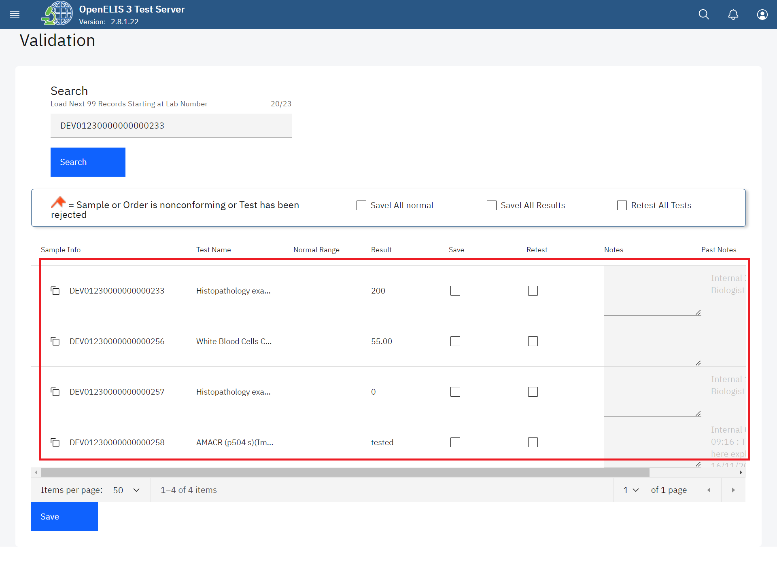

*Searched Results*

1. If there are results that are within normal range of acceptance, you can check the box **Save All Normal** to validate the normal results on the page at once. Click on the **Save** button.

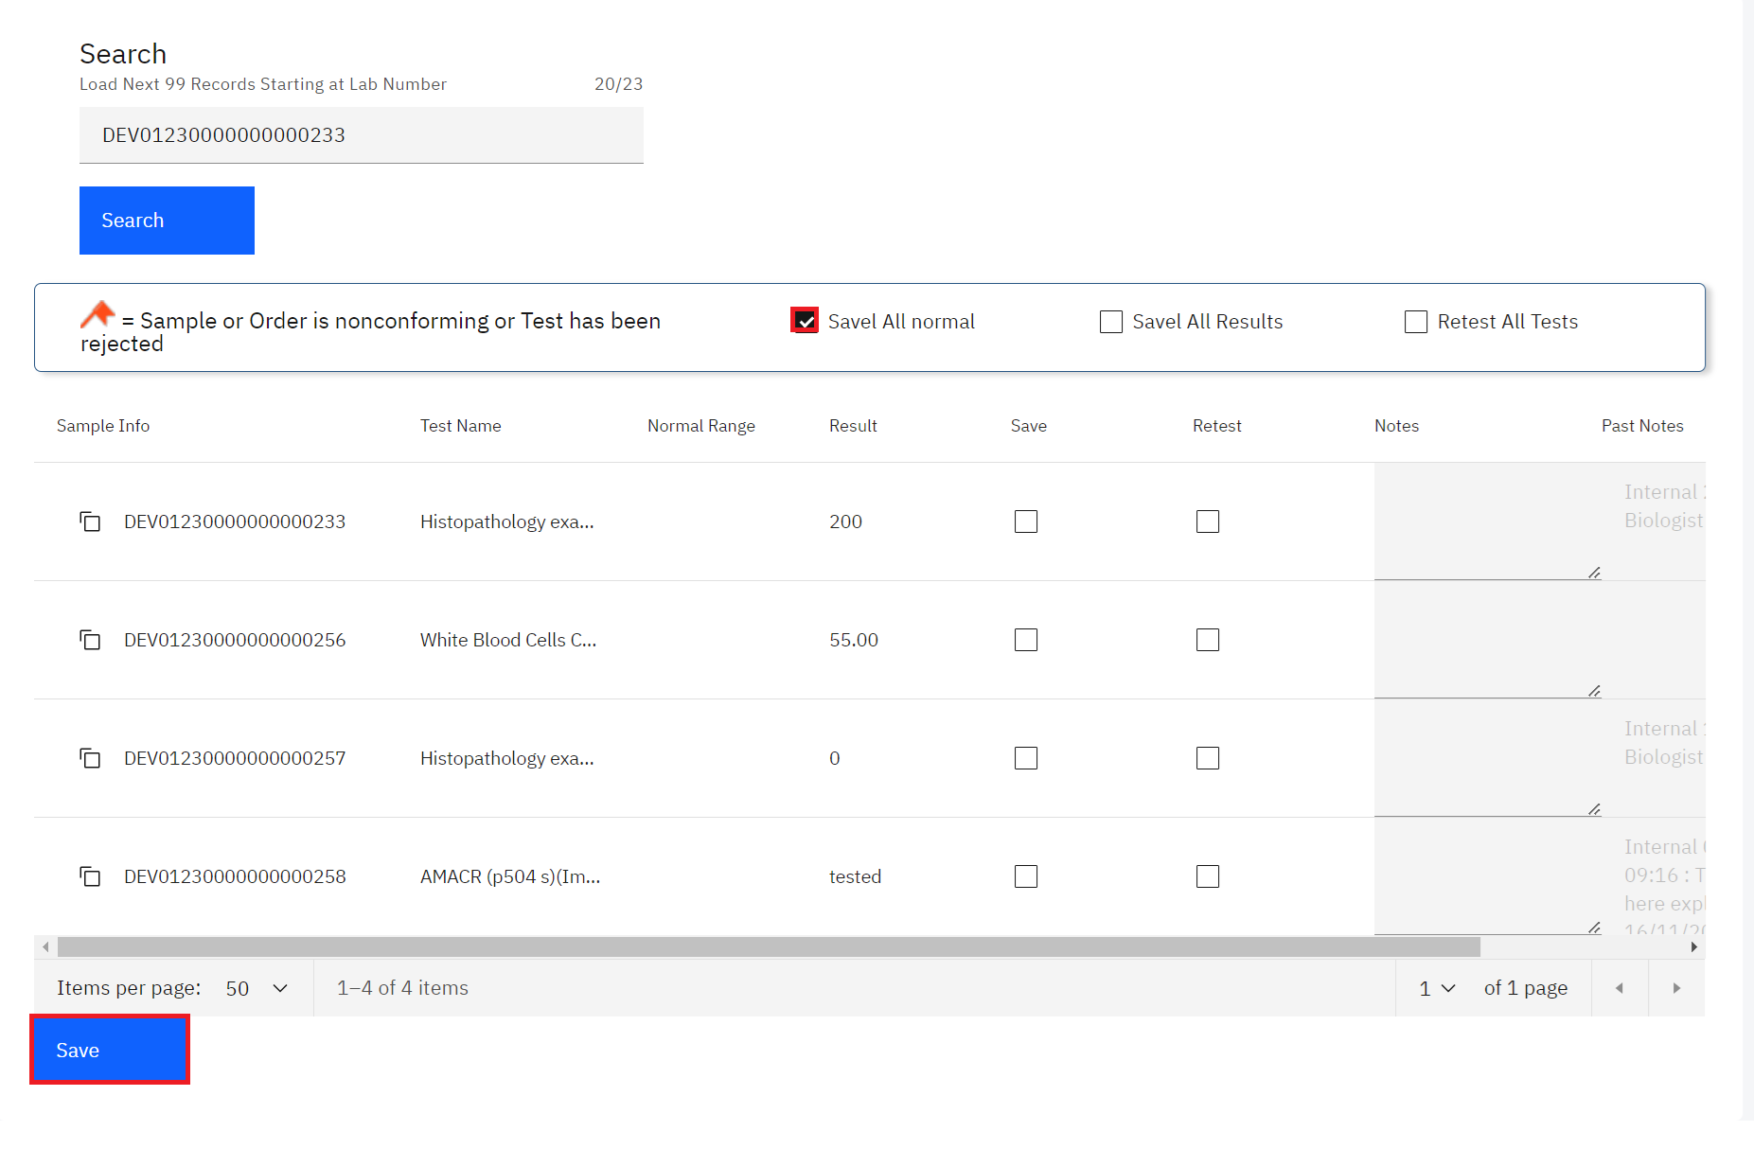

*Save All Normal Results*

The normal results will be validated and saved successfully.

1. If all results are valid, you can check the box **Save All Results** to validate all results on the page at once then click on the **Save** button.

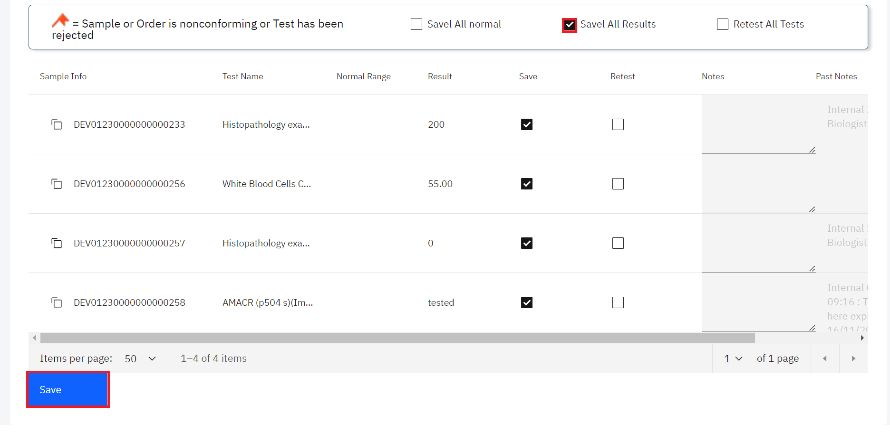*Save all results*

1. If none of the results are valid as illustrated below, use the checkbox **Retest All Results**  to reject all of the results at once. 

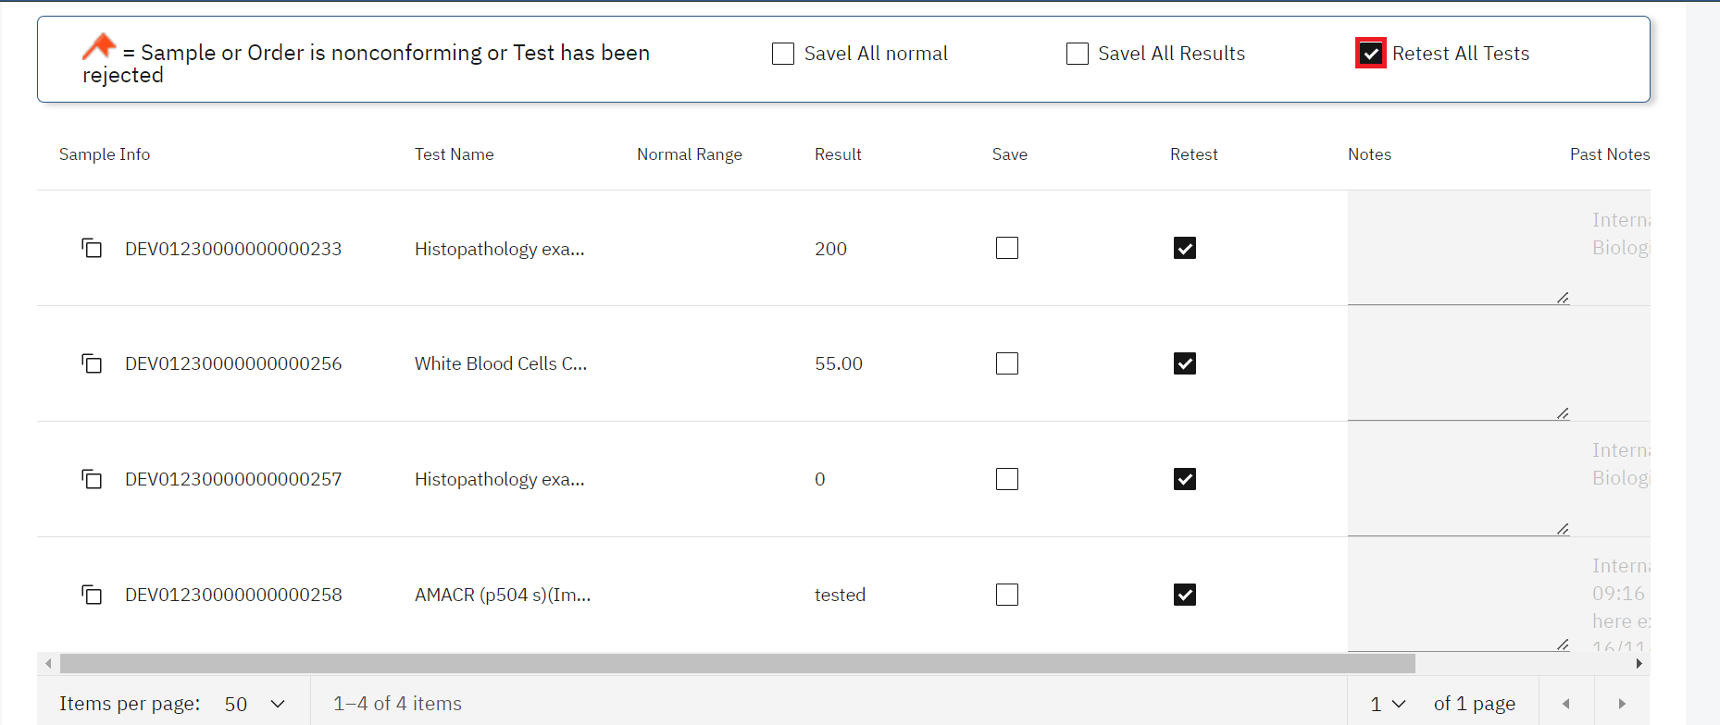*Click Retest Checkbox for Invalid Result*

**Note:** you can check the box under the appropriate column—Save for validate, Retest for reject—next to each test result.

1. For *valid results*, enter any comments for the patient or provider that should accompany the test results. These comments will appear on the patient report. For *invalid results*, enter any comments for the lab technician regarding the validation of results and any required follow-up. These comments appear only for the lab and do not appear on the patient report.

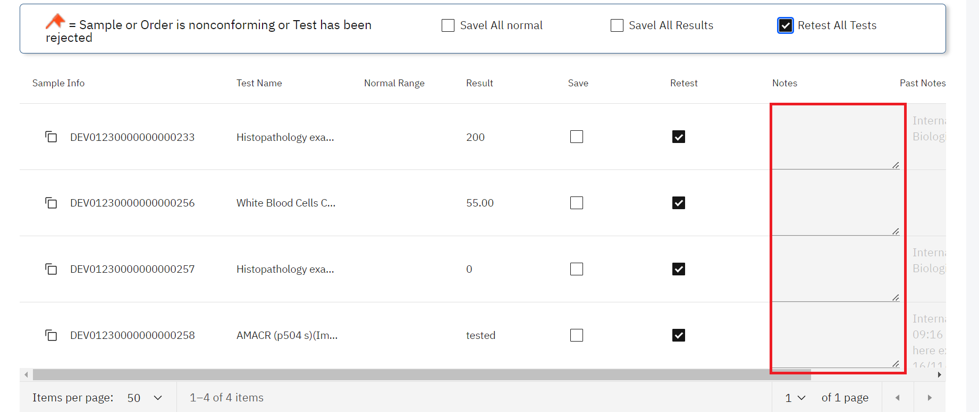*Enter Comments under Notes*

The Past Notes are displayed in the last column. Use the horizontal scroll bar to scroll.

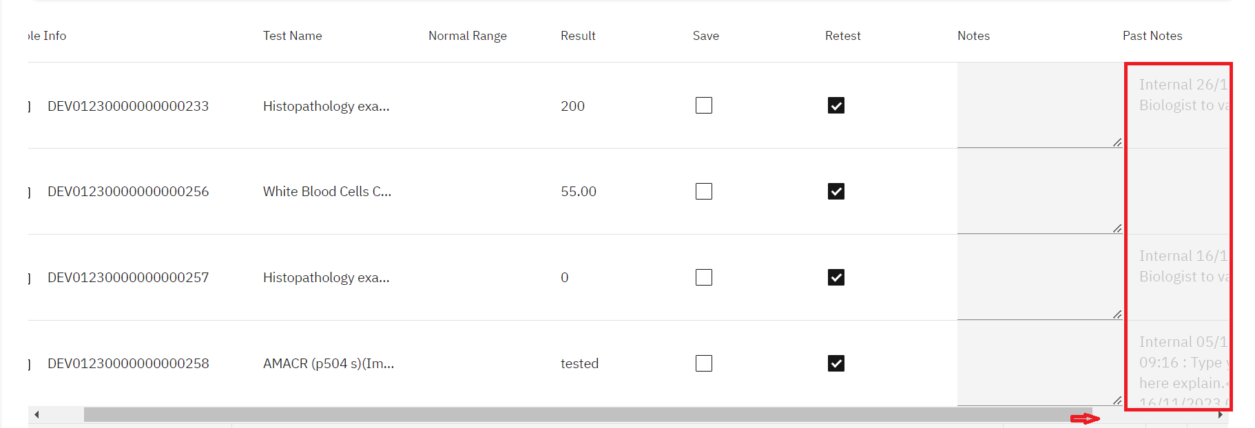

*Past notes*

1. Once you have entered all the results, go to the bottom of the page and click the **Save**  button.

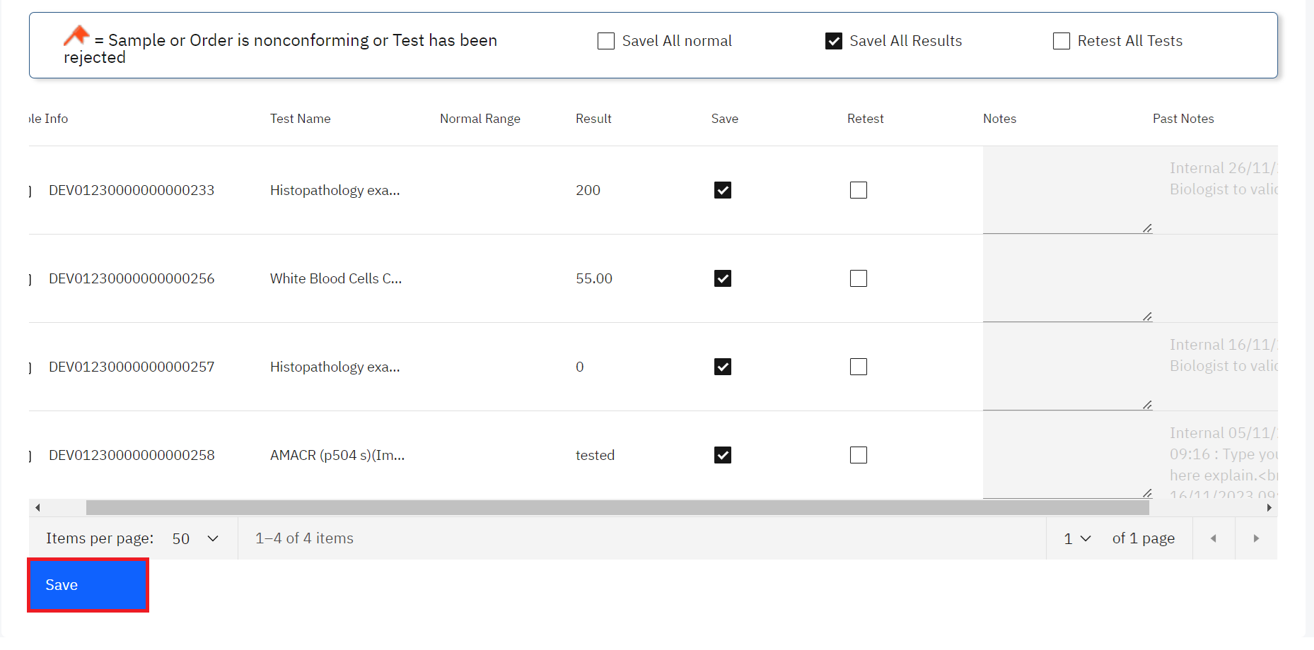

*Click save*

## **How to validate results By Test Date**

1. To validate results routinely, click on **Search By Test Date** under the Validation module.

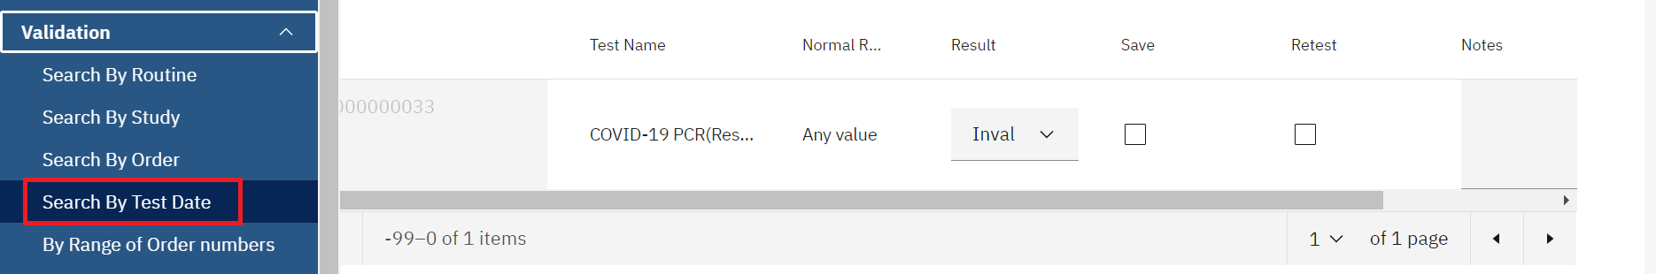*Click Search By Test Date*

1. Enter the **Date** from the calendar and click on the **Search** button..

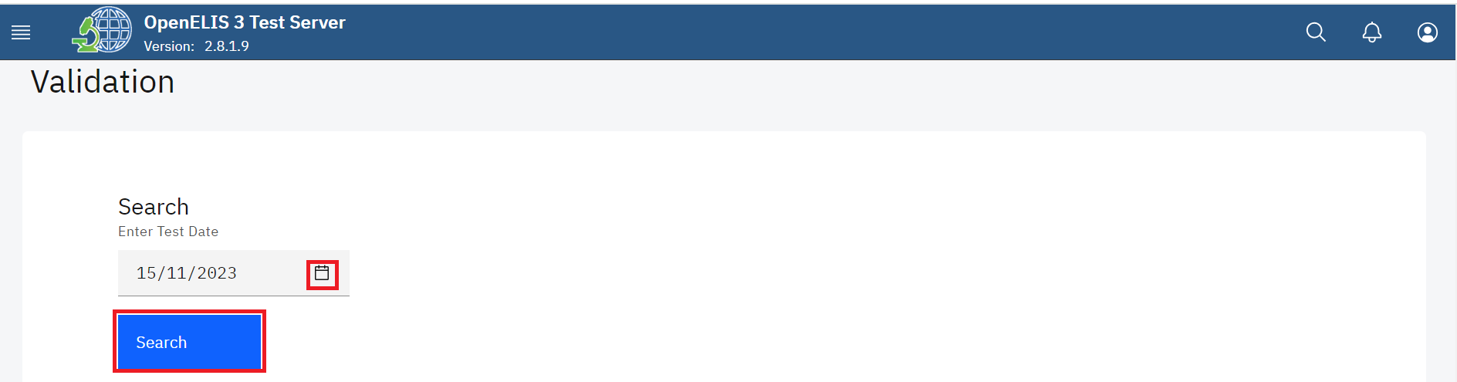*Select Data from Calendar*

Upon clicking on the search button, the system will conduct a search. A list of all the results ready for validation is displayed.

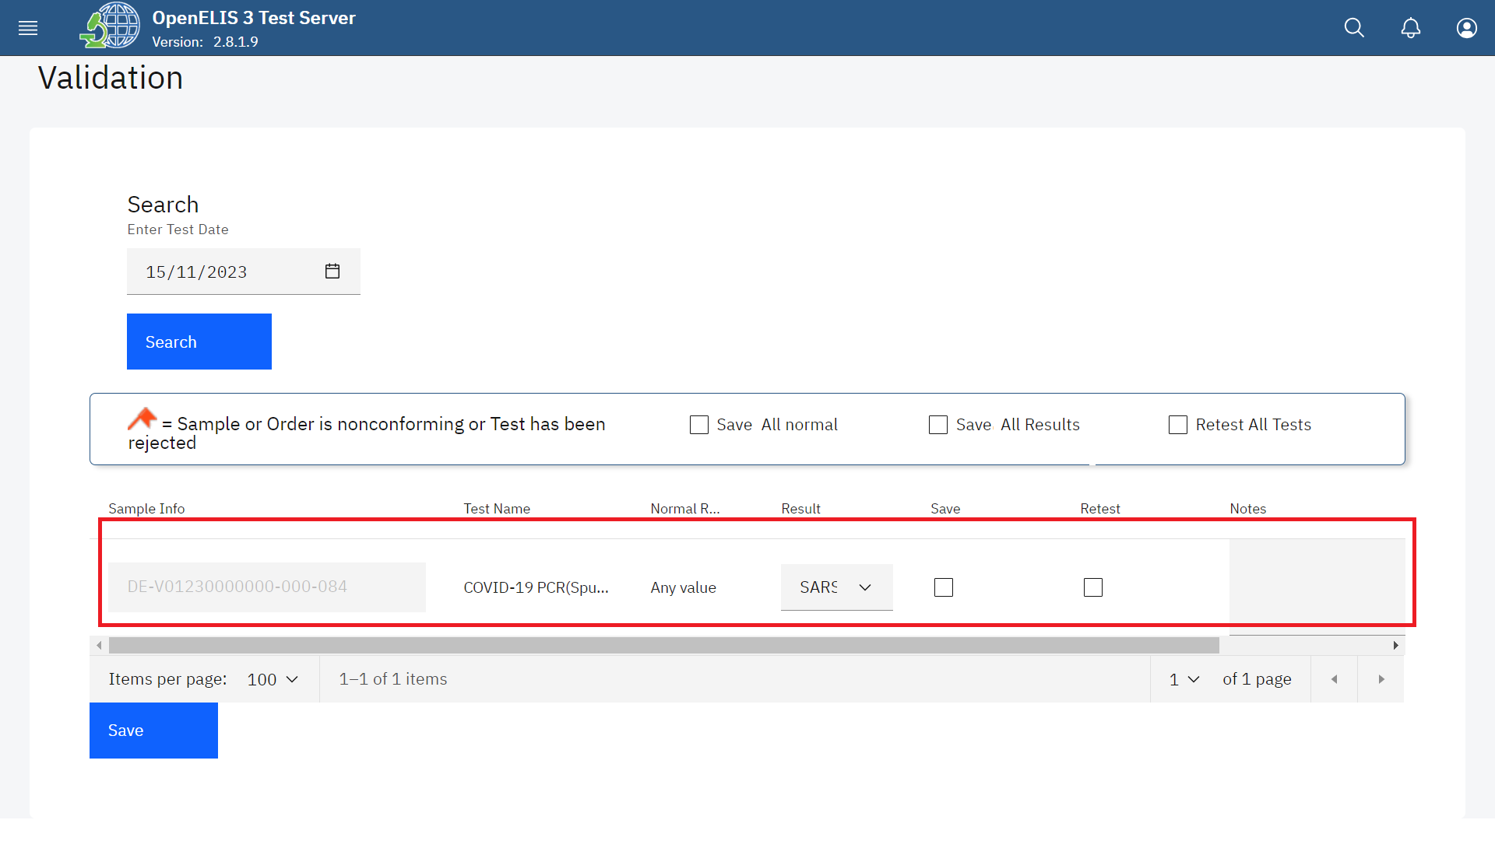

*Searched Results*

1. If there are results that are within normal range of acceptance, you can check the box **Save All Normal** to validate the normal results on the page at once. Click on the **Save** button.

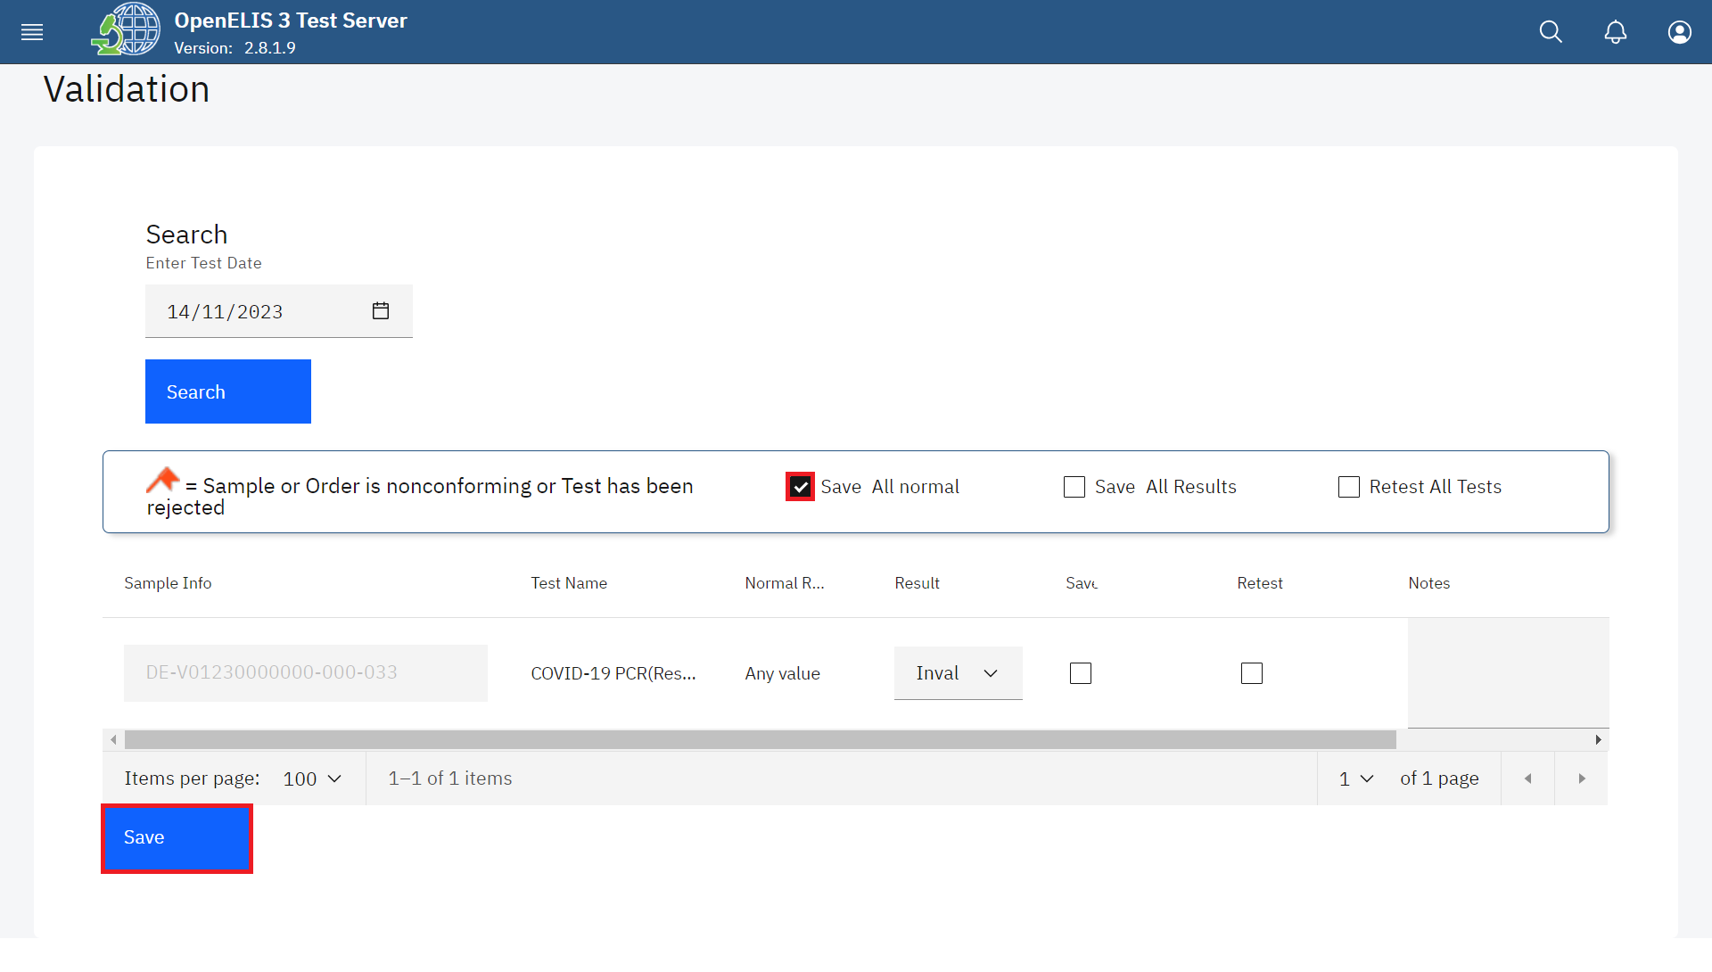*Save All Normal Results*

The normal results will be validated and saved successfully.

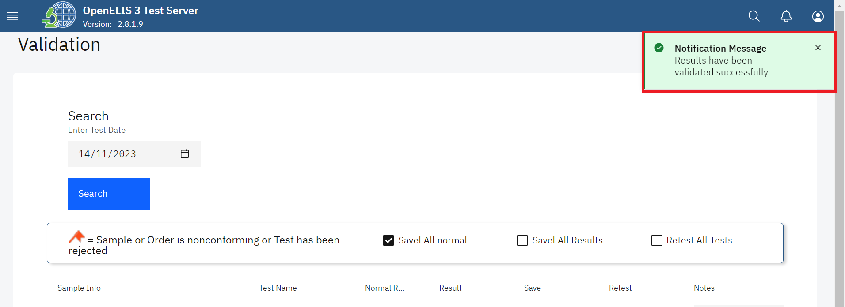*Normal Results Validated Successfully*

1. If all results are valid, you can check the box **Save All Results** to validate all results on the page at once.

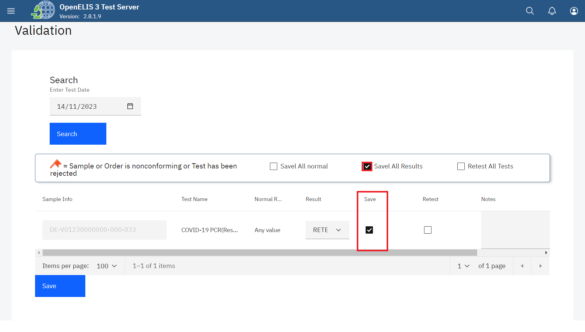

*Click Save All Results Checkbox for Valid Result*

The Results column has a drop-down menu that allows you to select the result.

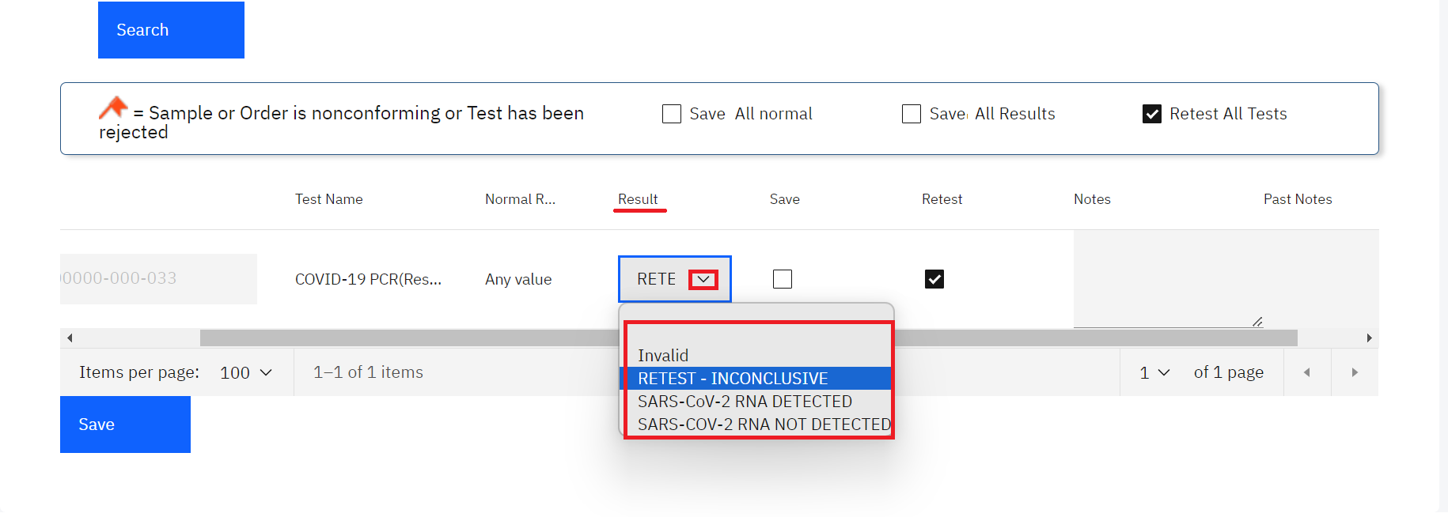*Results Drop-down menu*

1. If none of the results are valid as illustrated below, use the checkbox **Retest All Results**  to reject all of the results at once.

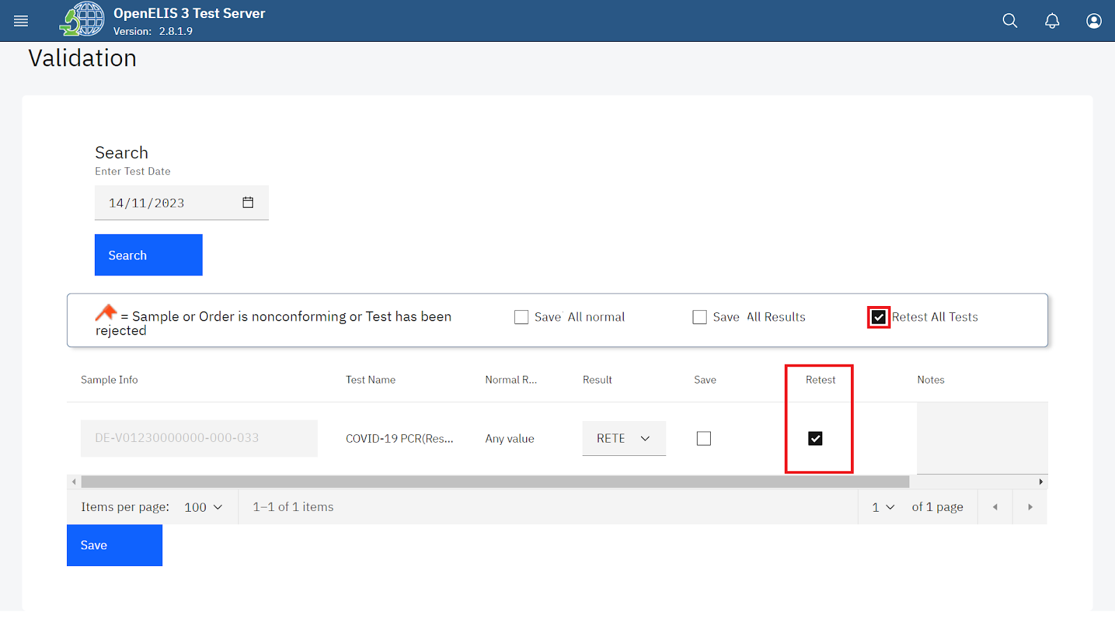

*Click Retest Checkbox for Invalid Result*

**Note:** you can check the box under the appropriate column—Save for validate, Retest for reject—next to each test result.

1. For *valid results*, enter any comments for the patient or provider that should accompany the test results. These comments will appear on the patient report. For *invalid results*, enter any comments for the lab technician regarding the validation of results and any required follow-up. These comments appear only for the lab and do not appear on the patient report.

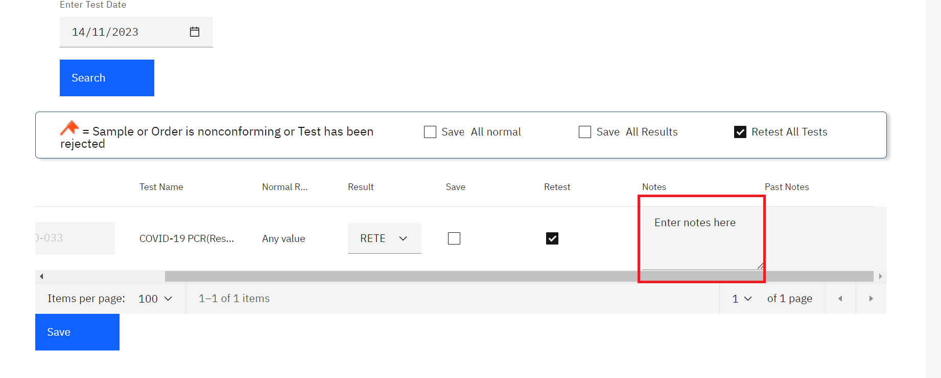

*Enter Comments under Notes*

The Past Notes are displayed in the last column.

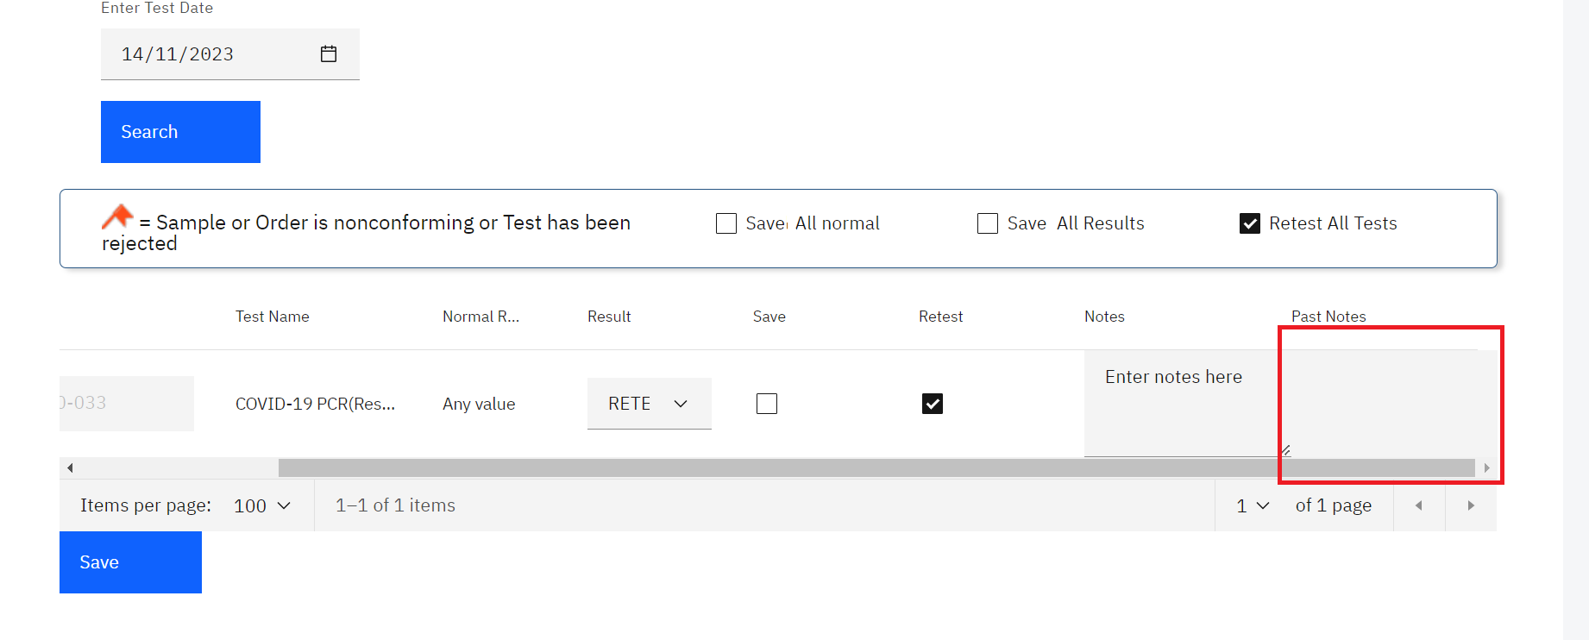*Past Notes*

1. Once you have entered all the results, go to the bottom of the page and click the **Save**  button.

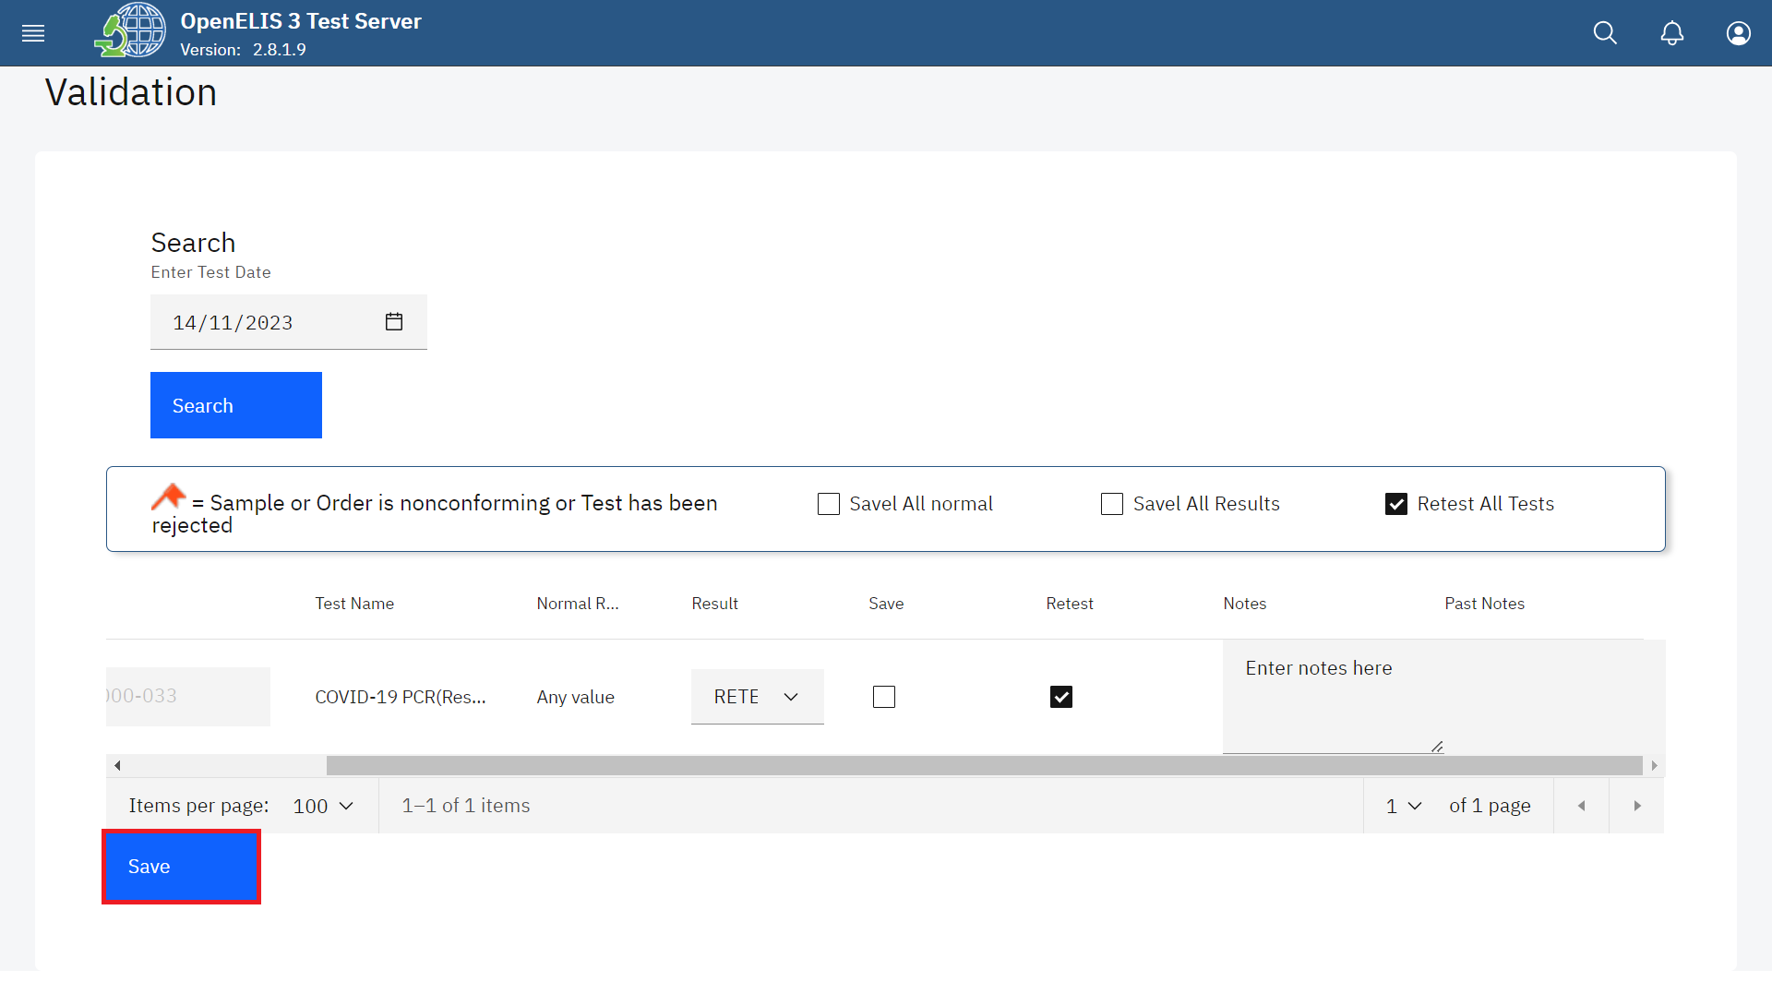

*Click Save*

A successful message will be displayed at the top of the page.

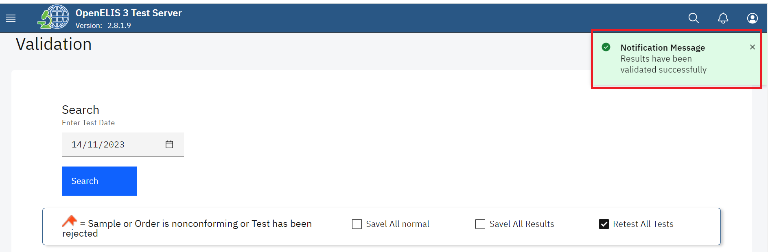

*Results Validated Successfully*

# **PART 14: REPORT**

Various reports are available in OpenELIS Global. They are grouped into three categories:

1. Individual Patient Report.
2. Aggregate Reports.
3. Management Reports

The reports available depend on your local configuration.

| **CATEGORY** | **REPORT** |
| --- | --- |
| Individual Patient Report | Patient Test Results Report  “Patient Status Report” |
| Aggregate Report | Summary of All Tests |
| Summary of HIV test |
| Management Report | Activity Reports |
| Referred Tests Report  Non Conformity Events Report |
| Delayed Validation Report  Audit Trail Report |

There are two guides to producing reports:

1. How to generate the Patient Results Report.
2. How to generate a Study Report
3. How to generate all other report

## **How to get to the results validation page and generate a report by routine.**

1. Hover the mouse over the hamburger icon and click to open the menu.



*Access the OpenELIS menu*

1. Hover the mouse and click on the drop-down menu under the Reports module.

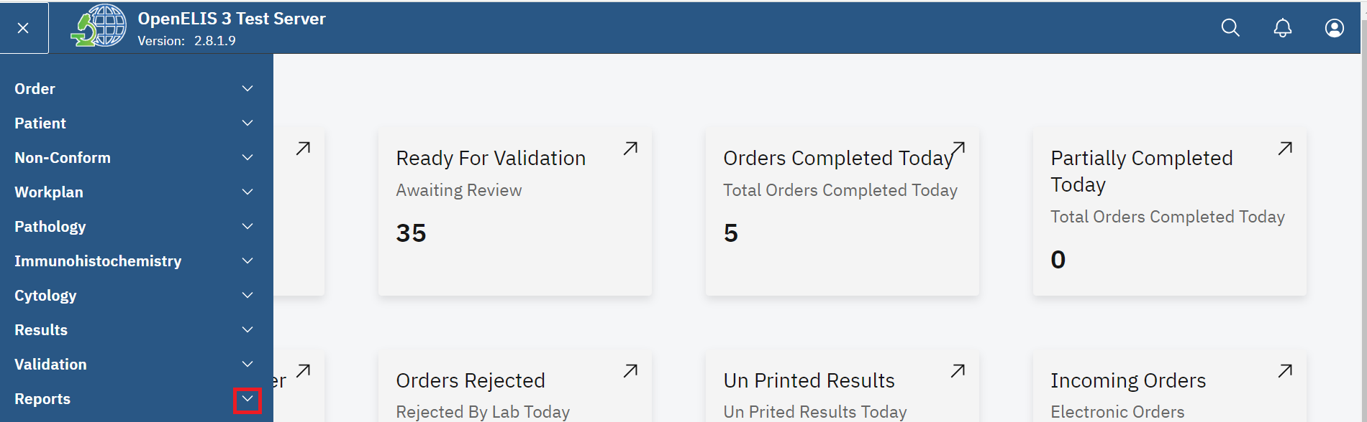

*Click on Report dropdown Menu*

1. Select **Routine.**

**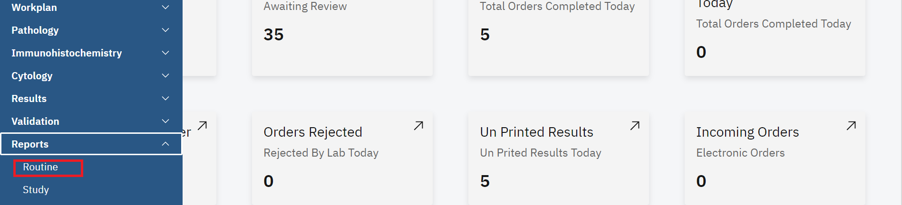***Click on Routine*

1. Click on the **Patient Status Report** drop-down menu.

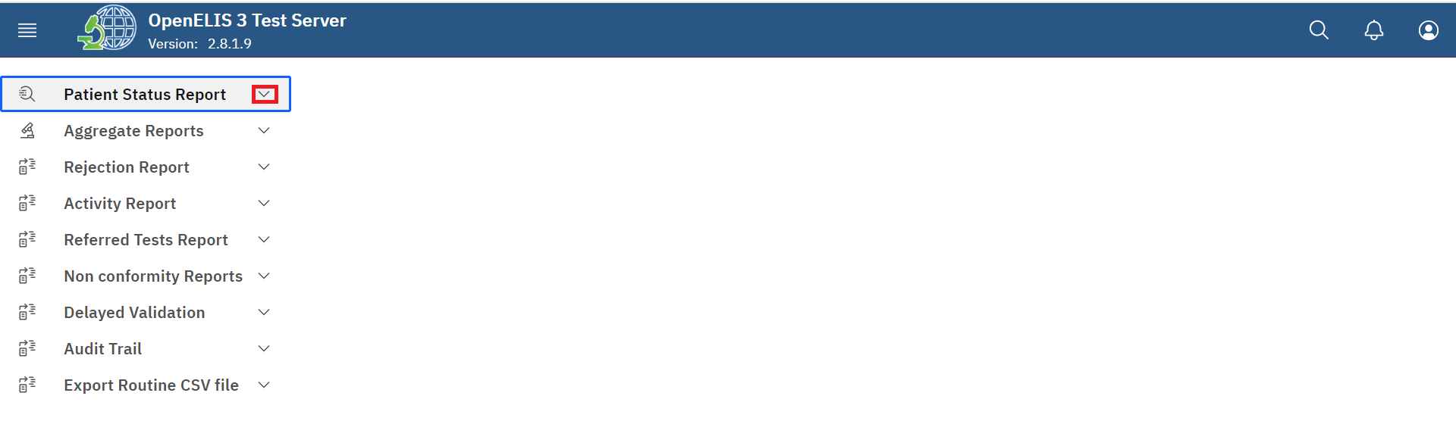*Click Patient Status Report Drop-down Menu*

1. Click on report

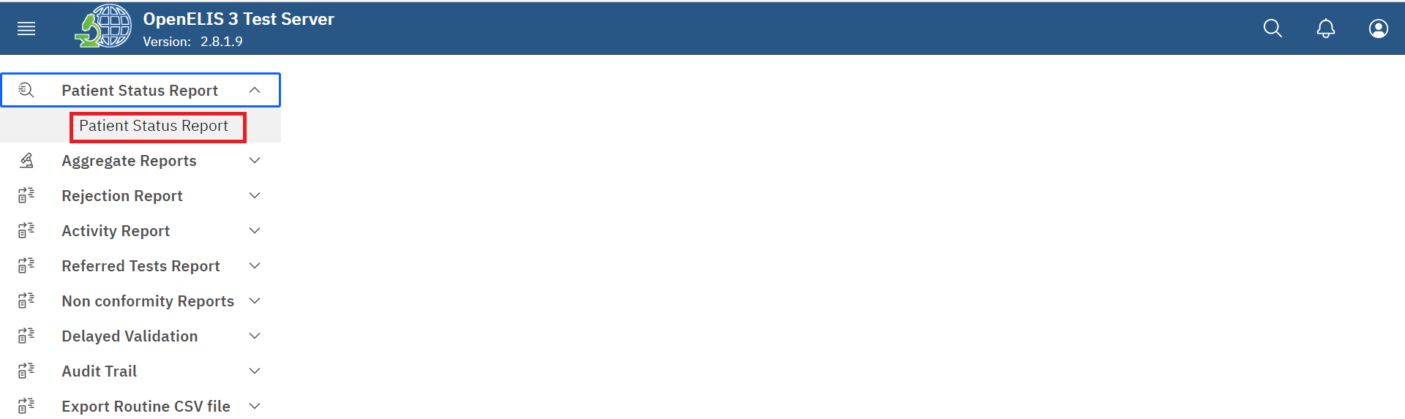*Click Patient Status Report* 

1. For *a single laboratory order:* Enter or scan the laboratory number in the **From** field.

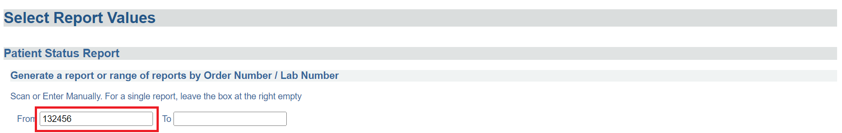

*Enter or Scan Lab/Order Number*

1. Click the **Generate printable version** button. A PDF version of the report will appear in a new browser window.

*Click Generate*

1. For *a contiguous range of laboratory orders by number:* Enter or scan the starting laboratory number in the **From** field and enter or scan the ending laboratory number in the **To** field.

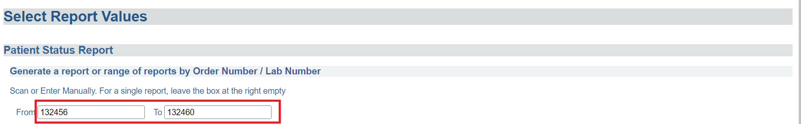*Enter Range of Laboratory Orders* 

1. Click the **Generate printable version** button. A PDF version of the report will appear in a new browser window.

*Click Generate*

1. For *a single patient’s entire order history:* Enter the **Patient ID** in the **From** field.

**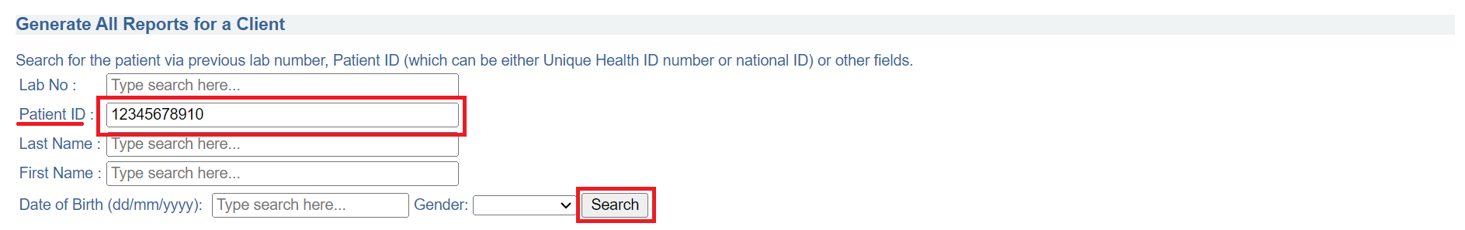***Enter Patient ID and Search*

1. Upon clicking on the Search button, the search results will return a matching patient with a selected radio-button.
2. Click the **Generate printable version** button. A PDF version of the report will appear in a new browser window.

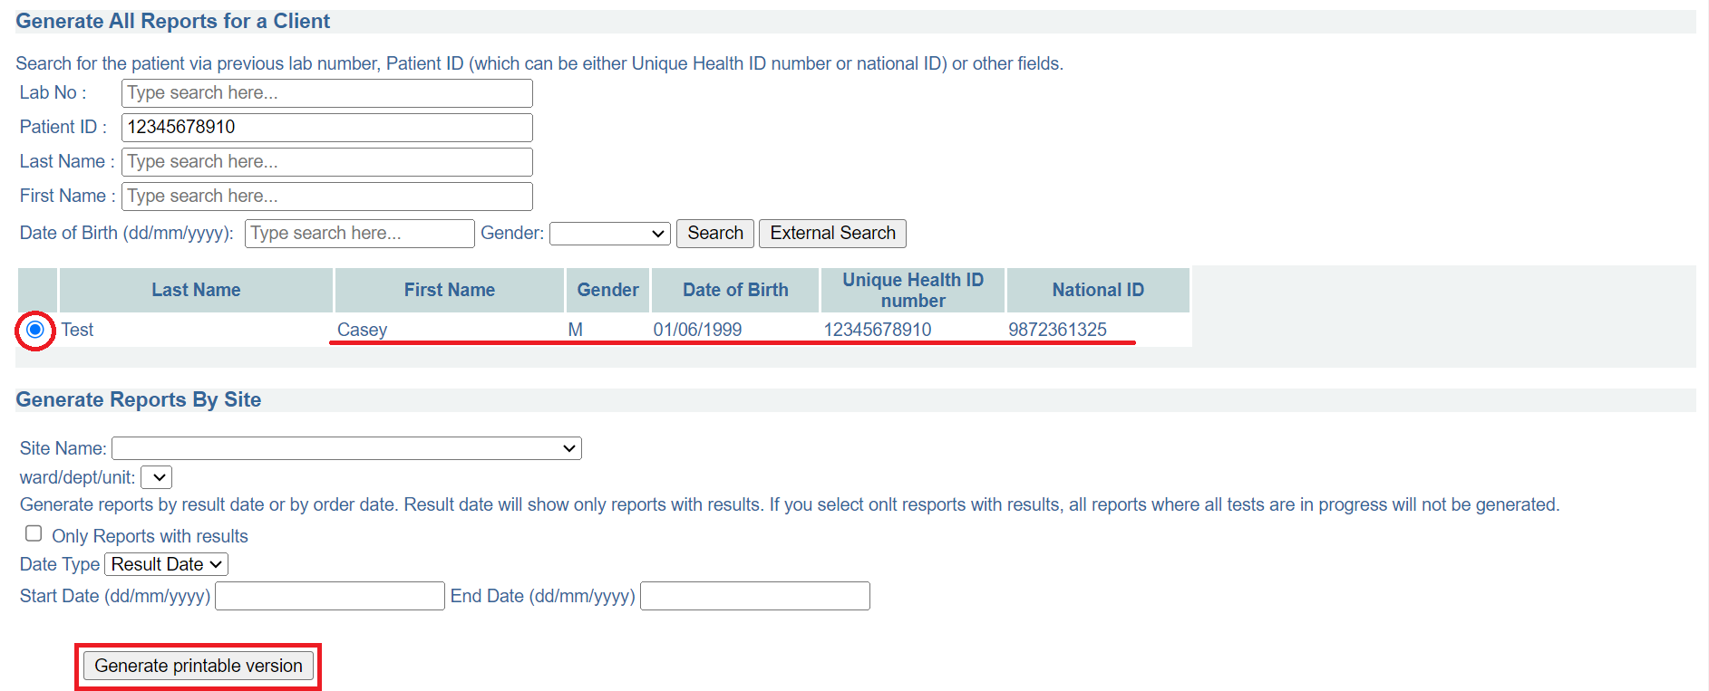*Click Generate* 

13.To generate reports by site, select the **Site Name**, you can check the check box for **Only Reports with results**, select the **Date Type** from the drop-down menu, enter the **Start** and **End Date** and click on **Generate printable version**. A PDF version of the report will appear in a new browser window.

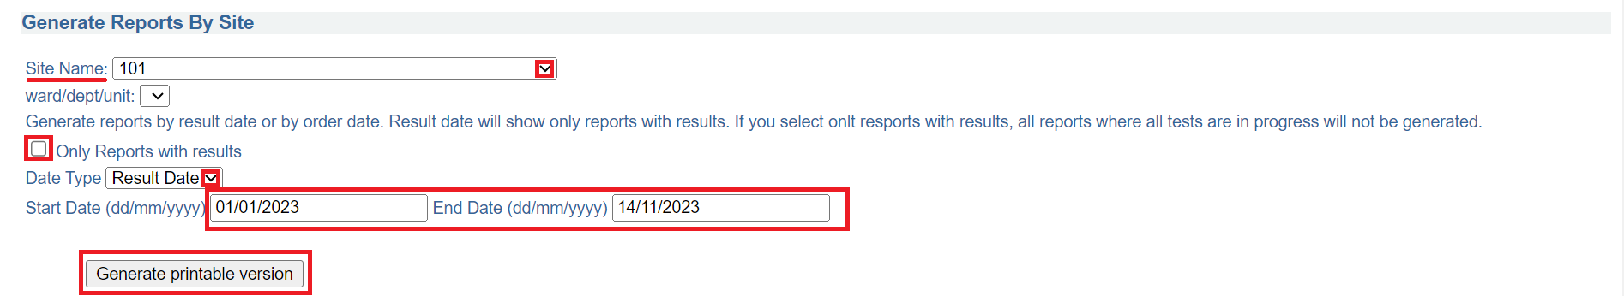*Generate Reports By Site*

## **How to generate all other reports.**

1. Hover the mouse over the hamburger icon and click to open the menu.



*Access the OpenELIS menu*

1. Hover the mouse and click on the drop-down menu under the Reports module.



*Click on Report dropdown Menu*

1. Click on either **Routine** or **Study.**

**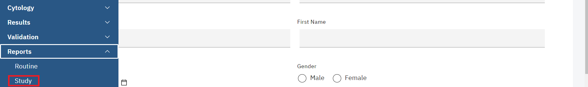***Click on Study*

1. Click on the drop-down menu for desired.

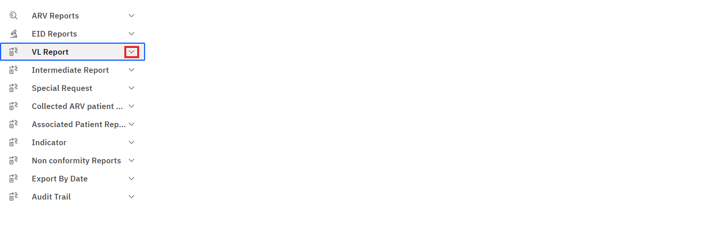

*Click Drop-down Menu*

1. Click on a report.

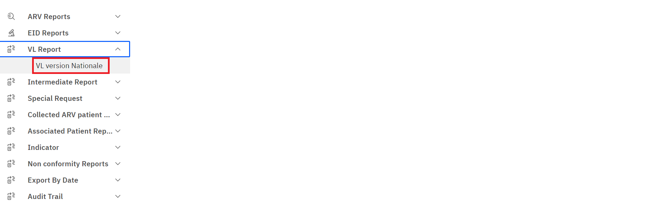

*Click on a Report*

1. Enter the search parameters. In this illustration, the last name is entered and the search button is clicked.

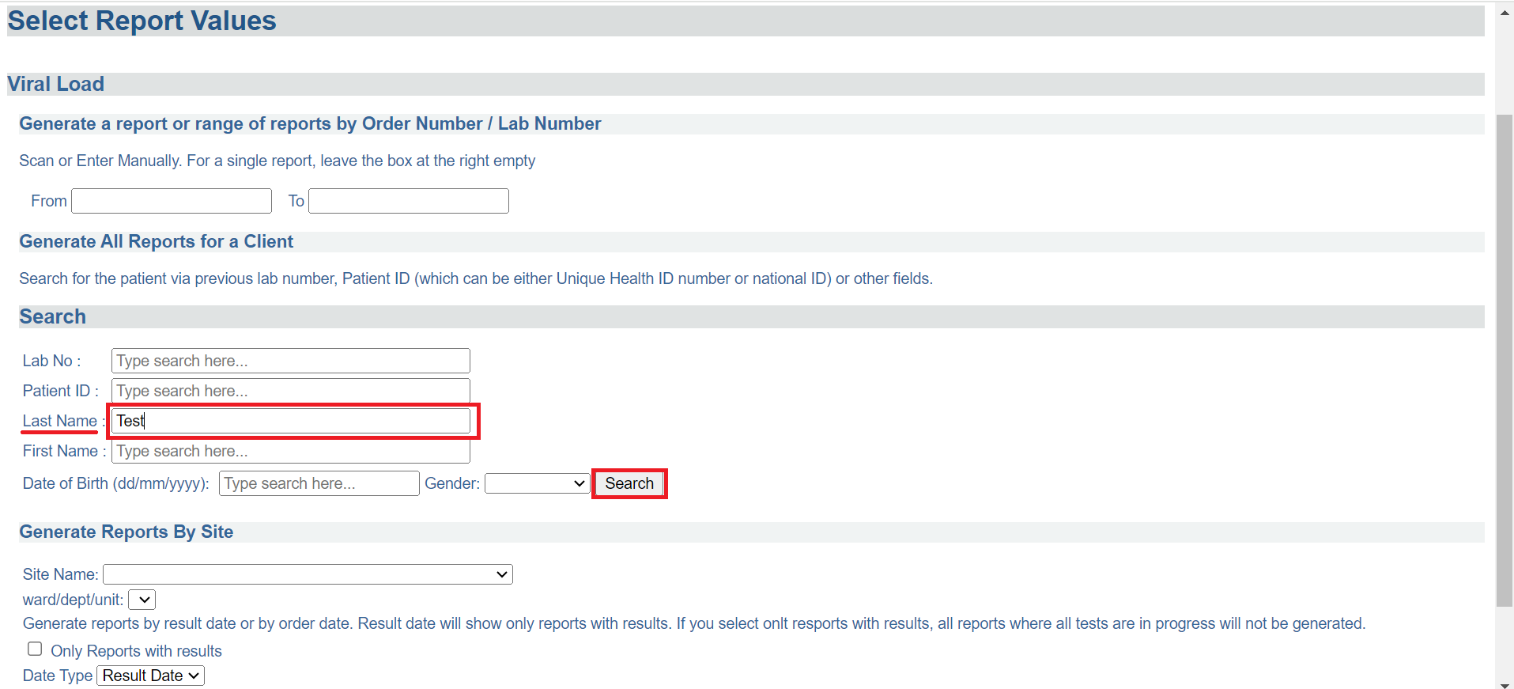*Enter Patient ID and Search*

1. Click on the radio-button against the desired patient to select the patient. Click the **Generate printable version** button. A PDF version of the report will appear in a new browser window.

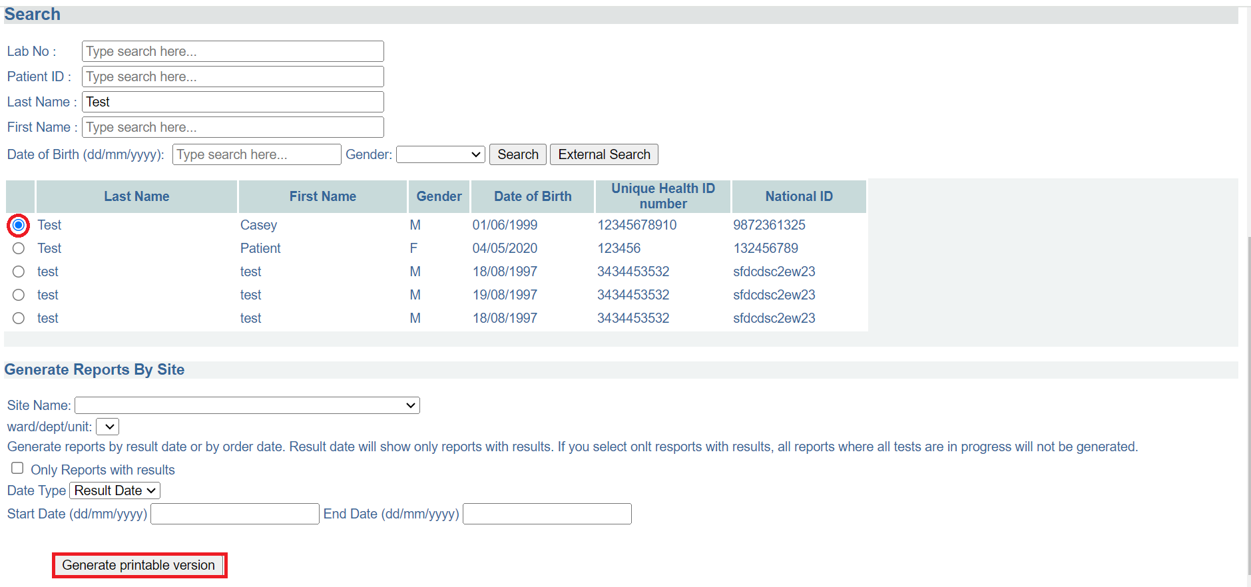*Click on Patient and Generate Printable Version*

# **PART 15: HELP**

## **How to access the user manual**

1. Hover the mouse over the hamburger icon and click to open the menu.



*Access the OpenELIS menu*

1. Hover the mouse and click on the drop-down menu under the Help module.

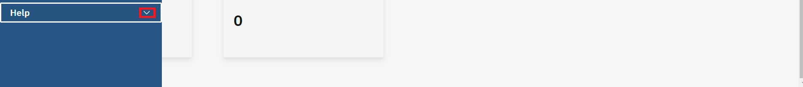

*Click help drop-down menu*

1. Click on the **User Manual** to access the user manual

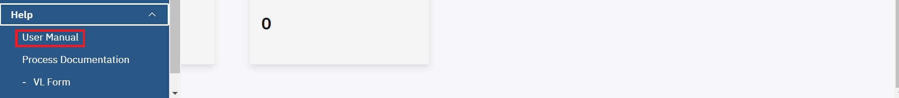

*Click manual*

## **How to access process documentation.**

1. Click **VL Form** under process documentation to access the form.

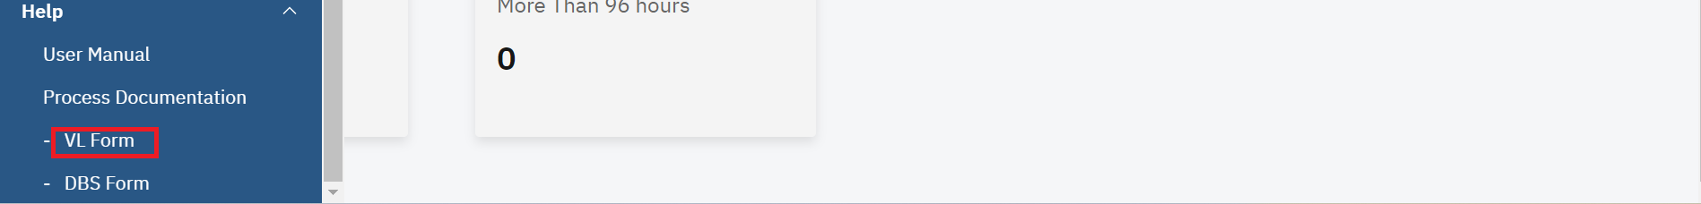

*Click VL form*

A portable document format (PDF)will be opened for the VL Form

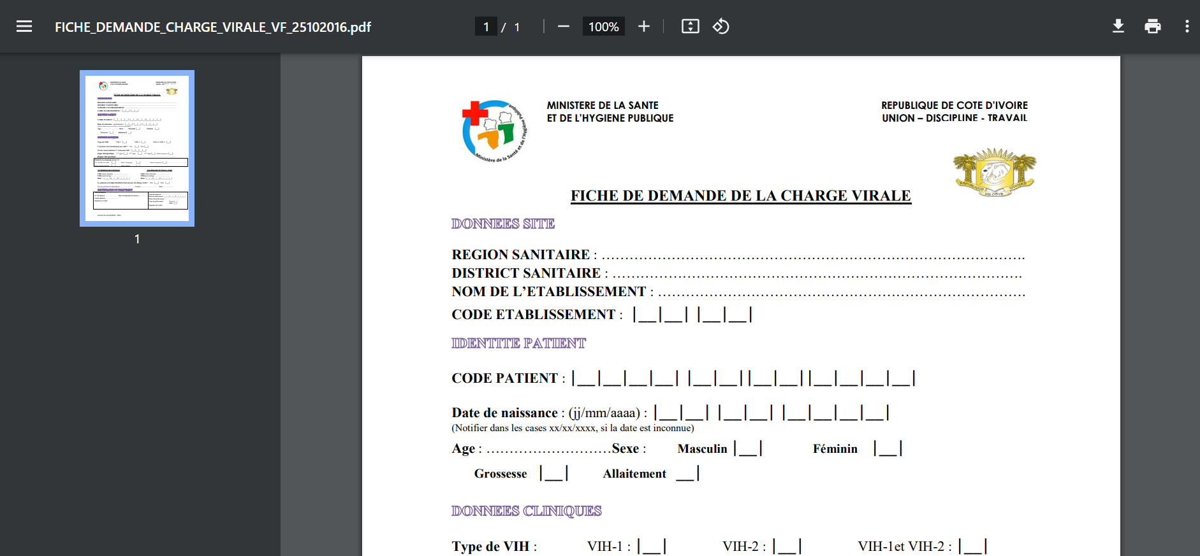*VL form*

1. To download the form, click on the download icon at the top right.

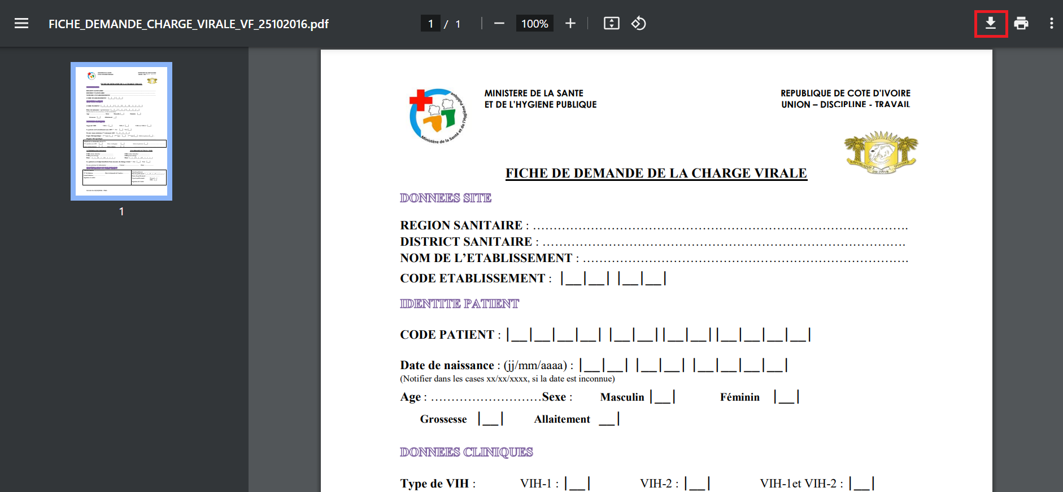

*Download form*

1. To print the form, click on the printer icon at the top of the top right.

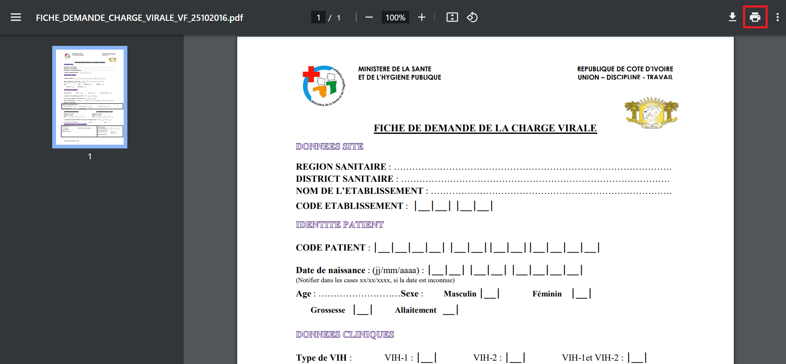

*Print form*

1. Click **VL Form** under process documentation to access the form.

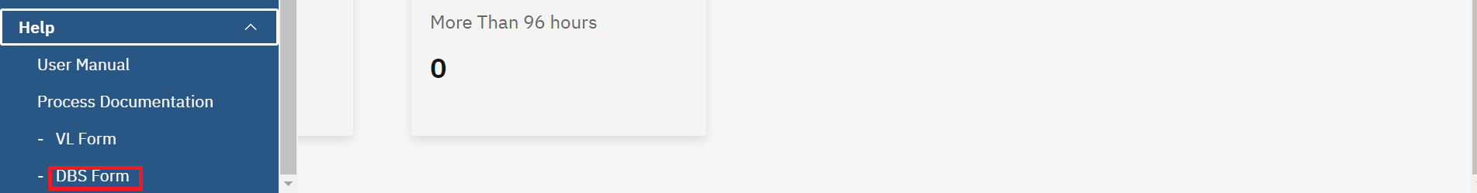

*Click VL form*

A portable document format (PDF)will be opened for the VL Form

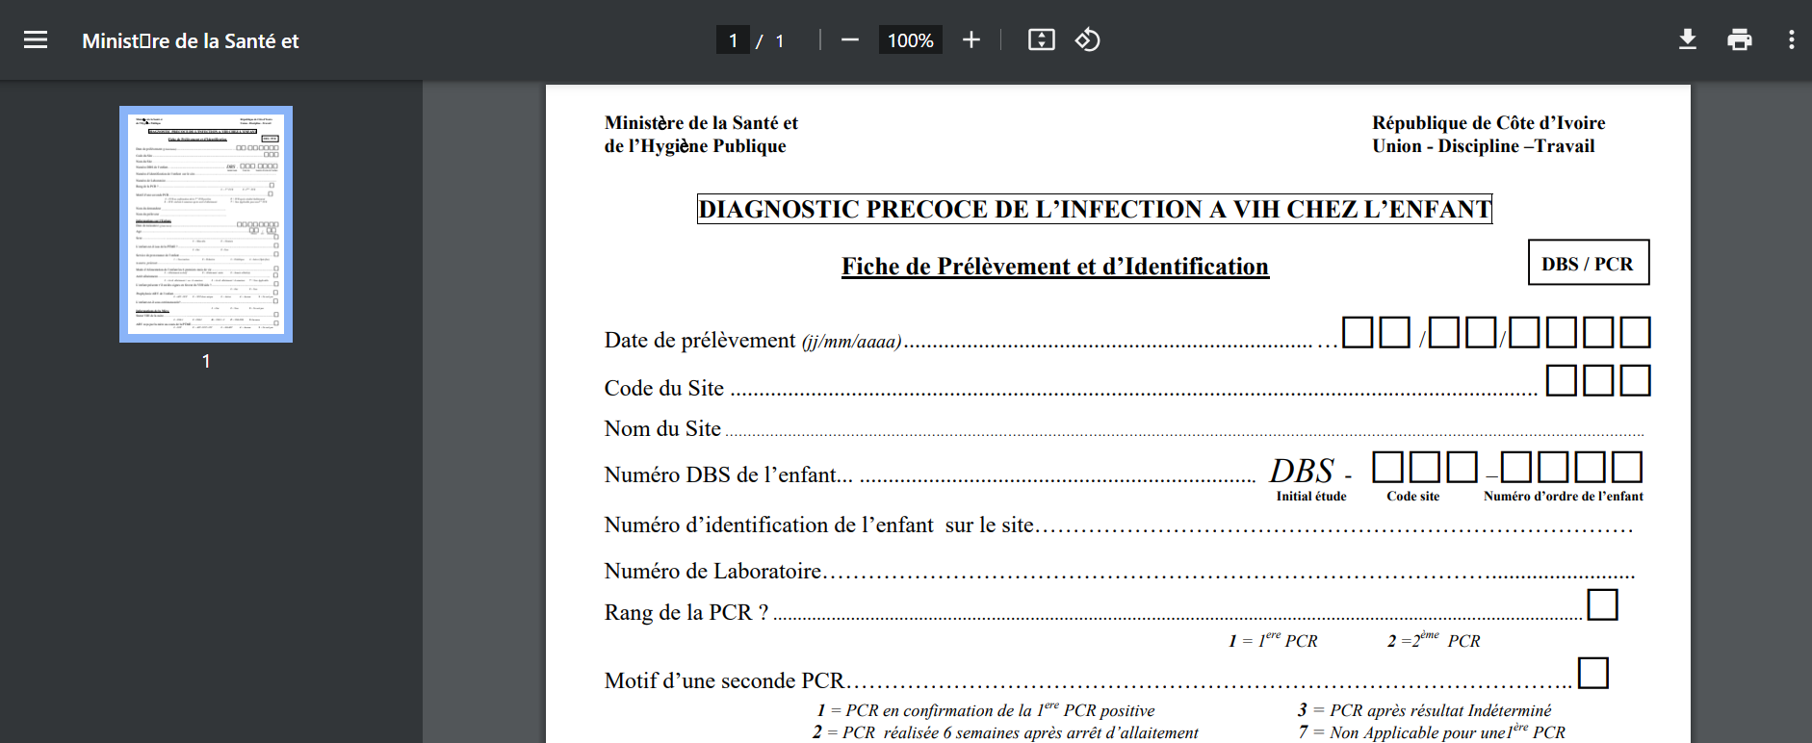

*DBS form*

1. To download the form, click on the download icon at the top right.

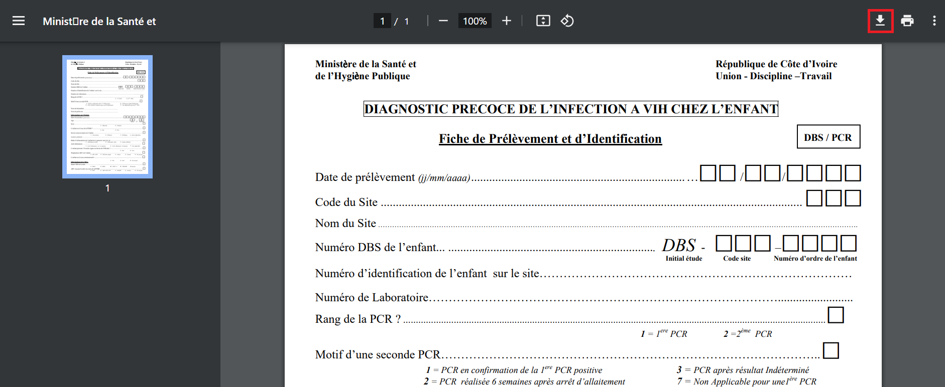

*Print form*

1. To print the form, click on the printer icon at the top of the top right.

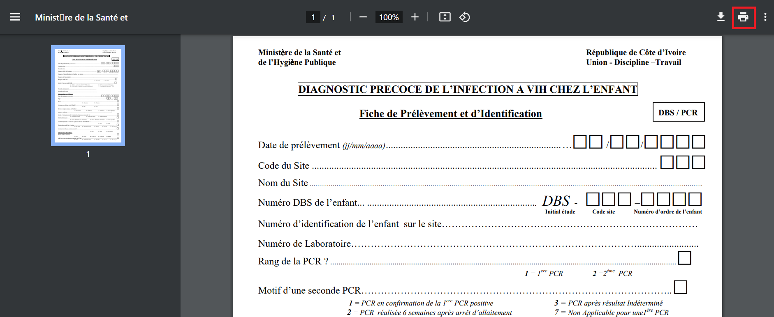

*Print form*

# **PART 16: LOGGING OUT OF OPENELIS**

## **How to logout of your OpenELIS session**

1. To logout from your OpenELIS session, hover the mouse to the top right corner and click on the profile icon 



*Accessing Logout*

1. Click on the logout menu option. Upon successful logout, you will be navigated to the login

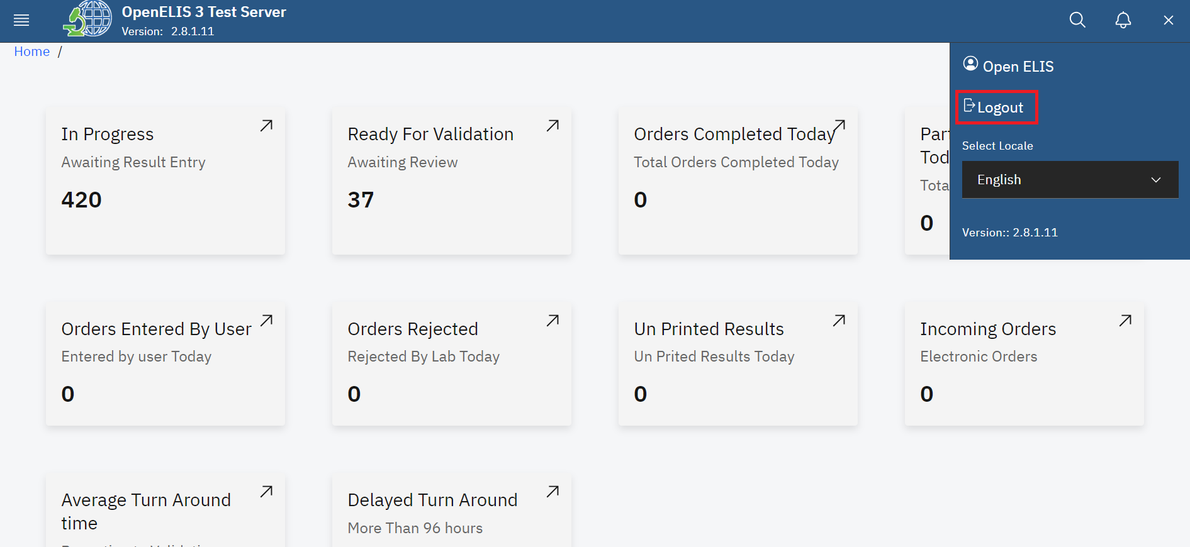

*Logout*